**Supplementary material**

**Construction of enhanced multi-polarization and high performance electromagnetic wave absorption by self-growing ZnFe2O4 on Cu9S5**

*Wenxiong Chen and Honglong Xing*🖂

School of Chemical Engineering, Anhui University of Science and Technology, Huainan 232001, China

🖂Corresponding author: Honglong Xing Email: austxhl@163.com; hlxing@aust.edu.cn

**Results and discussion**

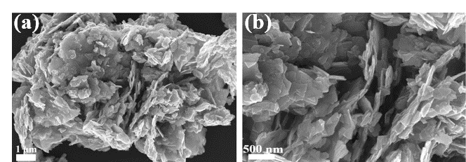

Fig. S1. SEM images of Cu9S5.

The RCS simulation is performed using the computer simulation technology (CST 2021) tool. The model consists of an upper layer of CZ composite for the absorber layer (thickness: 1.78 mm) and a lower layer of PEC layer (thickness: 1 mm). Its dimensions are 180 mm × 180 mm.

The obtained material was mixed with paraffin wax and compacted into a coaxial ring (outer/inner diameter of 7 mm/3.04 mm), the transmission line theory can be expressed by the RL curve, as follows [4–8].

$\text{RL=20lg}\left|\frac{{\text{Z}}_{\text{in}}\text{-}{\text{Z}}_{\text{0}}}{{\text{Z}}_{\text{in}}\text{+}{\text{Z}}_{\text{0}}}\right|$ (S1)

where *Z*in and *Z*0 are the input impedance and free space impedance, respectively.

**Table S1.** Values of saturation magnetization (*M*s), remanence (*M*r), coercivity (*H*c), and squareness ratio (*M*r/*M*s) of samples

|  |  |  |  |  |
| --- | --- | --- | --- | --- |
| Sample | *M*s / (emu·g–1) | *M*r / Oe | *H*c / Oe | *M*r/*M*s |
| CZ-1 | 45.9 | 7.1 | 99.2 | 0.155 |
| CZ-2 | 21.8 | 2.6 | 104.4 | 0.119 |
| CZ-3 | 18.2 | 2.5 | 105.8 | 0.137 |
| ZnFe2O4 | 92.4 | 10.5 | 90.7 | 0.113 |

Cu9S5 sheets are not ferromagnetic as semiconductor materials. The characterization results demonstrated that Cu9S5 exhibited typical ferromagnetic hysteresis properties due to the presence of certain orbital magnetic moments and spin magnetic moments inside the ZnFe2O4 molecule after the composite ZnFe2O4. The introduction of ZnFe2 O4 made *M*s of Cu9S5/ZnFe2O4 reach 18.2, 21.8, and 45.9 emu/g, and Cu9S5/ZnFe2O4 exhibited soft magnetic properties. With the decrease in ZnFe2O4 addition, the proportion of Cu9S5 in the composite gradually increased, the local magnetic moment direction and magnetic field direction unity decreased, and the demagnetization process gradually became stronger, thereby leading to the increase in coercivity (Hc). The coercivity values were 99.2, 104.4, and 105.8 Oe, which were in agreement with the results of *M*s.