Supplemental information
Corrosion engineering on AlCoCrFeNi high-entropy alloys toward highly efficient electrocatalysts for the oxygen evolution of alkaline seawater

Zhibin Chen¹⁾, Kang Huang¹⁾, Bowei Zhang^{1),}, Jiuyang Xia¹⁾, Junsheng Wu^{1),},
Zequn Zhang¹⁾, and Yizhong Huang^{2),}

1) Institute for Advanced Materials and Technology, University of Science and Technology Beijing, Beijing 100083, China
2) School of Materials Science and Engineering, Nanyang Technological University, 50 Nanyang Avenue 639798, Singapore
(Received: 13 November 2022; revised: 05 March 2023; accepted: 06 March 2023)
Corresponding authors: Bowei Zhang E-mail: bwzhang@ustb.edu.cn; Junsheng Wu E-mail: wujs@ustb.edu.cn; Yizhong Huang E-mail: YZHuang@ntu.edu.sg

Table S1. Chemical composition of AlCoCrFeNi high entropy alloys wt%
Al | Co | Cr | Fe | Ni
20 | 20 | 20 | 20 | 20

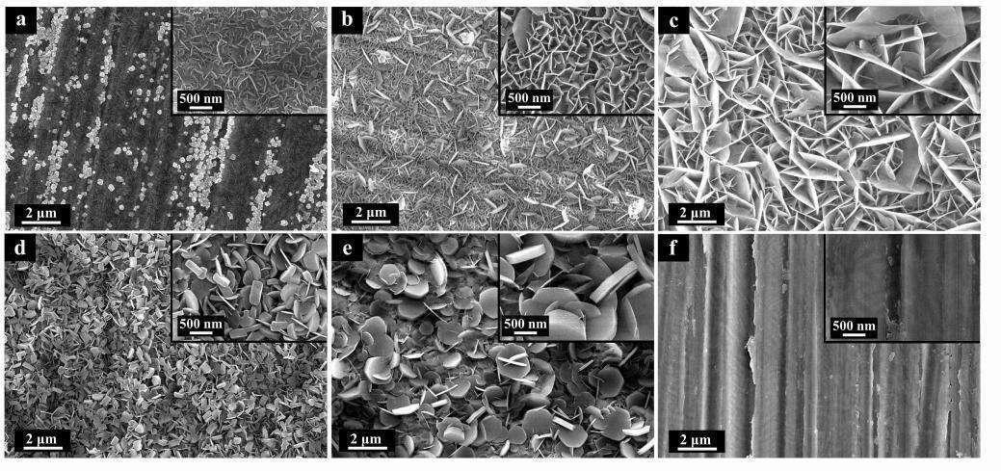
Fig. S1. SEM images of as-prepared samples in different NaOH solution and AlCoCrFeNi-HEAs: (a) LDHs–0.1 M–8 h; (b) LDHs–1 M–8 h; (c) LDHs–5 M–8 h; (d) LDHs–7 M–8 h; (e) LDHs–9 M–8 h; (f) AlCoCrFeNi-HEAs.
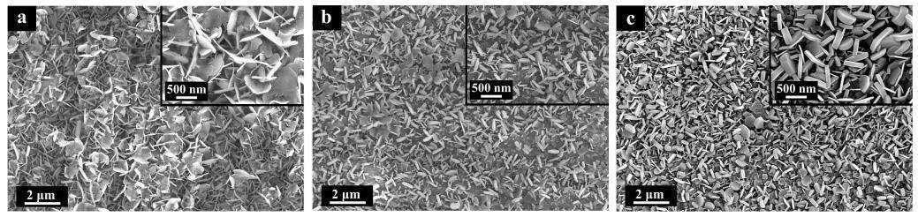
Fig. S2. SEM images of as-prepared samples underwent different heating duration: (a) LDHs–3 M–4 h; (b) LDHs–3 M–12 h; (c) LDHs–3 M–24 h.
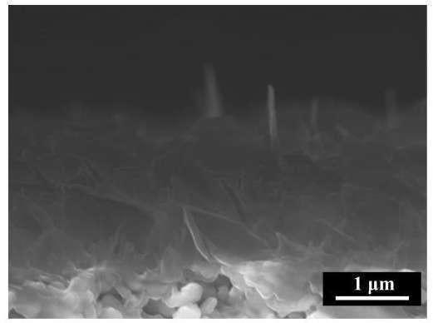
Fig. S3. Sectional SEM images of LDHs–3 M–8 h.
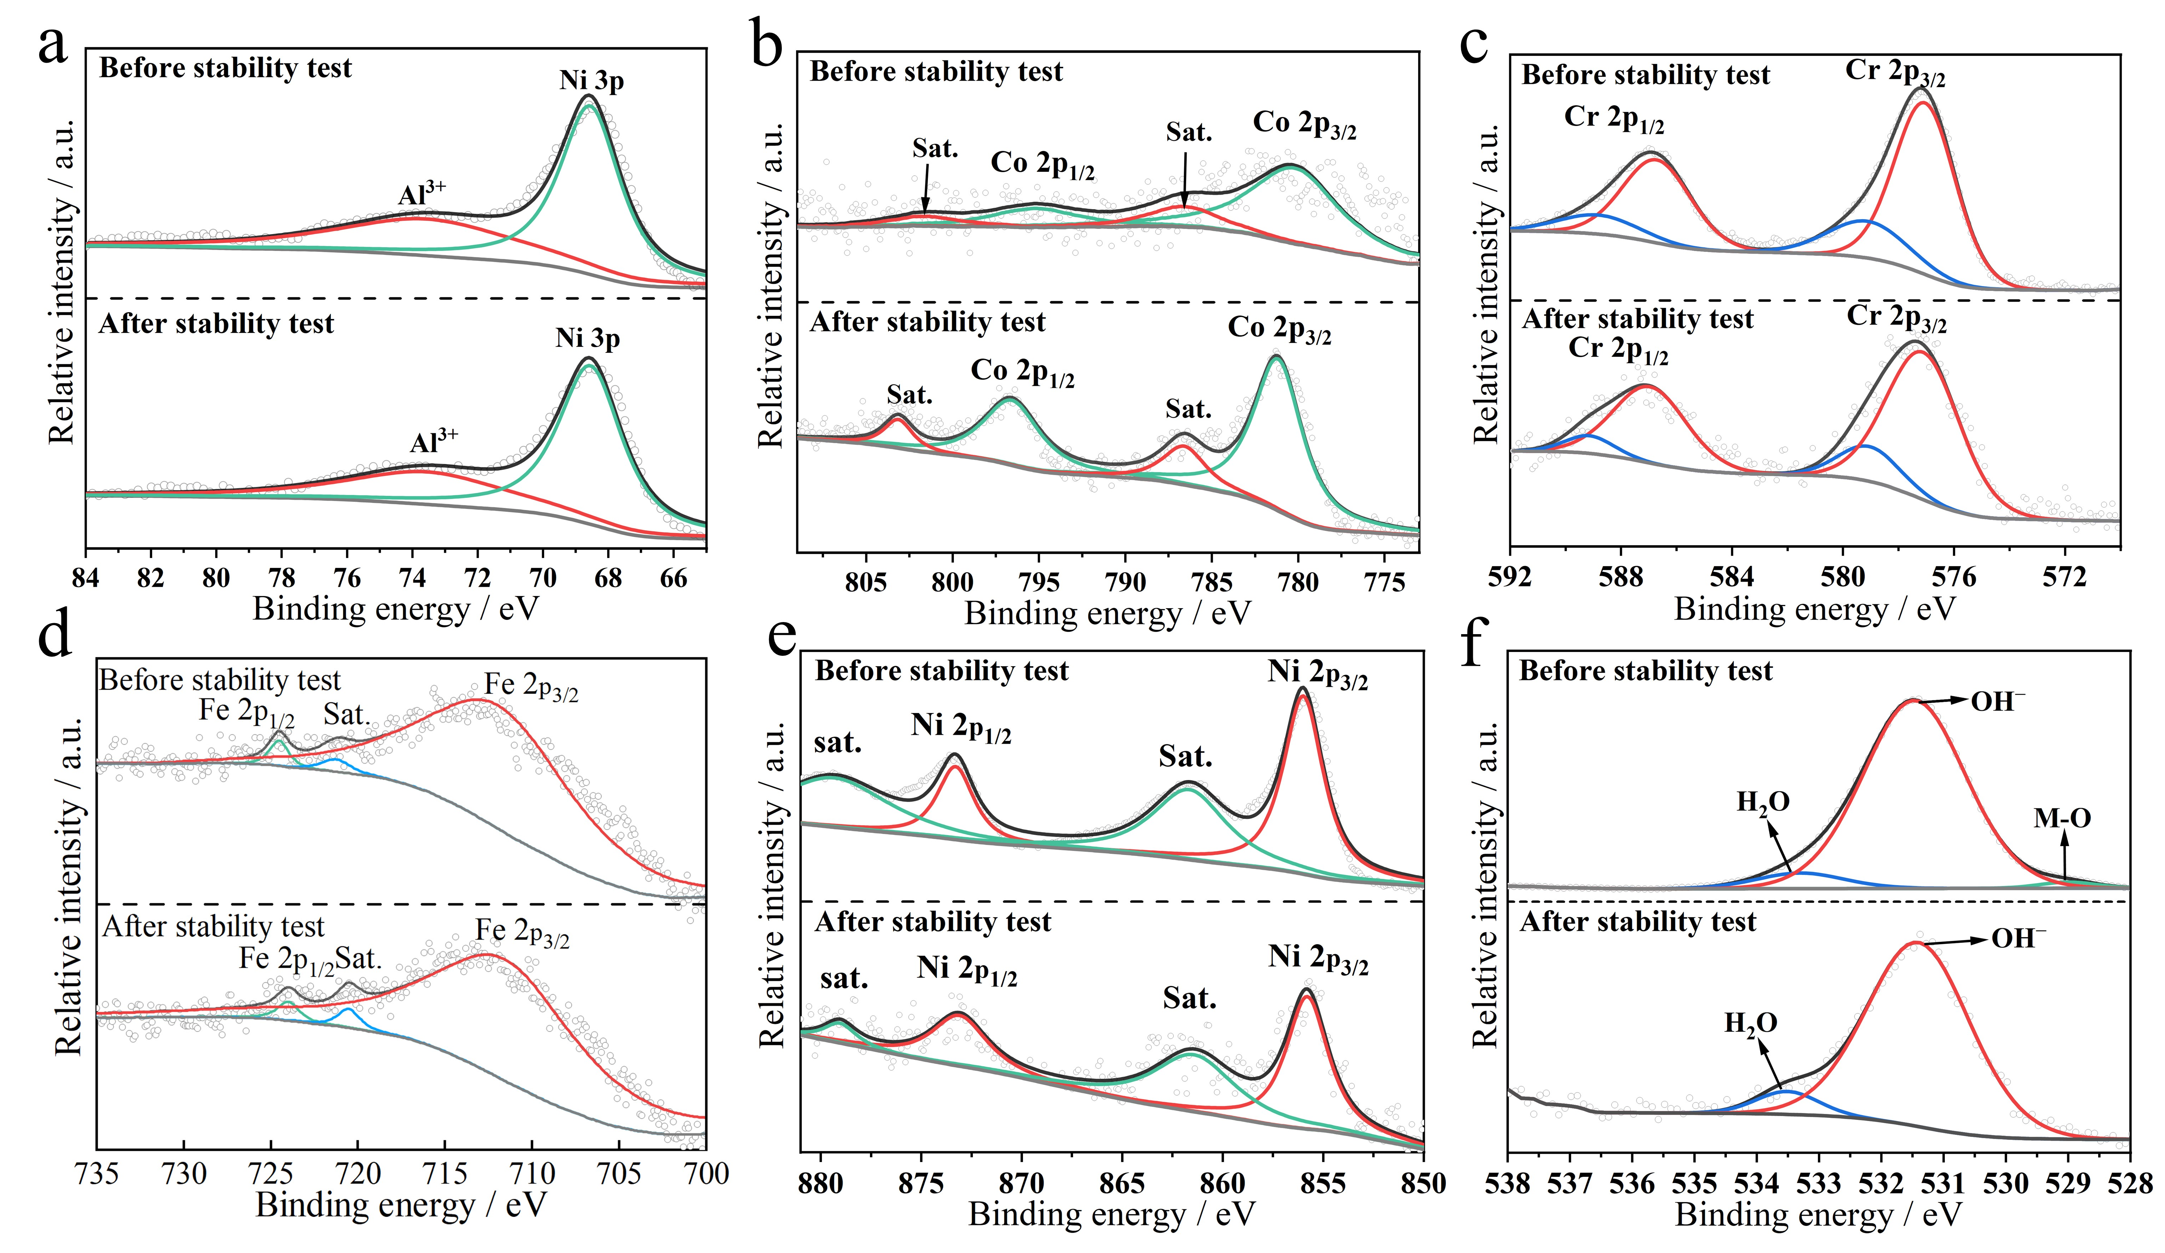
Fig. S4. High-resolution XPS of (a) Al 2p, (b) Co 2p, (c) Cr 2p, (d) Fe 2p, (e) Ni 2p, and (f) O 1s of AlCoCrFeNi-LDHs-AST in comparison with AlCoCrFeNi-LDHs-BST.

Fig. S5. CV curves of as-prepared samples prepared in different NaOH solution and AlCoCrFeNi-HEA: (a) LDHs–0.1 M–8 h; (b) LDHs–1 M–8 h; (c) LDHs–5 M–8 h; (d) LDHs–7 M–8 h; (e) LDHs–9 M–8 h; (f) AlCoCrFeNi-HEAs.
Fig. S6. CV curves of as-prepared samples underwent different heating duration: (a) LDHs–3 M–4 h; (b) LDHs–3 M–12 h; (c) LDHs–3 M–24 h.
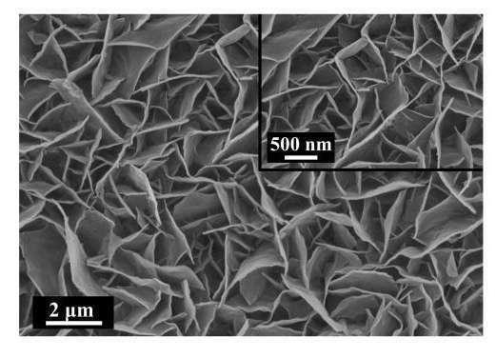
Fig. S7. SEM images of AlCoCrFeNi-LDHs-AST.
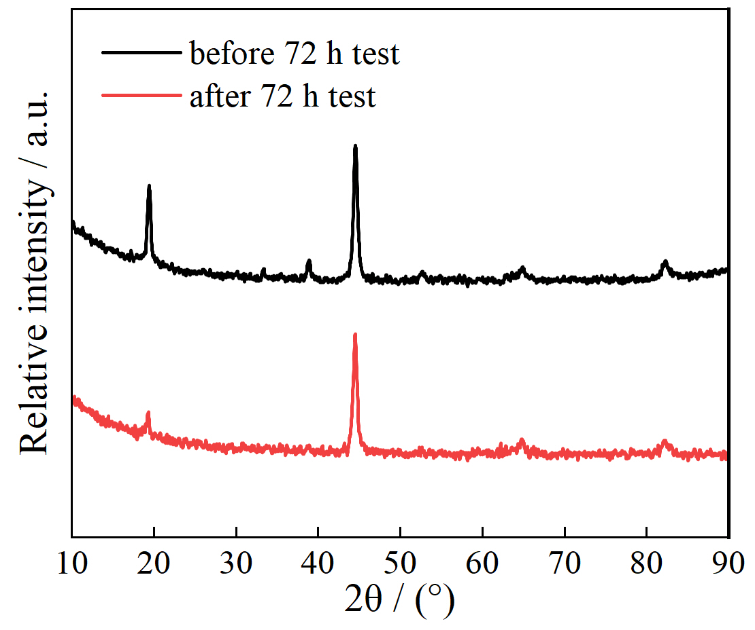
Fig. S8. XRD pattern of catalyst before and after 72 h stability test.

