Supplementary Material

**Comparison of the effects of Ti- and Si-containing minerals on goethite transformation in the Bayer digestion of goethitic bauxite**

*Guotao Zhou*, *Yilin Wang*🖂, *Tiangui Qi*, *Qiusheng Zhou*, *Guihua Liu*, *Zhihong Peng*, *and Xiaobin Li*🖂

School of Metallurgy and Environment, Central South University, Changsha 410083, China

(Received: 29 November 2022; revised: 9 March 2023; accepted: 10 March 2023)

🖂 Corresponding author: Yilin Wang E-mail: wang.yi.lin@outlook.com; Xiaobin Li E-mail: x.b.li@csu.edu.cn

 

**Fig. S1. XRD patterns of the (a) synthetic goethite, (b) anatase, and (c) kaolinite.**

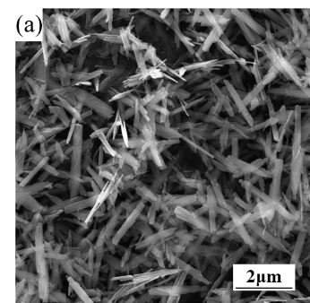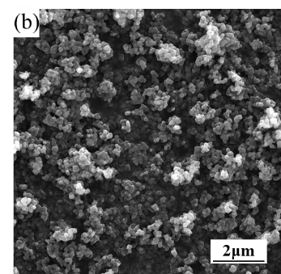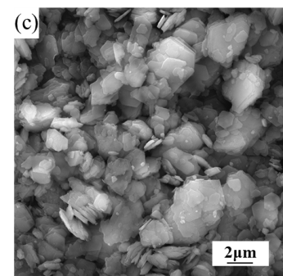

**Fig. S2. SEM images of the (a) synthetic goethite, (b) anatase, and (c) kaolinite.**



**Fig. S3. XRD patterns of the goethitic bauxite.**





**Fig. S4.** **XRD pattern of the reaction products of goethitic bauxite and hydrazine hydrate in sodium aluminate solution with different dosages of (a) anatase, (b) kaolinite, and (c) *η*AG.**