Supplementary Information

Solvent extraction and separation of cobalt from leachate of spent lithium-ion battery cathodes with N263 in nitrite media
Yingnan Yang^{1,2)}, Yingjie Yang^{1,2)}, Chunlin He^{1,2,3),}, Yuezhou Wei^{4,5)}, Toyohisa Fujita^{1,2)}, Guifang Wang^{1,2)}, Shaojian Ma^{1,2)}, and Wenchao Yang^{1,2)}

1) School of Resources, Environment and Materials, Guangxi University, Nanning 530004, China
2) Guangxi Key Laboratory of Processing for Non-ferrous Metals and Featured Materials, Nanning 530004, China
3) Key Laboratory of New Low-carbon Green Chemical Technology, Education Department of Guangxi Zhuang Autonomous Region, Nanning 530004, China
4) School of Nuclear Science and Technology, University of South China, Hengyang 421000, China
5) School of Nuclear Science and Engineering, Shanghai Jiao Tong University, Shanghai 200240, China

Corresponding author: Chunlin He E-mail: helink1900@126.com

To explore the role of modifiers in the extraction process, Fig S1 shows the changes of modifiers under different conditions. As shown in Fig S1, sample 1 is the organic phase with modifier (N263/modifier/sulfonated kerosene) and the organic phase compositions are completely dissolved. Sample 2 is the organic phase without modifier, the mixed solution of N263 and kerosene shows turbidity, and undissolved N263 is still present at the bottom. It can be clearly seen that the addition of the modifier can improve the solubility of the extractant in the kerosene. In addition, sample 3 is the organic phase after extraction (N263/sulfonated kerosene), and the modifier can prevent the formation of the third phase. Samples 4 and 5 are the aqueous phase. The solution remains turbid after standing for 10 min, but after 12 h, the solution becomes clear.

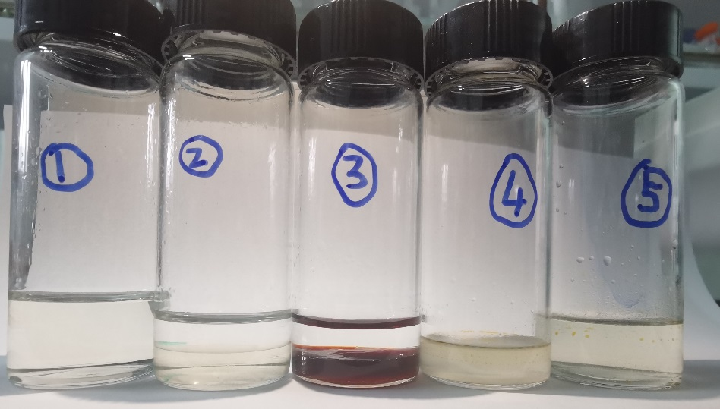
Fig. S1. Effect of modifiers on N263 in kerosene: 1―the organic phase with modifier added (N263/modifier/sulfonated kerosene), 2―the organic phase without modifier (N263/sulfonated kerosene), 3―the organic phase after extraction (N263/sulfonated kerosene), 4―the extraction aqueous phase after standing for 10 min, and 5―the extraction aqueous phase after standing for 12 h.

Table S1. Composition of simulated solutions
Element | Raw solution /  (mg⋅L^{‒1}) | After-extraction solution /  (mg⋅L^{‒1}) | D | β_{(Co/Li)} | β_{(Co/Mn)} | β_{(Co/Ni)}
Li | 780 | 727 | 0.14 | 1140.95
Mn | 778 | 727 | 0.14 |  | 1171.70
Co | 747 | 9 | 167.00
Ni | 770 | 731 | 0.10 |  |  | 1547.31

Table S2. Composition of the simulated solutions and the extraction efficiency under various conditions
Element | Raw solution /  (mg⋅L^{‒1}) | Extraction efficiency / %
 |  | Condition 1 | Condition 2 | Condition 3
Li | 1225 | 0 | 9.50 | 10.11
Mn | 3595 | 0 | 7.59 | 10.98
Co | 2568 | 0 | 62.99 | 94.24
Ni | 7210 | 0 | 12.03 | 12.29

Table S3. Composition of the real leaching solutions and back-extraction
Element | Raw solution /  (mg⋅L^{‒1}) | After-extraction solution /  (mg⋅L^{‒1}) | Back-extraction solution /  (mg⋅L^{‒1}) | Purity / %
Li | 1409 | 1317 | 5.1 | 0.23
Mn | 3260 | 2951 | 17.7 | 0.81
Co | 2404 | 0 | 2154 | 97.98
Ni | 6051 | 5513 | 21.6 | 0.98

