**Supplementary Information**

**From waste to wealth: Coal tar residue** **derived carbon materials as low-cost anodes for** **potassium-ion batteries**

*Zhonghua Lu*1), *Jun Shen*1),🖂, *Xin Zhang*1), *Lingcong Chao*1), *Liang Chen*2), *Ding Zhang*3), *Tao Wei*4),🖂, *and Shoudong Xu*1),🖂

1) College of Chemical Engineering and Technology, Taiyuan University of Technology, Taiyuan 030024, China

2) College of Chemistry, Taiyuan University of Technology, Taiyuan 030024, China

3) School of Chemical Engineering and Pharmacy, Wuhan Institute of Technology, Wuhan 430205, China

4) School of Energy and Power, Jiangsu University of Science and Technology, Zhenjiang 212003, China

🖂 Corresponding authors: Shoudong Xu E-mail: xushoudong@tyut.edu.cn; Jun Shen E-mail: shenjun@tyut.edu.cn; Tao Wei E-mail: wt863@126.com



**Fig. S1. Spectra of (002) and γ band of CTRCs.**



Fig. S2. XPS survey spectra of CTRCs.

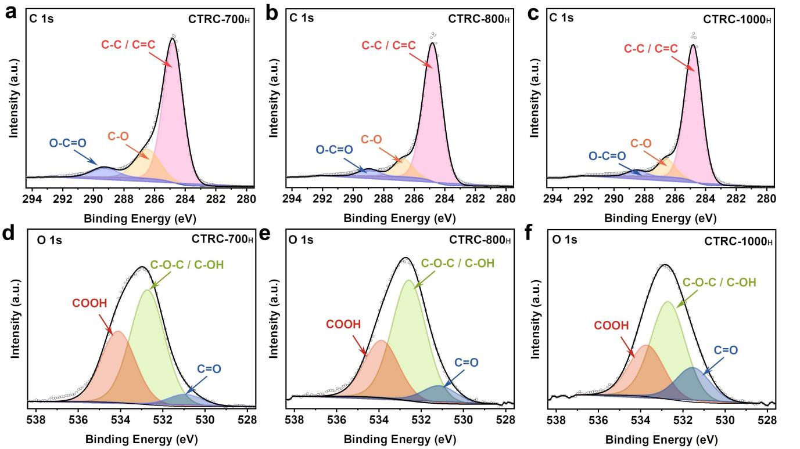

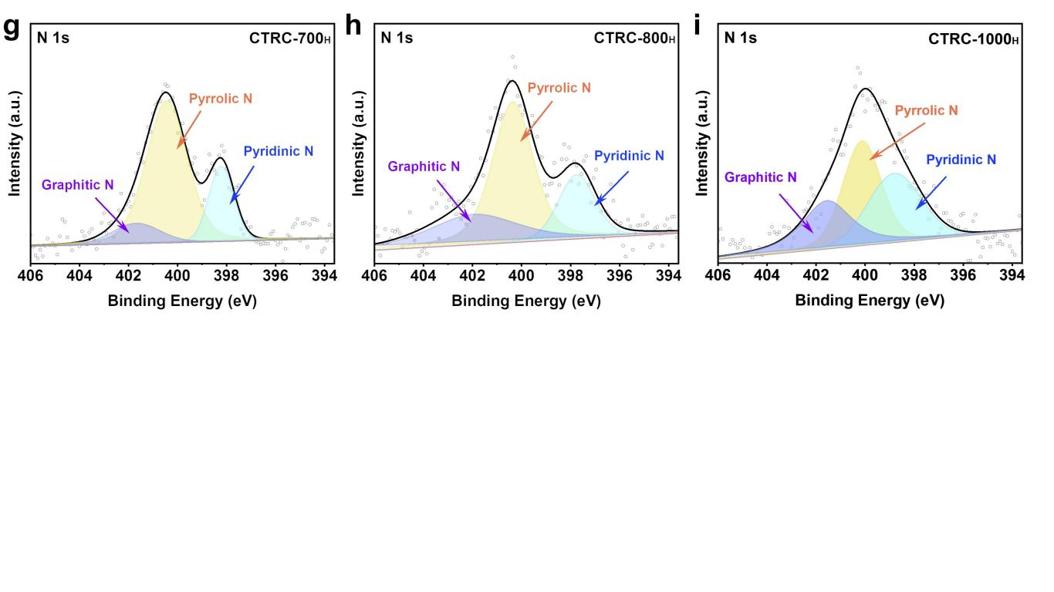

Fig. S3. (a–c) C 1s, (d–f) O 1s, and (g–i) N 1s peak fitting results of the XPS spectra for CTRC-700H, CTRC-800H, and CTRC-1000H.



**Fig. S4. Conductivity curves of CTRCs.**



Fig. S5. Individual GITT curves.

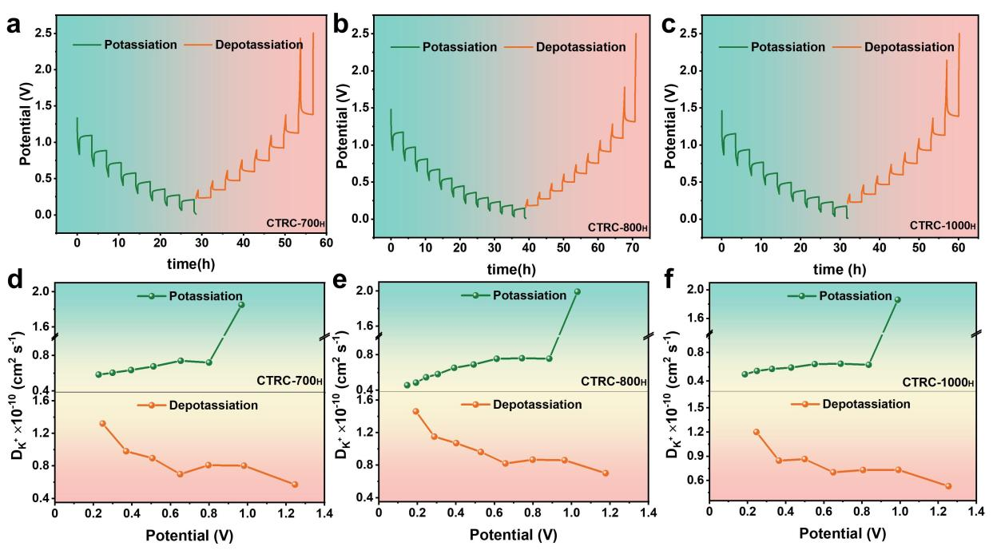

Fig. S6. GITT curves of (a) CTRC-700H, (b) CTRC-800H, and (c) CTRC-1000H; (b) K+ apparent diffusion coefficients for the potassiation/depotassiation process of (d) CTRC-700H, (e) CTRC-800H, and (f) CTRC-1000H.

**Table S1. Structural parameters of CTRCs**

|  |  |  |  |
| --- | --- | --- | --- |
| Samples | Specific surface area, *S*BET / (m2·g−1) | Pore volume, *V*BJH / (cm3·g−1) | Average pore size, *D*BJH / nm |
| CTRC-700H | 1.864 | 0.00504 | 16.83 |
| CTRC-800H | 3.484 | 0.00897 | 9.52 |
| CTRC-900H | 3.933 | 0.00842 | 8.36 |
| CTRC-1000H | 3.163 | 0.00688 | 11.07 |

Table S2. Contents of the C 1s, O 1s, and N 1s peaks in deconvoluted CTRCs samples

|  |  |  |  |  |
| --- | --- | --- | --- | --- |
| Peak | CTRC-700 | CTRC-800 | CTRC-900 | CTRC-1000 |
| C 1s | 86.9 | 88.1 | 89.8 | 90.8 |
| O 1s | 10.3 | 9.0 | 7.5 | 7.2 |
| N 1s | 1.1 | 0.9 | 1.3 | 1.0 |
| Others | 1.7 | 2.0 | 1.4 | 1.0 |
| C 1s element composition / at% | | | | |
| C–C/C=C | 73.8 | 84.5 | 86.0 | 84.5 |
| C–O | 19.4 | 11.1 | 10.9 | 11.6 |
| O–C=O | 6.8 | 4.4 | 3.1 | 3.9 |
| O 1s element composition / at% | | | | |
| C=O | 6.0 | 9.0 | 24.1 | 18.7 |
| C–OH/C–O–C | 57.9 | 61.7 | 62.2 | 53.2 |
| –COOH | 36.1 | 29.3 | 13.7 | 28.1 |
| N 1s element composition / at% | | | | |
| Graphitic nitrogen (N-Q) | 11.6 | 14.9 | 19.7 | 21.2 |
| Pyrrolic (N-5) | 62.5 | 57.7 | 55.7 | 56.2 |
| Pyridinic (N-6) | 25.9 | 27.4 | 24.6 | 22.6 |

Table S3. Electrochemical performances of coal/ pitch/solid waste-derived carbon as anode materials for potassium ion batteries.

|  |  |  |  |  |  |  |  |  |
| --- | --- | --- | --- | --- | --- | --- | --- | --- |
| No. | Sample | Precursor | Synthesis method | Initial reversible capacity / (mAh·g−1) | Current density / (mA·g−1) | Rate performance / (mAh·g−1) | Cycling performance / (mAh·g−1) | Ref. |
| 1 | HC1200 | Coal tar pitch | Carbonization | **296** | 0.1 C | **115.2** (5 C) | 93.1% (1000 cycles, 1 C) | [1] |
| 2 | NPPC-2-700 | Coal tar pitch | N P doping + template + carbonization | **240** | 50 | **133** (5 A·g−1) | **121** (400 cycles, 1 A·g−1) | [2] |
| 3 | SC-800 | Polyvinyl chloride | Carbonization | **280** | 50 | **127** (1 A·g−1) | **106** (150 cycles, 0.1 A·g−1) | [3] |
| 4 | PET | Polyethylene terephthalate | Solvent thermal method | **225** | 50 | **75** (0.5 A·g−1) | **158.7** (800 cycles, 0.1 A·g−1) | [4] |
| 5 | rGOCOF | Coffee waste + graphene oxide | Carbonization | **175** | 0.1 C | **50** (2 C) | 80% (300 cycles, 1 C) | [5] |
| 6 | NOS-HC900 | Waste tires containing N, O, S | Carbonization | **323.1** | 100 | **231.7** (2 A·g−1) | **322.7** (1000 cycles, 0.1 A·g−1) | [6] |
| 7 | M700 | Lignin | Carbonization | **304** | 50 | **171** (0.2 A·g−1) | 79% (100 cycles, 0.05 A·g−1) | [7] |
| 8 | CSHP2 | Camellia shell | Carbonization | **264.5** | 100 | **164** (0.5 A·g−1) | **237.6** (100 cycles, 0.1 A·g−1) | [8] |
| 9 | A-900 | Anthracite | Carbonization | **213** | 100 | **118.6** (0.5 A·g−1) | **138.7** (100 cycles, 0.1 A·g−1) | [9] |
| 10 | CTRC-800 | Coal tar residue | Carbonization | **265.6** | 50 | **171.8** (0.5 A·g−1) | **249.2** (93.8%; 0.05 A·g−1) | This work |

**References**[1] Y. Liu, Y.X. Lu, Y.S. Xu, *et al.*, Pitch-derived soft carbon as stable anode material for potassium ion batteries, *Adv*. *Mater*., 32(2020), No. 17, art. No. 2000505.[2] X.Q. Ma, N. Xiao, J. Xiao, *et al.*, Nitrogen and phosphorus dual-doped porous carbons for high-rate potassium ion batteries, *Carbon*, 179(2021), p. 33.[3] X. He, L. Zhong, X.Q. Qiu, *et al.*, Sustainable polyvinyl chloride-derived soft carbon anodes for potassium-ion storage: Electrochemical behaviors and mechanism, *ChemSusChem*, 16(2023), No. 19, art. No. e202300646.[4] Z.H. Kang, K.X. Sun, C.F. Sun, and Q. Liu, A plastics-derived organic anode material for practical and sustainable potassium-ion batteries, *Int*. *J*. *Electrochem*. *Sci*., 18(2023), No. 9, art. No. 100222.[5] J.L. Gómez-Urbano, C. Leibing, M. Jauregui, *et al.*, Unravelling charge storage mechanisms of lithium, sodium and potassium into graphene-coffee waste derived hard carbon composites, *Batter*. *Supercaps*, 6(2023), No. 3, art. No. e202200508.[6] Q. Zhao, Q.T. Zheng, S.H. Li, *et al.*, Nitrogen/oxygen/sulfur tri-doped hard carbon nanospheres derived from waste tires with high sodium and potassium anodic performances, *Inorg*. *Chem*. *Front*., 10(2023), No. 9, p. 2574.[7] Z.R. Wu, J. Zou, Y. Zhang, *et al.*, Lignin-derived hard carbon anode for potassium-ion batteries: Interplay among lignin molecular weight, material structures, and storage mechanisms, *Chem*. *Eng*. *J*., 427(2022), art. No. 131547.[8] S.J. Chen, K.J. Tang, F. Song, *et al.*, Porous hard carbon spheres derived from biomass for high-performance sodium/potassium-ion batteries, *Nanotechnology*, 33(2022), No. 5, art. No. 055401.[9] X.Y. Liu, H.C. Tao, C.Y. Tang, and X.L. Yang, Anthracite-derived carbon as superior anode for lithium/potassium-ion batteries, *Chem*. *Eng*. *Sci*., 248(2022), art. No. 117200.