Supplementary Information

High-entropy ferrite with tunable magnetic properties for excellent microwave absorption
Yuying Huo^{1,2)}, Zhengyan Wang^{1,2)}, Yanlan Zhang^{1,2),}, and Yongzhen Wang^{1,2),}
1) College of Materials Science and Engineering, Taiyuan University of Technology, Taiyuan 030024, China
2) Shanxi Joint Laboratory of Coal based Solid Waste Resource Utilization and Green Ecological Development, Taiyuan 030024, China
Corresponding authors: Yanlan Zhang E-mail: zhangyanlan@tyut.edu.cn; Yongzhen Wang E-mail: wangyongzhen@tyut.edu.cn

Fig. S1. Schematic process of HEF used as a microwave absorber.
Fig. S2. Enlarged XRD patterns of (CoNi)_{x/2}(CuZnAl)_{(1−x)/3}Fe₂O₄ (x = 0.25, 0.34, 0.40, 0.50).

Fig. S3. Matching Rietveld refinement patterns of (CoNi)_{x/2}(CuZnAl)_{(1−x)/3}Fe₂O₄ (x = 0.25, 0.34, 0.40, 0.50).
Table S1. Refined parameters of HEF
(Co_{1/2}Ni_{1/2})_{x}(Cu_{1/3}Zn_{1/3}Al_{1/3})_{1−x}Fe₂O₄ | Lattice constant / Å | R_{wp}
x = 0.25 | 8.348 | 5.55
x = 0.34 | 8.355 | 5.51
x = 0.40 | 8.351 | 4.49
x = 0.50 | 8.353 | 5.33

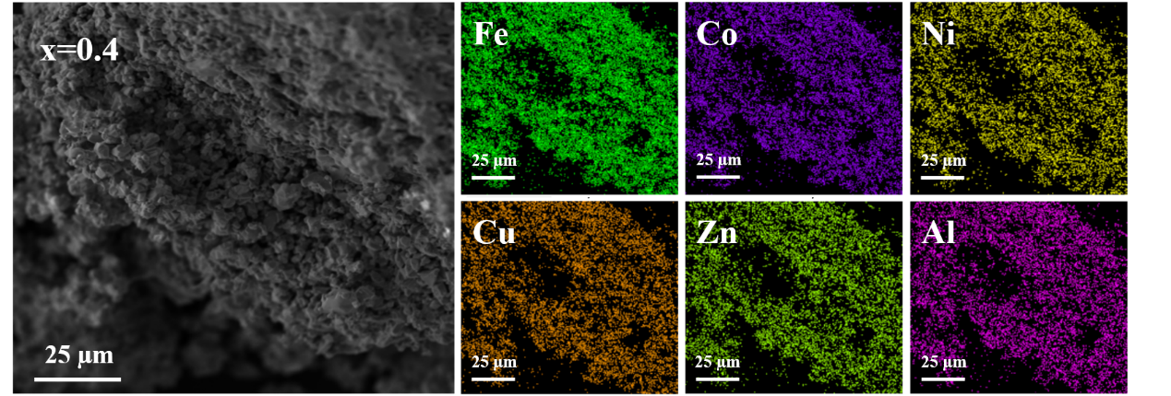
Fig. S4. Representative EDS elemental mappings of (CoNi)_{x/2}(CuZnAl)_{(1−x)/3}Fe₂O₄ (x = 0.40).
Fig. S5. XPS patterns of (CoNi)_{x/2}(CuZnAl)_{(1−x)/3}Fe₂O₄ (x = 0.25, 0.34, 0.40, 0.50) samples.
Fig. S6. XPS patterns of (CoNi)_{x/2}(CuZnAl)_{(1−x)/3}Fe₂O₄ (x = 0.25, 0.34, 0.40, 0.50) samples.
Table S2. Magnetic characteristics of HEF with different x values obtained from VSM
x | M_{s} / (A·m²·kg⁻¹) | H_{c} / mT
0.25 | 62.47 | 3.60
0.34 | 58.73 | 5.46
0.40 | 58.10 | 6.26
0.50 | 62.77 | 8.38

