**Supplementary Information**

**Realizing high-performance Na3V2(PO4)2O2F cathode for sodium-ion batteries via Nb-doping**

*Jie Wang*1,2),*, *Yifeng Yuan*1),*, *Xianhui Rao*1), *Min’an Yang*1), *Doudou Wang*1), *Ailing Zhang*1), *Yan Chen*1), *Zhaolin Li*1,2), *and Hailei Zhao*1,2),🖂

1) School of Materials Science and Engineering, University of Science and Technology Beijing, Beijing 100083, China

2) Beijing Municipal Key Lab of Advanced Energy Materials and Technologies, Beijing 100083, China

*These authors contributed equally to this work.

🖂 Corresponding author: Hailei Zhao E-mail: hlzhao@ustb.edu.cn



**Fig. S1.**  Rietveld refined patterns of (a) NVPOF/rGO and (b) NVN10POF/rGO samples.



**Fig. S2.** FESEM images of the synthesized (a) NVPOF/rGO, (b) NVN05POF/rGO, and (c) NVN10POF/rGO materials.



**Fig. S3.** TEM image of the NVPOF/rGO material.

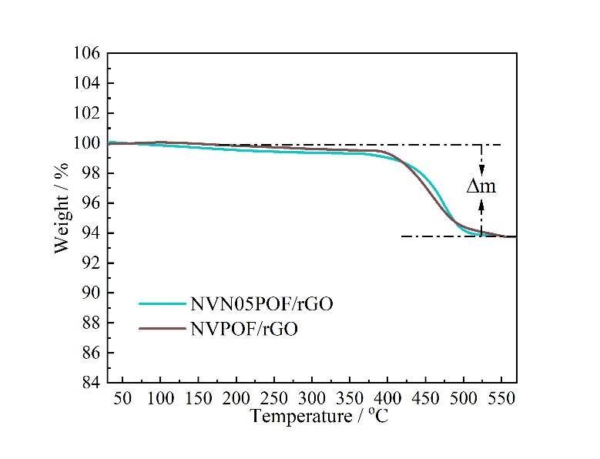

**Fig. S4.** TG curves of the synthesized NVN05POF/rGO and NVPOF/rGO materials.

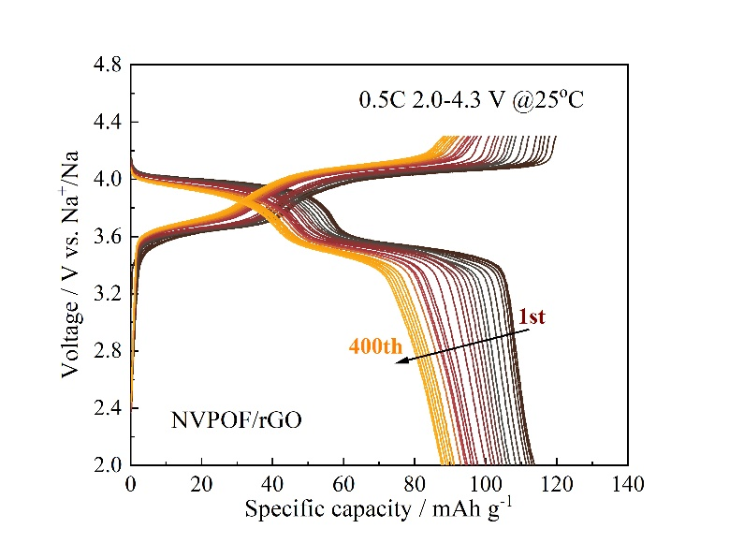

**Fig. S5.** Charge/discharge curves of the NVPOF/rGO electrode at different cycles.



**Fig. S6.** Charge/discharge curves of the (a) NVN05POF/rGO and (b) NVPOF/rGO electrode at different current rates.

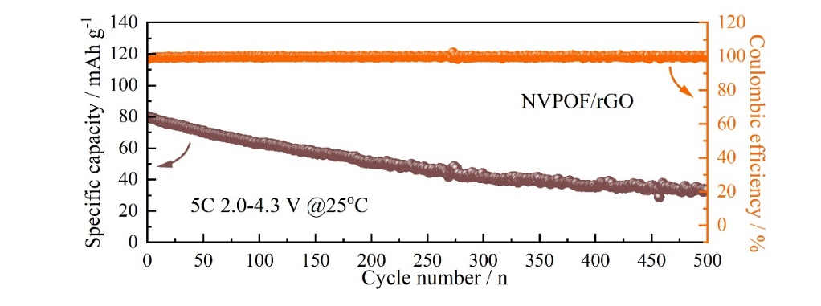

**Fig. S7.** Long-term cycling performance of the NVPOF/rGO electrode at 5 C.

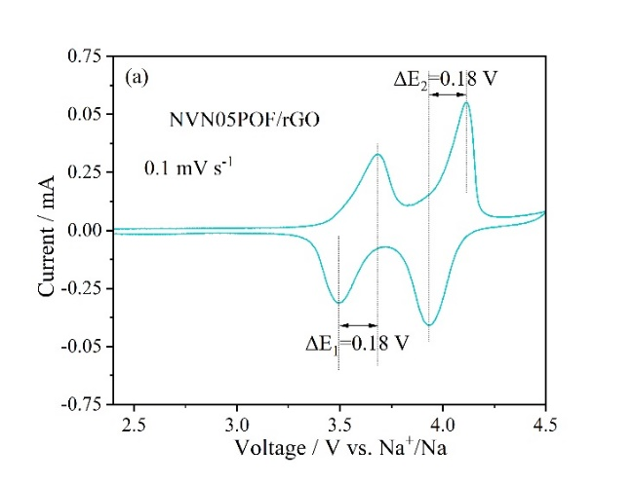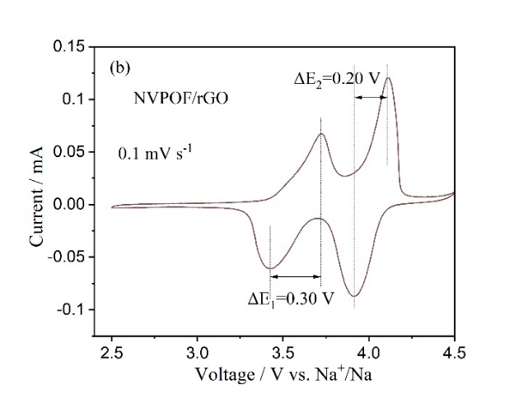

**Fig. S8.** CV curves of the (a) NVN05POF/rGO and (b) NVPOF/rGO electrodes at a scan rate of 0.1 mV·s−1.

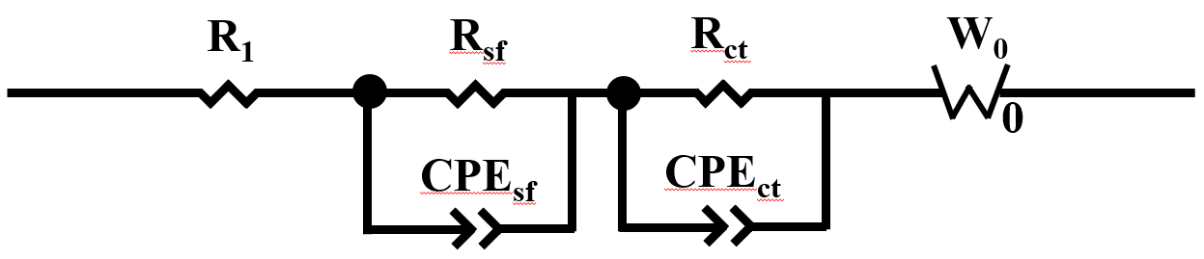

**Fig. S9.** Equivalent circuit for EIS data fitting.

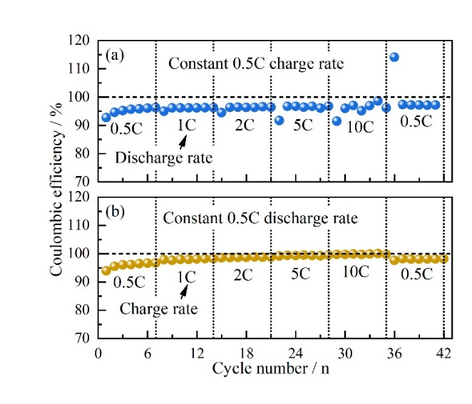

**Fig. S10.** Coulombic efficiency of the NVN05POF/rGO electrode under the different test conditions: (a) charge at 0.5 C and discharge at 0.5, 1, 2, 5, and 10 C, respectively; (b) discharge at 0.5 C and charge at 0.5, 1, 2, 5, and 10 C, respectively.

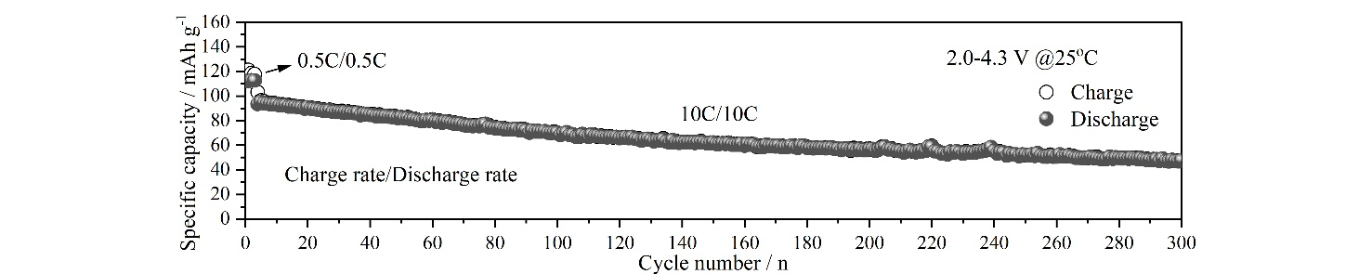

**Fig. S11**. Long-term cycling performance of the NVN05POF/rGO electrode at 10 C/10 C (charge rate/discharge rate).

**Table S1.** Structural parameters of the synthesized Na3V2−*x*Nb*x*(PO4)2O2F/rGO (*x* = 0, 0.05, 0.1) samples from XRD Rietveld refinement

|  |  |  |  |  |  |  |
| --- | --- | --- | --- | --- | --- | --- |
| Sample | Lattice constant | | | Refinement factors | | |
| *a* = *b* / Å | *c* / Å | *V* / Å3 | *R*wp / % | *R*p / % | **2 |
| Na3V2(PO4)2O2F | 6.3658(6) | 10.6355(5) | 430.99(7) | 9.20 | 7.31 | 2.786 |
| Na3V1.95Nb0.05(PO4)2O2F | 6.3681(8) | 10.6358(7) | 431.32(5) | 9.79 | 7.57 | 3.344 |
| Na3V1.9Nb0.1(PO4)2O2F | 6.3756(8) | 10.6381(8) | 432.43(5) | 9.96 | 7.56 | 3.687 |

**Table S2.** Atomic ratio of Nb and V in Na3V2−*x*Nb*x*(PO4)2O2F/rGO (*x* = 0.05, 0.1) samples derived from ICP-OES results

|  |  |
| --- | --- |
| Sample | Nb : V |
| Na3V1.95Nb0.05(PO4)2O2F/rGO | 0.05:0.95 |
| Na3V1.9Nb0.1(PO4)2O2F/rGO | 0.088:0.912 |