**Supporting Information**

Construction of 3D porous Cu1.81S/nitrogen-doped carbon frameworks for ultrafast and long-cycle life sodium-ion storage

*Chen Chen*1),\*,🖂, *Hongyu Xue*1),\*, *Qilin Hu*1), *Mengfan Wang*1), *Pan Shang*1), *Ziyan Liu*1), *Tao Peng*1), *Deyang Zhang*1), and *Yongsong Luo*1,2),🖂

1) Key Laboratory of Microelectronics and Energy of Henan Province, Henan Joint International Research Laboratory of New Energy Storage Technology, School of Physics and Electronic Engineering, Xinyang Normal University, Xinyang 464000, China

2) School of Physics and Electronic Engineering, Nanyang Normal University, Nanyang 473061, China

Eqs. (S1) and (S2)

$Z^{'}=R+σω^{-1/2} (ω=2πf)$（S1）

$D_{{Na}^{+}}=\frac{1}{2}R^{2}T^{2}A^{-2}n^{-4}F^{-4}C^{-2}σ^{-2}$（S2）

where R, T, A, n, F and C are constant. $σ$ can be calculated from the relationship of $Z^{'}$ and -1/2. There is a negative correlation between of $D_{{Na}^{+}}$ and $σ$.

Eq. (S3)

The sodium ion mobility can be calculated by the following formula.

$D_{{Na}^{+}}={\frac{4}{πτ}\left(\frac{m_{M}V_{M}}{V}\right)}^{2}{\left(\frac{∆E_{S}}{∆E_{τ}}\right)}^{2} (τ≪\frac{L^{2}}{D_{{Na}^{+}}})$ (S3)

where mM and VM are the molar mass and volume of the electrode, respectively. τ is the pulse duration, V is the total surface area of the electrode, $∆E_{s}$ is the voltage drop between the initial and the steady-state processes, and $∆E_{τ}$ is the total change of the cell at a constant pulse time.

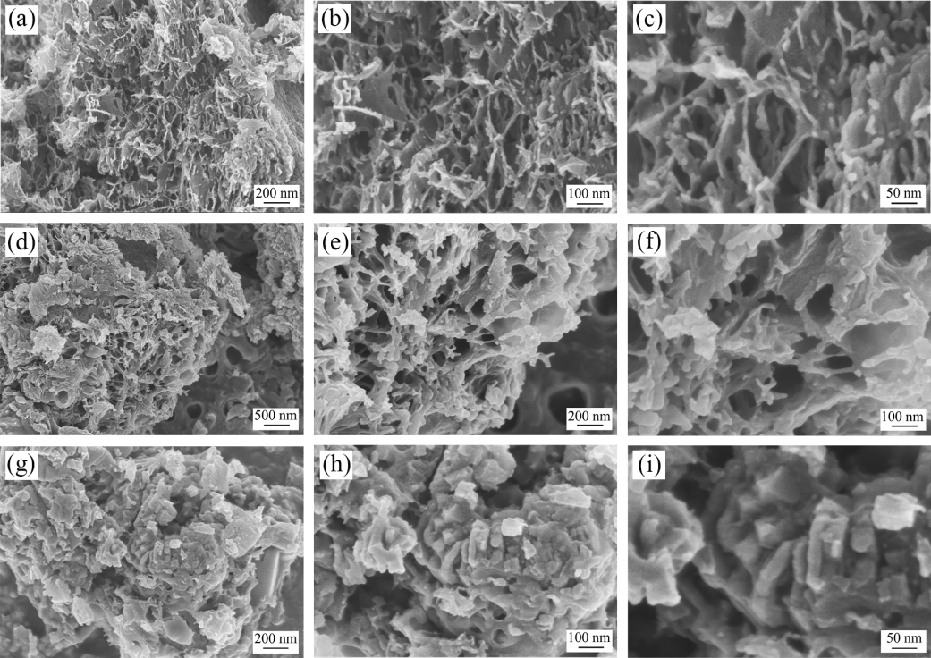

Fig. S1. SEM images of (a-c) Cu1.81S/NC-1, (d-f) Cu1.81S/NC-2 and (g-i) Cu1.81S/NC-3.

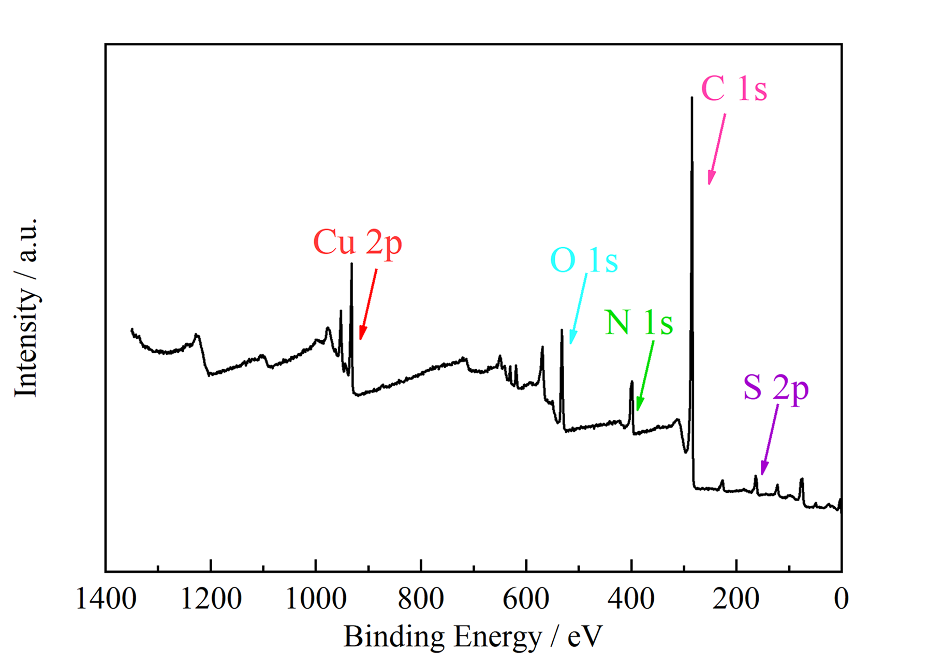

Fig. S2. XPS survey scan spectra of Cu1.81S/NC-2.

D:\0E科研数据\文章\CuS-WMF\International Journal of Minerals Metallurgy and Materials\纯1.81s对比 .tif

Fig. S3. Cycling performances of pure Cu1.81S and Cu1.81S/NC-2 electrodes at 0.2 A g-1.

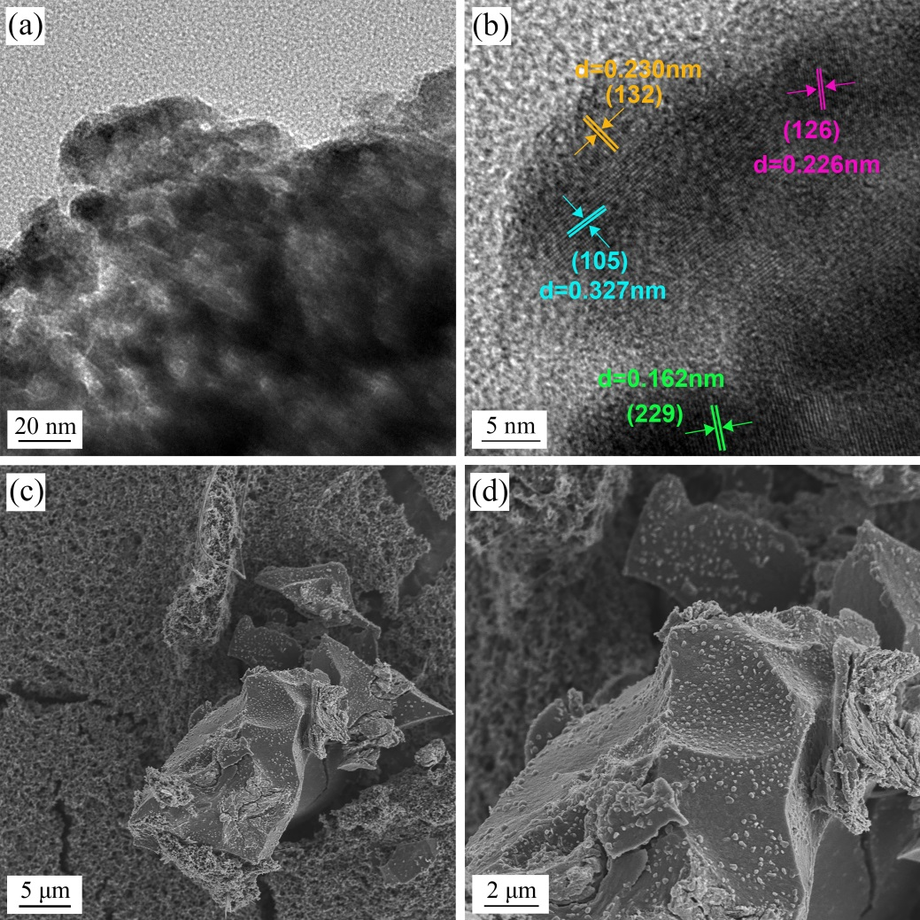

Fig. S4. (a, b) HRTEM images and (c, d) SEM images of Cu1.81S/NC-2 electrode charged to 3.0 V after 50 cycles at 1 A g-1.

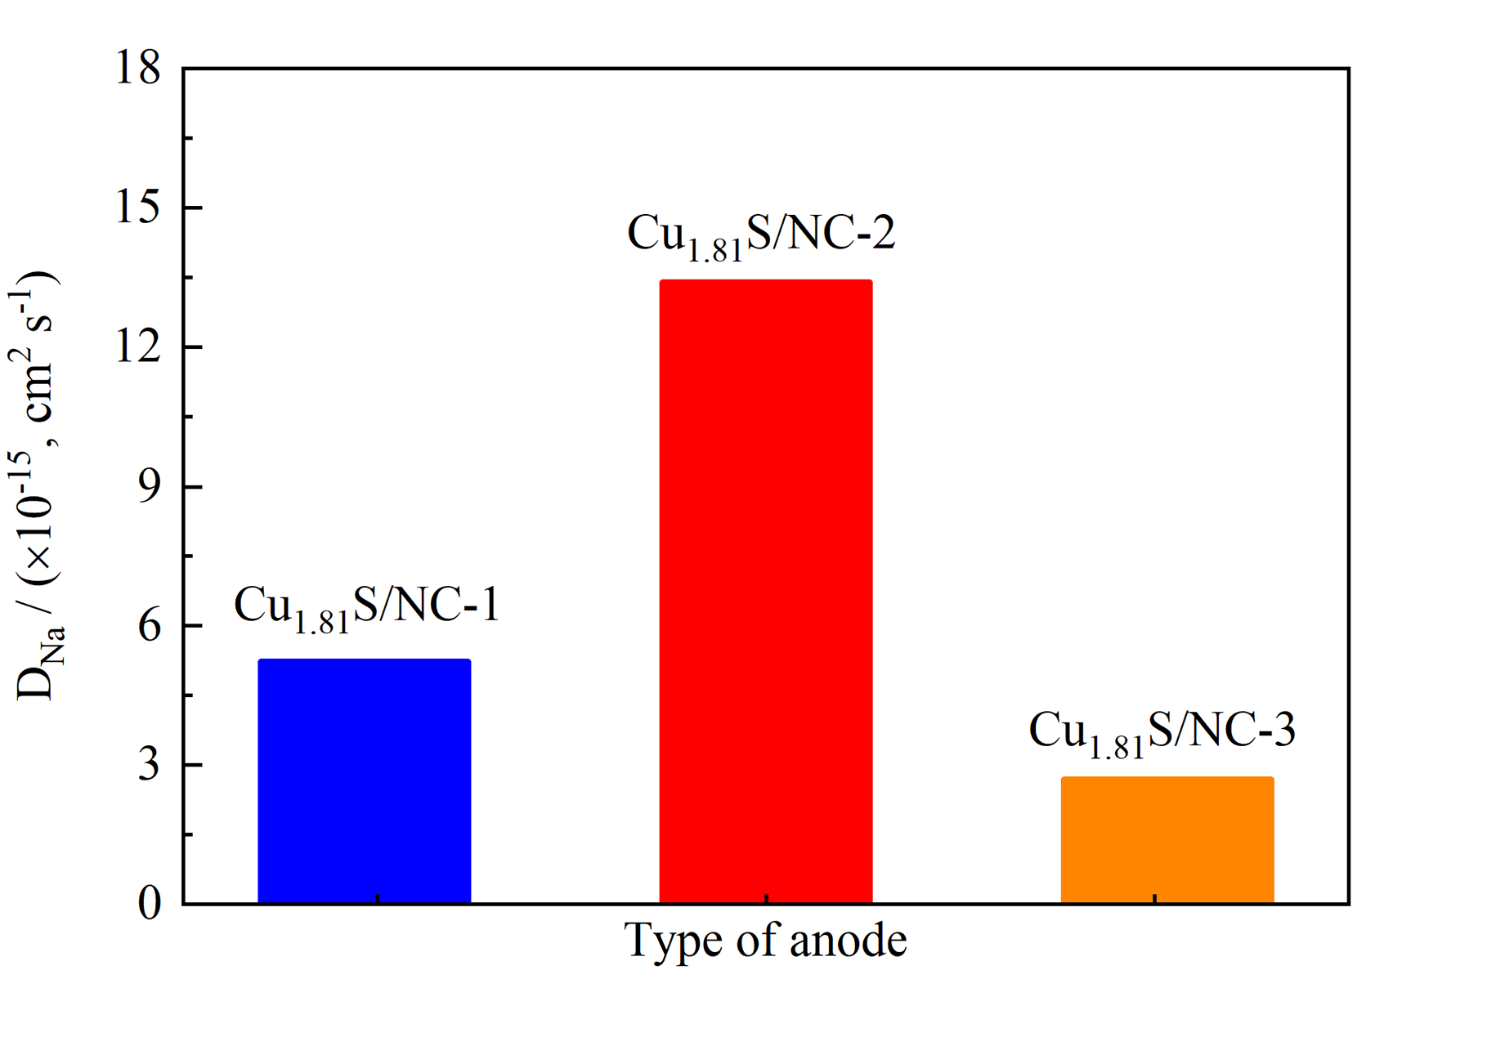

Fig. S5. Na+ transport coefficients of Cu1.81S/NC-1, Cu1.81S/NC-2 and Cu1.81S/NC-3 electrode.

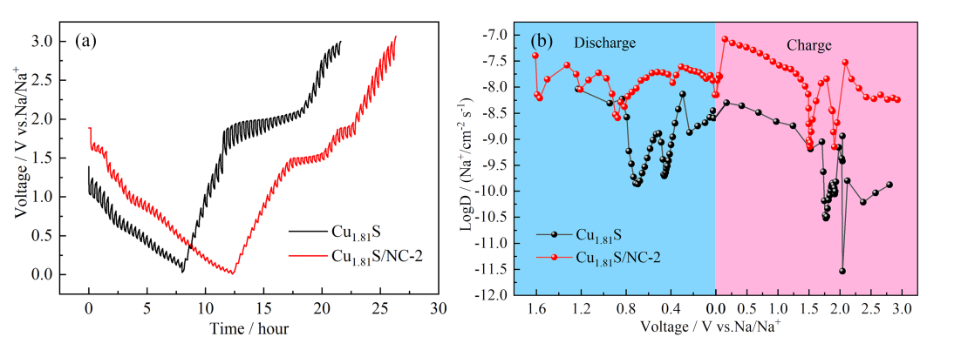

Fig. S6. (a) GITT potential profiles and (b) the corresponding Na+ diffusion coefficients of Cu1.81S/NC-2 and Cu1.81S.常用对数写法

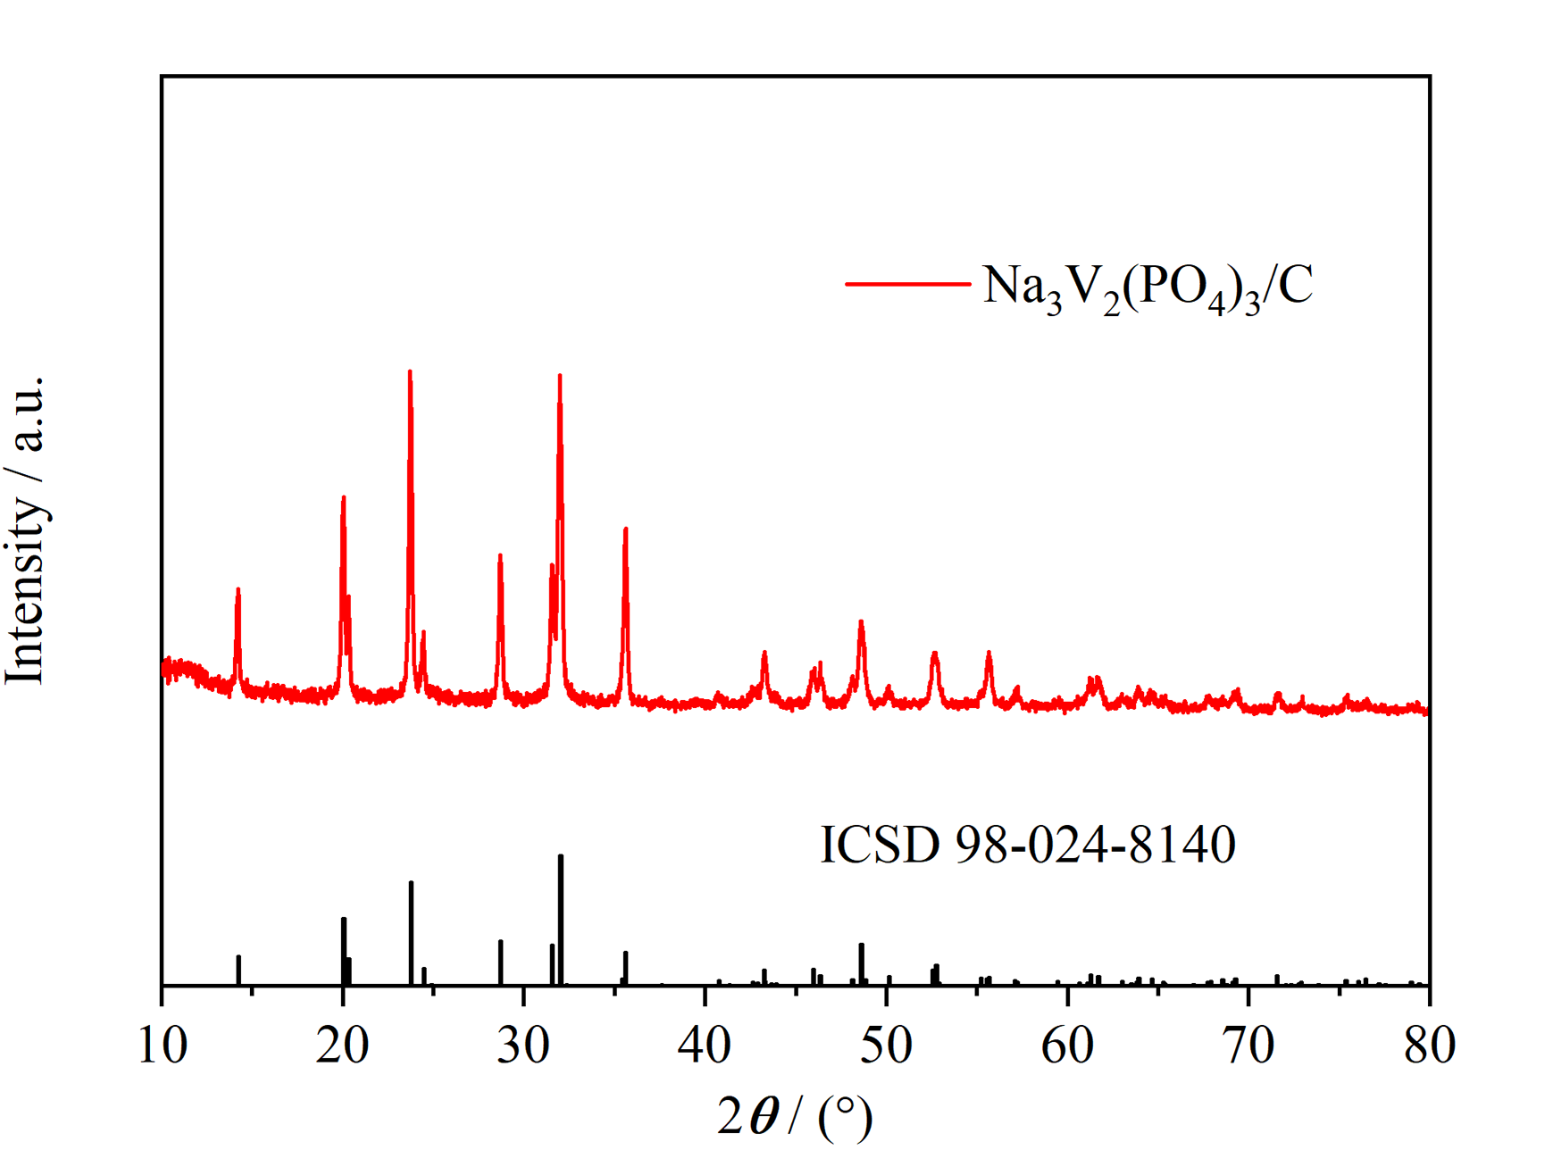

Fig. S7. XRD pattern of Na3V2(PO4)/C.

D:\Users\微信文件信息\WeChat Files\wxid_dp29hbwgy3a322\FileStorage\File\2024-03\全电池0.2-160.tif

Fig. S8. The cycling performance of sodium-ion full cell at 0.2 A g-1.