Supporting material

Hydration reactivity difference between dicalcium silicate and tricalcium silicate revealed from structural and Bader charge analysis

Chongchong Qi^{1,2*}, Xinhang Xu¹, Qiusong Chen¹

Author affiliations
¹ School of Resources and Safety Engineering, Central South University, Changsha 410083, China
² School of Molecular Science, University of Western Australia, Perth, 6009, Australia

Corresponding author:
* Chongchong Qi (chongchong.qi@csu.edu.cn)

Table S1 Lattice parameters of β-C₂S and M3-C₃S (experimental measurements and DFT calculations)
Types | Volume(Å^3) | a (Å) | b (Å) | c (Å) | α (°) | β (°) | γ (°)
β-C₂S(Exp) | 343.91 | 5.50 | 6.75 | 9.30 | 90 | 94.59 | 90
β-C₂S(PBE) | 346.02 | 5.53 | 6.76 | 9.30 | 90 | 95.09 | 90
β-C₂S(PBE_{sol}) | 334.02 | 5.46 | 6.68 | 9.20 | 90 | 95.26 | 90
M3-C₃S(Exp) | 722.32 | 9.30 | 7.08 | 12.22 | 90 | 116.08 | 90
M3-C₃S(PBE) | 717.60 | 9.28 | 7.11 | 12.16 | 90 | 116.56 | 90
M3-C₃S(PBE_{sol}) | 689.55 | 9.12 | 7.05 | 11.98 | 90 | 116.38 | 90

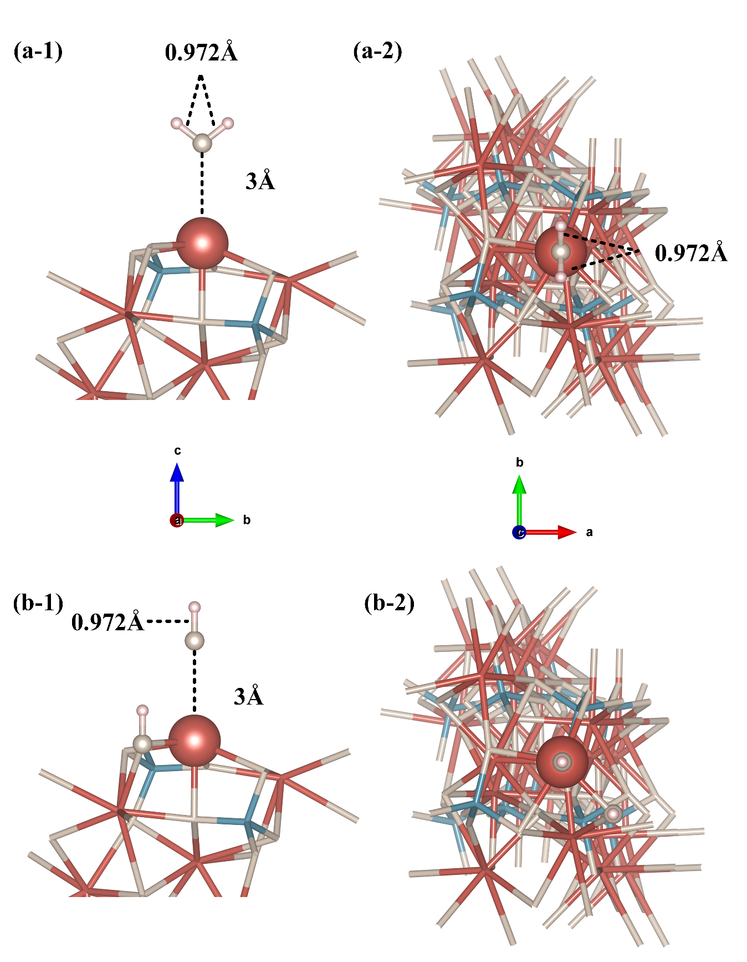
Fig. S1. Initial structure of molecules and dissociative adsorption on the surface of β-C₂S (001): a-1) Molecular adsorption, a-2) Molecular adsorption, b-1) Dissociative adsorption, b-2) Dissociative adsorption.

