**Supporting Information**

**Force and impulse multi-sensor based on flexible gate dielectric field effect transistor**

Chao Tan1),*, Junling Lü1),*, Chunchi Zhang1), Dong Liang2), Lei Yang1), and Zegao Wang1),🖂

1. College of Materials Science and Engineering, Sichuan University, Chengdu-610065, China
2. The 54th Research Institute of China Electronics Technology Group Corporation, Shijiazhuang 050081, China

* These authors contributed equally to this work.

🖂 Corresponding author: Zegao Wang E-amil: zegao@scu.edu.cn

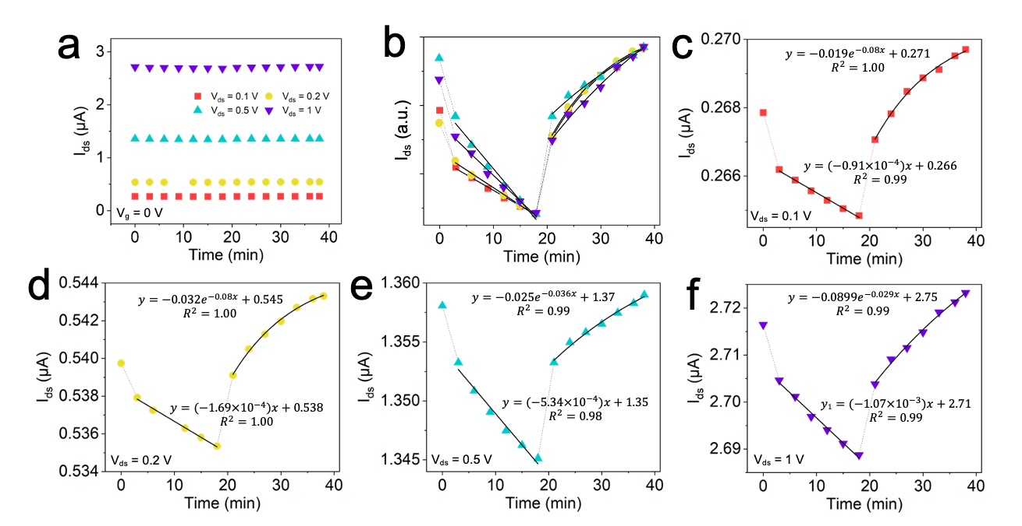

Fig. S1. (a) Zero-*V*g field-effect responses under different *V*ds values and (b) its normalization curves. The zero-*V*g field-effect responses under *V*ds values of (c) 0.1 V, (d) 0.2 V, (e) 0.5 V, and (f) 1 V.

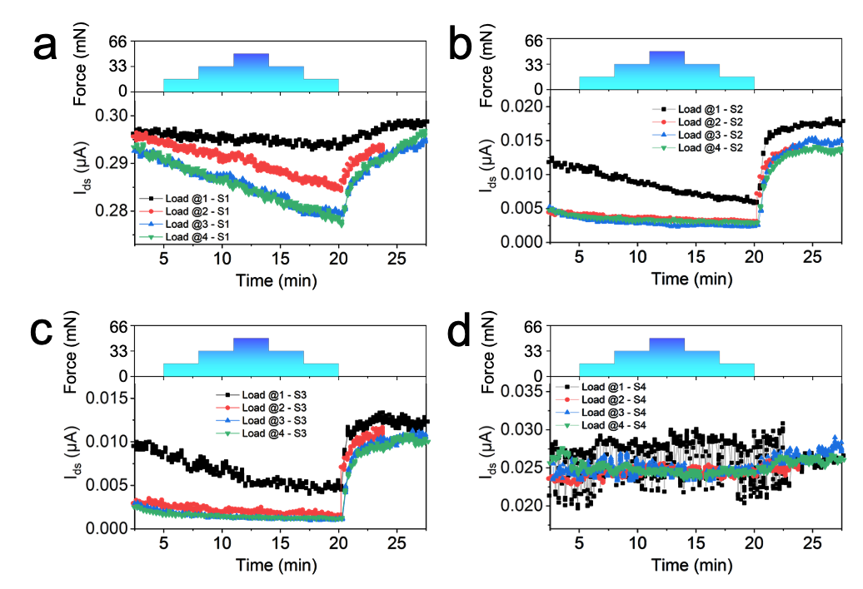

Fig. S2. Real-time *I*ds responses of the sensor array with different applied forces.