**Supporting Information**

**Boosting thermoelectric efficiency of Ag2Se through cold sintering process with Ag nano-precipitate formation**

Dejwikom Theprattanakorn1,2), Thanayut Kaewmaraya1,2), and Supree Pinitsoontorn1,2),🖂

1) Department of Physics, Faculty of Science, Khon Kaen University, Khon Kaen 40002, Thailand

2) Institute of Nanomaterials Research and Innovation for Energy (IN-RIE), Khon Kaen University, Khon Kaen 40002, Thailand

🖂Corresponding author: Supree Pinitsoontorn E-mail: [psupree@kku.ac.th](mailto:pimieamviteevanich@gmail.com)

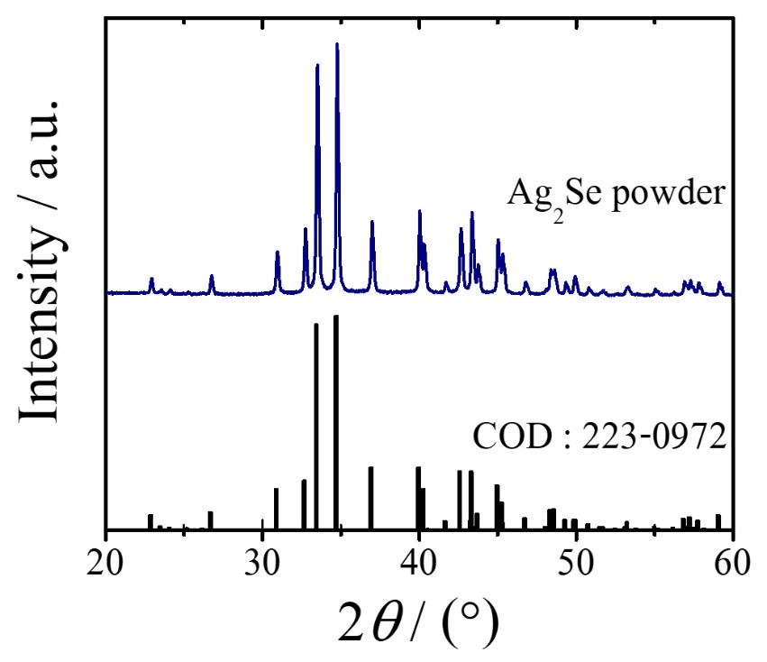

**Fig. S1.** X-ray diffraction (XRD) pattern of as-synthesized Ag2Se powder along with a reference pattern.

**Table S1.** Rietveld refinement parameters from XRD results of the as-synthesized Ag2Se powder and Ag2Se powders after cold sintering process (CSP)

|  |  |  |  |  |  |  |  |
| --- | --- | --- | --- | --- | --- | --- | --- |
| Sample | *a* / Å | *b* / Å | *c* / Å | Volume / Å3 | *R*p / % | *R*wp / % | *χ*2 |
| As-synthesized Ag2Se powder | 4.334 | 7.066 | 7.770 | 237.9 | 4.54 | 5.89 | 1.97 |
| Ag:0% | 4.333 | 7.064 | 7.767 | 237.8 | 8.19 | 10.07 | 1.91 |
| Ag:0.5% | 4.328 | 7.065 | 7.777 | 237.8 | 7.82 | 9.66 | 2.26 |
| Ag:1% | 4.327 | 7.066 | 7.780 | 237.8 | 7.04 | 8.80 | 1.93 |
| Ag:2% | 4.327 | 7.068 | 7.784 | 238.1 | 6.71 | 8.43 | 1.76 |

Note: Here, *a*, *b*, *c* represent lattice parameters, *R*p, *R*wp and *χ2* represent profile *R*-factor, weighted profile *R*-factor and goodness of fit.

**Table S2.**  Densities and chemical compositions of the CSP Ag2Se pellets.

|  |  |  |  |  |  |  |
| --- | --- | --- | --- | --- | --- | --- |
| Sample | Theoretical density / (g⋅cm−3) | Experimental density / (g⋅cm−3) | Relative density / % | Ag / at% | Se / at% | Molar ratio Ag:Se |
| Ag:0% | 8.22 | 7.62 ± 2.947 | 92.70 | 66.89 | 33.11 | 2.006:1 |
| Ag:0.5% | 8.23 | 7.47 ± 1.584 | 90.76 | 68.60 | 31.40 | 2.057:1 |
| Ag:1% | 8.24 | 7.32 ± 2.973 | 88.83 | 69.86 | 30.10 | 2:096:1 |
| Ag:2% | 8.26 | 7.34 ± 2.840 | 88.86 | 70.79 | 29.21 | 2.124:1 |

Note: Theoretical densities were calculated from the density of Ag2Se (8.22 g⋅cm−3) and Ag (10.49 g⋅cm−3) [S1], whereas experimental densities were measured using an Archimedes’ method. Chemical compositions were determined by energy-dispersive X-ray spectroscopy (EDS) mapping analyses.

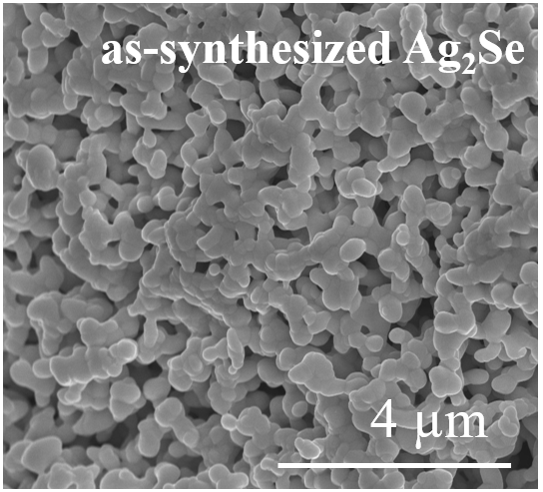

**Fig. S2.** A scanning electron microscope (SEM) image of as-synthesized Ag2Se powder.

**Fig. S3.** A bright-field transmission electron microscope (TEM) image showing the crystallite size of the Ag:0% sample. The (121) plane of the Ag2Se crystal is observed (inset).

**Fig. S4**. A cross-sectional SEM image of the Ag:0% sample.

**Fig. S5.** Grain size distribution from SEM images of the CSP samples: (a) Ag:0%, (b) Ag:0.5%, (c) Ag:1%, (d) Ag:2%. Here, SD represents standard deviation.

**References**

[S1] J. Brillo, I. Egry and I. Ho, Density and Thermal Expansion of Liquid Ag–Cu and Ag–Au Alloys, *Int. J. Thermophys.*, 27(2006), No.2, p.494.