Supplementary Information
Technical factors affecting the performance of anion exchange membrane water electrolyzer
Xun Zhang¹⁾, Yakang Li¹⁾, Wei Zhao²⁾, Jiaxin Guo^{1),}, Pengfei Yin^{1),}, and Tao Ling^{1),}
1) Key Laboratory for Advanced Ceramics and Machining Technology of Ministry of Education, Institute of New-Energy, School of Materials Science and Engineering, Tianjin University, Tianjin 300072, China
2) School of Materials Science and Engineering, Tianjin Chengjian University, Tianjin 300384, China
Corresponding authors: Jiaxin Guo E-mail: guojiaxin06@tju.edu.cn; Pengfei Yin E-mail: pengfeiyin@tju.edu.cn; Tao Ling E-mail: lingt04@tju.edu.cn
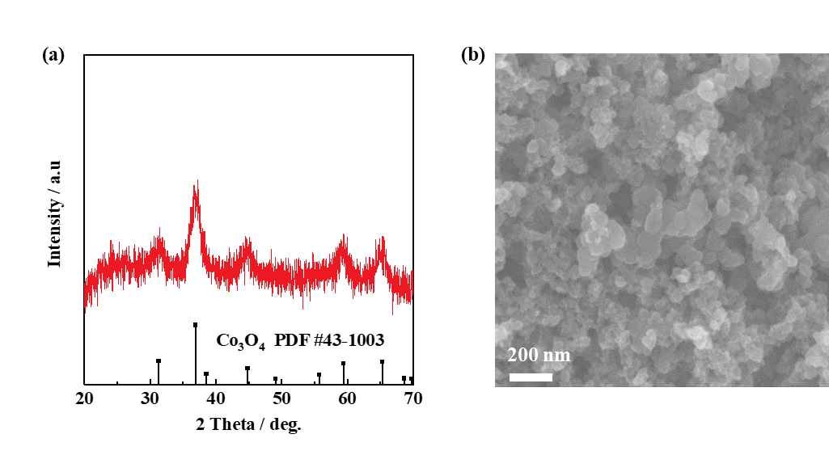
Fig. S1. Characterization of a CoO_{x} catalyst: (a) XRD pattern; (b) SEM image.

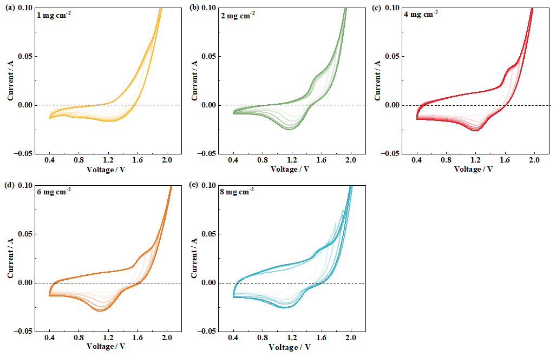
Fig. S2. CV curves of CoO_{x} with various catalyst loadings under different operating potential ranges: (a) 1, (b) 2, (c) 4, (d) 6, and (e) 8 mg·cm⁻². Note that the CV curves were recorded in the AEM electrolyzer with scan rate of 50 mV·s⁻¹.
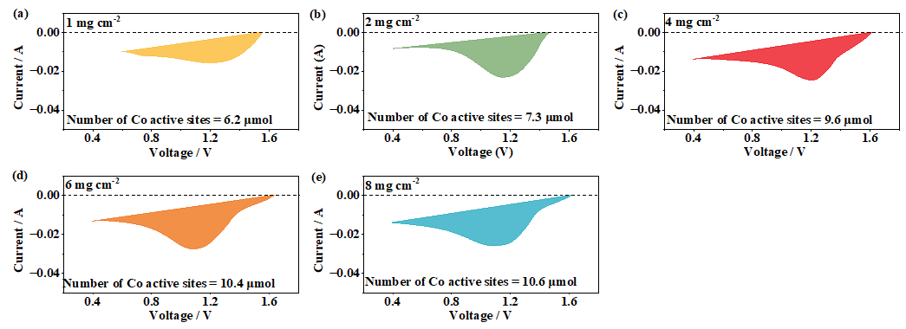
Fig. S3. Reductive current of CV curves with various catalyst loadings at a potential range of 0.4–2.0 V: (a) 1, (b) 2, (c) 4, (d) 6, and (e) 8 mg·cm⁻². According to literature [1], the negative cathodic current is mainly the reduction current of transition metal ions and does not include the OER current, and the number of electrons associated with cobalt ion reduction (Co⁴⁺ + e⁻ → Co³⁺ and Co³⁺ + e⁻ → Co²⁺) is proportional to the number of active Co sites on the electrode.

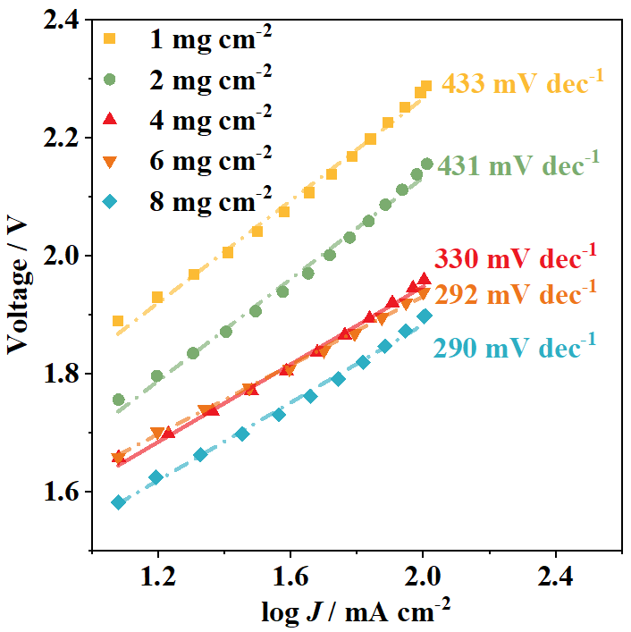
Fig. S4. Tafel curves of the AEM electrolyzer with various catalyst loading.

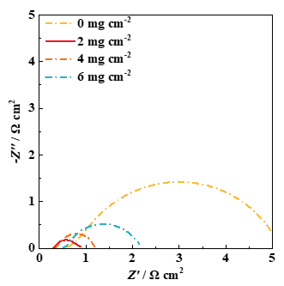
Fig. S5. EIS data with different carbon black loadings at a voltage of 2.0 V.

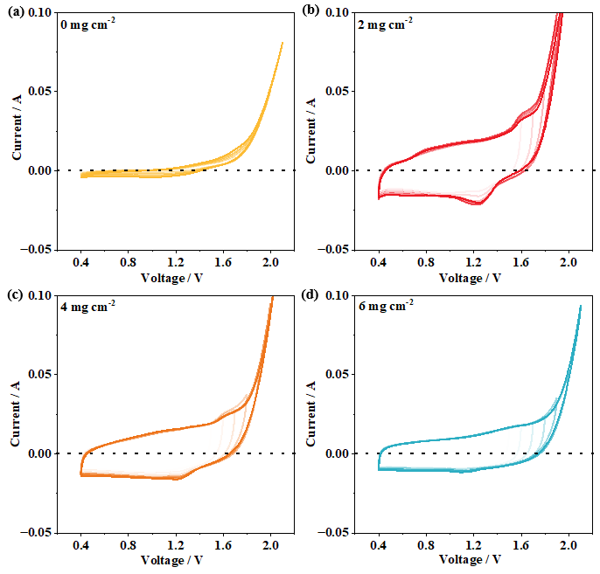
Fig. S6. CV curves of CoO_{x} with various carbon black loadings under different potential ranges: (a) 1, (b) 2, (c) 4, and (d) 6 mg·cm⁻². Note that the CV curves were recorded in the AEM electrolyzer with scan rate of 50 mV·s⁻¹.

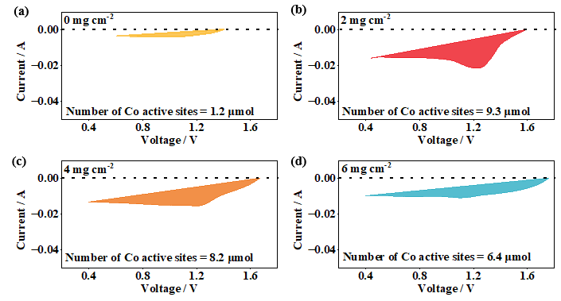
Fig. S7. Reductive current of CV curves with various carbon black loadings at a voltage range of 0.4–2.0 V: (a) 1, (b) 2, (c) 4, and (d) 6 mg·cm⁻².

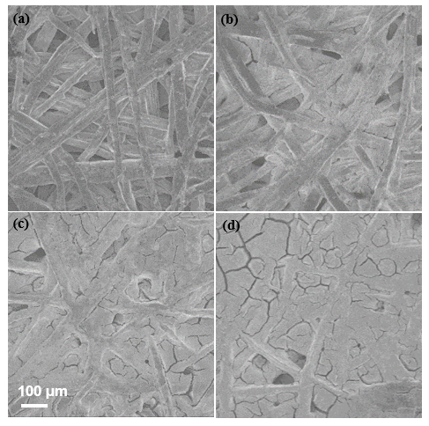
Fig. S8. SEM images of catalysts with various carbon black loadings: (a) 1, (b) 2, (c) 4, and (d) 6 mg·cm⁻².

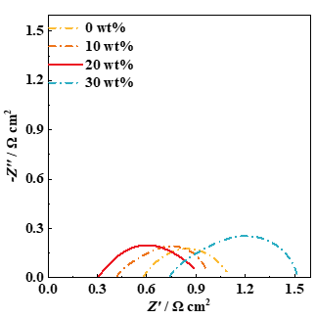
Fig. S9. EIS data with different ionomer loadings at a voltage of 2.0 V.

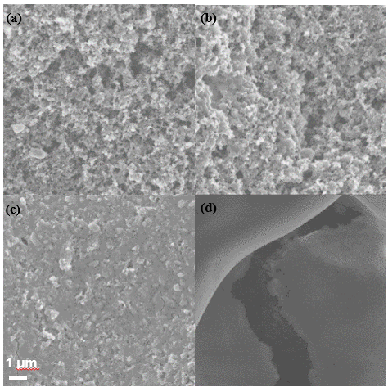
Fig. S10. SEM images of catalysts with various ionomer loadings: (a) 0wt%; (b) 10wt%; (c) 20wt%; (d) 30wt%.

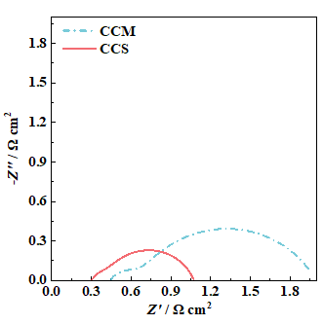
Fig. S11. EIS data with CCS and CCM methods at a voltage of 2.0 V.

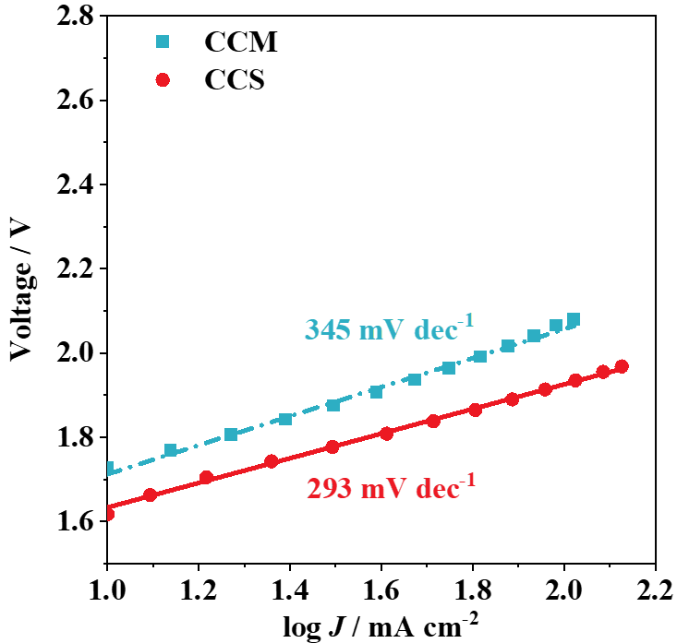
Fig. S12. Tafel curves of the AEM electrolyzer with CCS and CCM methods.

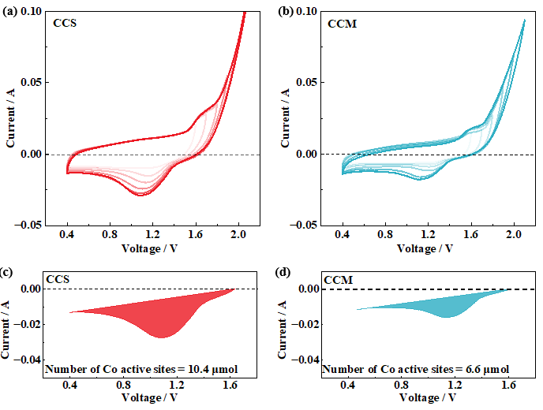
Fig. S13. CV curves of CoO_{x} with (a) CCS and (b) CCM methods at a voltage range of 0.4–2.0 V. Note that the CV curves were recorded in the AEM electrolyzer with scan rate of 50 mV·s⁻¹. Reductive current of CV curves with (c) CCS and (d) CCM methods at a voltage range of 0.4–2.0 V.

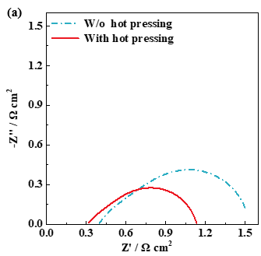
Fig. S14. EIS data of the AEM electrolyzer with and without hot pressing at a voltage of 2.0 V.

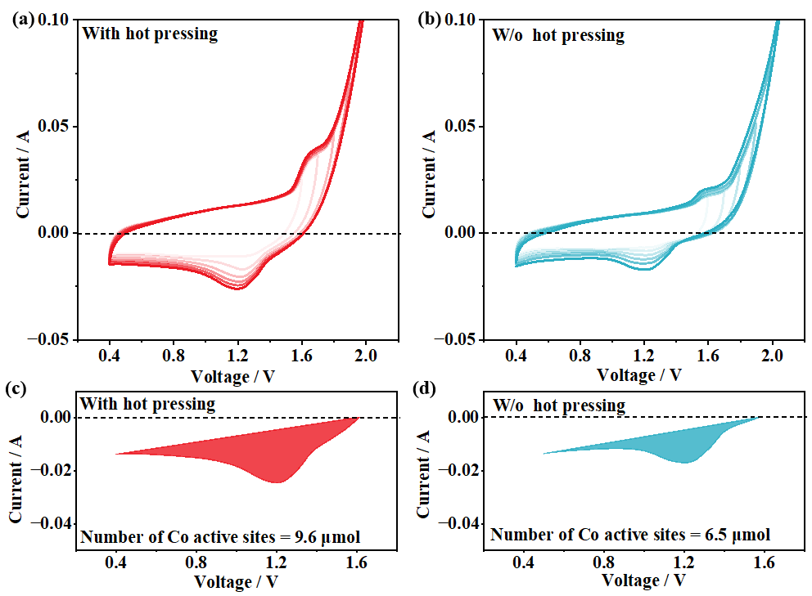
Fig. S15. CV curves of CoO_{x} (a) with and (b) without hot pressing at a voltage range of 0.4–2.0 V. Note that the CV curves were recorded in the AEM electrolyzer with scan rate of 50 mV·s⁻¹. Reductive current of CV curves (c) with and (d) without hot pressing at a voltage range of 0.4–2.0 V.

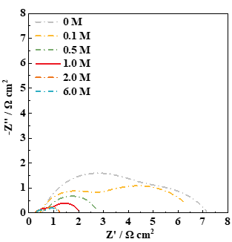
Fig. S16. EIS data with various KOH concentrations in the electrolyte at a voltage of 2.0 V.

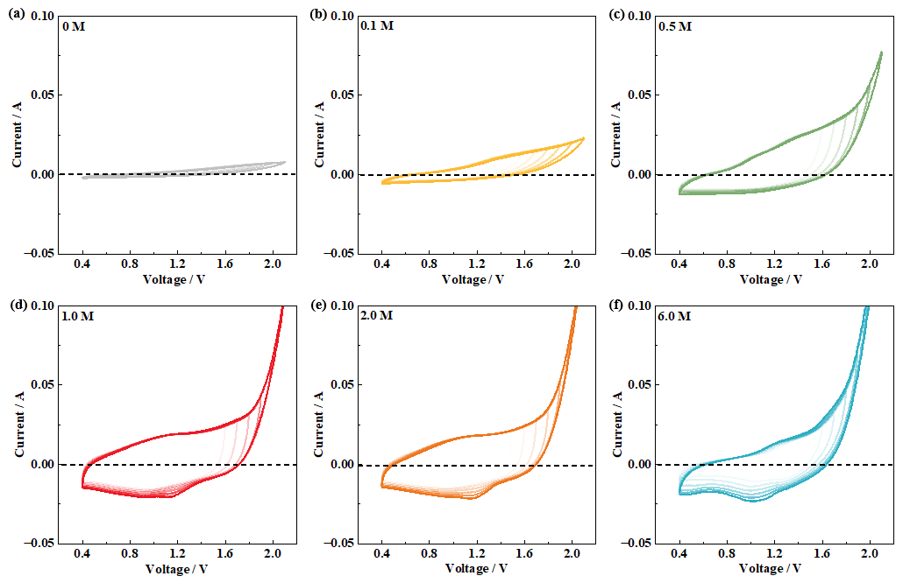
Fig. S17. CV curves of CoO_{x} with various KOH concentrations in the electrolyte at a voltage range of 0.4–2.0 V: (a) 0, (b) 0.1, (c) 0.5, (d) 1.0, (e) 2.0, and (f) 6.0 M. Note that the CV curves were recorded in the AEM electrolyzer with scan rate of 50 mV·s⁻¹.

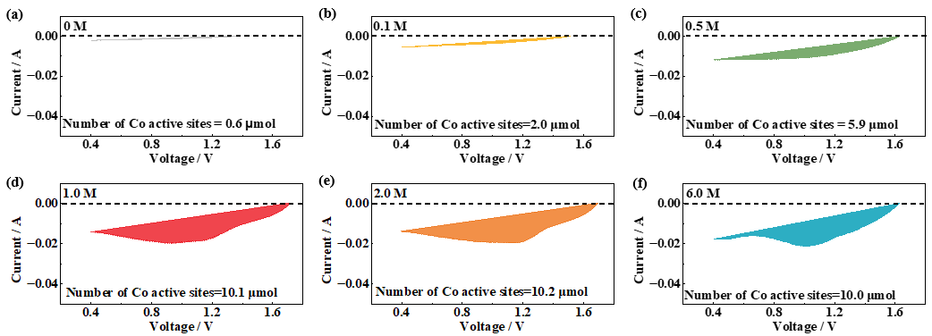
Fig. S18. Reductive current of CV curves with various KOH concentrations in the electrolyte at a voltage range of 0.4–2.0 V: (a) 0, (b) 0.1, (c) 0.5, (d) 1.0, (e) 2.0, and (f) 6.0 M.

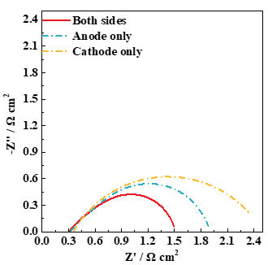
Fig. S19. EIS data of various electrolyte feeding modes at a voltage of 2.0 V: feeding to both sides; feeding only to the anode; feeding only to the cathode.

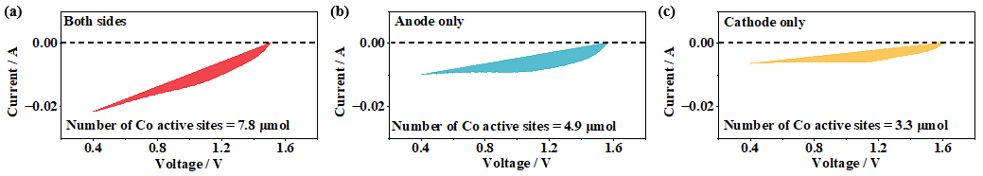
Fig. S20. Reductive current of CV curves with various electrolyte feeding modes at a voltage range of 0.4–2.0 V: (a) feeding to both sides; (b) feeding only to the anode; (c) feeding only to the cathode.

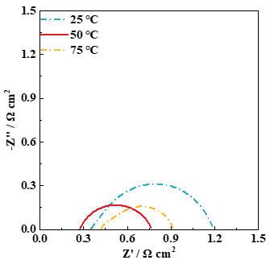
Fig. S21. EIS data of the AEM electrolyzer with various operating temperatures at a voltage of 2.0 V.

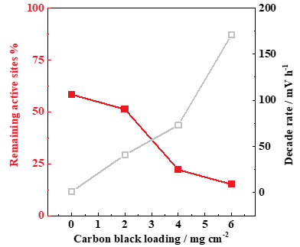
Fig. S22. Variation of the number of active Co sites with carbon black loading after stability test at 100 mA·cm⁻². Note that the number of active Co sites decreases with increasing the carbon black loading after the stability test, this is because excess carbon black will increase the thickness of the catalyst layer, which is easy to fall off when large amounts of hydrogen and oxygen bubbles are generated under the high current.

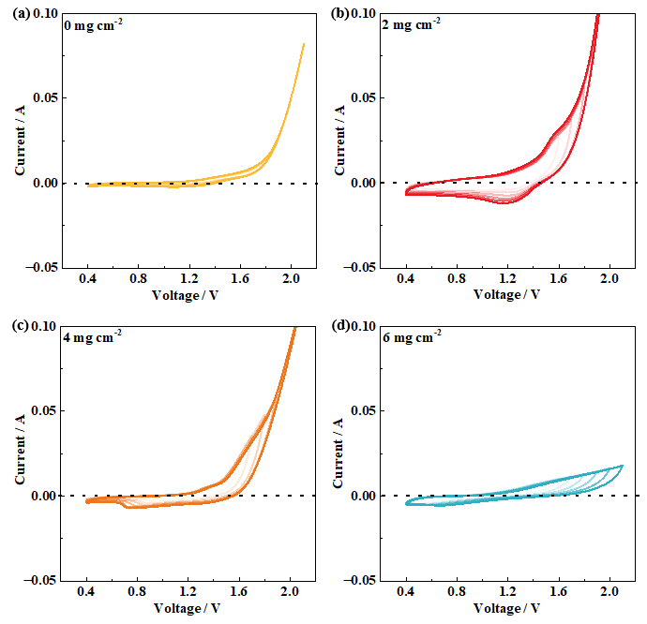
Fig. S23. CV curves of CoO_{x} with various carbon black loadings at a voltage range of 0.4–2.0 V after stability test at 100 mA·cm⁻²: (a) 0, (b) 2, (c) 4, and (d) 6 mg·cm⁻². Note that the CV curves were recorded in the AEM electrolyzer with scan rate of 50 mV·s⁻¹.

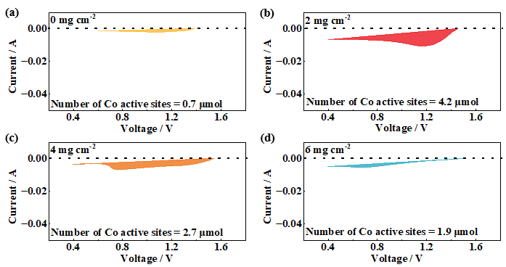
Fig. S24. Reductive current of CV curves with various carbon black loadings at a voltage range of 0.4–2.0 V after stability test at 100 mA·cm⁻²: (a) 0, (b) 2, (c) 4, and (d) 6 mg·cm⁻².

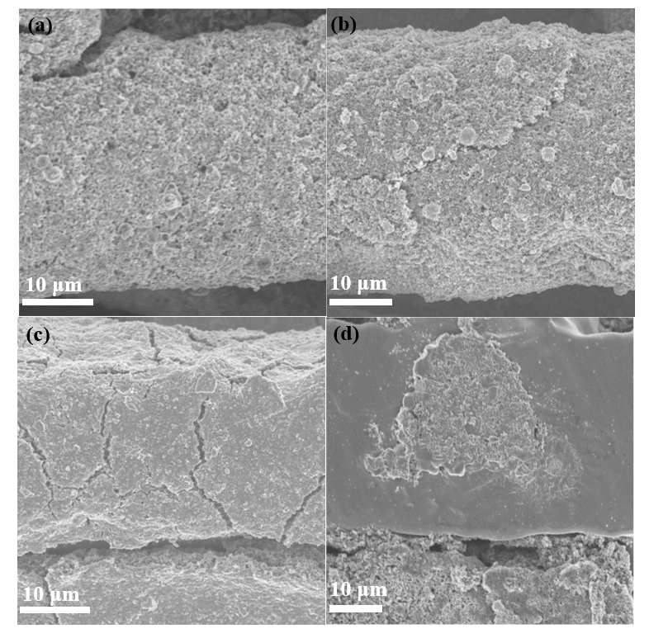
Fig. S25. SEM images of catalyst layer with various carbon black loadings (a, c) before and (b, d) after stability test: (a, b) 0 mg·cm⁻²; (c, d) 6 mg·cm⁻².
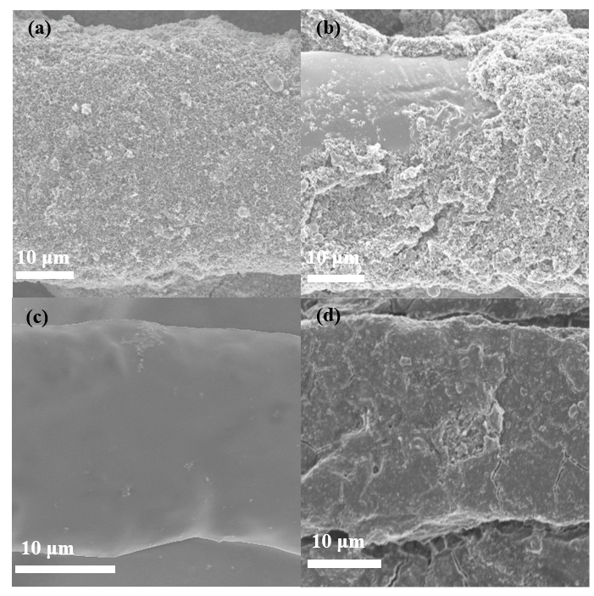
Fig. S26. SEM images of catalyst layer with various ionomer loadings (a, c) before and (b, d) after stability test: (a, b) 10wt%; (c, d) 30wt%.

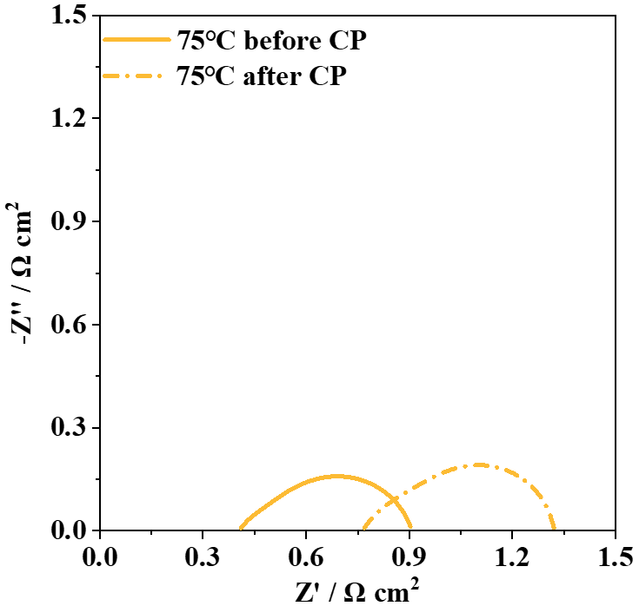
Fig. S27. EIS data of the AEM electrolyzer before and after stability test at a voltage of 2.0 V.
References
[1] Y.M. Dong, K. He, L. Yin, and A.M. Zhang, A facile route to controlled synthesis of Co₃O₄ nanoparticles and their environmental catalytic properties, Nanotechnology, 18(2007), No. 43, art. No. 435602.
[2] Z. Li, Y. Zhang, Y. Feng, et al., Co₃O₄ nanoparticles with ultrasmall size and abundant oxygen vacancies for boosting oxygen involved reactions, Adv. Funct. Mater., 29(2019), No. 36, art. No. 1903444.
[3] K. Karthick, S. Anantharaj, P.E. Karthik, B. Subramanian, and S. Kundu, Self-assembled molecular hybrids of CoS-DNA for enhanced water oxidation with low cobalt content, Inorg. Chem., 56(2017), No. 11. p. 6734.

