Supporting Information
Design and tailoring of patterned ZnO nanostructures for perovskite light absorption modulation
Haonan Si^{1,2)}, Xuan Zhao^{1,2)}, Qingliang Liao^{1,2),}, and Yue Zhang^{1,2),}
1) Academy for Advanced Interdisciplinary Science and Technology, Beijing Advanced Innovation Center for Materials Genome Engineering, University of Science and Technology Beijing, Beijing 100083, China
2) Key Laboratory of Advanced Materials and Devices for Post-Moore Chips, Ministry of Education, Beijing Key Laboratory for Advanced Energy Materials and Technologies, School of Materials Science and Engineering, University of Science and Technology Beijing, Beijing 100083, China

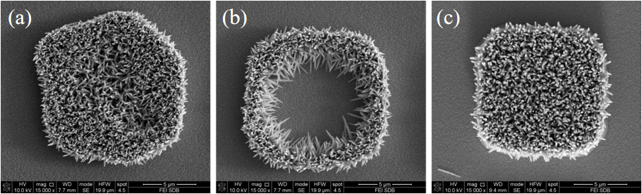
Fig. S1. Locally enlarged view of ZnO nanorods: (a) underexposure; (b) overexposure; (c) suitable exposure.
Fig. S2. Over developing (a) and properly developing (b) line patterned ZnO NRAs.

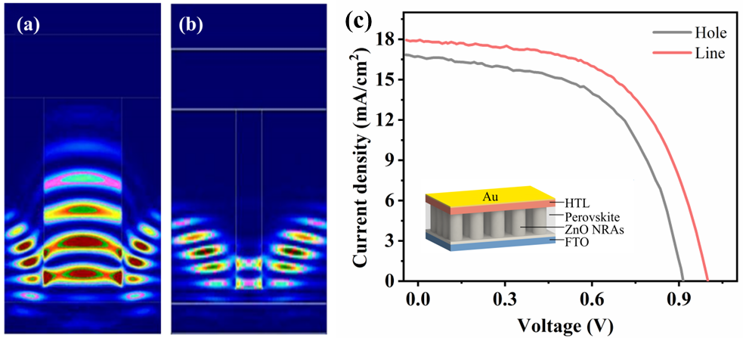
Fig. S3. FDTD optical absorption simulation results of patterned (a) and unpatterned (b) ZnO NRAs. (c) Comparison of I-V curves of different patterned ZnO NRAs.

Fig. S4. SEM profile of ZnO spin-coated perovskite with hole (a) and line (b) patterns.

Table S1. Comparison of J–V data of different patterned battery devices
Type | V_{oc} / V | J_{sc} / (mA⋅cm⁻²) | FF / % | η_{c} / %
Pattern (line) | 1.00 | 17.91 | 57.45 | 10.28
Pattern (holes) | 0.91 | 16.73 | 56.36 | 8.62
Note: FF⎯fill factor; η_{c}⎯ photoelectrical efficiency.

