Supplementary Information

Effect of Zn content on microstructure, mechanical properties and thermal conductivity of extruded Mg–Zn–Ca–Mn alloys

*Bei Tang*1,2), *Jinlong Fu*2),🖂, *Jingkai Feng*2), *Xiting Zhong*2), *Yangyang Guo*2), *and Haili Wang*1)

1. School of Materials Science and Engineering, Xi’an Shiyou University, Xi’an 710065, China
2. Xi’an Rare Metal Materials Institute Co., Ltd., Xi’an 710016, China

🖂 Corresponding author: Jinlong Fu E-mail: jinlongsjz@126.com

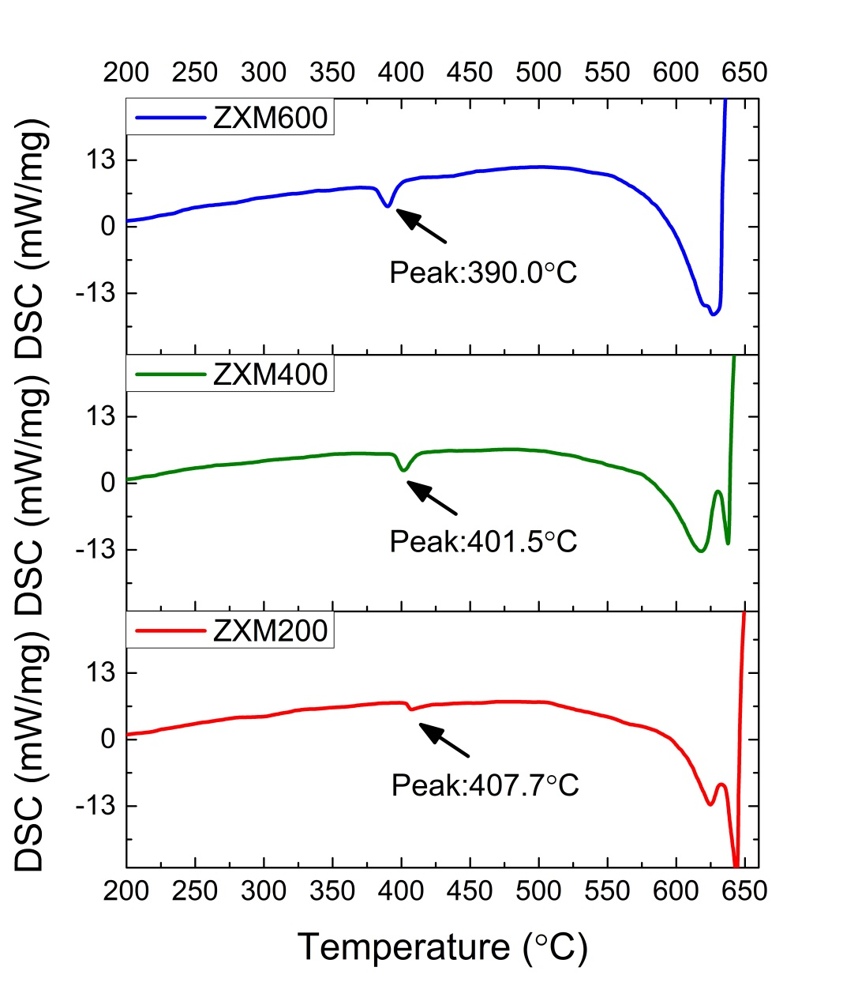

**Fig. S1.** **Differential scanning calorimetry results of Mg–Zn–Ca–Mn alloys.**

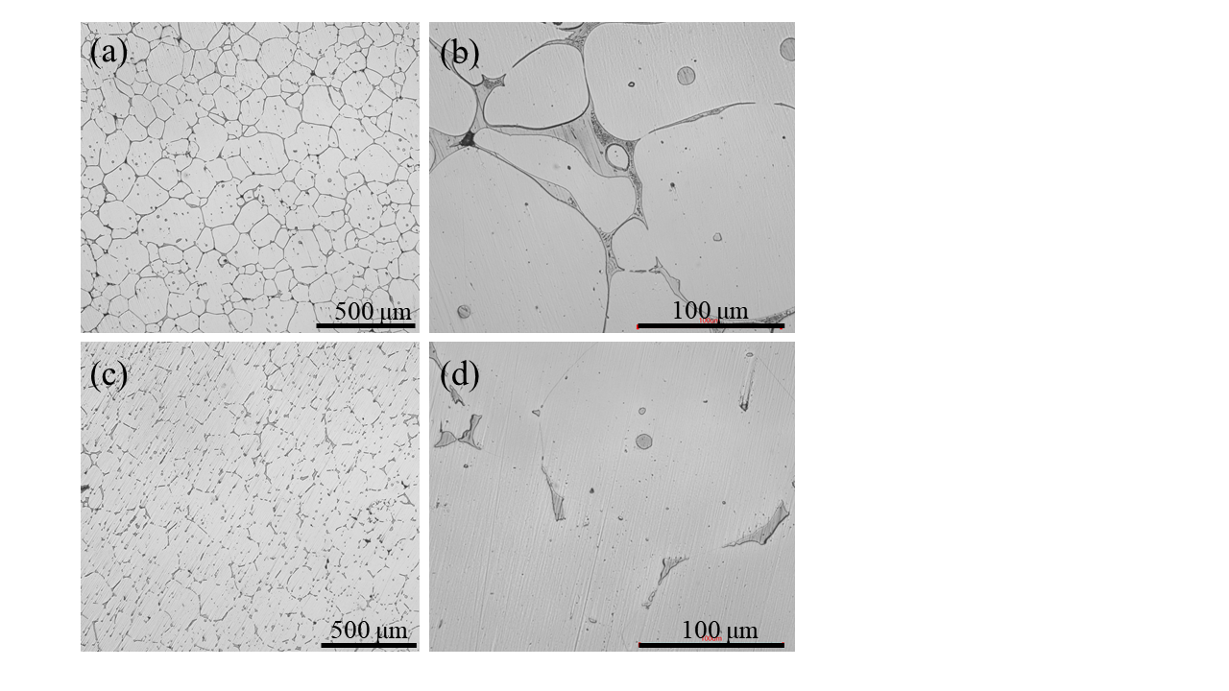

**Fig. S2.** **OM images of Mg–2Zn–0.4Ca–0.2Mn (wt%) alloys after different homogenization time: (a, b) 12 h and (c, d) 26 h in (a, c) low magnification and (b, d) high magnification.**



**Fig. S3. Distribution of Schmid factor for {0001}<11 $\overline{2}$ 0> dislocation slip: (a, d) ZXM200 alloy; (b, e) ZXM400 alloy; (c, f) ZXM600 alloy.**