Supplementary Information

Insights into the changes in the surface properties of goethite with Ni in the lattice in the presence of salicylhydroxamic acid: Experimental and density functional theory studies
Levie Mweene*, Gilsang Hong*, Hee-Eun Jeong, Hee-won Kang, and Hyunjung Kim
Department of Earth Resources and Environmental Engineering, Hanyang University, 222 Wangsimni-ro, Seongdong-gu, Seoul 04763, Republic of Korea

HOMO–LUMO analysis of the structures
The highest occupied molecular orbitals (HOMO) and the lowest unoccupied molecular orbitals (LUMO) are vital parameters in the calculation of kinetics and chemical stability. This implies that HOMO and LUMO can further help in determining the electronegativity, global electrophilicity index, chemical hardness, and softness. Table S1 summarizes the HOMO–LUMO energies of the complexes under consideration. Figure S1 shows the frontier molecular orbitals of goethite and goethite with Ni. Parr and Zhou [1] reported that the LUMO energy is proportional to the electronic affinity, while that of the HOMO is proportional to the ionization potential. The energy gap determines the chemical stability of the complex. That is, the higher the energy gap, the more stable the complex compared to the rest. For example, the recorded energy gap for goethite was 0.0594 eV, while that of goethite with Niwas 0.1246 eV, indicating that goethite-Ni structure is more stable than goethite without Ni (see Figure S1). In agreement with Maslov et al. [2], an increase in the bandgap also implies an increase in the magnetic field. Other important parameters were calculated, as presented in Table S1. The chemical hardness of goethite with Ni and goethite was 0.0623 eV and 0.0297 eV, respectively. Moreover, the softness of goethite with Ni and goethite was 8.0257 eV⁻¹ and 16.8350 eV⁻¹, respectively. This implies that stronger bonds are formed upon Ni substitution for Fe, promoting the hardness of goethite with Ni compared to goethite alone. Moreover, a higher bandgap in goethite with Ni than that in goethite alone indicates that the former possesses a higher conductivity.

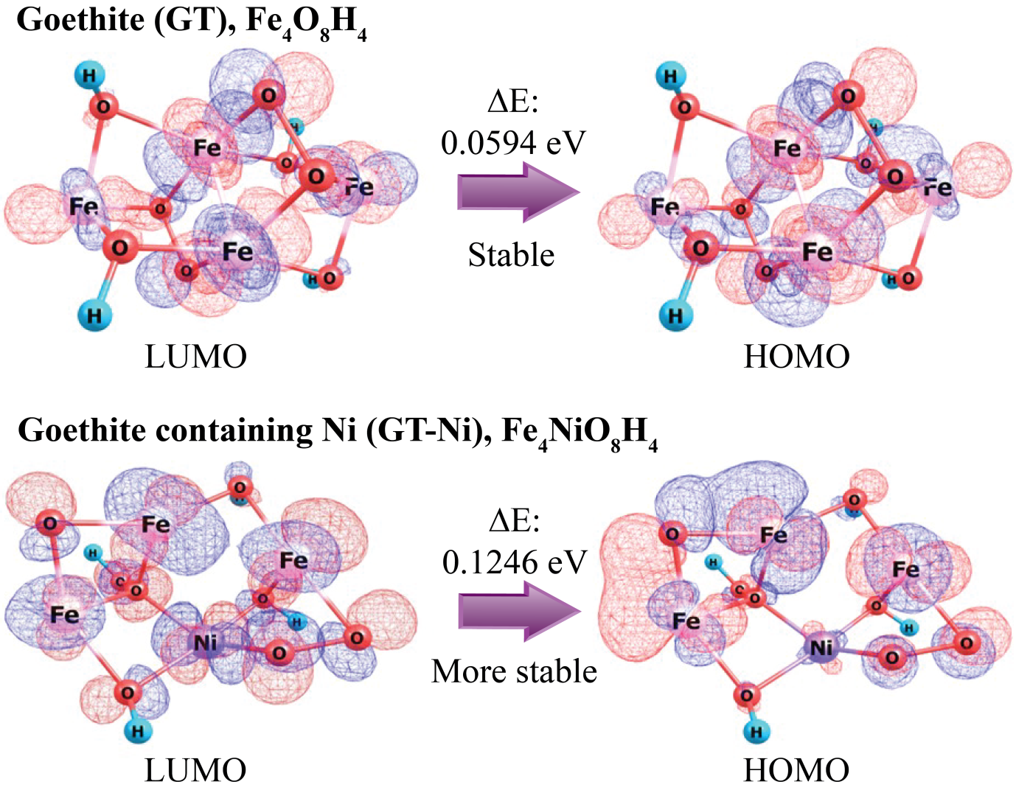
Figure S1. Frontier molecular orbitals (generated by using ChemCraft) and gap between the highest occupied molecular orbital (HOMO) and lowest unoccupied molecular orbital (LUMO)for goethite and goethite with Ni calculated at the PBE0/6-31g(d,p) level of theory. The blue and red colors represent the positive and negative regions, respectively.

Table S1. Energies of highest occupied molecular orbitals (E_{HOMO}) and lowest unoccupied molecular orbitals (E_{LUMO}), HOMO–LUMO energy gap (ΔE), and different global reactivity descriptors for monomers and the dimer calculated at the PBE0/6-31(d,p) level of theory for both goethite and goethite with Ni.
Molecular Properties | Fe₂OH | Ni₂OH | 2FeO₄H₂ | Fe₄O₈H₄ | Fe₃NiO₈H₄
E_{HOMO} (eV) | −0.2587 | −0.0198 | −0.0004 | −0.1590 | −0.2018
E_{LUMO} (eV) | −0.1135 | −0.1338 | −0.1135 | −0.0996 | −0.0772
ΔE (eV) | 0.1452 | −0.1140 | −0.1131 | 0.0594 | 0.1246
Ionization potential, I (eV) | 0.2587 | 0.0198 | 0.0004 | 0.1590 | 0.2018
Electron affinity, A (eV) | 0.1135 | 0.1338 | 0.1135 | 0.0996 | 0.0772
Electronegativity, χ (eV) | 0.1861 | 0.0768 | 0.0569 | 0.1293 | 0.1395
Chemical potential, µ (eV) | −0.1861 | −0.0768 | −0.0569 | −0.1293 | −0.1395
Chemical hardness, ŋ (eV) | 0.0726 | −0.0570 | −0.0565 | 0.0297 | 0.0623
Chemical softness, S (eV⁻¹) | 6.8871 | −8.7719 | −8.8417 | 16.8350 | 8.0257
Global electrophilicity index, ω (eV) | 0.2385 | −0.0517 | −0.0287 | 0.2815 | 0.0149

In summary, it can be observed that both the minimum and maximum electrostatic potentials of goethite with Ni were far much lower than that for goethite calculated at the PBE0/def2-svp level of theory. Therefore, cationic collectors are likely to adsorb on the minimum potential sites, while anionic collectors are expected to adsorb on the maximum potential sites. However, since goethite with Ni occurs with other gangue minerals, namely, quartz, the utilization of anionic collectors is common because these collectors are more selective with regard to quartz compared to cationic ones.

Nature of interactions in goethite and goethite containing Ni in lattice
Table S2. Electron density (ρ), Laplacian of electron density ($∇$²ρ), potential energy density (V), kinetic energy density (G), total energy density (H = V + G), |V|/G ratio, and the ratio of first and third eigenvalues of the Hessian matrix of electron density (|λ₁|/λ₃) for intermolecular interactions occurring in Fe₄O₈H₄(goethite) under investigations calculated at the PBE0/6-31g(d,p) level of theory. All quantities are expressed in atomic units (a.u.). Refer to Figure 6 (a) for the labeling of intermolecular bonding and bond critical points (BCP).
Intermolecular bonding | BCP | ρ | $∇$²ρ | H | |V|/G | |λ₁|/λ₃
O₁₅∙∙∙Fe₆∙∙∙O₃ | Fe₆∙∙∙O₃ | 0.0717 | 0.5109 | 0.0007 | 0.9943 | 2.1264
H₂∙∙∙O₄ | H₂∙∙∙O₄ | 0.3626 | −2.0093 | −0.5864 | 7.9787 | 1.0025
Fe₆∙∙∙Fe₅ | Fe₆∙∙∙Fe₅ | 0.0451 | 0.0946 | −0.0179 | 1.4306 | 1.0640
O₁₅∙∙∙Fe₆∙∙∙O₁₁ | Fe₆∙∙∙O₁₁ | 0.0825 | 0.5472 | −0.0044 | 1.0315 | 1.4423
O₁₃∙∙∙Fe₁∙∙∙O₁₅ | Fe₁∙∙∙O₁₅ | 0.1101 | 0.7780 | −0.0063 | 1.0312 | 1.5982
O₁₁∙∙∙Fe₆∙∙∙O₄ | Fe₆∙∙∙O₄ | 0.1129 | 0.6895 | −0.0134 | 1.0720 | 1.6561
O₁₁∙∙∙Fe₇∙∙∙O₃ | Fe₇∙∙∙O₃ | 0.1128 | 0.7749 | −0.0092 | 1.0453 | 1.3355
O₃∙∙∙Fe₇∙∙∙O₁₁ | Fe₇∙∙∙O₁₁ | 0.1291 | 0.9302 | −0.0145 | 1.0586 | 1.1051
O₃∙∙∙Fe₇∙∙∙O₁₄ | Fe₇∙∙∙O₁₄ | 0.1101 | 0.778 | −0.0063 | 1.0311 | 1.5982
O₁₆∙∙∙Fe₅∙∙∙O₁₄ | Fe₅∙∙∙O₁₄ | 0.0907 | 0.5608 | −0.0054 | 1.0373 | 1.8796
O₄∙∙∙Fe₆∙∙∙O₁₅ | Fe₆∙∙∙O₁₅ | 0.0907 | 0.5608 | −0.0054 | 1.0373 | 1.8796
O₁₂∙∙∙Fe₁∙∙∙O₁₃ | Fe₁∙∙∙O₁₃ | 0.1128 | 0.7749 | −0.0092 | 1.0453 | 1.3355
O₁₆∙∙∙Fe₅∙∙∙O₁₃ | Fe₅∙∙∙O₁₃ | 0.0717 | 0.5109 | 0.0007 | 0.9943 | 2.1264
O₄∙∙∙O₁₁ | O₄∙∙∙O₁₁ | 0.2727 | 0.0460 | −0.2138 | 1.9490 | 1.0126
O₁₄∙∙∙Fe₅∙∙∙O₁₁ | Fe₅∙∙∙O₁₁ | 0.0467 | 0.1881 | −0.0080 | 1.1452 | 2.2149
O₁₄∙∙∙Fe₅∙∙∙O₁₂ | Fe₅∙∙∙O₁₂ | 0.0825 | 0.5472 | −0.0044 | 1.0315 | 1.4423
O₁₃∙∙∙Fe₁∙∙∙O₁₂ | Fe₁∙∙∙O₁₂ | 0.1291 | 0.9301 | −0.0145 | 1.0586 | 1.1051
O₄∙∙∙Fe₆∙∙∙O₁₂ | Fe₆∙∙∙O₁₂ | 0.0467 | 0.1881 | −0.0080 | 1.1452 | 2.2149
O₁₄∙∙∙Fe₅∙∙∙O₁₆ | Fe₅∙∙∙O₁₆ | 0.1129 | 0.6895 | −0.0134 | 1.0720 | 1.6561
H₁₀∙∙∙O₁₃ | H₁₀∙∙∙O₁₃ | 0.3626 | −2.0093 | −0.5864 | 7.9787 | 1.0026
H₈∙∙∙O₁₄ | H₈∙∙∙O₁₄ | 0.3631 | −2.0852 | −0.5996 | 8.6565 | 1.0059
H₉∙∙∙O₁₅ | H₉∙∙∙O₁₅ | 0.3631 | −2.0852 | −0.5996 | 8.6565 | 1.0059
O₁₂∙∙∙O₁₆ | O₁₂∙∙∙O₁₆ | 0.2727 | 0.0460 | −0.2138 | 1.9490 | 1.0126

Table S3. Electron density (ρ), Laplacian of electron density ($∇$²ρ), potential energy density (V), kinetic energy density (G), total energy density (H = V + G), |V|/G ratio, and the ratio of the first and third eigenvalues of the Hessian matrix of electron density (|λ₁|/λ₃) for intermolecular interactions occurring in Fe₃NiO₈H₄(goethite with Ni) under investigation calculated at the PBE0/6-31g(d,p) level of theory. All quantities are expressed in atomic units (a.u.). Refer to Figure 6(b) for the labeling of intermolecular bonding and bond critical points (BCP).
Intermolecular bonding | BCP | ρ | $∇$²ρ | H | |V|/G | |λ₁|/λ₃
O₉∙∙∙Ni₁₅∙∙∙O₁₀ | Ni₁₅∙∙∙O₁₀ | 0.0949 | 0.5132 | −0.0229 | 1.1515 | 1.2810
O₁₃∙∙∙Ni₁₅∙∙∙O₃ | Ni₁₅∙∙∙O₃ | 0.1122 | 0.7083 | −0.0186 | 1.0953 | 1.1229
H₂∙∙∙O₃ | H₂∙∙∙O₃ | 0.3589 | −2.0459 | −0.5897 | 8.5352 | 1.0007
O₁₀∙∙∙Fe₁∙∙∙O₁₁ | Fe₁∙∙∙O₁₁ | 0.1771 | 0.9852 | −0.054 | 1.1799 | 1.4641
O₁₂∙∙∙Fe₁₆∙∙∙O₃ | Fe₁₆∙∙∙O₃ | 0.1021 | 0.7295 | −0.004 | 1.0213 | 1.1798
O₄∙∙∙Fe₁₆∙∙∙O₉ | Fe₁₆∙∙∙O₉ | 0.1018 | 0.6692 | −0.0076 | 1.0434 | 1.3173
O₁₁∙∙∙Fe₅∙∙∙O₁₂ | Fe₅∙∙∙O₁₂ | 0.1104 | 0.6800 | −0.0108 | 1.0560 | 1.6032
O₁₀∙∙∙Fe₁∙∙∙O₁₃ | Fe₁∙∙∙O₁₃ | 0.1096 | 0.7375 | −0.0072 | 1.0374 | 1.7401
O₁₃∙∙∙Ni₁₅∙∙∙O₉ | Ni₁₅∙∙∙O₉ | 0.1206 | 0.6806 | −0.0268 | 1.1361 | 1.1033
O₁₂∙∙∙Fe₅∙∙∙O₁₀ | Fe₅∙∙∙O₁₀ | 0.0903 | 0.6065 | −0.0035 | 1.0225 | 1.6720
O₁₁∙∙∙Fe₁∙∙∙O₁₀ | Fe₁∙∙∙O₁₀ | 0.1055 | 0.7665 | −0.0049 | 1.0252 | 1.2767
Ni₁₅∙∙∙O₉∙∙∙O₄ | O₄∙∙∙O₉ | 0.3065 | −0.0423 | −0.2675 | 2.0412 | 1.0242
O₁₀∙∙∙O₁₄ | O₁₀∙∙∙O₁₄ | 0.2718 | 0.0076 | −0.2085 | 1.9909 | 1.0660
H₈∙∙∙O₁₄ | H₈∙∙∙O₁₄ | 0.3668 | −2.1451 | −0.6096 | 9.3158 | 1.0451
O₁₂∙∙∙Fe₅∙∙∙O₁₁ | Fe₅∙∙∙O₁₁ | 0.1487 | 0.8705 | −0.0325 | 1.1301 | 1.5969
H₆∙∙∙O₁₂ | H₆∙∙∙O₁₂ | 0.3591 | −2.0578 | −0.5919 | 8.6434 | 1.0034
H₇∙∙∙O₁₃ | H₇∙∙∙O₁₃ | 0.3639 | −2.1179 | −0.6060 | 8.9206 | 1.0057
O₃∙∙∙Ni₁₅∙∙∙O₁₃ | Ni₁₅∙∙∙O₁₃ | 0.1034 | 0.6872 | −0.0137 | 1.0738 | 1.0678
O₁₂∙∙∙Fe₁₆∙∙∙O₄ | Fe₁₆∙∙∙O₄ | 0.1220 | 0.7678 | −0.0162 | 1.0776 | 1.5509
O₉∙∙∙Fe₁₆∙∙∙O₁₂ | Fe₁₆∙∙∙O₁₂ | 0.1042 | 0.6177 | −0.0095 | 1.0577 | 2.0606

Non-covalent analysis
To further understand the weaker interactions and the present steric repulsions that were not spotted by QTAIM, NCI investigations were conducted, as proposed by Johnson et al. [3], in conjunction with the multiwfn code [4] and VMD application [5]. Figure S2 shows the results of the NCI investigations. Strong interactions (blue color) were observed in both structures, and the steric repulsions indicated in red were also noted in both structures (see Figure S2). A weak interaction, O₁₇∙∙∙H₂∙∙∙O₃, was also noticed in goethite with Ni (see Figure S2). This interaction was not observed using QTAIM. Moreover, the interactions between O₇∙∙∙Ni₁₅∙∙∙Fe₅, O₃∙∙∙Fe₁₆∙∙∙Fe₅, and O₄∙∙∙Fe₁∙∙∙Fe₅ were also confirmed to be very strong using NCI.
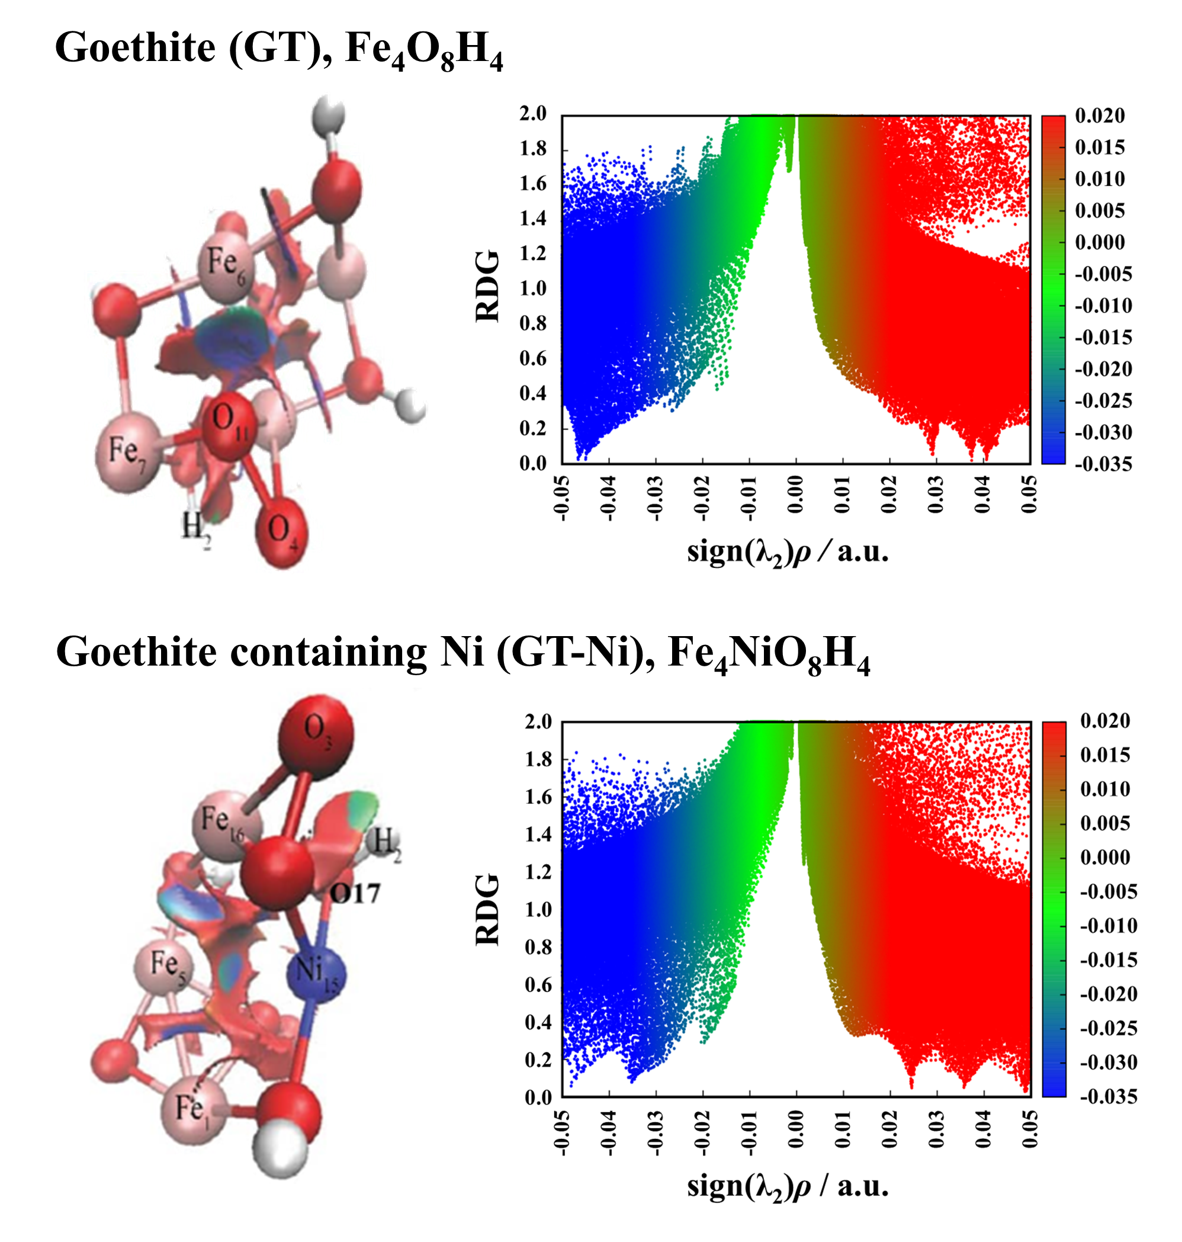
Figure S2. 2D iso-surface plots for reduced density gradient and scatterplots between $s$ and sign(λ₂)ρ for Fe₄O₈H₄ (goethite) and Fe₃NiO₈H₄ (goethite with Ni) complexes. All quantities plotted are in atomic units (a.u.). The green, blue, and red colors denote van der Waals attraction/weak hydrogen bonding, strong hydrogen bonding, and steric repulsions, respectively.

NBO analysis
To further understand the nature of bonding promoted by the donor and acceptor atoms in the system, the NBO analysis was conducted. Tables S4 and S5 present the results. Since the second-order perturbation energy also involves the sharing of electrons, NBO can also be used to confirm the strength of the bonds in a complex. The second-order perturbation for the orbital interactions in goethite was between 2.09 and 15.06 kJ∙mol⁻¹, suggesting the presence of bonding in the Fe₄O₈H₄ complex (see Table S4). Furthermore, the second-order perturbation energy in the Fe₃NiO₈H₄ complex indicated the energies ranging between 3.47 and 25.10 kJ∙mol⁻¹ (see Table S5), further concretizing that goethite with Ni is more stable than goethite without Ni. This is also in agreement with the QTAIM results presented in Tables S1 and S2.

Table S4. Second-order perturbation energy (E⁽²⁾) (donor→acceptor) (in kJ∙mol⁻¹) for intermolecular interactions within goethite without Ni, involving nonbonding orbital of donor (LP(O))and antibonding orbital of acceptor (σ*(O∙∙∙X), where X is Fe, Ni, and H, respectively) in the Fe₄O₈H₄(goethite without Ni) complex. Refer to Figure 6(a) for labeling.
Intermolecular bonding | Donor (LP (O)) | Acceptor(σ*(O∙∙∙X)) | E⁽²⁾ (kJ∙mol⁻¹)
O₁₅∙∙∙Fe₆∙∙∙O₃ | LP(O₃) | σ* (O₁₅∙∙∙Fe₆) | 7.15
H₂∙∙∙O₄ | LP(O₄) | σ* (H₂) | 3.93
Fe₆∙∙∙Fe₅ | LP(Fe₅) | σ* (Fe₆) | 2.80
O₁₅∙∙∙Fe₆∙∙∙O₁₁ | LP(O₁₁) | σ* O₁₅∙∙∙Fe₆) | 4.90
O₁₃∙∙∙Fe₁∙∙∙O₁₅ | LP(O₁₅) | σ* (O₁₃∙∙∙Fe₁) | 2.18
O₁₁∙∙∙Fe₆∙∙∙O₄ | LP(O₄) | σ* (O₁₁∙∙∙Fe₆) | 5.77
O₁₁∙∙∙Fe₇∙∙∙O₃ | LP(O₃) | σ* (O₁₁∙∙∙Fe₇) | 7.15
O₃∙∙∙Fe₇∙∙∙O₁₁ | LP(O₁₁) | σ*(O₃∙∙∙Fe₇) | 9.20
O₃∙∙∙Fe₇∙∙∙O₁₄ | LP(O₁₄) | σ* (O₃∙∙∙Fe₇) | 10.42
O₁₆-Fe₅∙∙∙O₁₄ | LP(O₁₄) | σ* (O₁₆∙∙∙Fe₅) | 6.36
O₄-Fe₆∙∙∙O₁₅ | LP(O₁₅) | σ* (O₄∙∙∙Fe₆) | 6.36
O₁₂-Fe₁∙∙∙O₁₃ | LP(O₁₃) | σ* (O₁₂∙∙∙Fe₁) | 5.40
O₁₆-Fe₅∙∙∙O₁₃ | LP(O₁₃) | σ* (O₁₆∙∙∙Fe₅) | 10.42
O₄∙∙∙O₁₁ | LP(O₁₁) | σ* (O₂₃∙∙∙Cu₂₅) | 4.90
O₁₄∙∙∙Fe₅∙∙∙O₁₁ | LP(O₁₁) | σ* (O₄) | 14.85
O₁₄∙∙∙Fe₅∙∙∙O₁₂ | LP(O₁₂) | σ* (O₁₄∙∙∙Fe₅) | 7.74
O₁₃∙∙∙Fe₁∙∙∙O₁₂ | LP(O₁₂) | σ* (O₁₃∙∙∙Fe₁) | 9.20
O₄∙∙∙Fe₆∙∙∙O₁₂ | LP(O₁₂) | σ* (O₄∙∙∙Fe₆) | 7.74
O₁₄∙∙∙Fe₅∙∙∙O₁₆ | LP(O₁₆) | σ* (O₁₄∙∙∙Fe₅) | 12.18
H₁₀∙∙∙O₁₃ | LP(O₁₃) | σ* (H₁₀∙∙∙O₁₃) | 3.97
H₈∙∙∙O₁₄ | LP(O₁₄) | σ* (H₈) | 3.43
H₉∙∙∙O₁₅ | LP(O₁₅) | σ* (H₉) | 3.26
O₁₂∙∙∙O₁₆ | LP(O₁₆) | σ* (O₁₂) | 3.93

Table S5. Second-order perturbation energy (E⁽²⁾) (donor→acceptor) (in kJ∙mol⁻¹) for intermolecular interactions within goethite with Ni, involving nonbonding orbital of donor (LP(O))and antibonding orbital of acceptor (σ*(O∙∙∙X), where X is Fe, Ni, and H, respectively) in the Fe₃NiO₈H₄(goethite with Ni) complex. Refer to Figure 6(b) for the labeling.
Intermolecular bonding | Donor (LP (O)) | Acceptor(σ*(O∙∙∙X)) | E⁽²⁾ (kJ∙mol⁻¹)
O₉∙∙∙Ni₁₅∙∙∙O₁₀ | LP(O₁₀) | σ* (O₉∙∙∙Ni₁₅) | 3.72
O₁₃∙∙∙Ni₁₅∙∙∙O₃ | LP(O₃) | σ* (O₁₃∙∙∙Ni₁₅) | 8.12
H₂∙∙∙O₃ | LP(O₃) | σ* (H₂) | 4.02
O₁₀∙∙∙Fe₁∙∙∙O₁₁ | LP(O₁₁) | σ* (O₁₀∙∙∙Fe₁) | 5.10
O₁₂∙∙∙Fe₁₆∙∙∙O₃ | LP(O₃) | σ* (O₁₂-Fe₁₆₁) | 5.02
O₄∙∙∙Fe₁₆∙∙∙O₉ | LP(O₉) | σ* (O₄∙∙∙Fe₁₆) | 7.15
O₁₁∙∙∙Fe₅∙∙∙O₁₂ | LP(O₁₂) | σ* (O₁₁∙∙∙Fe₅) | 2.85
O₁₀∙∙∙Fe₁∙∙∙O₁₃ | LP(O₁₃) | σ* (O₁₀∙∙∙Fe₁) | 20.42
O₁₃∙∙∙Ni₁₅∙∙∙O₉ | LP(O₉) | σ* (O₁₃∙∙∙Ni₁₅) | 10.04
O₁₂∙∙∙Fe₅∙∙∙O₁₀ | LP(O₁₀) | σ* (O₁₂∙∙∙Fe₅) | 3.47
O₁₁∙∙∙Fe₁∙∙∙O₁₀ | LP(O₁₀) | σ* (O₁₁∙∙∙Fe₁) | 8.12
Ni₁₅∙∙∙O₉∙∙∙O₄ | LP(O₄) | σ* (Ni₁₅∙∙∙O₉) | 5.48
O₁₀∙∙∙O₁₄ | LP(O₁₄) | σ* (O₁₆∙∙∙Fe₅) | 7.28
H₈∙∙∙O₁₄ | LP(O₁₄) | σ* (O₁₀) | 4.02
O₁₂∙∙∙Fe₅∙∙∙O₁₁ | LP(O₁₁) | σ* (O₁₂∙∙∙Fe₅) | 29.12
H₆∙∙∙O₁₂ | LP(O₁₂) | σ* (H₆) | 3.31
H₇∙∙∙O₁₃ | LP(O₁₃) | σ* (H₇) | 3.47
O₃∙∙∙Ni₁₅∙∙∙O₁₃ | LP(O₁₃) | σ* (O₃∙∙∙Ni₁₅) | 23.85
O₁₂∙∙∙Fe₁₆∙∙∙O₄ | LP(O₄) | σ* (O₁₂∙∙∙Fe₁₆) | 6.23
O₉∙∙∙Fe₁₆∙∙∙O₁₂ | LP(O₁₂) | σ* (O₉∙∙∙Fe₁₆) | 4.69

References
[1] R.G. Parr, Z. Zhou, Absolute hardness: unifying concept for identifying shells and subshells in nuclei, atoms, molecules, and metallic clusters, Accounts of chemical research, 26(1993), p. 256.
[2] M.M. Maslov, A.I. Kochaev, M.A. Gimaldinova, A.A. Grekova, K.P. Katin, Hypercubane covalent crystals: Insight from density functional theory, Materials Today Communications, 35(2023), p. 106146.
[3] E.R. Johnson, S. Keinan, P. Mori-Sánchez, J. Contreras-García, A.J. Cohen, W. Yang, Revealing noncovalent interactions, Journal of the American Chemical Society, 132(2010), p. 6498.
[4] T. Lu, F. Chen, Multiwfn: A multifunctional wavefunction analyzer, Journal of computational chemistry, 33(2012), p. 580.
[5] W. Humphrey, A. Dalke, K. Schulten, VMD: visual molecular dynamics, Journal of molecular graphics, 14(1996), p. 33.

