**Supporting Information:**

**Bioleaching of vanadium from** **stone coal vanadium ore by *Bacillus mucilaginosus*: influencing factors and mechanism**

*Yingbo Dong*1,2), *Jinyu Zan*1), *and Hai Lin*1,2),[1]🖂

1) School of Energy and Environmental Engineering, University of Science and Technology Beijing, Beijing 100083, China

2) Beijing Key Laboratory on Resource-oriented Treatment of Industrial Pollutants, Beijing 100083, China

(Received: 14 October 2023; revised: 14 January 2024; accepted: 17 January 2024)

We used second-generation sequencing Illumina combined with third-generation sequencing PacBio technology to determine the genome of *Bacillus mucilaginosus*, which was preserved in the laboratory used in our study, and to functionally annotate the genome of *Bacillus mucilaginosus*. The results showed the presence of the bacterial genome of the gene encoding carbonic anhydrase, cynT, which is expressed in the cells of *Bacillus mucilaginosus*, with the gene information shown in Table S1 and the gene arrangement shown in Fig. S1.

**Table S1. Genetic information of the coding gene cynT**

|  |  |  |  |  |
| --- | --- | --- | --- | --- |
| Gene name | Start | End | Length (bp) | NR Description |
| cynT | 36588 | 35938 | 651 | carbonic anhydrase |

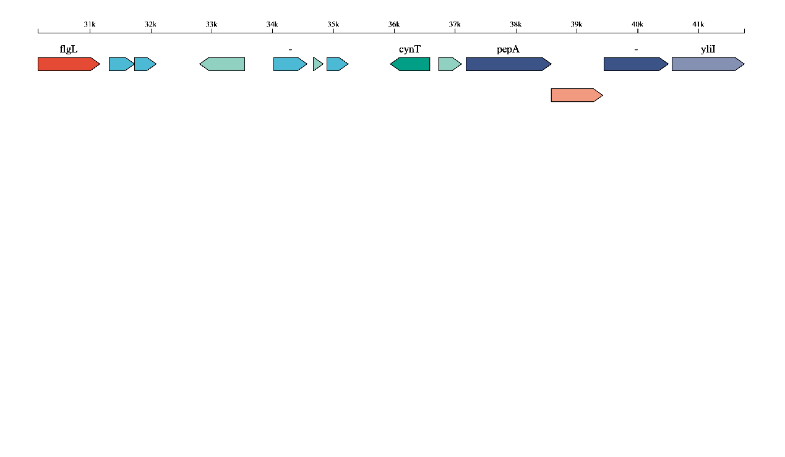

**Fig. S1. Gene arrangement of coding gene cynT**

1. 🖂Corresponding author: Hai Lin E-mail: linhai@ces.ustb.edu.cn