Supplementary Information

TiO₂@NH₂-MIL-125(Ti) composite derived from a partial-etching strategy with enhanced carriers’ transfer for the rapid photocatalytic Cr(VI) reduction
Fang Xu¹⁾, Wanning Cao¹⁾, Jinzhou Li¹⁾, Songsong Zhi²⁾, Zhiyong Gao¹⁾, Yuqin Jiang^{1),}, Wei Li¹⁾, Kai Jiang²⁾, and Dapeng Wu^{2),}
1) Collaborative Innovation Center of Henan Province for Green Manufacturing of Fine Chemicals, Key Laboratory of Green Chemical Media and Reactions, Ministry of Education, School of Chemistry and Chemical Engineering, Henan Normal University, Xinxiang 453007, China
2) School of Environment, Henan Normal University, Xinxiang 453007, China
 Corresponding authors: Yuqin Jiang E-mail: jiangyuqin@htu.cn; Dapeng Wu E-mail: dapengwu@htu.edu.cn

1. Characterizations methods
The crystal structure and composition of the products were characterized by X-ray powder diffraction (XRD, Rigaku D/max-2500 diffractometer with Cu Ka radiation 40 kV, 100 mA) and X-ray photoelectron spectroscopy (XPS) on a Thermo Fisher ESCALab 250 system with an Al Ka X-ray source and pass energy of 40 eV. The binding energy was calibrated using the C 1s peak (284.8 eV). The morphology and microstructure were characterized via field-emission scanning electron microscopy (FEI, Quanta FEG 250) and JEOL JEM-2100 transmission electron microscope. Fourier transform infrared (FTIR) spectra were measured using Thermo Electron Nicolet-360, and Raman spectra were conducted on Aramis using a laser with a wavelength of 532 nm. The surface and pores features were measured via nitrogen adsorption-desorption isotherms measured at 373 K using NOVA Surface Area and Porosity Analyzer (Quantum, USA). The optical responses were detected by UV-visible spectrophotometer (Cary5000 UV-vis-NIR, USA). The steady state photoluminescence (PL) spectroscopy was performed on a fluorescence spectrophotometer (FP-6500, Japan) at room temperature with an excitation wavelength of 350 nm. Time-resolved photoluminescence (TRPL) decay spectra were measured on a FLS980 fluorescence spectrometer (Edinburgh instrument). The electron paramagnetic resonance (EPR) measurements were performed on a Bruker EMXplus EPR spectrometer. The g-factors were determined by the EPR Data Processing program.
2. Photoelectrochemical measurements
All the photoelectrochemical measurements were performed in a homemade three electrode quartz cell on CHI660D electrochemical analyzer (Chenhua, China) under the irradiation of a 300 W Xe arc lamp system at room temperature. Photocatalyst-covered fluorine-doped tin oxide (FTO) glasses, Pt plate, saturated Ag/AgCl, and 1 mol/L Na₂SO₄ solution were used as the working electrode, counter electrode, reference electrode and electrolyte respectively.
3. Figures
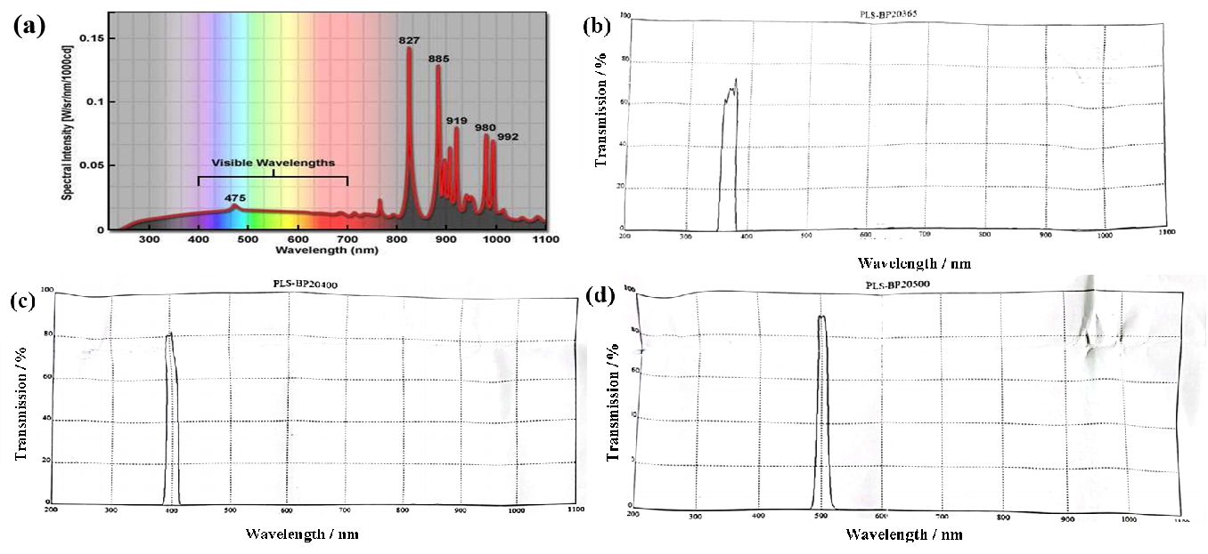
Fig. S1. The optical spectrum and the intensity of 300 W Xe lamp (a) and the optical spectrum and the transmission of band-pass filters with central wavelength of 365 nm (b), 400 nm (c) and 500 nm (d).

Fig. S2. The diameter distribution histogram of MT-2.

Fig. S3. XPS survey spectra of M and MT-2.

Fig. S4. Room temperature EPR spectra of M and MT-2.

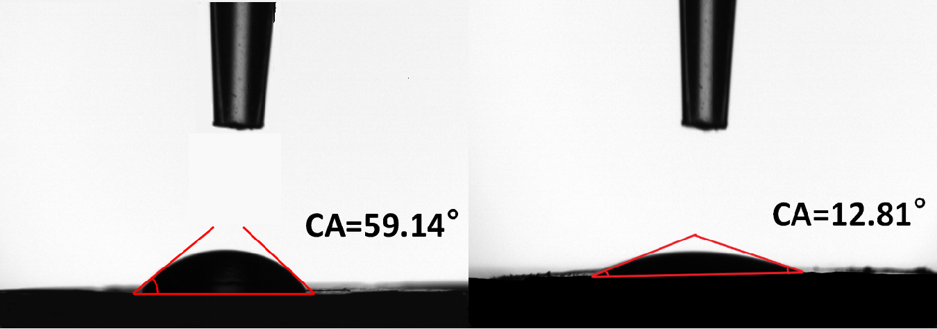
Fig. S5. The contact angle of M and MT-2.

Fig. S6. XPS survey spectra (a) and high resolution XPS spectra for Cr2p (b) of MT-2 used after photocatalytic Cr(VI) reduction reaction.

Fig. S7. The SEM images after Cr(VI) reduction experiments.
Fig. S8. The photocatalytic performance curves of MT-2 with band-pass filters (a) and corresponding apparent reaction rate constant k (b).
Fig. S9. The photodegradation curve of methylene blue (MB) over MT-2.

Fig. S10. Valence band (VB) XPS of M and TiO₂.

As shown in Fig. S10, the valence band (VB) XPS of M and TiO₂ were measured. The intercept of the curve on the x-axis indicated the energy gaps of semiconductor between the Fermi level (E_{f}) and VB. Combined with the Mott-schottky plots, the HOMO of M and VB of TiO₂ could to be ~2.10 and ~2.78 V, agreeing well with the results calculated based on the bandgap energy.
Fig. S11. The EPR spectra of ·O₂⁻ trapped by DMPO over M and MT-2.

4. Tables
Table S1. The parameters of band-pass filters with central
wavelength of 365 nm, 400 nm and 500nm
Parameters | 365 nm | 400 nm | 500 nm
Scan-Range | 200.0-1100.0 nm | 200.0-1100.0 nm | 200.0-1100.0 nm
Central wavelength | 367.5 nm | 400 nm | 501 nm
Full Width Half Maximum | 25 nm | 20 nm | 19 nm
Peak Transmission | 72.96% | 82.25% | 89.99%
Peak wavelength | 375 nm | 403 nm | 504 nm
Out of Band Transmission | OD3/0.1% | OD3/0.1% | OD3/0.1%
Sizes | Φ63×2mm | Φ63×2mm | Φ63×2mm

Table S2. The XPS atomic percentage and peak area in M and MT-2
 | Peak area |  | Atomic (%)
 | M | MT-2 | M | MT-2
O 1s | 124034.9+89670.7+ 46192.35 | 402652.6+78793.09+ 49970.4 | 29.2 | 49.35
Ti 2p | 118620.8+66189.25 | 358326.5+217211.9 | 8.81 | 22.21
C 1s | 46925.16+73679.27+ 45792.25+27264.55 | 39000.63+21955.43+ 37423.39+11659.3 | 56.49 | 25.61
N 1s | 19062.21+9868.316 | 13586.06+3363.438 | 5.5 | 2.83

Table S3. Specific surface area and pore volume of
NH₂-MIL-125, TiO₂@NH₂-MIL-125 and TiO₂
Parameter | M | MT-0.5 | MT-1 | MT-2 | TiO₂
S_{BET} (m²/g) | 1210.45 | 463.45 | 347.25 | 105.28 | 117.44
V_{v} (cm³/g) | 0.61 | 0.56 | 0.53 | 0.47 | 0.46

Table S4. Photogenerated carriers’ lifetime of M and MT-2
Sample | τ_{a} (ns) | τ₁ (ns) (Rel%) | τ₂ (ns) (Rel%) | τ₃ (ns) (Rel%)
M | 2.15 | 0.2394 (54.15) | 1.733 (27.14) | 8.973 (18.71)
MT-2 | 3.54 | 0.4036 (49.21) | 2.496(24.82) | 1.106 (25.97)

The carrier density of N_{d} was calculated and shown in Table S3 based on the following equation:
where C is the capacitance of space charge layer, N_{d} is the carrier density, e is the electron charge (1.602×10⁻¹⁹ C), ε₀ is the permittivity in vacuum (8.85×10⁻¹⁴ F/cm), ε is the relative permittivity of the semiconductor (1.90 for M, and 170 for TiO₂) [1], A is the electrode area, E is the applied potential, E_{fb} is the flat band potential, κ is the Boltzmann constant and T is the temperature.

Table S5. Carrier density of M, MT-2 and TiO₂
calculated based on the Mott-Schottky curves
Sample | E_{fb} (V) | N_{d} (cm⁻³)
M | -0.70 | 1.65×10²²
MT-2 | -0.64 | 2.36×10²⁰
TiO₂ | -0.56 | 1.48×10²⁰

Reference
[1] N. Celebi, M.Y. Aydin, F. Soysal, N. Yıldız, and K. Salimi, Core/shell PDA@UiO-66 metal−organic framework nanoparticles for efficient visible-light photodegradation of organic dyes, ACS Appl. Nano Mater., 3(2020), p 11543.

