# Role of tannin pretreatment in flotation separation of magnesite and dolomite

*Xiufeng Gong*1), *Jin Yao*1,2), ✉, *Jun Guo*1), *Bin Yang*3), ✉, *Haoran Sun*4), *Wanzhong Yin*1), *Yulian Wang*4), ✉, *Yafeng Fu*5)

1)School of Resources and Civil Engineering, Northeastern University, Shenyang 110819, China

2) Key Laboratory of Solid Waste Treatment and Resource Utilization of the Ministry of Education, Southwest University of Science and Technology, Mianyang 621010, China

3)School of Chemical Engineering, China University of Mining and Technology, Xuzhou 221116, China

4) School of Materials Science and Engineering, Shenyang Ligong University, Shenyang 110159, China

5) Ansteel Beijing Research Institute Co., Ltd., Beijing 102200, China

✉Corresponding authors: Jin Yao E-mail: yaojin@mail.neu.edu.cn; Bin Yang E-mail: nemoybmaster@outlook.com; Yulian Wang E-mail: [ylwang0908@163.com](mailto:ylwang0908@163.com)

**Table S1.** **Chemical composition of mineral samples** wt%

|  |  |  |  |  |  |
| --- | --- | --- | --- | --- | --- |
| Sample | MgO | CaO | SiO2 | TFe | Purity |
| Magnesite | 47.12 | 0.14 | 0.16 | <0.10 | 98.56 |
| Dolomite | 20.95 | 29.92 | 0.11 | 0.12 | 98.42 |

**Table S2.** **Flotation separation results of the mixed mineral samples**

|  |  |  |  |  |  |  |  |  |
| --- | --- | --- | --- | --- | --- | --- | --- | --- |
| Reagents | Products | Yields (%) | Grade (%) | | | Recovery (%) | | SI |
| MgO | CaO | Magnesite | | Dolomite |
| NaOl: 110 mg·L−1 | Concentrate | 87.56 | 42.18 | 5.78 | 88.77 | | 82.72 | 1.65 |
| Tailing | 12.44 | 39.85 | 8.31 | 11.23 | | 17.28 |
| Feed | 100.00 | 41.89 | 6.10 | 100.00 | | 100.00 |
| Tannin pretreatment  NaOl:110 mg·L−1 | Concentrate | 75.65 | 44.76 | 2.84 | 86.05 | | 34.04 | 3.46 |
| Tailing | 24.35 | 32.94 | 16.21 | 13.95 | | 65.96 |
| Feed | 100.00 | 41.89 | 6.10 | 100.00 | | 100.00 |

**Table S3. Surface element composition of magnesite and dolomite before and after tannin pretreatment**

|  |  |  |  |  |
| --- | --- | --- | --- | --- |
| Sample | Element (atomic %) | | | |
| C 1s | O 1s | Mg 1s | Ca 2p |
| Magnesite | 43.59 | 51.80 | 4.61 |  |
| Tannin-pretreated magnesite | 44.66 | 50.88 | 4.46 |  |
| Offset | 1.07 | −0.92 | −0.15 |  |
| Dolomite | 43.49 | 43.90 | 3.74 | 8.87 |
| Tannin-pretreated dolomite | 45.95 | 42.15 | 3.63 | 8.27 |
| Offset | 2.46 | −1.75 | −0.11 | −0.60 |

**Table S4. Interaction energies of the magnesite and dolomite surfaces with tannin**

|  |  |  |  |  |
| --- | --- | --- | --- | --- |
| Reaction conditions | *Etotal* (eV) | *Emole* (eV) | *Ecrystal* (eV) | *Eads* (eV) |
| Dolomite (104) + tannin | −339.45396 | −78.652617 | −213.22243 | −5.218543 |
| Magnesite (104) + tannin | −292.69208 | −78.652617 | −255.5828 | −0.817033 |

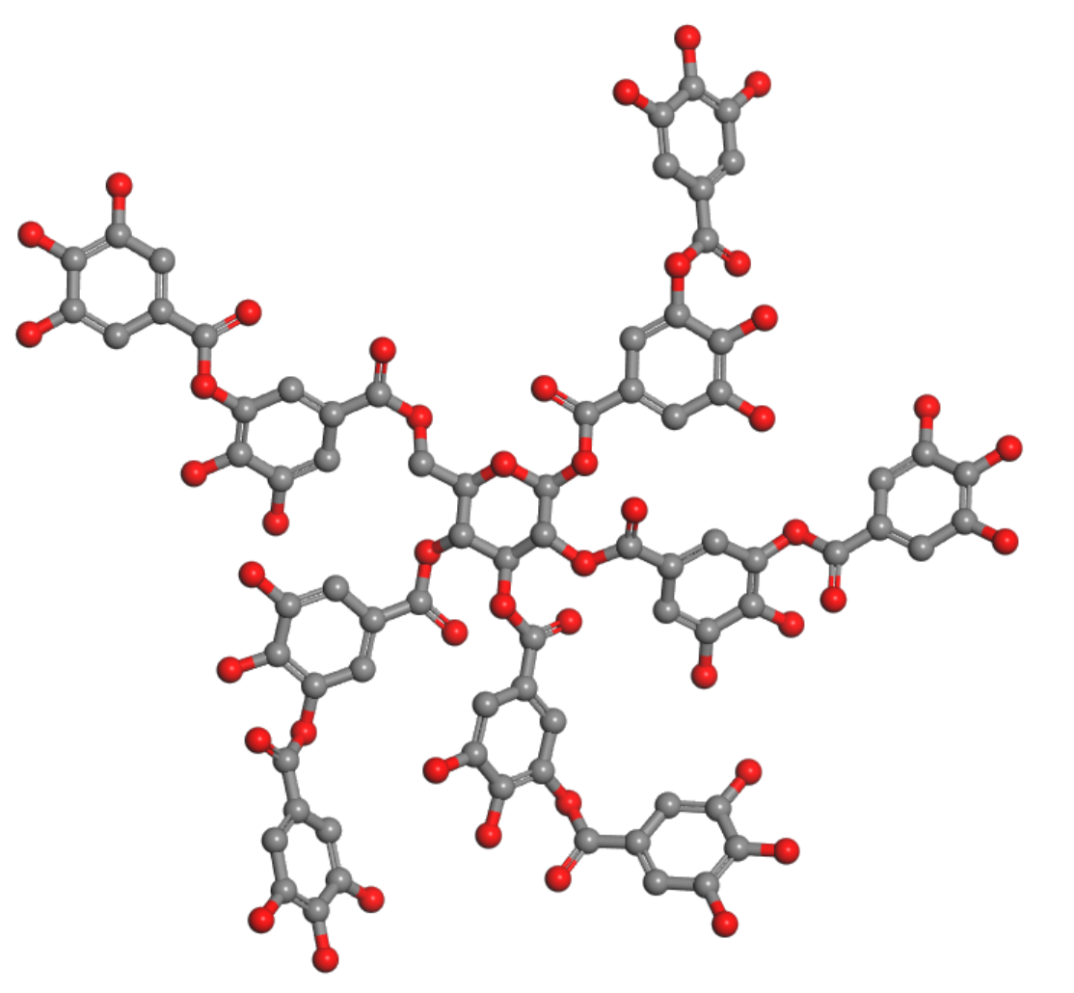

**Fig. S1. Structure of the tannic acid.**



**Fig. S2. X-ray powder diffraction patterns of the magnesite (a) and dolomite (b) samples.**

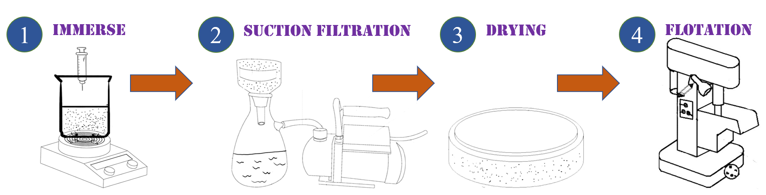

**Fig. S3. Tannin pretreatment process.**

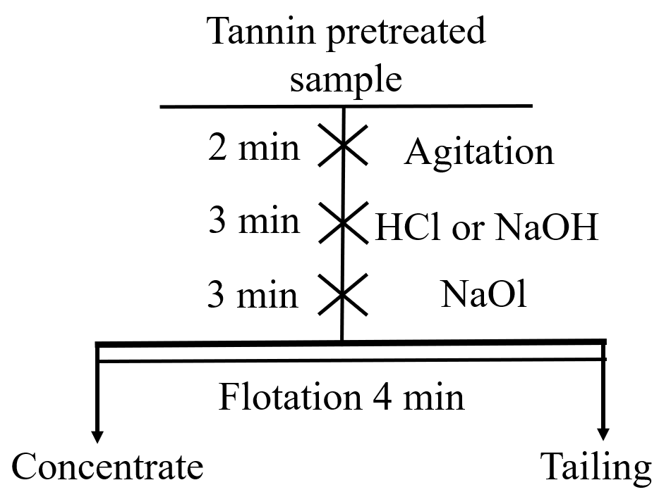

**Fig. S4. Flow chart of microflotation test.**



**Fig. S5. Effect of tannin-pretreated concentrations on the floatabilities of magnesite and dolomite.**



**Fig. S6. Effect of pretreatment time of tannin on the floatabilities of magnesite and dolomite.**