Toughness enhancement of single-crystal diamond by the homoepitaxial growth of periodic nitrogen-doped nano-multilayers
Yun Zhao^{1,2,4),*}, Juping Tu^{3),*}, Liangxian Chen³⁾, Junjun Wei³⁾, Jinlong Liu^{3),}, and Chengming Li^{3),}
1) The Future Laboratory, Tsinghua University, Beijing 100084, China
2) Academy of Arts & Design, Tsinghua University, Beijing 100084, China
3) Institute for Advanced Materials and Technology, University of Science and Technology Beijing, Beijing 100083, China
4) College of Science, China Agricultural University, Beijing 100083, China
(Received: 25 February 2022; revised: 11 April 2022; accepted: 14 April 2022)

* These authors contributed equally to this work.
Corresponding authors: Jinlong Liu E-mail: liujinlong@ustb.edu.cn; Chengming Li E-mail: chengmli@mater.ustb.edu.cn

Abstract: Periodic nitrogen-doped homoepitaxial nano-multilayers were grown by microwave plasma chemical vapor deposition. The residual time of gases (such as CH₄ and N₂) in the chamber was determined by optical emission spectroscopy to determine the nano-multilayer growth process, and thin, nanoscale nitrogen-doped layers were obtained. The highest toughness of 18.2 MPa∙m^{1/2} under a Young’s modulus of 1000 GPa is obtained when the single-layer thickness of periodic nitrogen-doped nano-multilayers is about 96 nm. The fracture toughness of periodic nitrogen-doped CVD layer is about 2.1 times that of the HPHT seed substrate. Alternating tensile and compressive stresses are derived from periodic nitrogen doping; hence, the fracture toughness is significantly improved. Single-crystal diamond with a high toughness demonstrates wide application prospects for high-pressure anvils and single-point diamond cutting tools.
Keywords: microwave plasma chemical vapor deposition; diamond; fracture toughness; nitrogen doping

1. Introduction
Diamond exhibits a high Young’s modulus and hardness [1]; hence, it exhibits several important applications, including fine grinding materials [2], high-hardness cutting tools [3], various drills [4–5], and wire drawing molds [6] and so on [7–9]. However, in case of considerable deformation, brittle fracture can be easily caused [10]. The multi-layered method has been successfully employed to improve the hardness and toughness of ceramic coatings [11]. To improve the toughness of single-crystal diamond (SCD), the periodic growth of nitrogen-doped layers was adopted [12]. The thickness of a single nitrogen-doped layer was ~650 nm. The fracture toughness of an SCD prepared by chemical vapor deposition (CVD) is improved by this method. To further improve the toughness of SCD, it is crucial to further reduce the thickness of the nitrogen-doped layer and increase the nitrogen doping cycles within a certain thickness to completely reflect the strengthening and toughening effects of nitrogen-doped nano-multilayers.
Currently, a quartz-tube microwave plasma chemical vapor deposition (MPCVD) system has been utilized to grow multilayered nitrogen-doped layers [13–14]. The single-layer thickness of the nitrogen-doped layer is 50–100 nm. The main feature of the reactor is that the gas mixture is switched by an electrically controlled rapid gas switch, and the discharge is maintained in a laminar, making it possible to attain the residence time of the gas mixture in the reactor in ~5 s. Hence, it is possible to obtain nitrogen- or boron-doped delta layers with sharp boundaries [15].
However, for the currently used quartz bell jar and metal resonator CVD system, it is impossible to form nitrogen-doped layers with clear boundaries by simply switching the nitrogen flow meter switch [12]. This leads to a slow process for the change in the nitrogen concentration between nitrogen-doped and non-nitrogen-doped layers. Therefore, to obtain nitrogen-doped layers with an extremely low thickness at a high growth rate, it is crucial to find an appropriate process to achieve the periodic doping of the nitrogen nano-multilayer structure, which can improve the toughness of CVD-prepared SCD.
2. Experimental
A home-made 2.45 GHz quartz bell jar microwave plasma reactor was used for experiments. Ib-type high-pressure–high-temperature (HPHT) diamond substrates with a (100) orientation and a size of 4.0 mm × 4.0 mm × 1.0 mm were purchased from SINO CRYSTAL (Zhengzhou, China). Before the CVD growth of diamond, the substrates were subjected to mechanical polishing to obtain smooth surfaces. Substrates with an Ra ≈ 2 nm were used for CVD diamond growth. All experiments were performed at a microwave power of 2.1 kW and a gas pressure of 10 kPa. Substrate temperatures were controlled in the range of 750–845°C by adjusting the thermal barrier. The hydrogen flow was 300 standard cubic centimeter per minute (sccm), the methane flow was 3 sccm, and the nitrogen flows were 0.12 and 0.15 sccm. We use a flowmeter with full scale of 5 sccm or 10 sccm to adjust the gas flow, and such small gas flow was within the allowable range of error. Fig. 1 shows the schematic of the CVD nano-multilayer SCD grown by periodic nitrogen doping.
The gas-phase species in the plasma were determined by optical emission spectroscopy (OES). The morphology of indentation and surface of samples were observed by scanning probe microscopy and laser confocal microscopy, respectively. The micro-Vickers hardness tester was used to measure the Vickers hardness (H_{V}) and fracture toughness (K_{IC}) with a load of 9.8 N and a dwell time of 10 s. H_{V} and K_{IC} were obtained from the equation [16–17]: H_{V} = 1854∙P/a², K_{IC} = (0.016 ± 0.004)∙(E/H_{V})^{1/2}∙(P/b^{3/2}), where P is the applied load, N; a is the arithmetic mean of the two diagonals of the Vickers indentation, μm; E is the Young’s modulus (assumed to be 1000 GPa); b = (b₁ + b₂)/4, and b₁ and b₂ are the lengths of the two diagonal cracks. The Young’s modulus of different SCDs was characterized by laser-induced surface acoustic waves (LAwave) (Figs. S1 and S2). Their Young’s modulus was almost the same (1200 GPa), but to compare with previously reported mechanical properties, a Young’s modulus of 1000 GPa was also utilized from literature [18–20]. The Raman mapping of the cross-section of the sample was obtained by laser scanning Raman microscopy under an excitation wavelength of 532 nm and a spatial resolution of 260 nm. The Raman and photoluminescence (PL) spectra were recorded at room temperature at a spectral resolution of 0.4 cm⁻¹.
The thickness of the nitrogen-doped layers was determined by secondary-ion mass spectrometry (SIMS), and the resolution of SIMS was 3 nm. The depth profile was analyzed by double focusing magnetic SIMS, Alpha-step 500 surface profiler was used to measure the depth of etching pit. CS⁺ with energy of 14.5 keV was used for ion sputtering, and single crystal diamond with nitrogen concentration of 5.93 × 10¹⁷ cm⁻³ was used for quantitative calibration of nitrogen concentration.
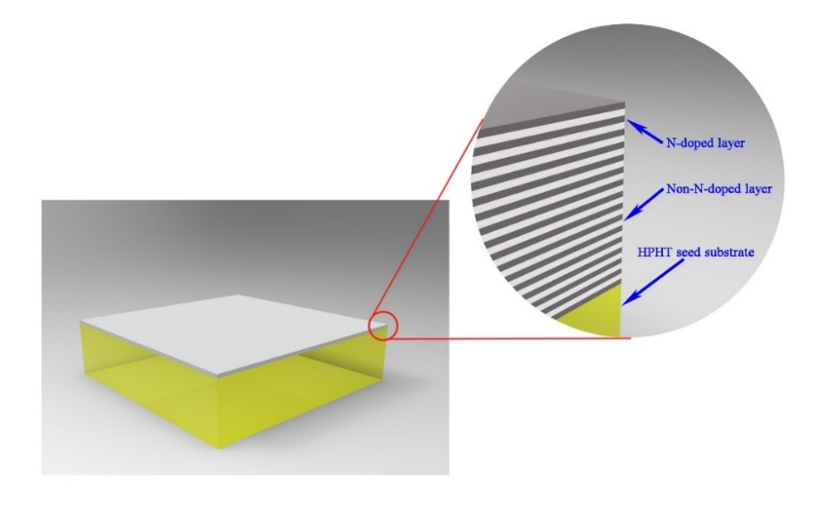
Fig. 1. Schematic of CVD nano-multilayer single-crystal diamond grown by periodic nitrogen doping. White and light-gray layers correspond to the non-nitrogen-doped and nitrogen-doped layers, respectively. The yellow part corresponds to the Ib-type HPHT seed substrate.

3. Results and discussion
3.1. Growth of periodic nitrogen doped diamond
Eight growth process exploration experiments were performed, four times for nitrogen-doped growth and the remaining four times for non-nitrogen-doped growth. Growth temperatures were 750, 780, 800, and 845°C. The surface of nitrogen-doped CVD-grown SCD was smooth and free of defects at a temperature of 845°C and a nitrogen flow of 0.12 sccm. Similarly, the growth temperature was determined to be 800°C for non-nitrogen doped growth (Figs. S3 and S4 for details of the growth process). When the periodic nitrogen-doped nano-multilayers was grown at the corresponding temperature, the surface of nano-multilayers should be smooth and flat.
When the gas flow meter was switched off, the gas remained in the chamber for a while [21]. Therefore, if the nitrogen flow meter is simply switched to grow the nitrogen-doped and non-nitrogen-doped layers, it is obvious that the change in the nitrogen concentrations between the nitrogen-doped and non-nitrogen-doped layers is relatively flat. To obtain clear nitrogen-doped nano-multilayer boundaries, it is crucial to determine the equilibrium time for filling gas and outflow after switching the flow meter. The intensity of radicals in the optical emission spectrum (OES) of the plasma was investigated to determine whether the chamber contained the gas that produced the corresponding radicals. Hence, the equilibrium time of the gas is calculated [22–23]. For example, CH₄ produces C2 radicals and N₂ produces CN radicals in the microwave discharge plasma during growth.
Peaks corresponding to CN and C2 peak were observed at 388.3 and 516.5 nm, respectively, in the plasma of the gas passing through CH₄ and N₂ (Fig. 2). The right inset shows the time dependence of the C2 emission intensity after opening and closing the CH₄ flow meter. When the CH₄ flow meter was switched off, the intensity of C2 radicals started to decrease and stabilize after 3 min. When the CH₄ flow meter was switched on, the intensity of C2 radicals started to increase and stabilized after 1 min. Similarly, the left inset shows the time dependence of the CN emission intensity after opening and closing the N₂ flow meter. When the N₂ flow meter was switched off, the intensity of CN radicals started to stabilize after 25 min. When the N₂ flow meter was switched on, the intensity of CN radicals started to stabilize after 15 min. All emission peaks have corresponding background emission signals. Therefore, when there are no radicals in the chamber, OES can also collect a certain background signal, and the emission intensity is not zero.
Fig. 2. OES spectrum of the microwave discharge plasma. Right inset shows the time dependence of the C2 emission line (516.5 nm) intensity after opening and closing the CH₄ flow meter. Left inset shows the time dependence of the CN emission line (388.3 nm) intensity after opening and closing the N₂ flow meter.
The equilibrium time of CH₄ in the chamber was considerably less than that of N₂. According to this characteristic, the experimental scheme of periodic nitrogen-doped growth was designed. In the chamber with an H₂ flow of 300 sccm, an N₂ flow of 0.12 sccm was first introduced, and 15 min later, CH₄ was introduced, and a nitrogen-doped layer was grown at 845°C for 1.5 min. Next, CH₄ and N₂ flows were switched off at the same time, and after 25 min, CH₄ was introduced, and a non-nitrogen-doped layer was grown at 800°C for 20 min. Finally, CH₄ was switched off. After 5 min, the next cycle of nitrogen-doped and non-nitrogen-doped layers was grown.
Fig. 3(a) shows the surface morphology of the sample with the periodic nitrogen-doped layer. The sample surface did not exhibit defects, and a uniform step flow was formed. Fig. 3(b) shows the SIMS profile of the sample: The thickness of the nitrogen-doped layer was about 96 nm.
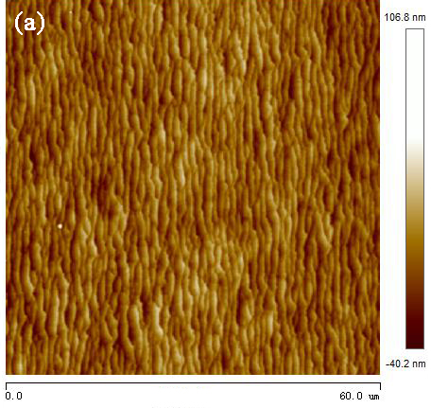
Fig. 3. (a) Surface morphology of the sample with a periodic nitrogen-doped layer and (b) the SIMS profile of the sample.

3.2. Mechanical properties of single crystal diamond
Fig. 4 shows the typical indentation morphologies of different types of SCD after the Vickers hardness test. The growth parameters of different CVD SCD samples are shown in Table 1. Left inset in Fig. 4 shows the maximum indentation depth of ~500 nm for the HPHT diamond substrate. Unlike other types of diamond, periodic nitrogen-doped SCD exhibited only square cracks along the <110> direction and almost no cross-like cracks along the <100> direction (Fig. 4(d)).
Table 2 summarizes the H_{V} and K_{IC} on the {100} faces of different types of SCD in the <100> direction. Each sample was tested at least four times, and the corresponding hardness and toughness were obtained by taking the average value. Periodic nitrogen-doped samples with different nitrogen-doped single-layer thicknesses were grown, and their mechanical properties were investigated (Figs. S5 and S6 and Table S1). Compared with that of the HPHT seed substrate ((8.5 ± 2.1) MPa∙m^{1/2}), the fracture toughness of CVD-grown SCD doped with nitrogen ((13.8 ± 2.7) MPa∙m^{1/2}) increased clearly. By periodic nitrogen doping, the thickness of a single nitrogen-doped layer was about 96 nm, and the fracture toughness of the CVD layer ((18.2 ± 1.9) MPa m^{1/2}) was about 2.1 times that of the HPHT seed substrate. This value is increased by ~32% compared with that of the CVD layer doped with the same nitrogen content, but grown by non-periodic nitrogen doping. Fig. S7 shows the correlation curve for the fracture toughness of all samples.

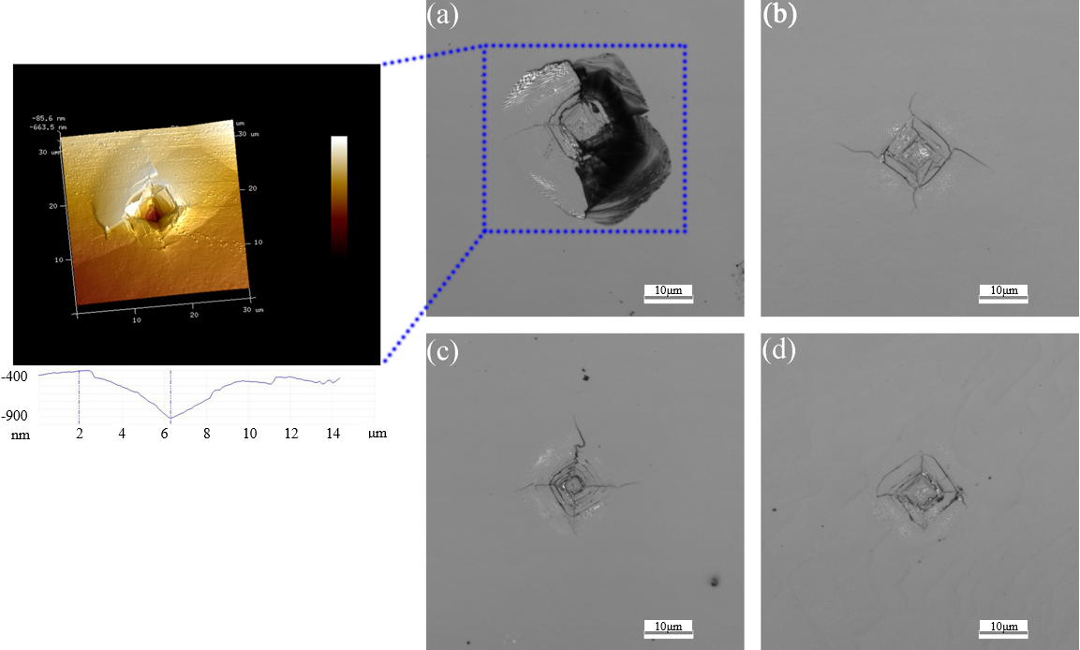
Fig. 4. Typical indentation morphology of different types of single-crystal diamond after the Vickers hardness test: (a) HPHT seed substrate (Left inset shows the surface profile of indentation, and the maximum indentation depth is ~500 nm); (b) non-nitrogen-doped CVD-grown single-crystal diamond; (c) nitrogen-doped CVD-grown single-crystal diamond at an N₂ flow of 0.12 sccm; (d) periodic nitrogen-doped CVD-grown single-crystal diamond with a single nitrogen-doped layer thickness of about 96 nm at an N₂ flow of 0.12 sccm.
Table 1. Growth parameters of different CVD SCD samples
Sample type | CH₄/H₂ ratio / vol% | H₂ / sccm | N₂ / sccm | Total thickness of the CVD layer / μm
Non-N-doped CVD SCD | 1 | 300 | 0 | ~6
N-doped CVD SCD | 1 | 300 | 0.12 | ~6
Periodic N-doped CVD SCD | 1 | 300 | 0.12/0/0.12/0/… | ~6

Table 2. Mechanical properties of various single-crystal diamond samples
Sample type | H_{V} / GPa | K_{IC} / (MPa∙m^{1/2})
HPHT seed substrate | 98.0 ± 22.8 | 8.5 ± 2.1
Non-N-doped CVD SCD | 88.6 ± 3.9 | 11.9 ± 1.7
N-doped CVD SCD | 90.8 ± 4.1 | 13.8 ± 2.7
Periodic N-doped CVD SCD | 83.9 ± 11.4 | 18.2 ± 1.9

3.3. Toughness enhancement mechanism
Nitrogen atoms cause the lattice expansion of diamond (Fig. S8). The distribution control of the impurities in diamond can strengthen diamond. By the formation of a nitrogen-doped thin layer on impurity-free diamond, a large compressive stress is produced on the diamond surface, which can improve the toughness of diamond [24–25].
Considering the spatial resolution and spectral resolution of the Raman spectrum, periodic nitrogen-doped SCD with a single nitrogen-doped layer thickness of 700 nm was grown. The deposition conditions were as follows: the flow rates of H₂, CH₄, and N₂ were 300 sccm, 3 sccm, and 0.15 sccm. Respectively; the total thickness of periodic nitrogen-doped CVD layer was 33 μm. Raman and PL spectra of nitrogen-doped CVD layer were measured (Fig. S9). Fig. 5 shows the Raman mapping of the fluorescence intensity of the NV⁰ defect of the cross-section of the sample: Alternately grown nitrogen-doped and non-nitrogen-doped layers are clearly visible.
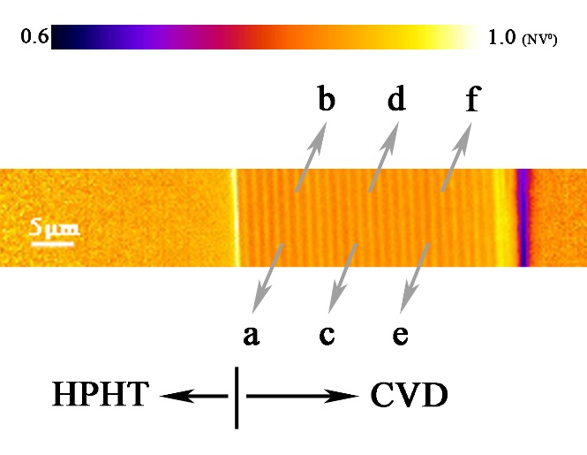
Fig. 5. Laser-scanning Raman image shows the Raman mapping of the fluorescence intensity of the NV⁰ defect of the cross-section of sample grown by periodic nitrogen doping. Positions of a, c, and e correspond to the non-nitrogen-doped layers, and the positions of b, d, and f correspond to the nitrogen-doped layers.
Fig. 6(a) shows the Raman spectrum of the first-order phonon peak of diamond in nitrogen-doped and non-nitrogen-doped layers at different points. The biaxial stress values for the periodic nitrogen-doped and non-nitrogen-doped layers were determined from the equation [26]: F = −0.61 GPa/cm⁻¹. In nitrogen-doped layers, the diamond peak shifted to 1333.1 cm⁻¹, corresponding to a compressive stress level of 0.37 GPa. In non-nitrogen-doped layers, the diamond peak shifted to 1332.1 cm⁻¹, corresponding to a tensile stress level of 0.24 GPa. Periodic compressive–tensile stresses were formed at the periodic nitrogen-doped and non-nitrogen-doped layers (Fig. 6(b)). When nitrogen is doped on the diamond surface, compressive stress is formed on the diamond surface, which plays a role in toughening diamond. The alternate change in the stress relaxation leads to the decrease in the hardness and sharp increase in the toughness, which has more practical significance for diamond with sufficiently hardness in expanding its application.
Fig. 6. (a) Raman spectrum of the first-order phonon peak of diamond in nitrogen-doped and non-nitrogen-doped layers at different points. (b) Stress of nitrogen-doped and non-nitrogen-doped layers at different points.

4. Conclusion
In summary, based on the residual times of CH₄ and N₂ in the chamber, an experimental scheme for the CVD-grown SCD by periodic nitrogen doping is designed in a quartz bell jar microwave plasma reactor. A periodic nitrogen-doped CVD-grown SCD with a single nitrogen-doped layer thickness of about 96 nm is grown, and a uniform step flow is formed on the diamond surface. The fracture toughness of periodic nitrogen-doped CVD layer ((18.2 ± 1.9) MPa∙m^{1/2}) is about 2.1 times that of the HPHT seed substrate. This value is increased by ~32% compared with that of the CVD layer doped with the same nitrogen content, but grown by non-periodic nitrogen doping. The periodic change in the components on the nanoscale leads to the increase in toughness. Periodic compressive–tensile stress is formed at the periodic nitrogen-doped and non-nitrogen-doped layers, which is the mechanism for the further improvement in the toughness of diamond.
Acknowledgements
This work was financially supported by the National Key Research and Development Program of China (No. 2018YFB0406501), the European Union’s Horizon 2020 Research and Innovation Staff Exchange (RISE) Scheme (No. 734578), and the Beijing Natural Science Foundation (No. 4192038).
Conflict of Interest
The authors declare no conflict of interest.

Supplementary Information
The online version contains supplementary material available at https://doi.org/10.1007/s12613-022-2497-1.
References
[1] Q. Huang, D. Yu, B. Xu, et al., Nanotwinned diamond with unprecedented hardness and stability, Nature, 510(2014), No. 7504, p. 250.
[2] Q.L. Zhang, Q.L. Zhao, S. To, B. Guo, and W.J. Zhai, Diamond wheel wear mechanism and its impact on the surface generation in parallel diamond grinding of RB-SiC/Si, Diamond Relat. Mater., 74(2017), p. 16.
[3] B. Akbari and S. Miska, The effects of chamfer and back rake angle on PDC cutters friction, J. Nat. Gas Sci. Eng., 35(2016), p. 347.
[4] K. Miyazaki, T. Ohno, H. Karasawa, and H. Imaizumi, Performance of polycrystalline diamond compact bit based on laboratory tests assuming geothermal well drilling, Geothermics, 80(2019), p. 185.
[5] L. Zheng, W.D. Wei, Y. Feng, et al., Drilling machinability of engineering ceramics under low-frequency axial vibration processing by sintering/brazing composite diamond trepanning bit, Ceram. Int., 45(2019), No. 9, p. 11905.
[6] X.C. Wang, C.C. Wang, X.T. Shen, and F.H. Sun, Tribological properties of diamond films for high-speed drawing Al alloy wires using water-based emulsions, Tribol. Int., 123(2018), p. 92.
[7] Y.Z. Guo, J.L. Liu, J.W. Liu, et al., Comparison of α particle detectors based on single-crystal diamond films grown in two types of gas atmospheres by microwave plasma-assisted chemical vapor deposition, Int. J. Miner. Metall. Mater., 27(2020), No. 5, p. 703.
[8] P.P. Wang, G.Q. Chen, W.J. Li, et al., Microstructural evolution and thermal conductivity of diamond/Al composites during thermal cycling, Int. J. Miner. Metall. Mater., 28(2021), No. 11, p. 1821.
[9] X.L. Yuan, Y.T. Zheng, X.H. Zhu, et al., Recent progress in diamond-based MOSFETs, Int. J. Miner. Metall. Mater., 26(2019), No. 10, p. 1195-1205.
[10] A. Banerjee, D. Bernoulli, H.T. Zhang, et al., Ultralarge elastic deformation of nanoscale diamond, Science, 360(2018), No. 6386, p. 300.
[11] J. Koehler, Attempt to design a strong solid, Phys. Rev. B, 2(1970), p. 547.
[12] Y. Zhao, C.M. Li, J.L. Liu, et al., The interface and mechanical properties of a CVD single crystal diamond produced by multilayered nitrogen doping epitaxial growth, Materials, 12(2019), No. 15, art. No. 2492.
[13] M.A. Lobaev, A.M. Gorbachev, S.A. Bogdanov, et al., NV-center formation in single crystal diamond at different CVD growth conditions, Phys. Status Solidi A, 215(2018), No. 22, art. No. 1800205.
[14] M.A. Lobaev, A.M. Gorbachev, S.A. Bogdanov, et al., Influence of CVD diamond growth conditions on nitrogen incorporation, Diamond Relat. Mater., 72(2017), p. 1.
[15] M.A. Lobaev, A.M. Gorbachev, A.L. Vikharev, et al., Misorientation angle dependence of boron incorporation into CVD diamond delta layers, Phys. Status Solidi B, 256(2019), No. 7, art. No. 1800606.
[16] N.V. Novikov and S.N. Dub. Fracture toughness of diamond single crystals, J. Hard Mater., 2(1991), No. 1, p. 3.
[17] M.D. Drory, R.H. Dauskardt, A. Kant, and R.O. Ritchie, Fracture of synthetic diamond, J. Appl. Phys., 78(1995), No. 5, p. 3083.
[18] C.S. Yan, H. Mao, W. Li, J. Qian, Y.S. Zhao, and R. Hemley, Ultrahard diamond single crystals from chemical vapor deposition, Phys. Status Solidi A, 201.4, (2004), p. R25-R27.
[19] Q. Liang, C.S. Yan, Y.F. Meng, et al., Enhancing the mechanical properties of single-crystal CVD diamond, J. Phys. Condens. Matter, 21(2009), No. 36, art. No. 364215.
[20] X. Liu, Y.Y. Chang, S.N. Tkachev, C.R. Bina, and S.D. Jacobsen, Elastic and mechanical softening in boron-doped diamond, Sci. Rep., 7(2017), art. No. 42921.
[21] A. Tallaire, M. Lesik, V. Jacques, et al., Temperature dependent creation of nitrogen-vacancy centers in single crystal CVD diamond layers, Diamond Relat. Mater., 51(2015), p. 55.
[22] E.V. Bushuev, V.Y. Yurov, A.P. Bolshakov, et al., Express in situ measurement of epitaxial CVD diamond film growth kinetics, Diamond Relat. Mater., 72(2017), p. 61. [LinkOut]
[23] K. Ohno, F. Joseph Heremans, L.C. Bassett, et al., Engineering shallow spins in diamond with nitrogen delta-doping, Appl. Phys. Lett., 101(2012), No. 8, art. No. 082413.
[24] T.R. Anthony, Stresses generated by impurities in diamond, Diamond Relat. Mater., 4(1995), No. 12, p. 1346.
[25] S. Zhang, Thin Films and Coatings: Toughening and Toughness Characterization, CRC Press, Boca Raton, FL, 2015, p. 28.
[26] Y. von Kaenel, J. Stiegler, J. Michler, and E. Blank, Stress distribution in heteroepitaxial chemical vapor deposited diamond films, J. Appl. Phys., 81(1997), No. 4, p. 1726.

