**Supplementary Information**

**Effect of NiO–NiCr2O4 nano-oxides on the microstructural, mechanical and corrosion properties of Ni-coated carbon steel**

*Saeed Mojallal*1), *Hurieh Mohammadzadeh*1),🖂, *Abbas Aghaeinejad-Meybodi*2), *and Robabeh Jafari*1)

1) Materials Engineering Department, Faculty of Engineering, Urmia University, Urmia, Iran

2) Chemical Engineering Department, Faculty of Engineering, Urmia University, Urmia, Iran

🖂 Corresponding author: Hurieh Mohammadzadeh E-mail: h.mohamadzadeh@urmia.ac.ir

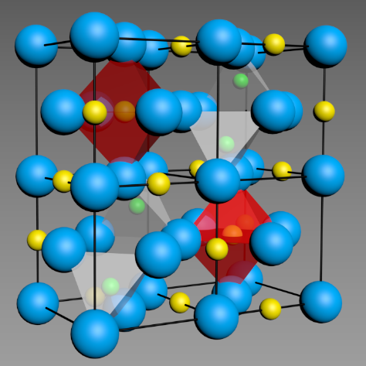

**Fig. S1. Schematic configuration of crystalline structure in NiCr2O4 spinel. Blue balls: O; yellow balls: Cr; green balls: Ni atoms.**

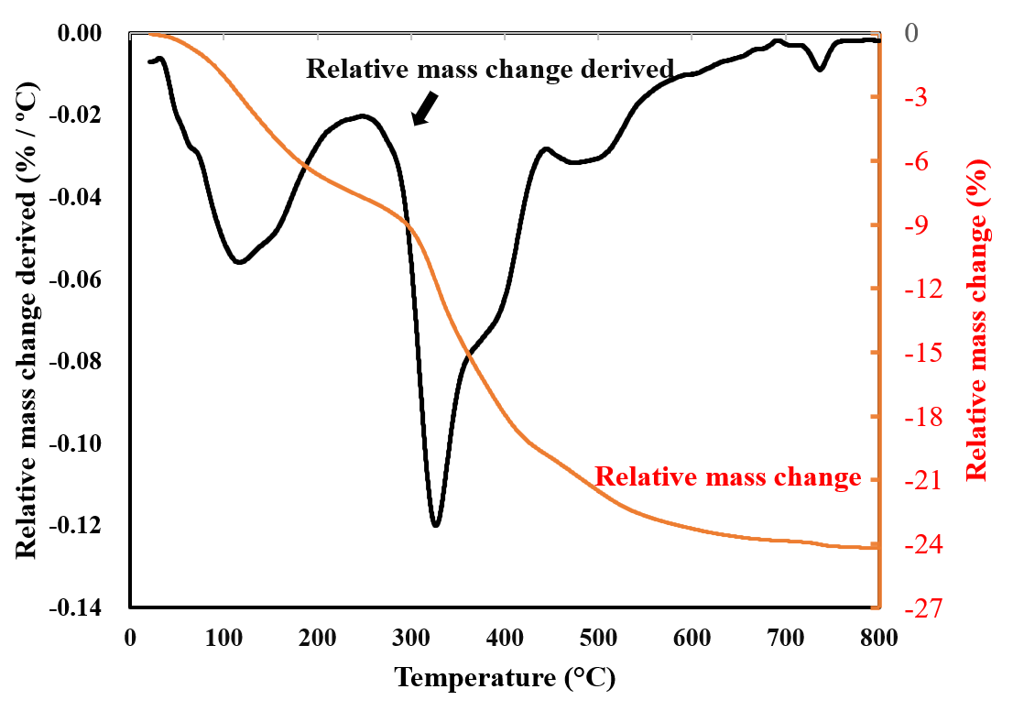

**Fig. S2. TGA/DTA curves of the dried powder heated up to 800°C at a heating rate of 10°C/min in an ambient atmosphere.**

|  |  |  |
| --- | --- | --- |
| **10 g/l**  **a)** | **20 g/l**  **b)** | **30 g/l**  **c)** |
| **40 g/l**  **d)** | **50 g/l**  **e)** | **f)** |

**Fig. S3. EDX elemental map of coating for different nano-oxide powders of a) 10, b) 20, c) 30, d) 40, and e) 50 g/L; O: red points; Cr: pink points; Ni: green points. f) The corresponding curve of elemental concentration in the coating.**

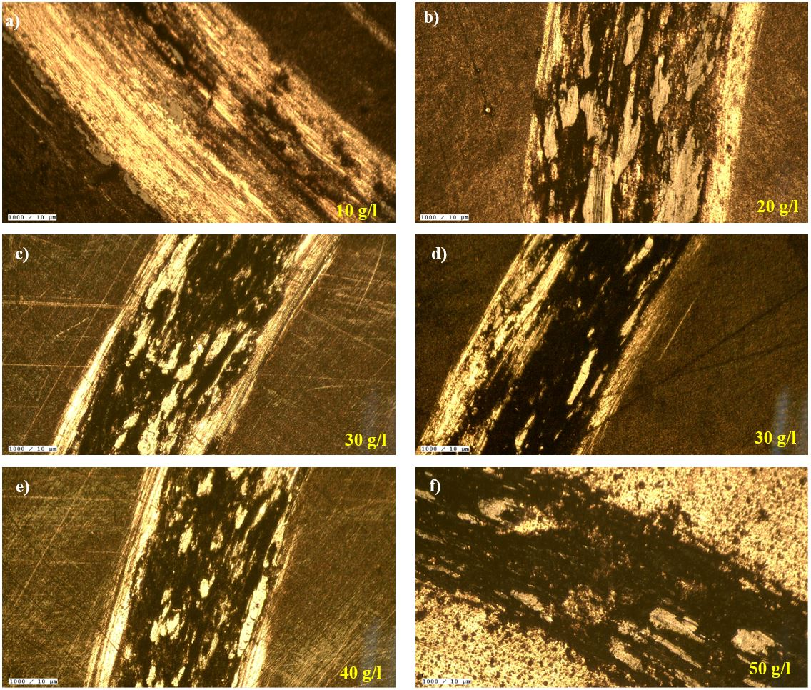

**Fig. S4.** **Optical images of the worn surfaces of the samples coated with different concentrations of Ni–Cr nano-oxide powder in the electrolyte: a) 0, b) 10, c) 20, d) 30, e) 40, and f) 50 g/L.**

**Table S1.** **Chemical composition of the substrate (plain carbon steel)** wt%

|  |  |  |  |  |  |  |  |  |  |
| --- | --- | --- | --- | --- | --- | --- | --- | --- | --- |
| C | Si | Mo | S | P | Ni | Cr | Mn | Cu | Fe |
| 0.112 | 0.125 | 0.007 | 0.030 | 0.004 | 0.063 | 0.078 | 0.295 | 0.028 | 99.02 |

**Table S2. Composition of the electrolyte in the electrolysis coating process**

|  |  |
| --- | --- |
| Composition and condition of the bath | Amount |
| Nickel Sulfate 6-water (NiSO4.6H2O) | 250 g/L |
| Nickel chloride (NiCl2) | 40 g/L |
| **Boric acid (H3BO3)** | 45 g/L |
| Sodium citrate (Na3C6H5O7) | 50 g/L |
| Sodium dodecyl sulfate (NaC12H25SO4) | 0.1 g/L |
| Current density | 0.12 A/dm2 |
| Temperature | 54°C |
| pH | 3.8–4 |
| Time | 60 min |

**Table S3. Electrochemical impedance parameters resulted from the fitting estimations of experimental results over the appropriate electrical equivalent circuit**

|  |  |  |  |  |  |  |  |  |  |  |
| --- | --- | --- | --- | --- | --- | --- | --- | --- | --- | --- |
| Sample | *R*s / (Ω·cm2) | CPE1 / (μF·cm−2) | *n*1 | *R*1 / (Ω·cm2) | CPE2 / (μF·cm−2) | *n*2 | *R*2 / (Ω·cm2) | CPE3 / (μF·cm−2) | *n*3 | *R*3 / (Ω·cm2) |
| Pure Ni | 30.15 | 0.00097 | 0.854 | 1080 | 0.044 | 0.918 | 740 | 0.0084 | 0.938 | 250 |
| 10 g/L | 33.81 | 0.00071 | 0.9201 | 1110 | 0.036 | 0.886 | 810 | 0.0031 | 0.744 | 280 |
| 20 g/L | 34.12 | 0.00033 | 0.902 | 1450 | 0.0277 | 0.944 | 950 | 0.0055 | 0.626 | 320 |
| 30 g/L | 49.4 | 0.00019 | 0.91 | 1850 | 0.31 | 0.741 | 1050 | 0.0065 | 0.932 | 350 |
| 40 g/L | 31.2 | 0.00049 | 0.887 | 1552 | 0.02 | 0.723 | 850 | 0.0071 | 0.941 | 295 |
| 50 g/L | 30 | 0.00021 | 0.826 | 2410 | 0.01 | 0.919 | 780 | 0.008 | 0.872 | 440 |