**Supplementary Information**

Solid Bi2O3-derived nanostructured metallic bismuth with high formate selectivity for the electrocatalytic reduction of CO2

Xiaoyan Wang1), Safeer Jan1), Zhiyong Wang1), and Xianbo Jin1,2)🖂

1) College of Chemistry and Molecular Sciences, Hubei Key Laboratory of Electrochemical Power Sources, Wuhan University, Wuhan 430061, China

2) Engineering Research Center of Organosilicon Compounds & Materials, Ministry of Education, Wuhan 430061, China

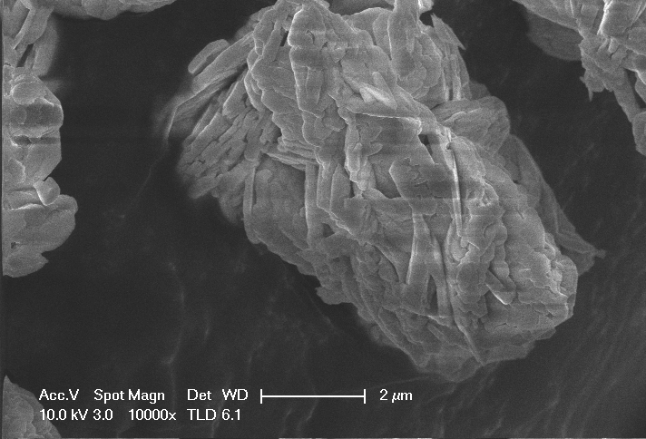

(a)

mBO

2 μm

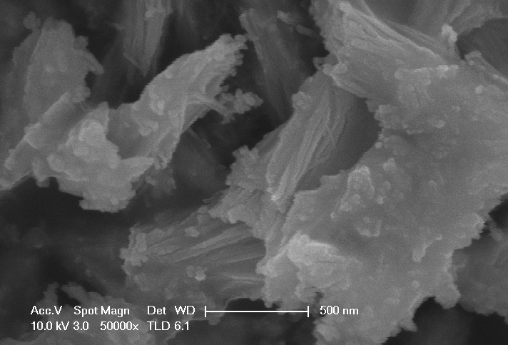

nB**O**

(b)

500 nm

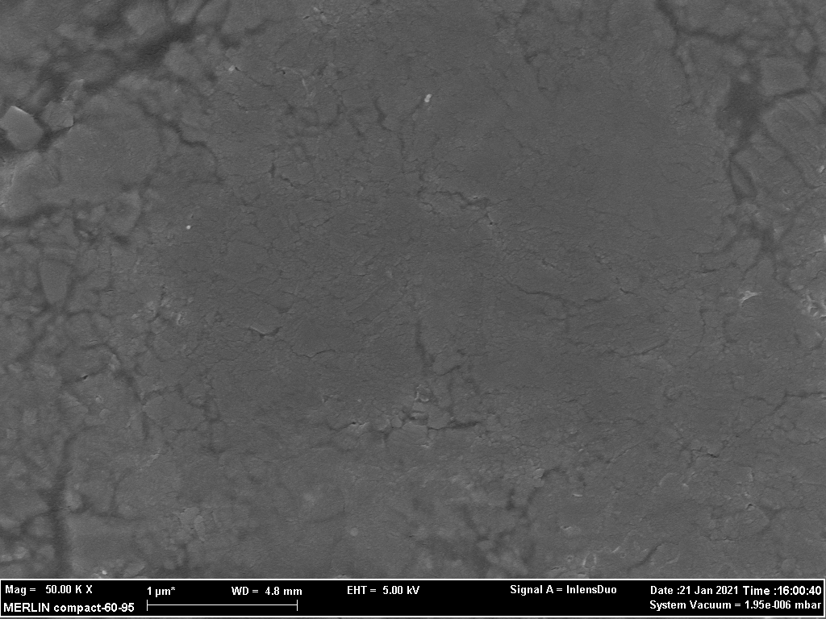

(c)

1 μm

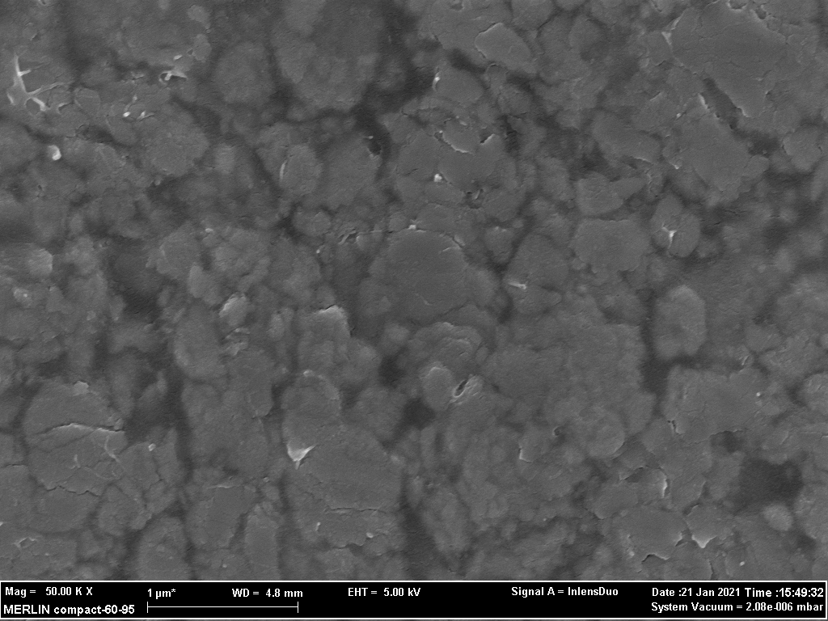

1 μm

(d)

Fig. S1. SEM images: (a) mBO; (b) nBO; (c) mBO membrane electrode; (d) nBO membrane electrod.



Total current densitytotal / mA cm-2

0

10

20

30

40

50

60

-0.6

-0.7

-0.8

-0.9

-1.0

-1.1

-1.2

mBO-nBo

nBO-nBo

Potential / V *vs*. RHE

Fig. S2. Total current density for the electrochemical CO2 reduction performance of different nBi catalysts.



Fig. S3. I-t curves for the electrochemical CO2 reduction performance of (a) nBO-nBi and (b) mBO-nBi catalysts.



Fig. S4. *I*–*t* curves (a) and the FEs of electrolytic products (b) for the electrochemical CO2 reduction performance of nBO.

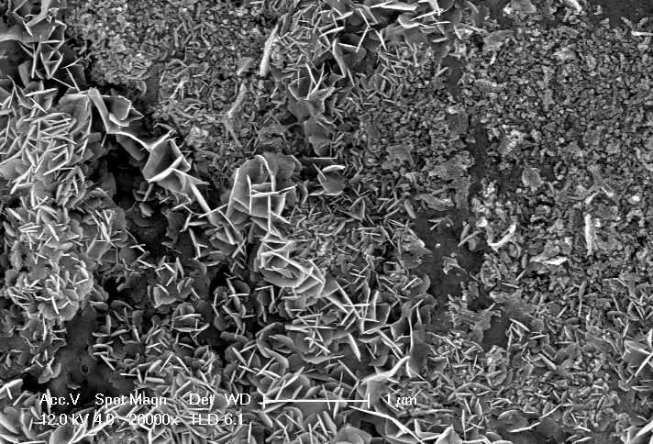

1 μm

(b)

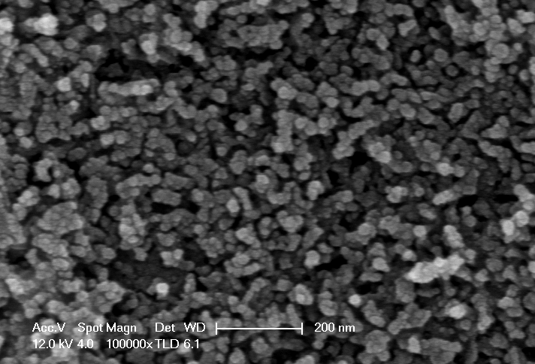

(c)

200 nm

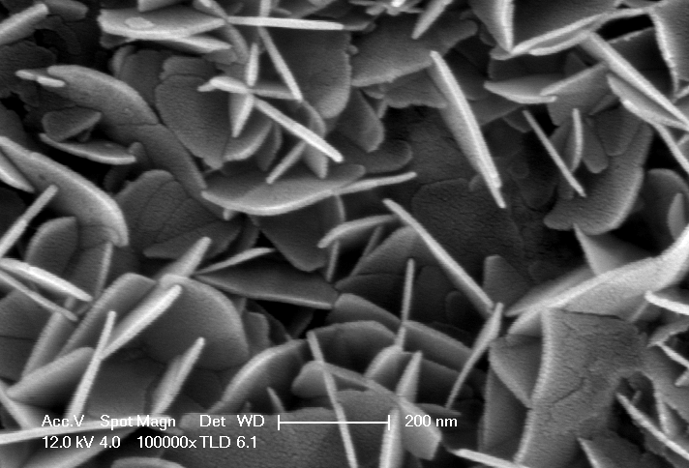

(d)

200 nm

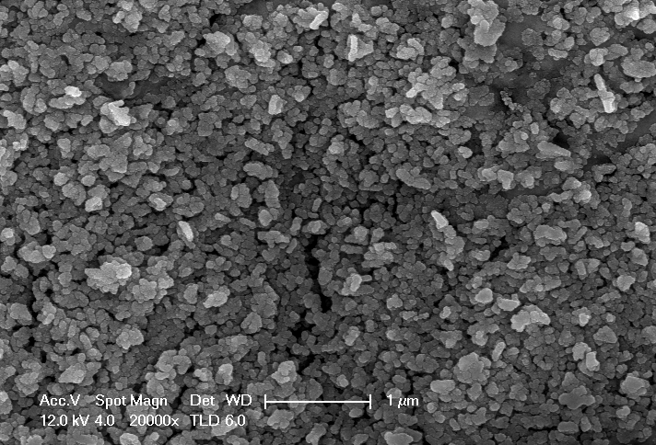

(e)

1 μm

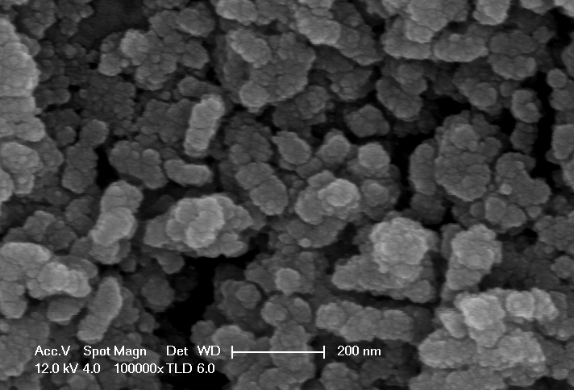

(f)

200 nm

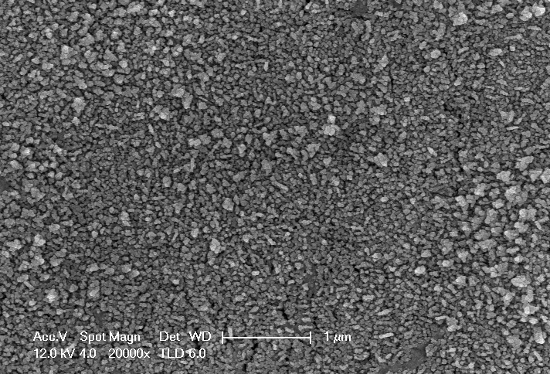

1 μm

(g)

80

70

60

50

40

10

30

20

2 *θ* / (°)

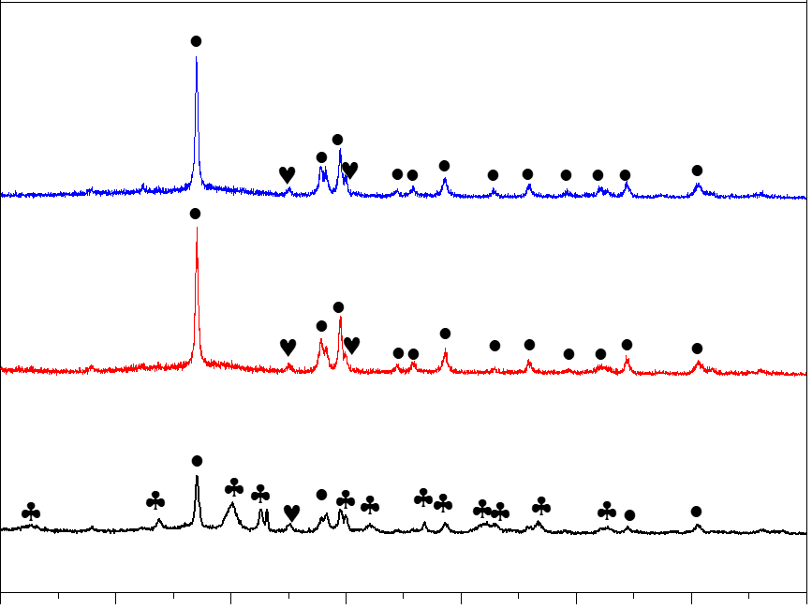

Intensity / a.u.

(a)

♣-Bi2O2CO3 •-Bi ♥-Ti

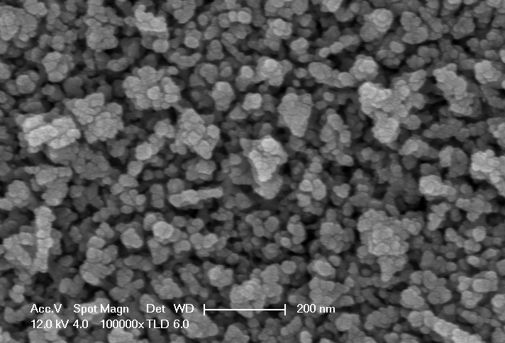

(h)

200 nm

-0.88 V

-0.78 V

-0.68 V

Fig. S5. (a) XRD patterns of nBO after the 2 hours electrolysis of CO2 at differernt potentials. (b-d) SEM images of nBO after electrolysis of CO2 at -0.68 V. (e-f) SEM images of nBO after electrolysis of CO2 at -0.78 V. (g-h) SEM images of nBO after electrolysis of CO2 at -0.88 V.

Table S1 Catalytic performance of various catalysts for CO2 reduction to formate.

|  |  |  |  |  |  |
| --- | --- | --- | --- | --- | --- |
| Catalysts | Electrolyte | Potential  (V vs. RHE) | jformate  (mA⋅cm-2) | FEformate  (%) | Reference |
| Bi-Doped SnO nanosheets | 0.1 M KHCO3 | -1.7 V vs. Ag/AgCl | About 11 | 93% | [1] |
| Sn0.80Bi0.20@Bi-SnOx | 0.5 M KHCO3 | -0.88 | 20.9 | 95.8 | [2] |
| Nano architectured dendritic  Bi | 0.5 M KHCO3 | -0.82 | 18.8 | 98% | [3] |
| Bi NP@ MWCNT | 0.5 M KHCO3 | -1.5 V vs. SCE | 10.2 | 95.2% | [4] |
| Cu@Bi nanocone | 0.5 M KHCO3 | -0.95 V | 30.9 | 96.9% | [5] |
| Bi nanoparticles  Embedded in N-doped porous carbon | 0.1 M KHCO3 | -1.5 V vs. SCE | 14.4 | 92% | [6] |
| Bi-MWCNT-COOH composite | 0.5 M KHCO3 | -0.76 | About 6.8 | 91.7% | [7] |
| Cu nanowire bridged Bi nanosheet | 0.5 M KHCO3 | -0.86 | About 6.2 | 87% | [8] |
| AgBi-500 | 0.1 M KHCO3 | -0.7 | 12.5 | 94.3% | [9] |
| Bi nanoparticles/graphene | 0.5 M KHCO3 | -0.97 | 22.5 | 92.1% | [10] |
| Wavy SnO2 | 0.5 M KHCO3 | -1.0 | 22 | 87.4% | [11] |
| Ultrathin SnS nanosheets | 0.5 M KHCO3 | -1.1 | 18.9 | 82.1% | [12] |
| Bismuth derivatives from Bi2S3 | 0.5 M KHCO3 | -1.0 | About 7 | 80% | [13] |
| mBO-nBi | 0.5 M KHCO3 | -0.78  -0.98 | 7.3  34.3 | 97.6%  93% | This work |
| nBO-nBi | 0.5 M KHCO3 | -0.73  -0.88 | 7.5  23.1 | 97.2%  91% | This work |

**References**

[1] X.W. An, S.S. Li, A. Yoshida, T. Yu, Z.D. Wang, X.G. Hao, A. Abudula, and G.Q. Guan, Bi-doped SnO nanosheets supported on Cu foam for electrochemical reduction of CO2 to HCOOH. *ACS Appl. Mater. Interfaces*, 11(2019), No. 45, p. 42114.

[2] Q. Yang, Q.L. Wu, Y. Liu, S.P. Luo, X.T. Wu, X.X. Zhao, H.Y. Zou, B.H. Long, W. Chen, Y.J. Liao, L.X. Li, P.K. Shen, L. Duan, and Z.W. Quan, Novel Bi-doped amorphous SnOx nanoshells for efficient electrochemical CO2 reduction into formate at low overpotentials, *Adv. Mater.*, 32(2020), No. 36, p. 2002822.

[3] M.Y. Fan, S. Prabhudev, S. Garbarino, J.L. Qiao, G.A. Botton, D.A. Harrington, A.C. Tavares, and D. Guay, Uncovering the nature of electroactive sites in nano architectured dendritic Bi for highly efficient CO2 electroreduction to formate, *Appl. Catal. B*, 274(2020), p. 119031.

[4] X. Zhang, J. Fu, Y.Y. Liu, X.D. Zhou, and J.L. Qiao, Bismuth anchored on MWCNTs with controlled ultrafine nanosize enables high-efficient electrochemical reduction of carbon dioxide to formate fuel, *ACS Sustain. Chem. Eng.*, 8 (2020), No.12, p. 4871.

[5] F.H. Zhang, C.Z. Chen, S.L. Yan, J.H. Zhong, B. Zhang, and Z.M. Cheng, Cu@Bi nanocone induced efficient reduction of CO2 to formate with high current density, *Appl. Catal. A: Gen.*, 598(2020), p. 117545.

[6] D.B. Zhang, Z.T. Tao, F.L. Feng, B.B. He, W. Zhou, J. Sun, J.M. Xu, Q. Wang, and L. Zhao, High efficiency and selectivity from synergy: Bi nanoparticles embedded in nitrogen doped porous carbon for electrochemical reduction of CO2 to formate, *Electrochim. Acta*, 334(2020), p. 135563.

[7] Q.Q. Li, X.R. Zhang, X.D. Zhou, Q.Y. Li, H.Q. Wang, J. Yi, Y.Y. Liu, and J.J. Zhang, Simply and effectively electrodepositing Bi-MWCNT-COOH composite on Cu electrode for efficient electrocatalytic CO2 reduction to produce HCOOH, *J. CO2 Util.*, 37(2020), p. 106.

[8] L. Li, F.F. Cai, F.X.Y. Qi, and D.K. Ma, Cu nanowire bridged Bi nanosheet arrays for efficient electrochemical CO2 reduction toward formate, *J. Alloys Compd.*, 841(2020), p. 155789

[9] J.H. Zhou, K. Yuan, L. Zhou, Y. Guo, M.Y. Luo, X.Y. Guo, Q.Y. Meng, and Y.W. Zhang, Boosting electrochemical reduction of CO2 at a low overpotential by amorphous Ag-Bi-S-O decorated Bi(0) nanocrystals, *Angew. Chem. Int. Ed.*, 58(2019), No. 40, p.14197.

[10] D. Wu, W.Y. Chen, X.W. Wang, X.Z. Fu, and J.L. Luo, Metal-support interaction enhanced electrochemical reduction of CO2 to formate between graphene and Bi nanoparticles, *J. CO2 Util.*, 37(2020), p. 353.

[11] Z. Chen, T.T. Fan, Y.Q. Zhang, J. Xiao, M.R. Gao, N.Q. Duan, J.W. Zhang, J.H. Li, Q.X. Liu, X.D. Yi, and J.L. Luo, Wavy SnO2 catalyzed simultaneous reinforcement of carbon dioxide adsorption and activation towards electrochemical conversion of CO2 to HCOOH, *Appl. Catal. B*, 261(2020), 118243.

[12] H.L. Chen, J.X. Chen, J.C. Si, Y. Hou, Q. Zheng, B. Yang, Z.J. Li, L.G. Gao, L.C. Lei, Z.H. Wen, and X.L. Feng, Ultrathin tin monosulfide nanosheets with the exposed (001) plane for efficient electrocatalytic conversion of CO2 into formate, *Chem. Sci.*, 11(2020), No. 15, p. 3952.

[13] Y.T. Wang, L. Cheng, J.Z. Liu, C.Q. Xiao, B. Zhang, Q.G. Xiong, T. Zhang, Z.L. Jiang, H. Jiang, Y.H. Zhu, Y.H. Li, and C.Z. Li, Rich bismuth‐oxygen bonds in bismuth derivatives from Bi2S3 pre‐catalysts promote the electrochemical reduction of CO2, *ChemElectroChem*, 7(2020), No. 13, p. 2864.