Supplementary Information
Effect of deformation parameters on the austenite dynamic recrystallization behavior of a eutectoid pearlite rail steel
Haibo Feng¹⁾, Shaohua Li¹⁾, Kexiao Wang¹⁾, Junheng Gao^{1,2),},Shuize Wang^{1,2),}, Haitao Zhao^{1,2)}, Zhenyu Han³⁾, Yong Deng³⁾, Yuhe Huang^{1,2)}, and Xinping Mao^{1,2),}
1) Institute for Carbon Neutrality, University of Science and Technology Beijing, Beijing 100083, China
2) Institute for Steel Sustainable Technology, Liaoning Academy of Materials, Shenyang 110004, China
3) Pangang Group Panzhihua Iron and Steel Research Institute Co. Ltd., Panzhihua 617000, China

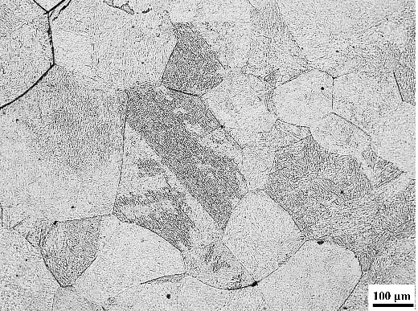
Fig. S1. Microstructure of the sample annealed at 1250°C for 300 s.

