**Supplementary Information**

**Quickly obtaining densely dispersed coherent particles in steel matrix and its related mechanical property**

*Xiaoxiao Wang and Qingsong Huang***[1]🖂**

School of Chemical Engineering, Sichuan University, Chengdu 610065, China

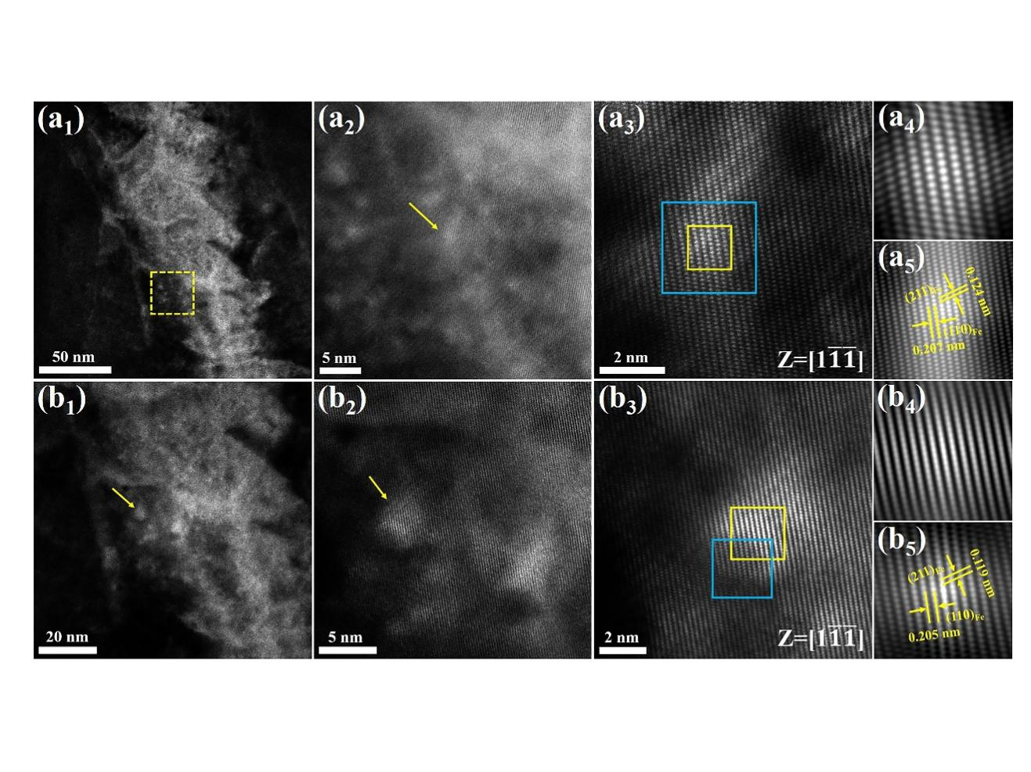

**Fig. S1.** STEM images of second phase nanoparticle: (a1) STEM image of the as-cast Fe–TYMO steel; (a2) STEM image of a particle with size of about 2.72 nm in the yellow dashed line box in (a1); (a3) atomic-resolution STEM image of the particle pointed by the yellow arrow in (a2), with the [1] zone axis; (a4, a5) cross correlation images from yellow square (particle position) and blue square in (a3), respectively; (b1) STEM image of the as-cast Fe–TYMO steel; (b2) STEM image of a particle with size of about 5.05 nm pointed by the yellow arrow in (b1); (b3) atomic-resolution STEM image of the particle pointed by the yellow arrow in (b2), with the [1] zone axis; (b4, b5) cross correlation images from yellow square (particle position) and blue square in (b3), respectively.

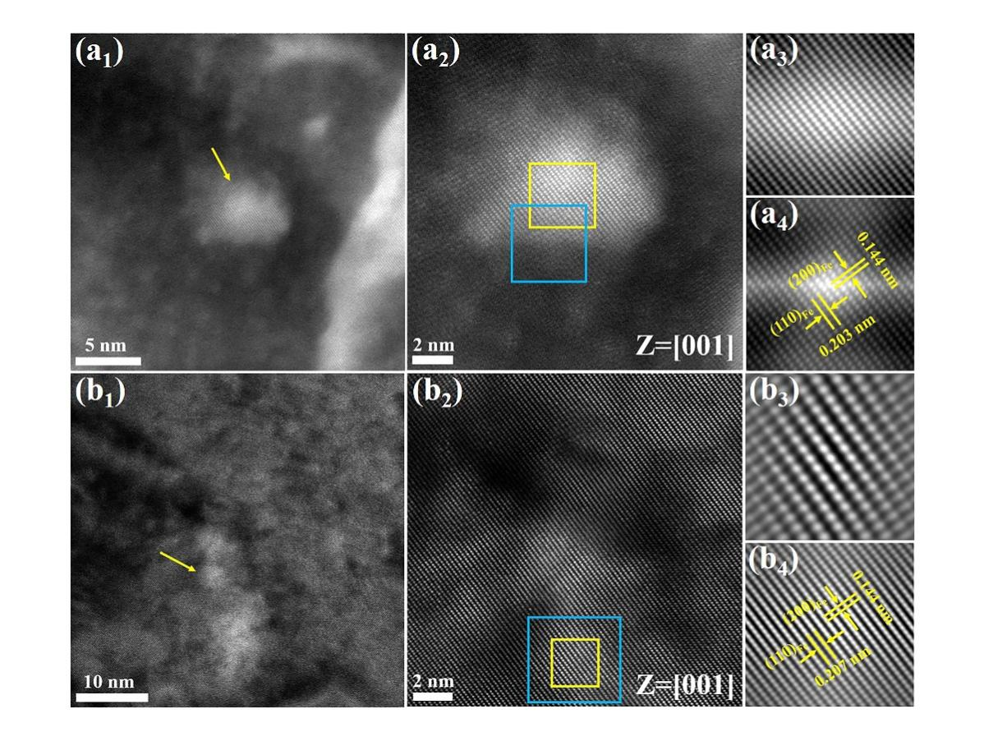

**Fig. S2.** STEM images of second phase nanoparticle in rolled (700℃,10 s-1) Fe-TYMO steel: (a1) STEM image of a particle with size of about 7.62 nm; (a2) atomic-resolution STEM image of the particle pointed by the yellow arrow in (a1), with the [001] zone axis; (a3, a4) cross correlation images from yellow square (particle position) and blue square in (a2), respectively; (b1) STEM image of a particle with size of about 3.91 nm; (b2) atomic-resolution STEM image of the particle pointed by the yellow arrow in (b1), with the [001] zone axis; (b3, b4) cross correlation images from yellow square (particle position) and blue square in (b2), respectively.

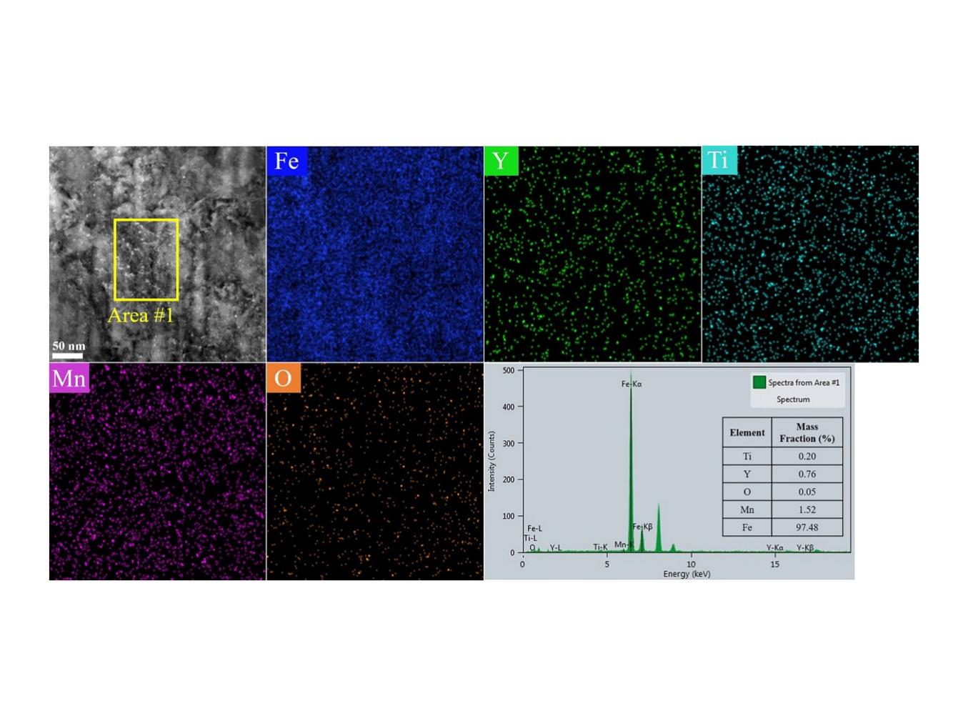

**Fig. S3.** HAADF and EDS mapping images of as-cast Fe–TYMO steel sample. The mass fraction of Fe, Y, Ti, Mn, and O element corresponds to the selected region area #1.

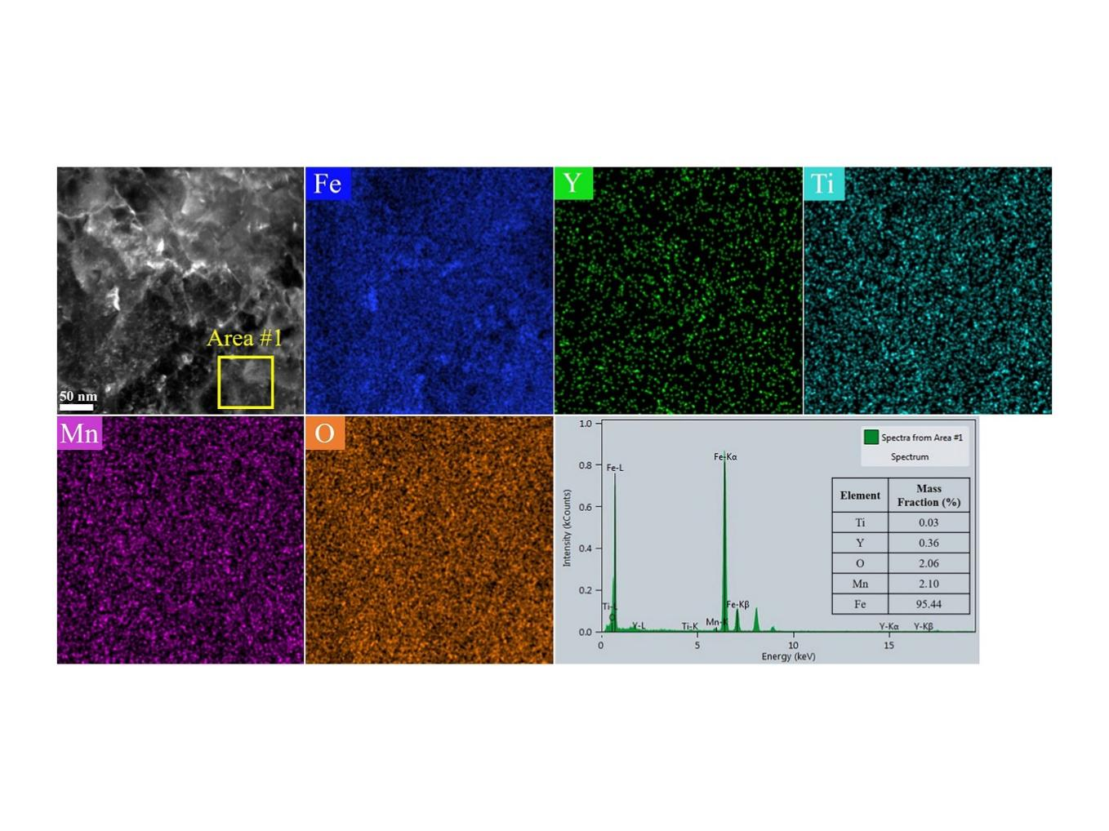

**Fig. S4.** HAADF and EDS mapping images of rolled (700℃, 10 s-1) Fe–TYMO steel sample at strain rate of 10 s-1 at 700 ℃. The mass fraction of Fe, Y, Ti, Mn, and O element corresponds to the selected region area #1.

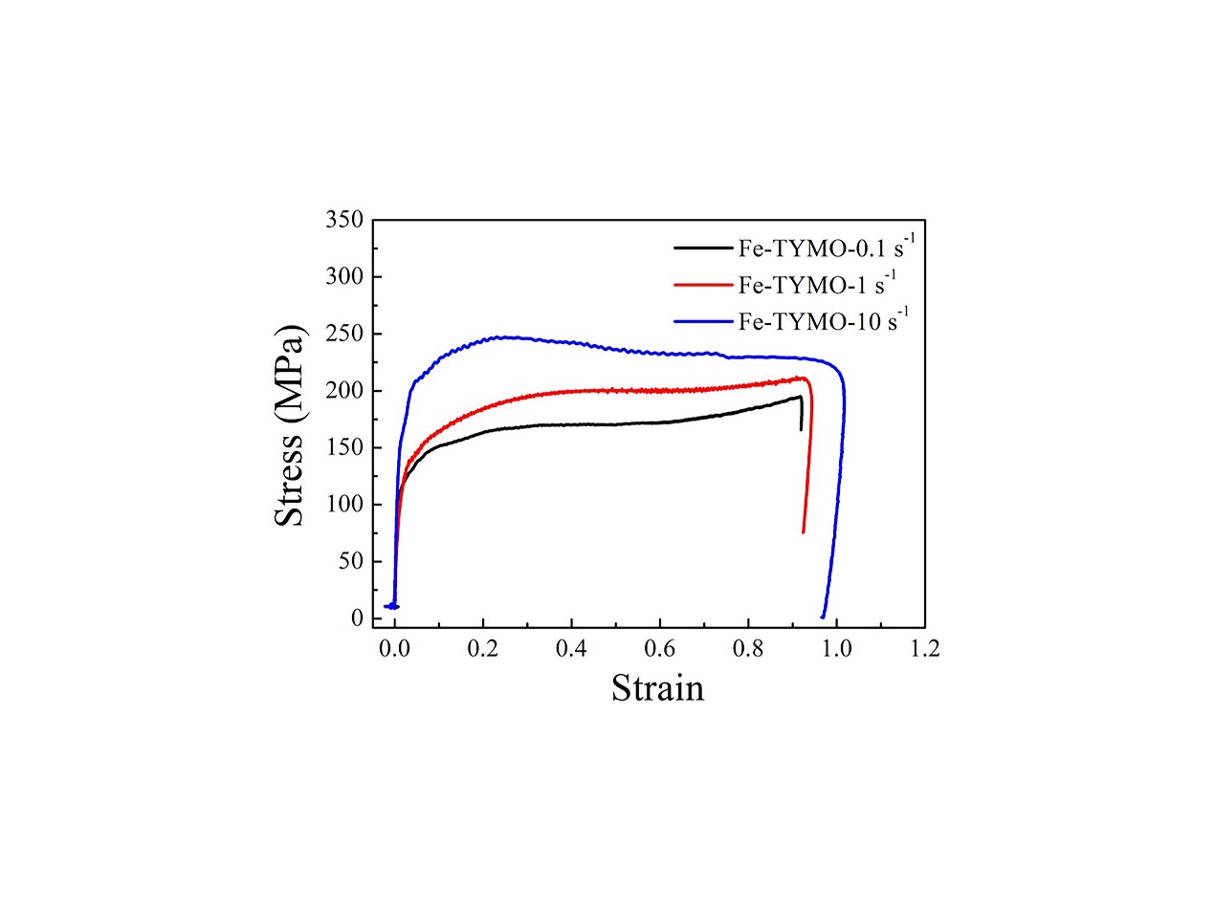

**Fig. S5.** Warm-Rolling stress-strain curves of Fe–TYMO steel at strain rate of 0.1, 1, and 10 s-1 at 700℃.

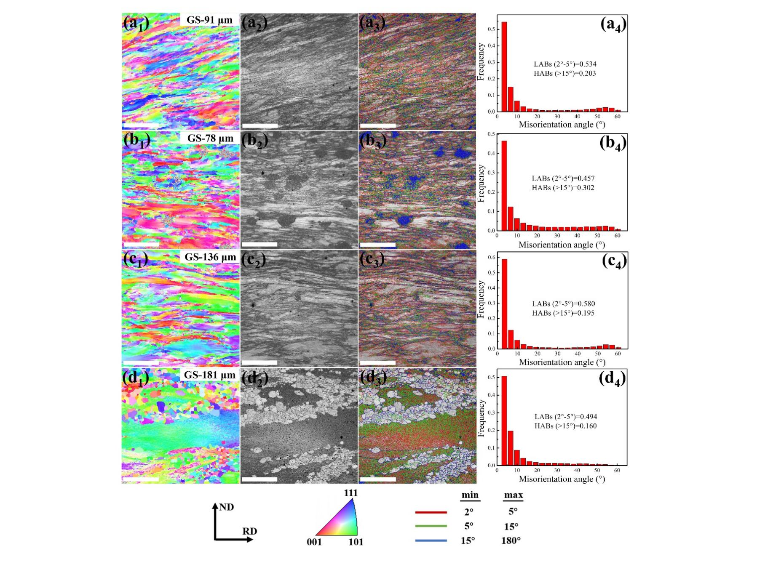

**Fig. S6.** Electron back-scattering diffraction (EBSD) IPF (inverse pole figure) maps and GB (grains boundary) maps and misorientation angle histogram of rolled Fe–TYMO steel and rolled pure ferrite steel grains: (a) Fe–TYMO steel (700℃, 0.1 s-1); (b) Fe–TYMO steel (700℃, 1 s-1); (c) Fe–TYMO steel (700℃, 10 s-1); (d) pure ferrite steel (700℃, 10 s-1). All the scale bars in the maps represent 300 μm.

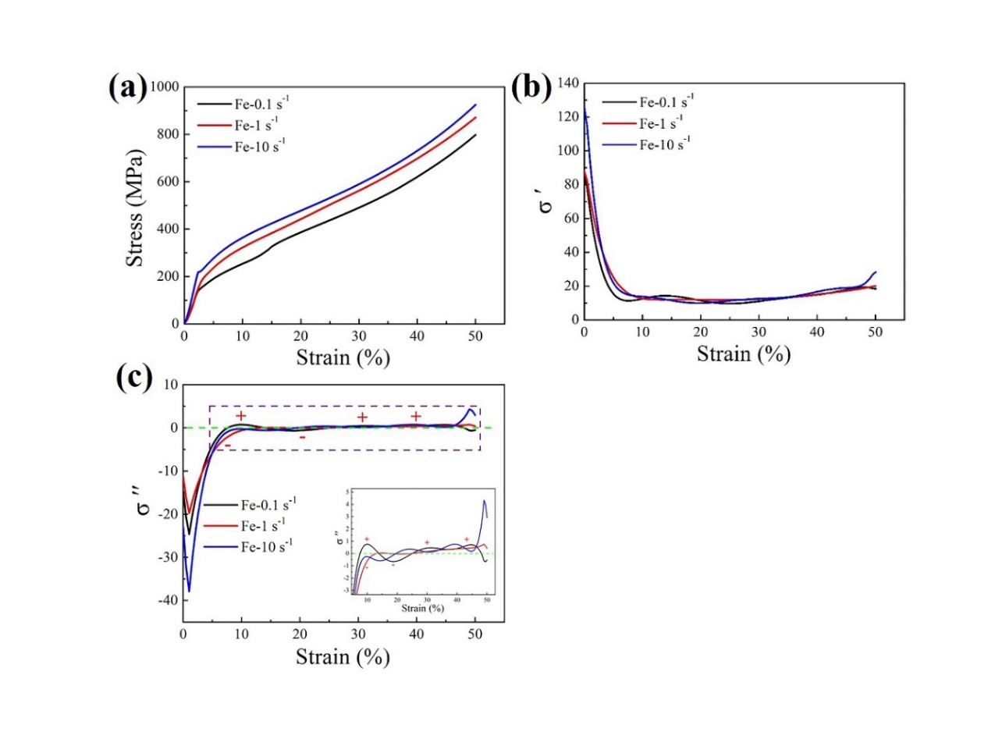

**Fig. S7.** (a)Compressive engineering stress–strain curve of the rolled pure ferrite steel at strain rate of 0.1, 1, and 10 s-1 under 700℃ respectively;(b) the first derivative of the compressive engineering stress–strain curve of the rolled pure ferrite steel; (c) the second derivative of the compressive engineering stress–strain curve of the rolled pure ferrite steel (the inset shows enlargement of the selected area in the purple dashed box).

**Table S1.** Compressive yield strength (*σ*0.2) and compressive strength (*σ*m) of as-cast, as-rolled, and as-annealed (annealed at 700℃ for 20 min) Fe–TYMO steels

|  |  |  |  |  |  |  |  |
| --- | --- | --- | --- | --- | --- | --- | --- |
| Compression test | As-cast | As-rolled | | | As-annealed | | |
| 0.1 s-1 | 1 s-1 | 10 s-1 | 0.1 s-1 | 1 s-1 | 10 s-1 |
| *σ*0.2 (MPa) | 303 | 397 | 514 | 569 | 425 | 415 | 385 |
| *σ*m (MPa) | 1037 | 1202 | 1220 | 1258 | 1216 | 1174 | 1112 |

1. **🖂** Corresponding author: Qingsong Huang E-mail: qshuang@scu.edu.cn