Supplementary Information

Fabrication of Gd₂O₃-doped CeO₂ thin films through DC reactive sputtering and their application in solid oxide fuel cells
Fuyuan Liang*, Jiaran Yang*, Haiqing Wang, and Junwei Wu
School of Materials Science and Engineering, Harbin Institute of Technology (Shenzhen), Shenzhen, 518055, China
*These authors contributed equally to this work.
Corresponding author: Junwei Wu E-mail: junwei.wu@hit.edu.cn

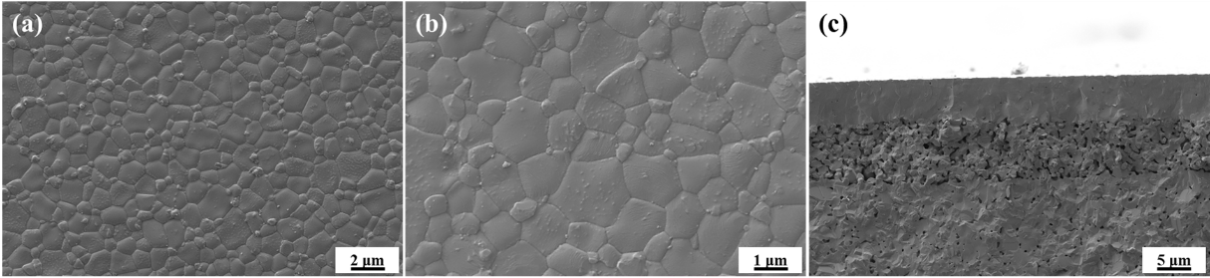

Fig. S1. Surface (a, b) and cross-sectional (c) morphology of NiO–YSZ/YSZ half cells.

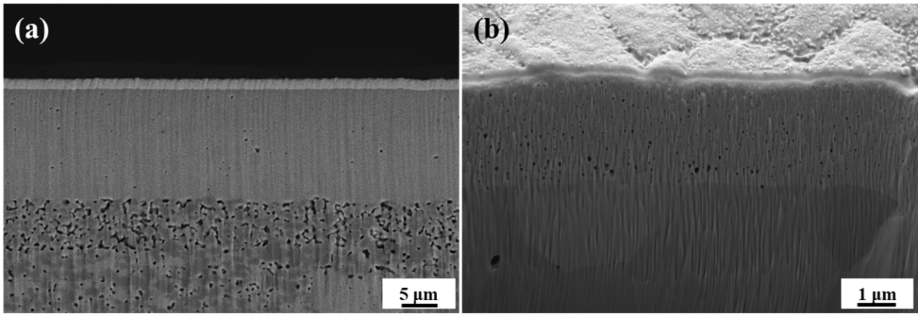
Fig. S2. Cross-sectional morphology of the annealed GDC films: (a) BSD mode; (b) SE2 mode.

Table S1. Ohmic resistance R_{s} and polarization resistance R_{p} of GDC-MS and GDC-SP tested at 800, 750, and 700℃
Cell | 800℃ |  | 750℃ |  | 700℃
 | R_{s} / (Ω·cm²) | R_{p} / (Ω·cm²) | R_{s} / (Ω·cm²) | R_{p} / (Ω·cm²) | R_{s} / (Ω·cm²) | R_{p} / (Ω·cm²)
GDC-MS | 0.170 | 0.313 | 0.214 | 0.423 | 0.295 | 0.655
GDC-SP | 0.278 | 0.521 | 0.381 | 0.699 | 0.569 | 1.091

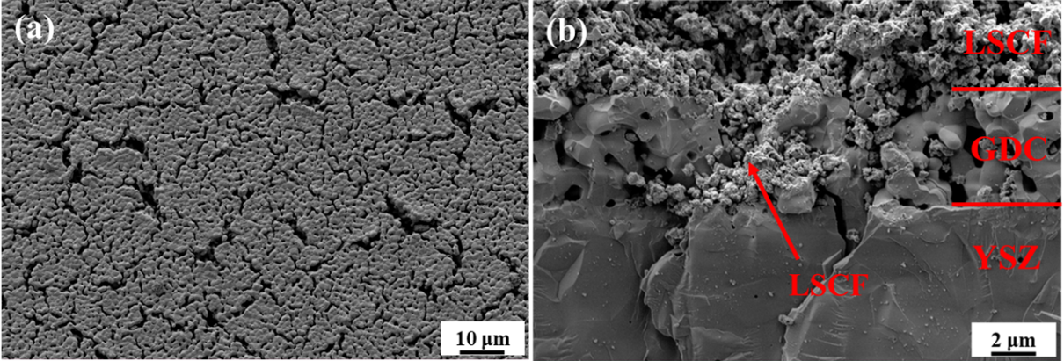
Fig. S3. Surface morphology of screen-printed GDC buffer layer (a) and cross-sectional morphology after sintering of LSCF cathode (b).

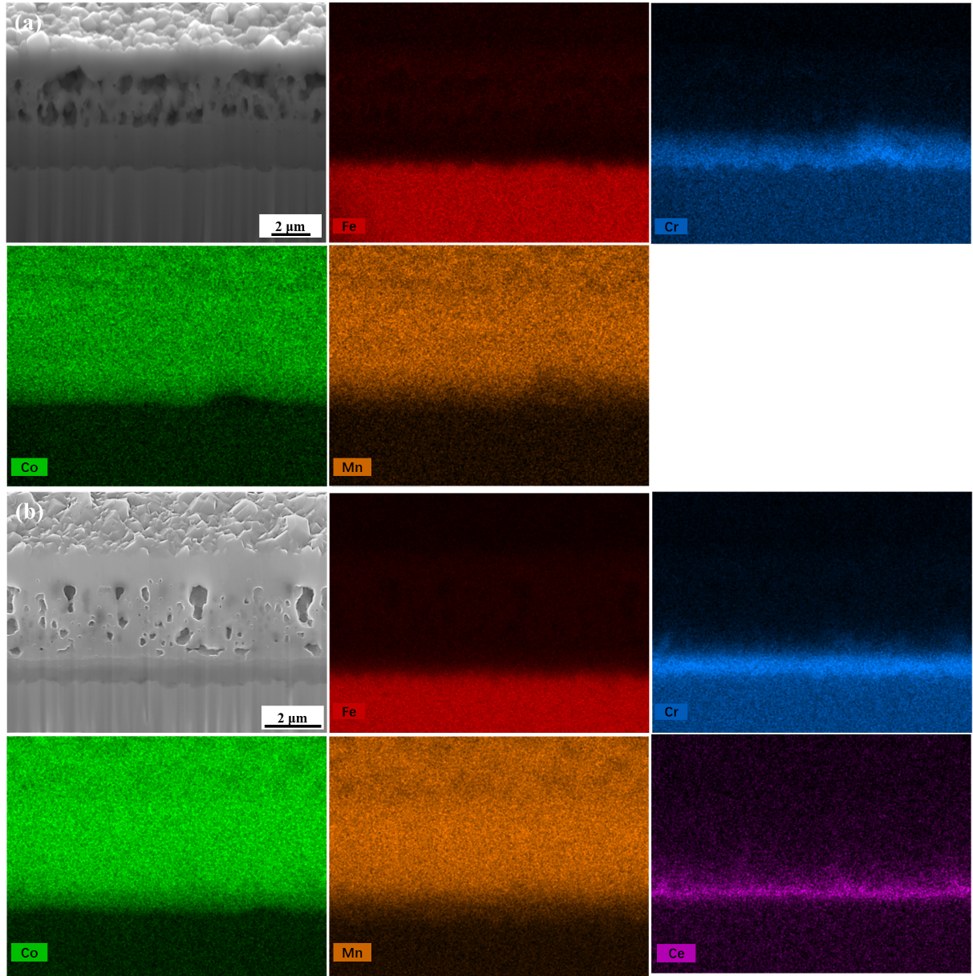
Fig. S4. Cross-sectional SEM-EDX of (a) SUS441/MCO and (b) SUS441/GDC/MCO.

Fig. S5. ASR of SUS441/MCO annealed in air as a function of time.

