Supplementary Information
Highly mass activity electrocatalysts with ultralow Pt loading on carbon black for hydrogen evolution reaction
Shaorou Ke*, Yajing Zhao*, Xin Min, Yanghong Li, Ruiyu Mi, Yangai Liu, Xiaowen Wu, Minghao Fang, and Zhaohui Huang
Engineering Research Center of Ministry of Education for Geological Carbon Storage and Low Carbon Utilization of Resources, Beijing Key Laboratory of Materials Utilization of Nonmetallic Minerals and Solid Wasters, National Laboratory of Mineral Materials, School of Materials Science and Technology, China University of Geosciences (Beijing), Beijing 100083, China
*These authors contributed equally to this work.
Corresponding author: Xin Min E-mail: minx@cugb.edu.cn
Fig. S1. XRD patterns obtained under different calcination temperatures in 5 mmol/L H₂PtCl₆ solution.
Fig. S2. XRD patterns obtained under different calcination temperatures in 10 mmol/L H₂PtCl₆ solution.
Fig. S3. XRD patterns obtained under different calcination temperatures in 15 mmol/L H₂PtCl₆ solution.
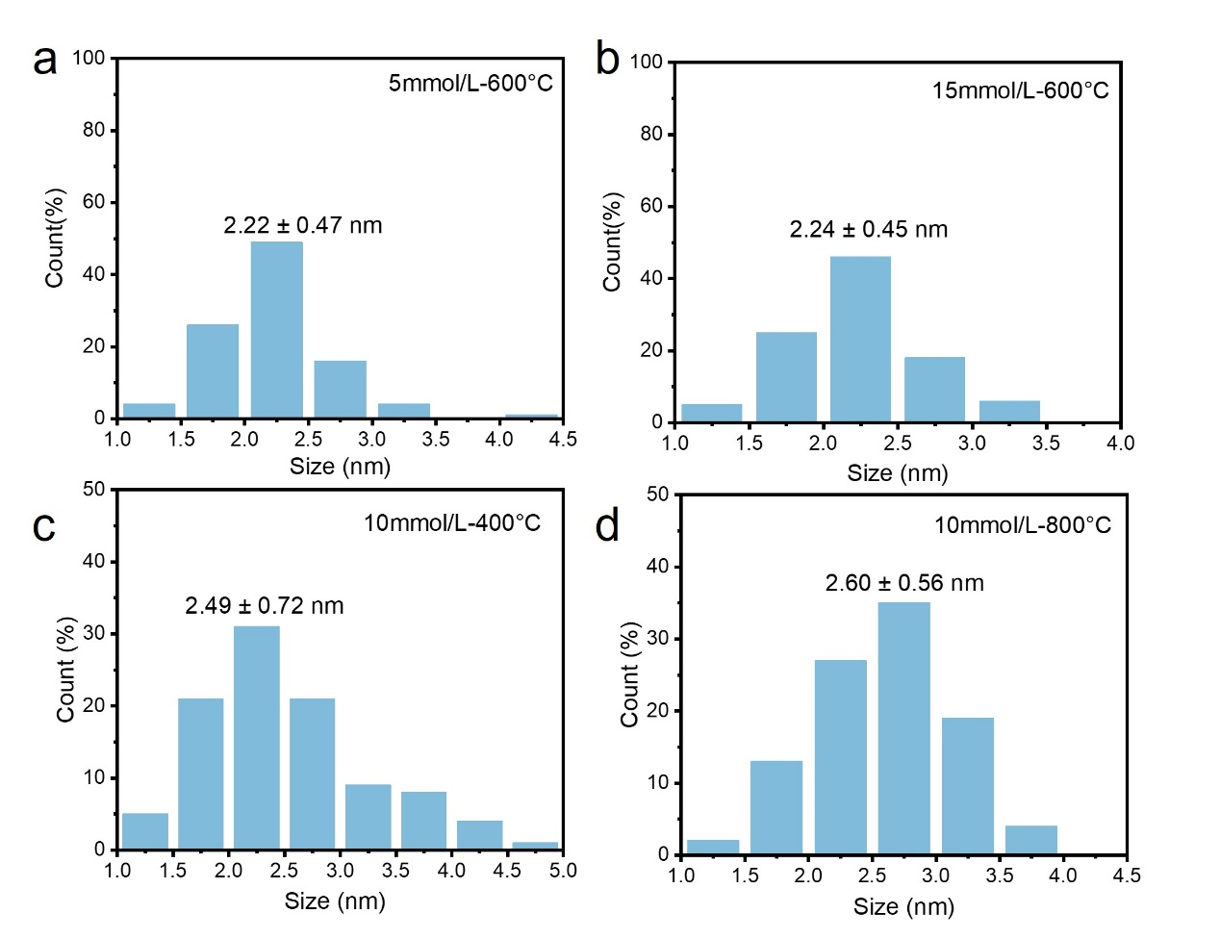
Fig. S4. Pt NPs size distribution: (a) concentration, 5 mmol/L; temperature, 600°C; (b) concentration, 15 mmol/L; temperature, 600°C; (c) concentration, 10 mmol/L; temperature, 400°C; (d) concentration, 10 mmol/L; temperature, 800°C.
Fig. S5. XPS spectra of carbon black: (a) C 1s and (b) O 1s.

Fig. S6. XPS spectra of self-prepared Pt/C under 5 mmol/L H₂PtCl₆ solution and 400°C:
(a) C 1s and (b) Pt 4f.

Fig. S7. XPS spectra of self-prepared Pt/C under 10 mmol/L H₂PtCl₆ solution and 400°C:
(a) C 1s and (b) Pt 4f.

Fig. S8. XPS spectra of self-prepared Pt/C under 15 mmol/L H₂PtCl₆ solution and 400°C: (a) C 1s and (b) Pt 4f.
Fig. S9. XPS spectra of self-prepared Pt/C under 5 mmol/L H₂PtCl₆ solution and 600°C: (a) C 1s and (b) Pt 4f.

Fig. S10. XPS spectra of self-prepared Pt/C under 15 mmol/L H₂PtCl₆ solution and 600°C. (a) C 1s and (b) Pt 4f.

Fig. S11. XPS spectra of self-prepared Pt/C under 5 mmol/L H₂PtCl₆ solution and 800°C: (a) C 1s and (b) Pt 4f.
Fig. S12. XPS spectra of self-prepared Pt/C under 10 mmol/L H₂PtCl₆ solution and 800°C: (a) C 1s and (b) Pt 4f.

Fig. S13. XPS spectra of self-prepared Pt/C under 15 mmol/L H₂PtCl₆ solution and 800°C: (a) C 1s and (b) Pt 4f.

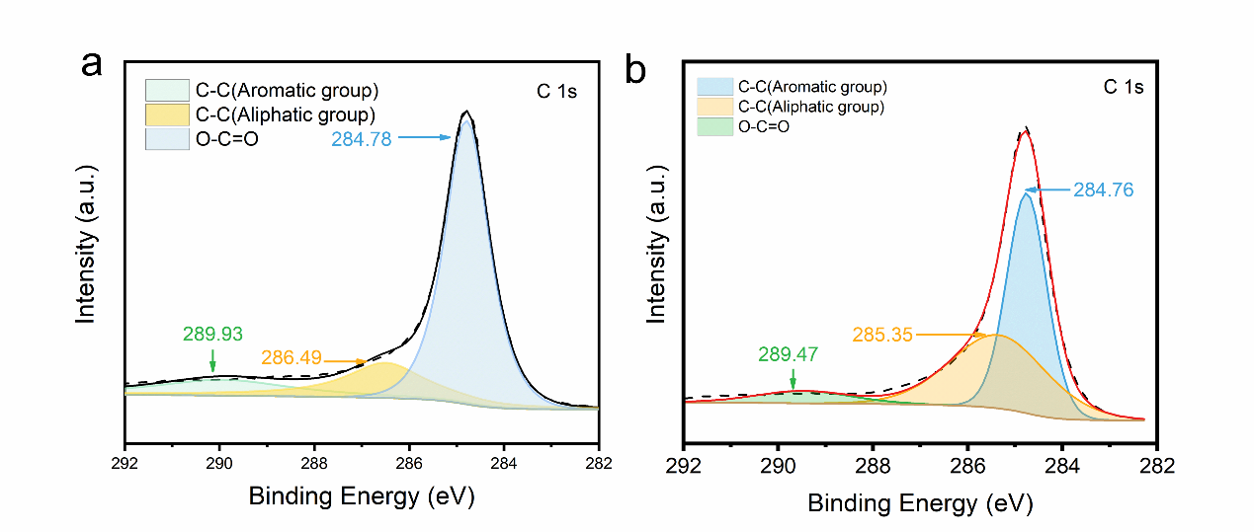
Fig. S14. C 1s XPS spectra of (a) commercial Pt/C and (b) carbon black.
Fig. S15. Pt 4f XPS spectra of commercial Pt/C.
Fig. S16. Morphology and structure of self-prepared Pt/C under 5 mmol/L H₂PtCl₆ solution and 400°C: (a) TEM image; (b) HRTEM image.
Fig. S17. Morphology and structure of self-prepared Pt/C under 10 mmol/L H₂PtCl₆ solution and 400°C: (a) TEM image; (b) HRTEM image.
Fig. S18. Morphology and structure of self-prepared Pt/C under 15 mmol/L H₂PtCl₆ solution and 400°C: (a) TEM image; (b) HRTEM image.
Fig. S19. Morphology and structure of self-prepared Pt/C under 5 mmol/L H₂PtCl₆ solution and 600°C: (a) TEM image; (b) HRTEM image.
Fig. S20. Morphology and structure of self-prepared Pt/C under 15 mmol/L H₂PtCl₆ solution and 600°C: (a) TEM image; (b) HRTEM image.

Fig. S21. Morphology and structure of self-prepared Pt/C under 5 mmol/L H₂PtCl₆ solution and 800°C: (a) TEM image; (b) HRTEM image.
Fig. S22. Morphology and structure of self-prepared Pt/C under 10 mmol/L H₂PtCl₆ solution and 800°C: (a) TEM image; (b) HRTEM image.
Fig. S23. Morphology and structure of self-prepared Pt/C under 15 mmol/L H₂PtCl₆ solution and 800°C: (a) TEM image; (b) HRTEM image.

Fig. S24. Raman spectra of (a) self-prepared Pt/C under 10 mmol/L H₂PtCl₆ solution and 400°C and
(b) self-prepared Pt/C under 10 mmol/L H₂PtCl₆ solution and 800°C.
Fig. S25. Polarization curves of self-prepared Pt/C and commercial Pt/C at a scan rate of 10 mV s⁻¹.
Fig. S26. Tafel slopes obtained from the polarization curves in Fig. S25.
Fig. S27. Mass activity of all self-prepared Pt/C and commercial Pt/C.
Fig. S28. Mass activity of self-prepared Pt/C and commercial Pt/C.
Fig. S29. Double layer capacitance (C_{dl}) of the self-prepared Pt/C.

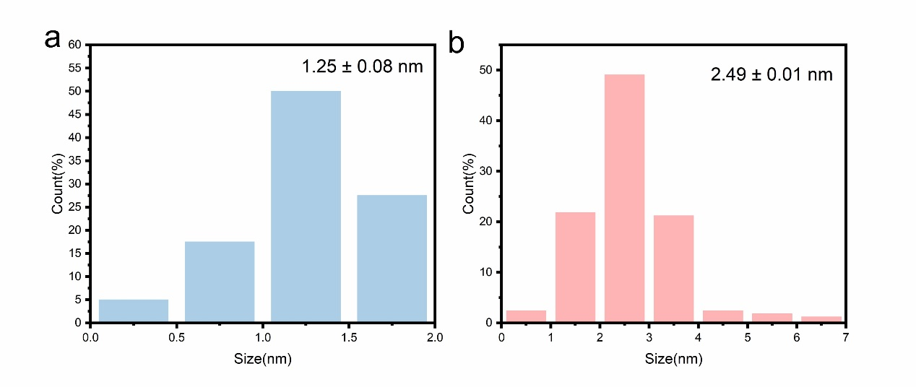
Fig. S30. Size distribution of (a) self-prepared Pt/C and (b) commercial Pt/C after chronoamperometry.

Fig. S31. Optimized calculation model.

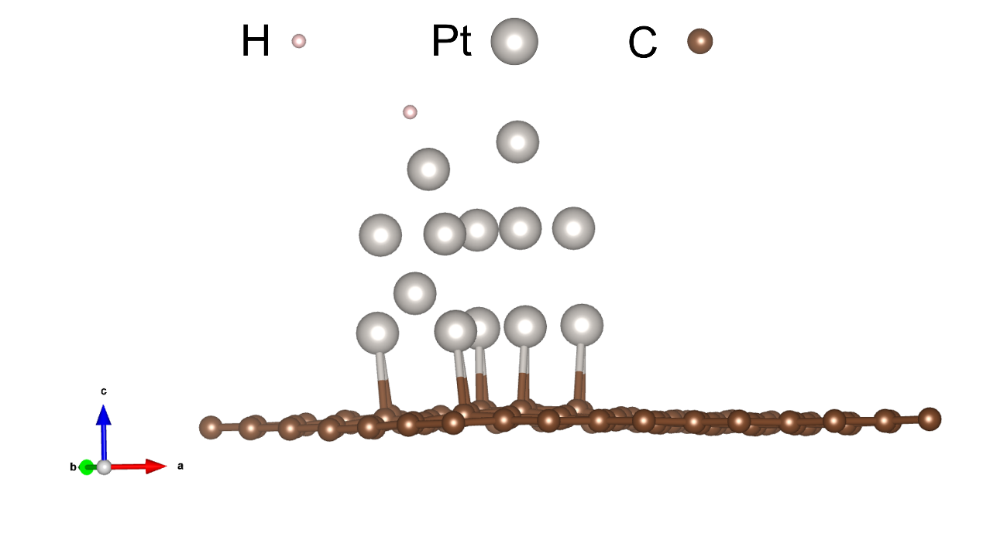
Fig. S32. Model after adsorption of H.

Table S1. Mass fraction of Pt wt%
Sample | Mass fraction
5-600 | 5.23
10-600 | 6.82
15-600 | 8.00
10-400 | 4.1
10-800 | 10.6

Table S2. Area ratio of different valence states of Pt in each sample
Sample | Pt⁰ / % | Pt²⁺ / % | Pt⁴⁺ / %
5-200 | --- | 58.7 | 41.7
5-400 | 42.83 | 29.73 | 27.44
5-600 | 64.70 | 33.30 | ---
5-800 | 62.08 | 37.92 | ---
10-400 | 52.12 | 28.05 | 19.83
10-600 | 61.70 | 38.30 | ---
10-800 | 59.46 | 40.54 | 1.80
15-200 | --- | 73.78 | 26.02
15-300 | --- | 83.20 | 16.80
15-400 | 45.11 | 35.42 | 19.47
15-600 | 68.97 | 31.03 | ----
15-800 | 59.46 | 40.54 | ---

Table S3. Area ratio of different valence states of Pt in each sample

Sample | Pt load capacity | Overpotential at 10 mV cm⁻² / mV | Tafel slope / (mV dec⁻¹) | Reference
Pt@PCM | 0.669wt% | 105 | 65.3 | [1]
Pt/N-VG-5 | 3.1 μg cm^{–2} | 42 | 52.2 | [2]
Pt@NHPCP | 3.6wt% | 57 | 27 | [3]
Pt-STA-CB | 1.2045wt% | 34 | 27.9 | [4]
PC-PtN4-600 | 18.70wt% | 31 | 42 | [5]
Pt1/NNGF | 4.96 μg cm^{–2} | 23 | 29.1 | [6]
Pt/f-MWCNTs | 0.323wt% | 43.9 | 30 | [7]
PtNC/S-C | 2.55 μg cm^{–2} | 11 | 24 | [8]
Pt/NP-CNTs | 1.4wt% | 25 | 28 | [9]
Pt/HPC-14.1 | 14.1wt% | 24 | 33 | [10]
3%Pt/WC/C10 | 1wt% | 85 | 42 | [11]
Pt NPs/DPC | 9.53wt% | 30 | 31 | [12]
Pt-CNTs | - | 41 | 48 | [13]
Pt1/NMC | 10 μg cm^{–2} (2.54%) | 29 | 26 | [14]
Pt/C₂N | - | 33 | 53 | [15]
400-SWNT/Pt | 0.3wt% | 27 | 38 | [16]
Pt@Pd NFs/rGO | - | 56 | 39 | [17]
Pt-4CDs/G | 1.02wt% | 36 | 28 | [18]
PtNi/[C–Si] | 6.85wt% | 161 | 136 | [19]

Table S4. C–C bond length near the carbon loaded with Pt (bond number according to Fig. S31)
Bond number | Bond length / Å | Bond number | Bond length / Å
1 | 1.446 | 12 | 1.429
2 | 1.445 | 13 | 1.440
3 | 1.438 | 14 | 1.438
4 | 1.435 | 15 | 1.438
5 | 1.436 | 16 | 1.440
6 | 1.446 | 17 | 1.433
7 | 1.455 | 18 | 1.434
8 | 1.403 | 19 | 1.430
9 | 1.420 | 20 | 1.439
10 | 1.433 | 21 | 1.441
11 | 1.456 | 22 | 1.442

References
[1] H.B. Zhang, P.F. An, W. Zhou, et al., Dynamic traction of lattice-confined platinum atoms into mesoporous carbon matrix for hydrogen evolution reaction, Sci. Adv., 4(2018), No. 1, art. No. eaao6657.
[2] H.Z. Yang, Z.J. Yang, D.W. Chu, et al., Highly dispersed platinum deposited on nitrogen-doped vertical graphene array for efficient electrochemical hydrogen evolution, 2D Mater., 9(2022), No. 4, art. No. 045011.
[3] J. Ying, G.P. Jiang, Z.P. Cano, L. Han, X.Y. Yang, and Z.W. Chen, Nitrogen-doped hollow porous carbon polyhedrons embedded with highly dispersed Pt nanoparticles as a highly efficient and stable hydrogen evolution electrocatalyst, Nano Energy, 40(2017), p. 88.
[4] T.R. Zhang, S.T. Weng, X.F. Wang, et al., Platinum atomic clusters embedded in polyoxometalates-carbon black as an efficient and durable catalyst for hydrogen evolution reaction, J. Colloid Interface Sci., 624(2022), p. 704.
[5] J.L. Kang, M.J. Wang, C.B. Lu, et al., Platinum atoms and nanoparticles embedded porous carbons for hydrogen evolution reaction, Materials, 13(2020), No. 7, art. No. 1513.
[6] J.S. Xu, R. Li, R.G. Zeng, et al., Platinum single atoms supported on nanoarray-structured nitrogen-doped graphite foil with enhanced catalytic performance for hydrogen evolution reaction, ACS Appl. Mater. Interfaces, 12(2020), No. 34, p. 38106.
[7] J.P. Ji, Y.P. Zhang, L.B. Tang, et al., Platinum single-atom and cluster anchored on functionalized MWCNTs with ultrahigh mass efficiency for electrocatalytic hydrogen evolution, Nano Energy, 63(2019), art. No. 103849.
[8] Q.Q. Yan, D.X. Wu, S.Q. Chu, et al., Reversing the charge transfer between platinum and sulfur-doped carbon support for electrocatalytic hydrogen evolution, Nat. Commun., 10(2019), No. 1, art. No. 4977.
[9] J.X. Han, C.H. Gong, C. He, P.R. He, J. Zhang, and Z.G. Zhang, Sub-1 nm Pt nanoclusters on N and P co-doped carbon nanotubes for the electrocatalytic hydrogen evolution reaction, J. Mater. Chem. A, 10(2022), No. 31, p. 16403.
[10] M.X. Song, Y.H. Song, H. Li, et al., Sucrose leavening-induced hierarchically porous carbon enhanced the hydrogen evolution reaction performance of Pt nanoparticles, Electrochim. Acta, 320(2019), art. No. 134603.
[11] X.D. Wei and N. Li, Tungsten carbide/carbon composites coated with little platinum nano particles derived from the redox reaction between in-situ synthesized WC_{1−x} and chloroplatinic acid as the electrocatalyst for hydrogen evolution reaction, Appl. Surf. Sci., 463(2019), p. 1154.
[12] X.R. Liu, K.J. Wang, Y.C. Li, et al., Ultrafine Pt nanoparticles embedded in defective porous carbon for efficient hydrogen evolution reaction, J. Alloys Compd., 968(2023), art. No. 171970.
[13] W.W. Zhong, W.G. Tu, Z.P. Wang, et al., Ultralow-temperature assisted synthesis of single platinum atoms anchored on carbon nanotubes for efficiently electrocatalytic acidic hydrogen evolution, J. Energy Chem., 51(2020), p. 280.
[14] H.H. Wei, H.B. Wu, K. Huang, et al., Ultralow-temperature photochemical synthesis of atomically dispersed Pt catalysts for the hydrogen evolution reaction, Chem. Sci., 10(2019), No. 9, p. 2830.
[15] X.Y. Zhou, Q.H. Zhang, X.S. Luo, et al., Drop-coated C₂N electrode for hydrogen evolution reaction, Mater. Lett., 309(2022), art. No. 131428.
[16] M. Tavakkoli, N. Holmberg, R. Kronberg, et al., Electrochemical activation of single-walled carbon nanotubes with pseudo-atomic-scale platinum for the hydrogen evolution reaction, ACS Catal., 7(2017), No. 5, p. 3121.
[17] X.X. Lin, A.J. Wang, K.M. Fang, J.H. Yuan, and J.J. Feng, One-pot seedless aqueous synthesis of reduced graphene oxide (rGO)-supported core–shell Pt@Pd nanoflowers as advanced catalysts for oxygen reduction and hydrogen evolution, ACS Sustainable Chem. Eng., 5(2017), No. 10, p. 8675.
[18] H. Xiao, M. Bai, M. Zhao, et al., Interfacial carbon dots introduced distribution-structure modulation of Pt loading on graphene towards enhanced electrocatalytic hydrogen evolution reaction, J. Colloid Interface Sci., 656(2024), p. 214.
[19] M.N. Elsodany, M.A.A. Rahim, N.H. Shalaby, and M.A. Sultan, Nickel and/or platinum modified crystalline silicon–carbon composites and their electrochemical behavior towards the hydrogen evolution reaction, J. Appl. Electrochem., 54(2024), No. 3, p. 531.

