**Supplementary Information**

**Enhanced properties of stone coal-based composite phase change materials for thermal energy storage**

*Baoshan Xie*1,2), *Huan Ma*1), *Chuanchang Li*1,2),🖂, *and Jian Chen*1,2)

1) Key Laboratory of Renewable Energy Electric-Technology of Hunan Province, School of Energy and Power Engineering, Changsha University of Science and Technology, Changsha 410114, China

2) State Key Laboratory of Disaster Prevention and Reduction for Power Grid, Changsha University of Science and Technology, Changsha 410114, China

🖂 Corresponding author: Chuanchang Li E-mail: chuanchangli@126.com

**Effect of roasting and acid leaching on crystal structure**

Fig. S1(a) is the XRD patterns of the SCs matrix materials under different roasting temperatures and times before leaching. Fig. S1(b) is the corresponding matrix materials after leaching. These XRD patterns are similar for each sample and the intensity of characteristic peaks are not changed so obvious. It indicates that different roasting conditions and acid leaching treatment had little effect on the crystal structure of stone coal. That is because the main peaks in XRD were characteristic peaks of SiO2, and the crystal structure of SiO2 in stone coal is difficult to be affected.

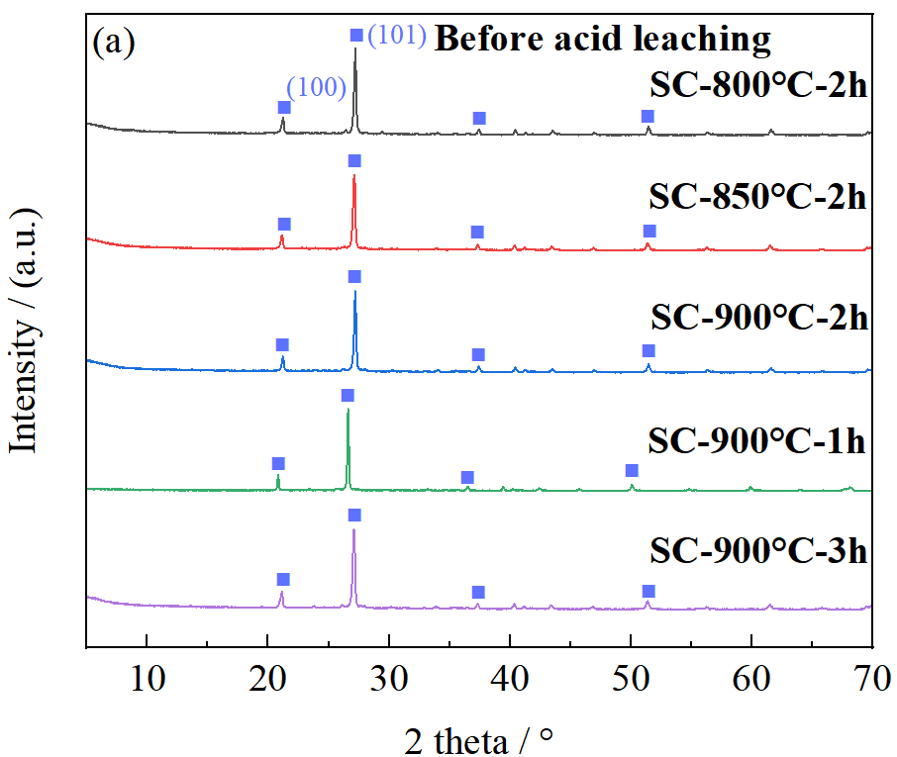 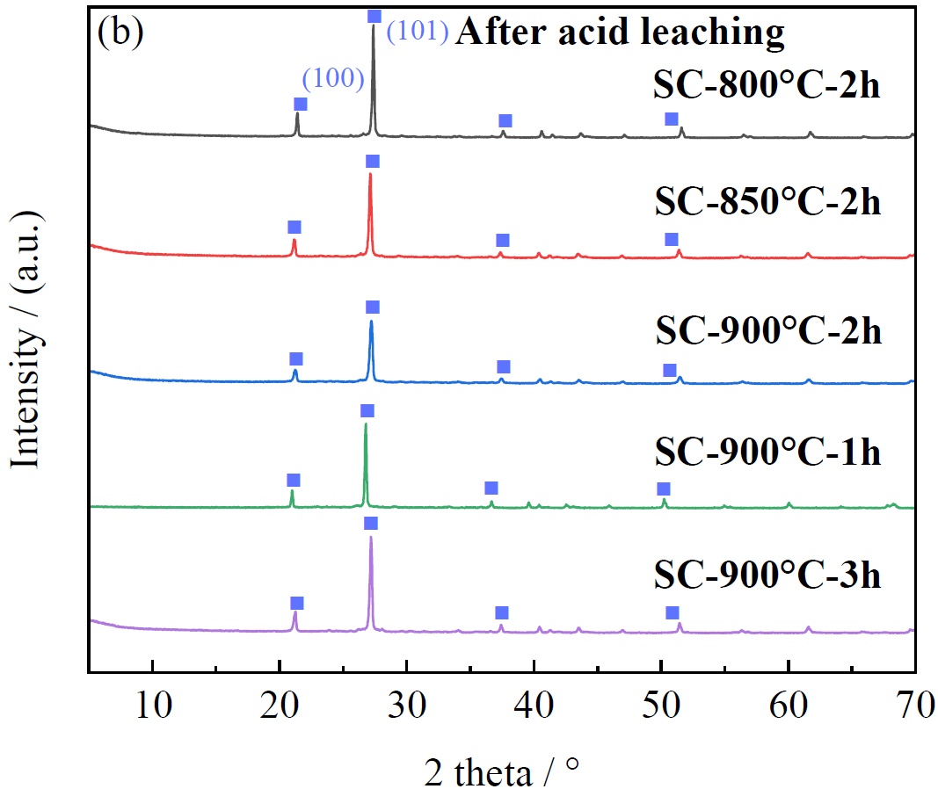

**Fig. S1**. XRD patterns of (a) SC under different roasted temperatures and times before acid leaching; (b) roasted SC after acid leaching.

Fig. S2(a) is the FTIR analysis of the stone coal-based matrix after roasting. It can be seen that the higher the roasting temperature at the same roasting time, the wider the peak of the FTIR curve at 1088 and 3427 cm−1 were. When the roasting temperature was 900 °C, the wider the peak of the FTIR curve at 1088 cm−1 with the increase of the roasting time. This was because the higher the roasting temperature or the longer the calcination time, the higher the degree of destruction of the silica tetrahedral structure in stone coal [1]. It can also be seen in Fig. S2(b) that acid leaching also widens the peak at 1088 cm−1 relative to Fig. S2(a), indicating that acid leaching can also play a role in destroying the structure.

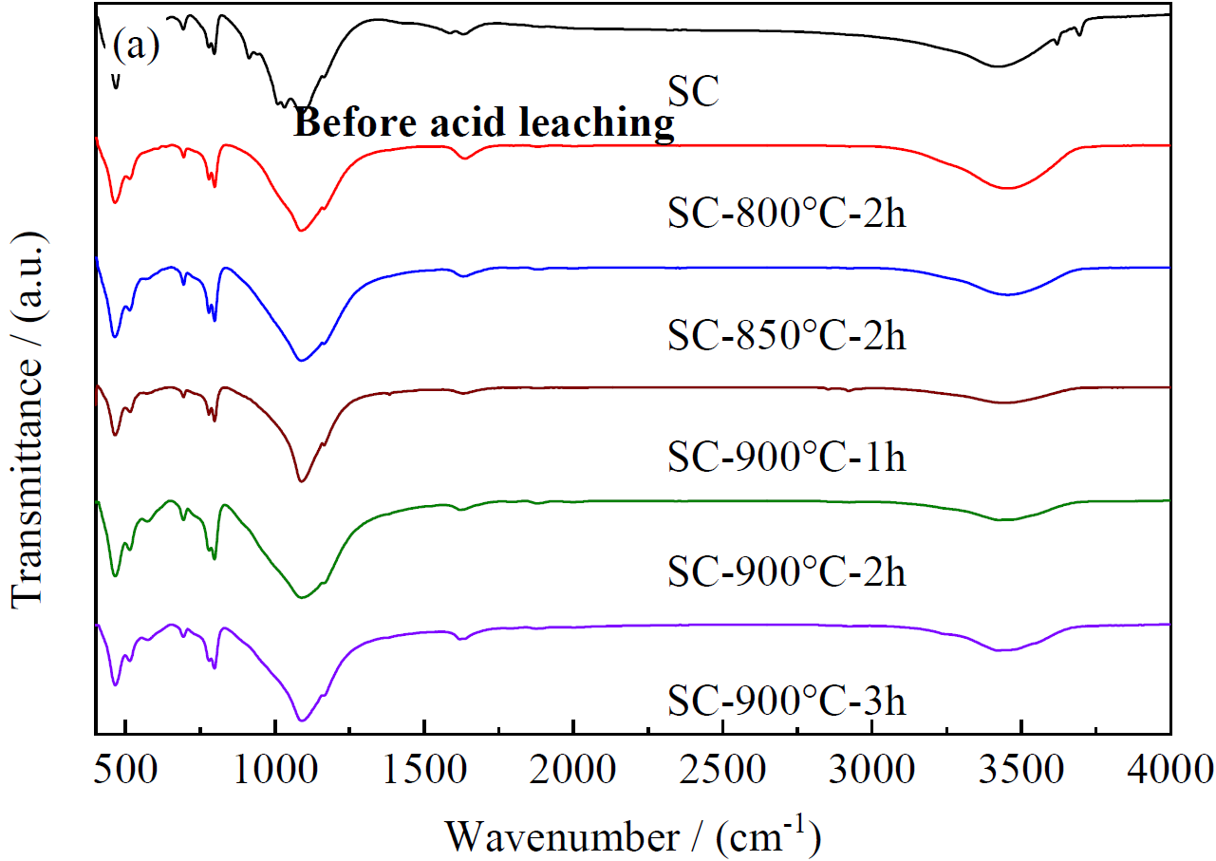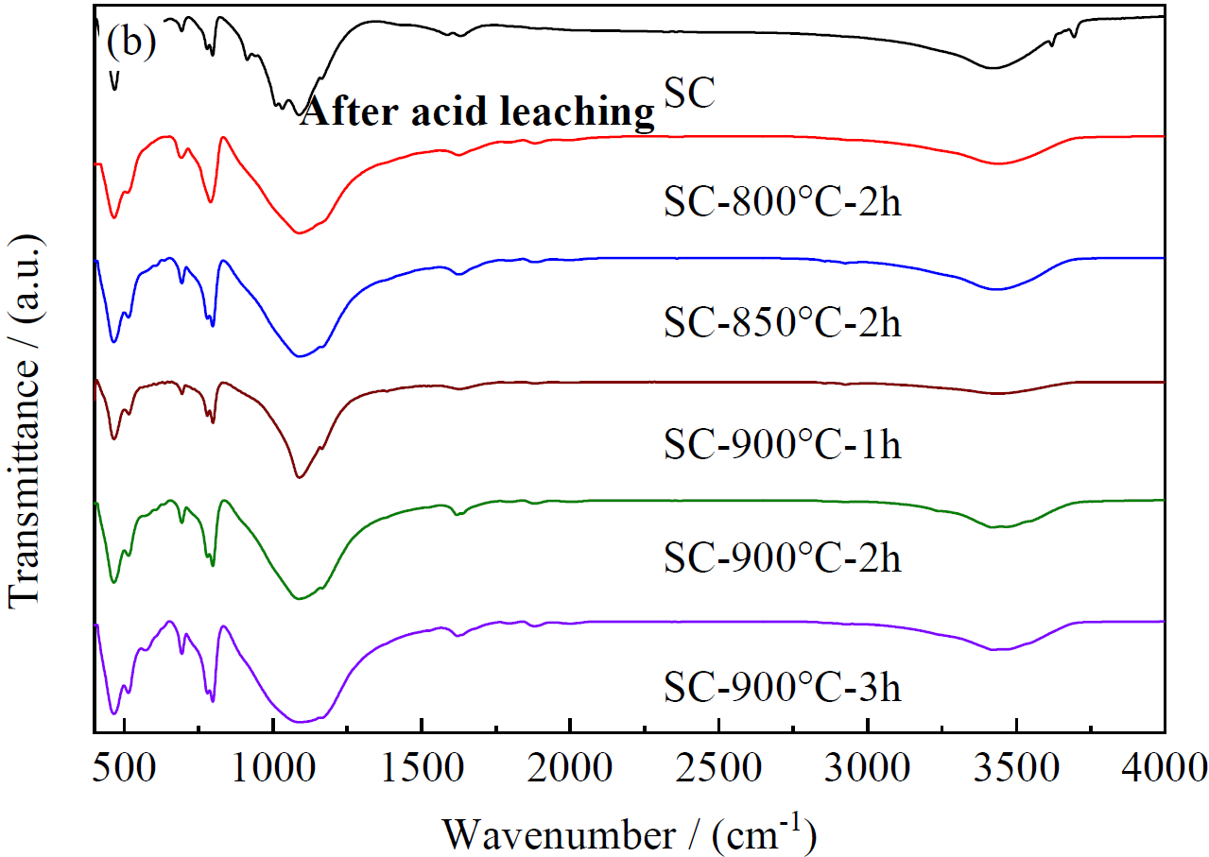

**Fig. S2**. FTIR patterns of (a) SC under different roasted temperatures and times before acid leaching; (b) roasted SC after acid leaching.

**Effect of roasting and acid leaching on pore structure**

The pore size distributions and incremental pore volume of SC and SC1L were shown in Fig. S3. As shown in the inset of Fig. S3(a), the incremental pore volume of 70–80 nm occupied primary, following by 120–180 nm. The pore volume was mildly increased by roasting and acid leaching of SC while the pore width was less than 4 nm (inset of Fig. S3(a)). The cumulative pore volume of SC1L was enhanced compared to that of SC while the pore width was 9–79 nm (Fig. S3(b)). It was found that 90% of the cumulative pore volume of SC1L was distributed in pore width less than 130 nm but that of SC less than 140 nm. It indicated that SA in SC1L was more stable than that in SC. This conclusion was consistent with the TG analysis results. Fig. S3(c) and (d) further studied the incremental pore area and cumulative pore area of SC and SC1L. The incremental pore area of SC was a little larger than that of SC while the pore width within 5–25 nm (Fig. S3(c)). But the incremental pore area of SC1L was a little larger than that of SC while the pore width within 25–180 nm. It is observed that the cumulative pore area of SC1L rose dramatically comparing with SC (Fig. S3(d)). This phenomenon was because pores in SC increased the pore area after roasting and acid leaching. The cumulative pore area provided higher surface area and more roughly surface for SC which was a benefit to support and stabilize SA. After vacuum impregnation, the SA was sucked into the pore of supporting materials, it can be concluded that there were more free-moving and melted SA in SC1L.

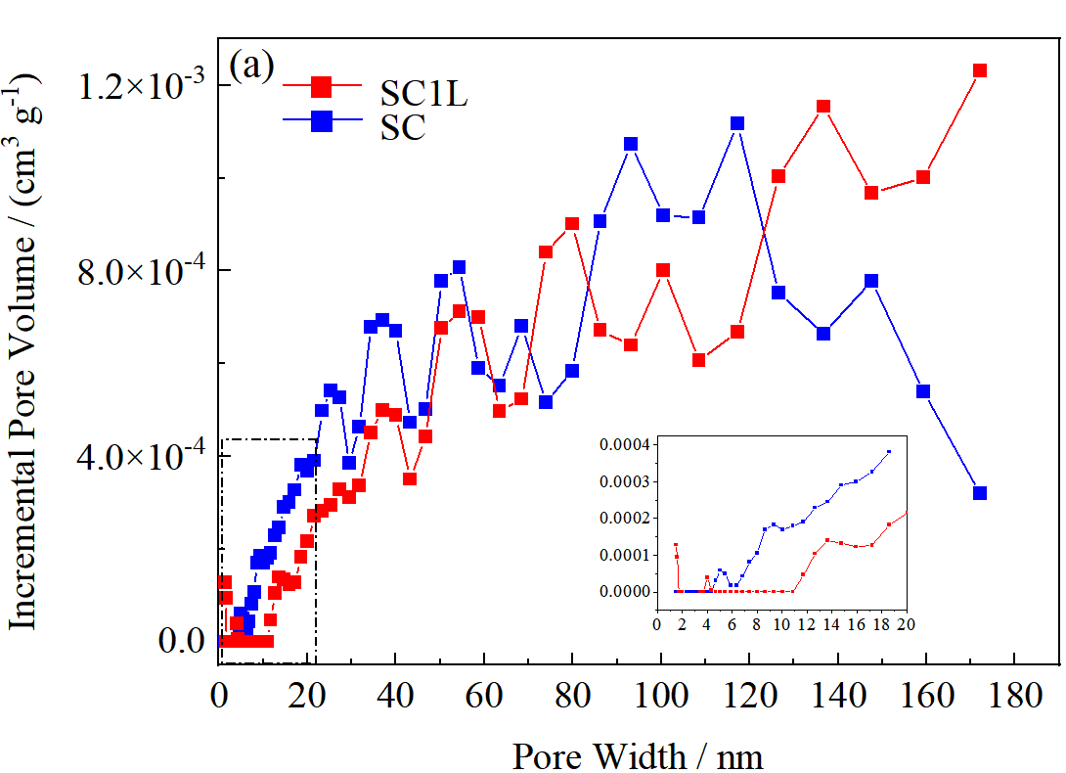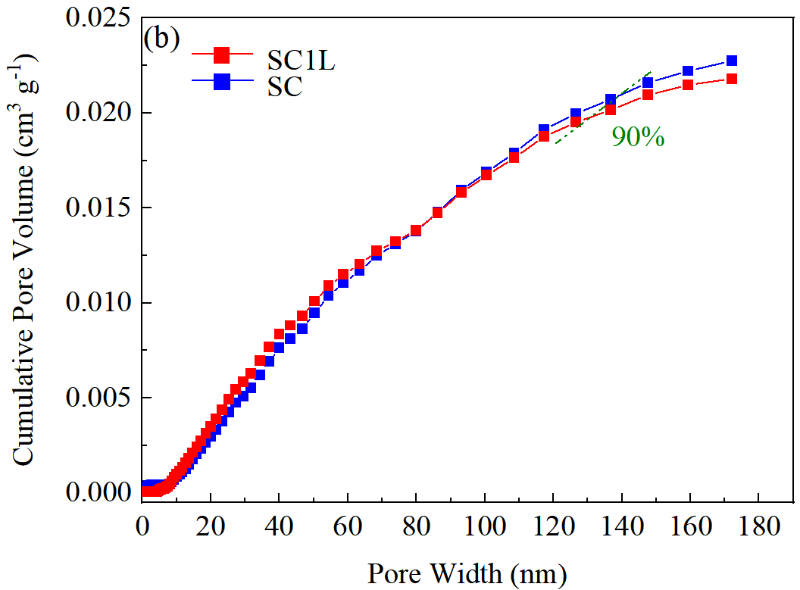

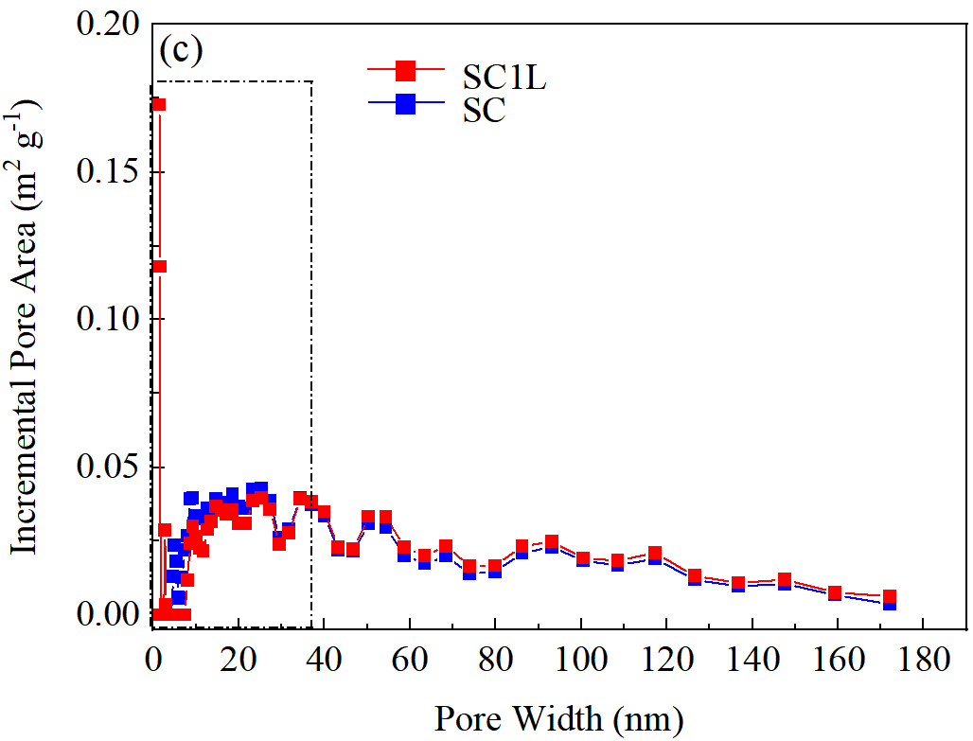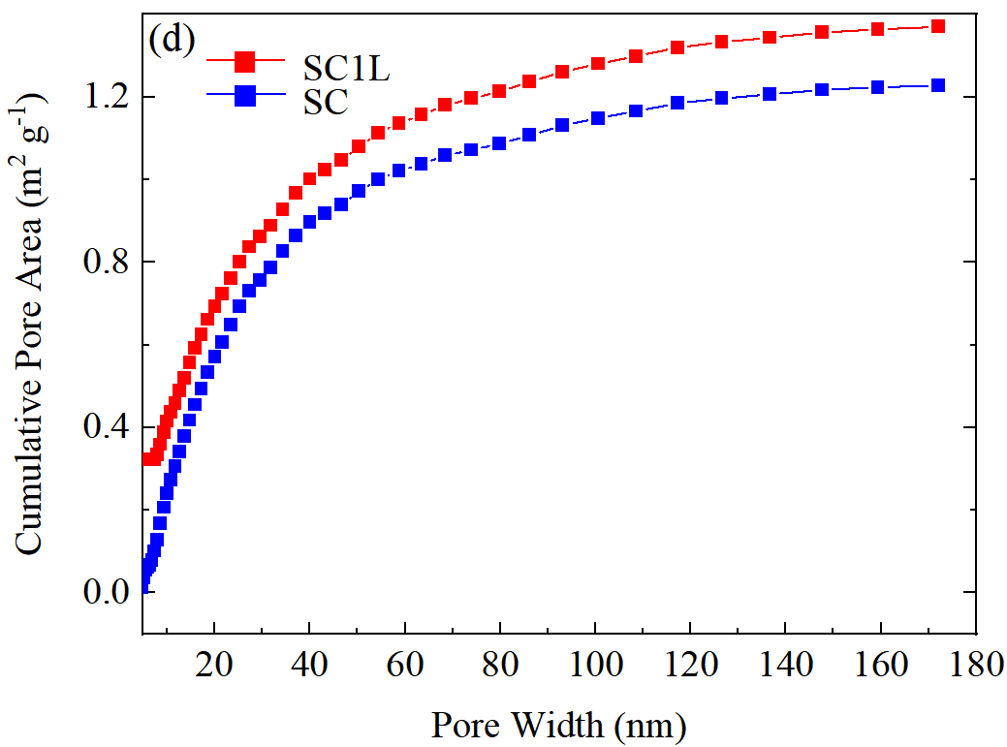

**Fig. S3**. Pore size distribution by Invalid Model: N2-DFT Model for (a) incremental pore volume, (b) cumulative pore volume, (c) incremental pore area, and (d) cumulative pore area of the SC and SC1L.

**Effect of roasting and acid leaching on obtained vanadium ions concentration**

Table S1 showed the vanadium ions leaching rate of the acid leachate under different conditions. The leaching rate is the rate of remaining content to the original content. From Table S1, it can be seen that when the roasting time was fixed, the higher the roasting temperature, the higher the V concentration in the acid leaching solution. Therefore, the roasting temperature was determined to be 900°C. When the temperature was fixed, the longer the roasting time, the higher the V concentration in the acid leachate.

**Table S1**. Leaching rate of vanadium ions

|  |  |
| --- | --- |
| Treatment | Rate / % |
| SC-800°C-2h after acid leaching | 19.80 |
| SC-850°C-2h after acid leaching | 19.91 |
| SC-900°C-2h after acid leaching | 32.23 |
| SC-900°C-1h after acid leaching | 16.12 |
| SC-900°C-3h after acid leaching | 35.92 |

[1] X. Wang, H. Lin, Y.B. Dong, and G.Y. Li, Bioleaching of vanadium from barren stone coal and its effect on the transition of vanadium speciation and mineral phase, *Int. J. Miner. Metall. Mater.*, 25(2018), p. 253.