Simultaneously removal of P and B from Si by Sr and Zr co-addition during Al–Si low-temperature solvent refining
Chen Chen^{1,2)}, Jingwei Li^{3,4.5,6)}, Qiuxia Zuo⁷⁾, Boyuan Ban^{1),}, Jian Chen^{1),}
1) Key Lab of Photovoltaic and Energy Conservation Materials, Institute of Solid State Physics, HFIPS, Chinese Academy of Sciences, Hefei 230031, China
2) University of Science and Technology of China, Hefei 230026, China
3) School of Materials Science and Engineering, Hefei University of Technology, Hefei 230009, China
4) State Key Laboratory of Mineral Processing, BGRIMM Technology Group, Beijing 100160, China
5) State Key Laboratory of Complex Nonferrous Metal Resources Clean Utilization，Kunming University of Science and Technology, Kunming 650504, China
6) Engineering Research Center of High Performance Copper Alloy Materials and Processing, Ministry of Education, Hefei University of Technology, Hefei 230009, China
7) Shandong Aluminum Vocational College, Weihai 264400, China

Corresponding authors: Jian Chen E-mail: jchen@ipp.ac.cn; Boyuan Ban E-mail: banboyuan@rntek.cas.cn

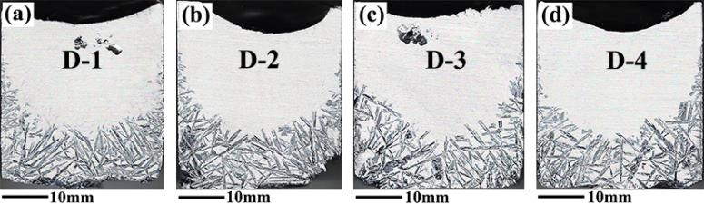
Fig. S1 Cross sections of samples after directional solidification with different Zr additions: (a) D-1; (b) D-2; (c) D-3; (d) D-4 [1].
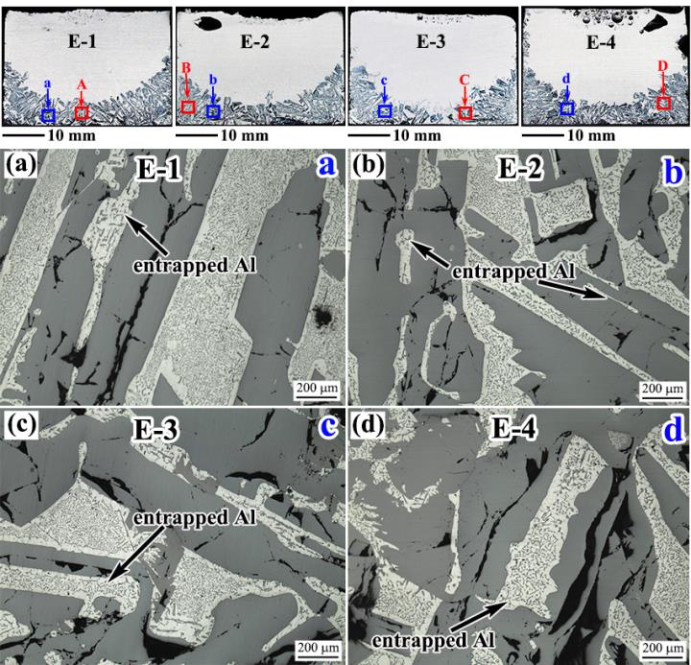
Fig. S2 The macro&micro structure of Al-Si ingots with the different Sr addition: (a) magnified view of the a rectangle region in the E-1; (b) magnified view of the b rectangle region in the E-2; (c) magnified view of the c rectangle region in the E-3; (d) magnified view of the d rectangle region in the E-4.
References
[1] C. Chen, J.W. Li, X.S. Jiang, W.F. Song, J. Shi, B.Y. Ban, and J. Chen, Effect of impurity phase migration on Al–30wt.%Si solvent refining with Zr additions during directional solidification, Sep. Purif. Technol., 278(2021), art. No. 119572.

