**Supplementary Information**

**TiN/Fe2N/C composite with stable and broadband high-temperature microwave absorption**

*Yahong Zhang*1,2), *Yi Zhang*1), *Huimin Liu*1), *Dan Li*1), *Yibo Wang*2), *Chunchao Xu*2), *Yuping Tian*1)🖂, *and Hongjie Meng*3),🖂

1) College of Chemistry and Molecular Sciences, Henan University, Kaifeng 475004, China

2) Key Laboratory of Micro-Nano Materials for Energy Storage and Conversion of Henan Province, Institute of Surface Micro and Nano Materials, College of Chemical and Materials Engineering, Xuchang University, Xuchang 461000, China

3) School of Energy Science and Technology, Henan University, Zhengzhou 450046, China

🖂Corresponding authors: Yuping Tian E-mail: [tianyuping@vip.henu.edu.cn](mailto:tianyuping@vip.henu.edu.cn); Hongjie Meng E-mail: [menghongjie@sjtu.edu.cn](mailto:menghongjie@sjtu.edu.cn).

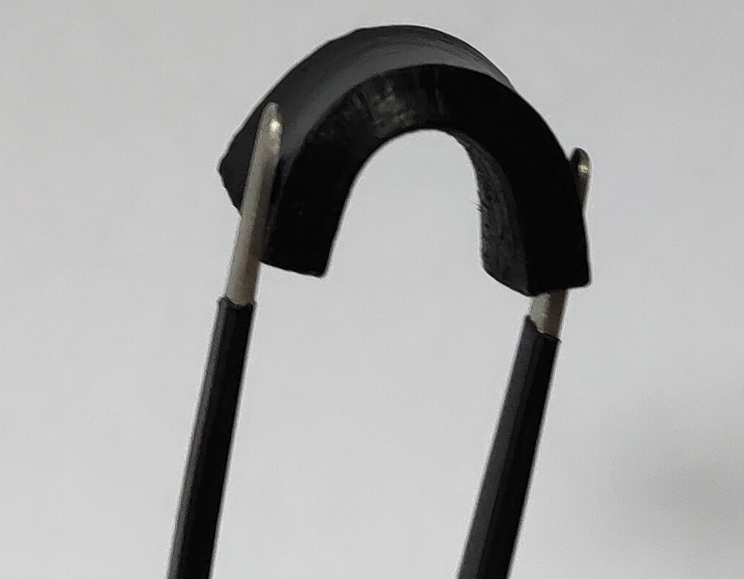

Fig. S1. The optical photograph of the test samples (22.86 mm × 10.16 mm × 3.00 mm)

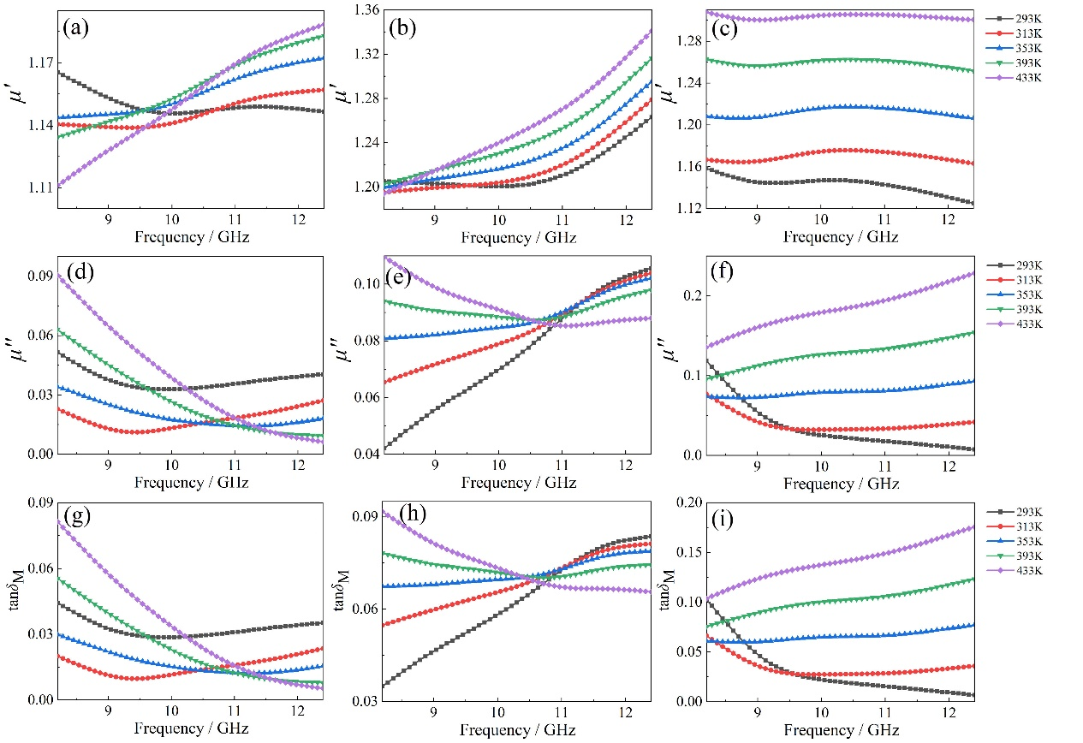

Fig. S2. The relative permeability (*μ*′ and *μ*″) and magnetic loss tangent (tan*δ*M) of the TiN/Fe2N/C composite: (a), (d), and (g) TiN/Fe2N/C-7, (b), (e), and (h) TiN/Fe2N/C-15, (c), (f), and (i) TiN/Fe2N/C-23