**Supplementary Information**

**Constructing BaTiO3/TiO2@polypyrrole composites with hollow multishelled structure for enhanced electromagnetic wave absorbing properties**

*Dan Mao*1,3), *Zhen Zhang*2), *Mei Yang*1), *Zumin Wang*1), *Ranbo Yu*2),🖂, *and Dan Wang*1,3),🖂

1) State Key Laboratory of Biochemical Engineering, Institute of Process Engineering, Chinese Academy of Sciences, Beijing 100190, China

2) Department of Energy Storage Science and Engineering, School of Metallurgical and Ecological Engineering, University of Science and Technology Beijing, Beijing 100083, China

3) University of Chinese Academy of Sciences, Beijing 100049, China

🖂 Corresponding authors: Ranbo Yu E-mail: ranboyu@ustb.edu.cn; Dan Wang E-mail: danwang@ipe.ac.cn



**Fig. S1. XRD patterns of 1s-, 2s-, and 3s-TiO2 HoMSs.**

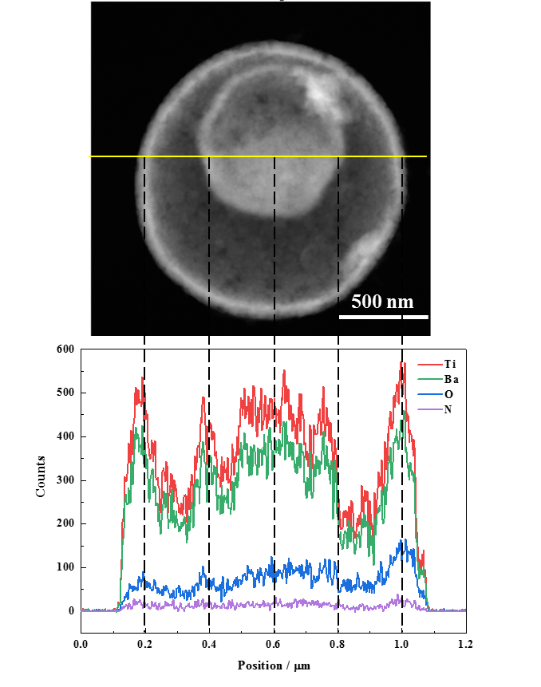

**Fig. S2. TEM image of a slice of 3s-BaTiO3/TiO2@PPy in dark field, and Ba, Ti, O, and N ratios in different shells by EDS line scanning**



**Fig. S3. The real (ε′) and imaginary (ε″) of complex permittivity (a, b), and tan δe (c) versus frequency of BaTiO3/TiO2 HoMSs; the real (μ′) and imaginary (μ″) of permeability (d, e), and tan δμversus frequency (f) of BaTiO3/TiO2 HoMSs.**





**Fig. S4. Cole-cole plots of 1s-BaTiO3/TiO2@PPy HoMSs(a), 2s-BaTiO3/TiO2@PPy HoMSs(b) and 3s-BaTiO3/TiO2@PPy HoMSs(c).**

  

**Fig. S5. RL curves and statistical diagram of absorption bandwidth<-5dB in the thickness range of 1-5mm of 1s-BaTiO3/TiO2 HoMSs (a), 2s-BaTiO3/TiO2 HoMSs (b) and 3s-BaTiO3/TiO2 HoMSs (c).**

 

**Fig. S6. Attenuation constant α curves of BaTiO3/TiO2 HoMSs (a), impedance matching ratio curves of BaTiO3/TiO2 HoMSs at a thickness of 1.3mm (b).**

**Table S1. Statistics table of absorbing performance of BaTiO3-based composite materials**

|  |  |  |  |
| --- | --- | --- | --- |
| absorbers | minimum RL values, thickness | bandwidth < −10 dB, thickness | References |
| Fe3O4/BaTiO3 | -24dB, 2.33mm | ~0.8GHz, 2.33mm | 42 |
| Ni@BaTiO3 | -42.3dB, 1.88mm | ~2.5GHz, 2mm | 43 |
| BaTiO3 NTs/RGO | -44.9dB, 3mm | 5.4GHz, 2.5mm | 44 |
| BaTiO3@C | -88.5dB, 3mm | 3GHz, 2mm | 10 |
| BaTiO3@MWCNTs | -45dB, 3.5mm | ~4GHz, 1.5mm | 45 |
| BaTiO3/NiFe2O4/RGO | -51.1dB, 2.9mm | 3.12GHz, 2.9mm | 46 |
| Fe3O4-BaTiO3 | -47.4dB, 2.2mm | 5.0GHz, 2mm | 47 |
| Fe3O4@BaTiO3/RGO | -38.2dB, 4mm | 3.5GHz, 1.5mm | 48 |
| CNTs/BaTiO3/PANI | -30.9dB, 4mm | 2.7GHz, 4mm | 49 |
| 1s-BaTiO3/TiO2 | -9.27dB, 5mm | 0 | This work |
| 2s-BaTiO3/TiO2 | -18.53dB, 5mm | 0.91GHz, 5mm | This work |
| 3s-BaTiO3/TiO2 | -9.84dB, 2mm | 0 | This work |
| 1s-BaTiO3/TiO2@PPy | -13.41dB, 1.3mm | 3.47GHz, 1.3mm | This work |
| 2s-BaTiO3/TiO2@PPy | -21.7dB, 1.3mm | 3.77GHz, 1.5mm | This work |
| 3s-BaTiO3/TiO2@PPy | -21.8dB, 1.5mm | 4.20GHz, 1.3mm | This work |