Supplementary Information

**Morphology engineering of ZnO micro/nanostructures under mild conditions for optoelectronic application**

*Liang Chu*1),🖂, *Haoyu Shen*1), *Hudie Wei*1), *Hongyu Chen*1), *Guoqiang Ma*2),🖂, *and Wensheng Yan*1),🖂

1) Institute of Carbon Neutrality and New Energy & School of Electronics and Information, Hangzhou Dianzi University, Hangzhou 310018, China

2) School of Applied Physics and Materials, Wuyi University, Jiangmen 529020, China

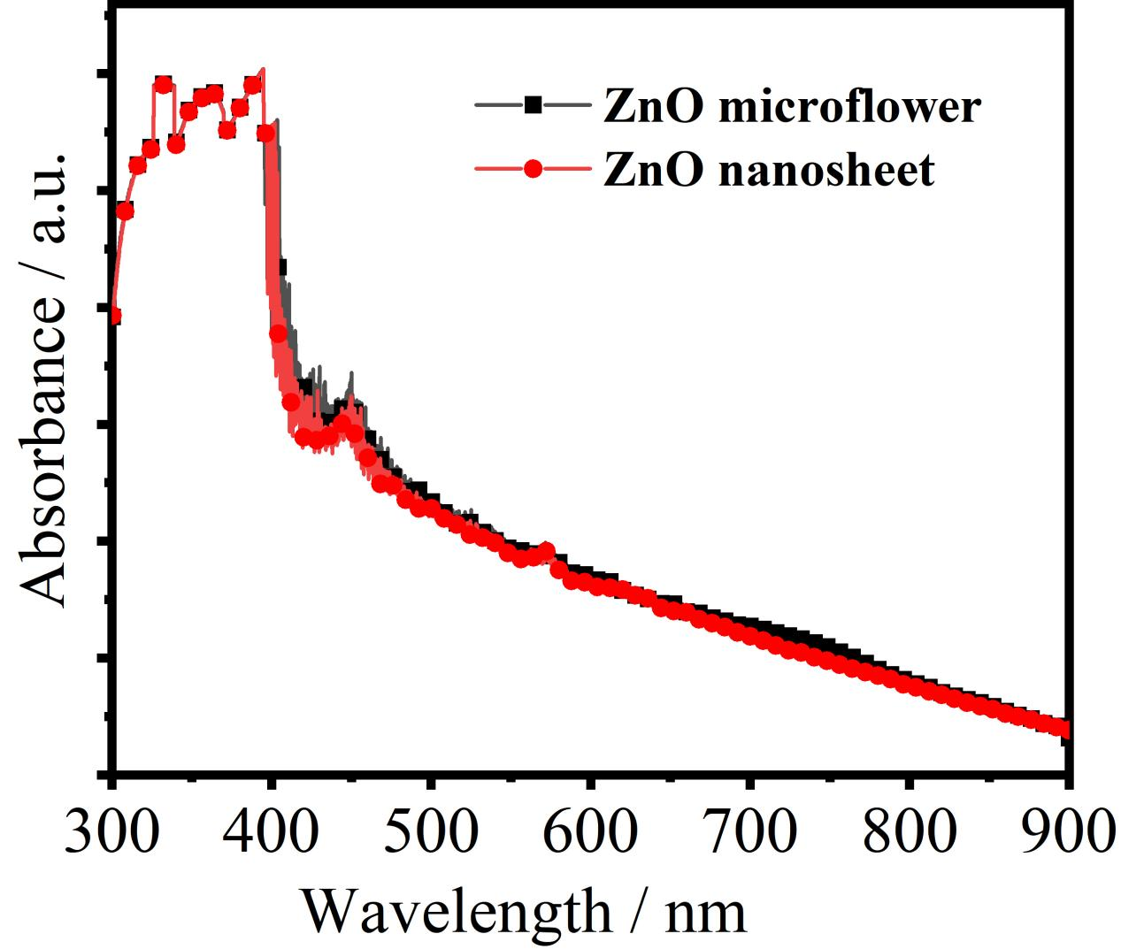

**Fig. S1.** UV-vis absorption spectra of ZnO microflowers and nanosheets between 300 and 900 nm.

The main absorption edges are both located at ultraviolet of 300–400 nm. Both covers have the same absorption edge due to the same bandgap of ZnO. The microflowers have relatively high absorption than nanosheets.

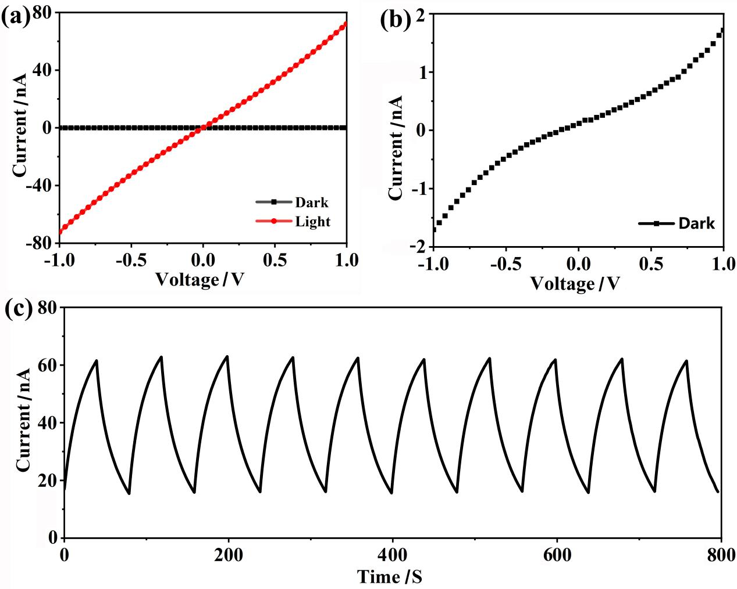

**Fig. S2.** (a) *I*−*V* characteristics of the ZnO-nanosheet-based UV detectors with and without 365 nm UV illustration, (b) *I*−*V* characteristics of the UV detectors without light irradiance, and (c) reversible switching of electrical current for the detector at 1 V biasing voltage in the dark state and under 365 nm UV illustration.

The UV detector based on ZnO nanosheets has lower dark current mainly due to the low conductivity of polycrystalline ZnO. Notably, the photocurrent is also lower than that of ZnO nanoflower-based detector.