Supplemental materials
Low-temperature chlorination roasting technology for the simultaneous recovery of valuable metals from spent LiCoO₂ cathode material
Junjie Shi^{1,2),}, Changle Hou^{1,2)}, Jingjing Dong^{1,2)}, Dong Chen^{1,2)}, and Jianzhong Li^{1,2)}
1) Key Laboratory for Ecological Metallurgy of Multimetallic Mineral (Ministry of Education), Northeastern University, Shenyang 110819, China
2) School of Metallurgy, Northeastern University, Shenyang 110819, China
Fig. S1. The XRD pattern of spent LiCoO₂ cathode powders.
Fig. S2. (a) TG and (b) DTG curves of the mixture at different heating rates.

Table S1. Calculated activation energy at different conversions by the model-free methods
α | FWO |  | KAS |  | Starink |  | Friedman
 | E_{a}  (kJ/mol) | r² | E_{a}  (kJ/mol) | r² | E_{a}  (kJ/mol) | r² | E_{a}  (kJ/mol) | r²
0.1 | 97.25 | 0.982 | 94.05 | 0.979 | 94.3 | 0.979 | 89.946 | 0.958
0.2 | 96.43 | 0.991 | 92.96 | 0.989 | 93.22 | 0.990 | 87.02 | 0.996
0.3 | 94.85 | 0.996 | 91.13 | 0.995 | 91.41 | 0.995 | 85.47 | 0.999
0.4 | 92.41 | 0.998 | 88.43 | 0.998 | 88.71 | 0.998 | 81.12 | 1
0.5 | 90.49 | 1.000 | 86.27 | 1.000 | 86.56 | 1.000 | 77.85 | 0.996
0.6 | 84.16 | 1.000 | 79.48 | 1.000 | 79.78 | 1.000 | 67.18 | 0.998
0.7 | 81.49 | 1.000 | 76.52 | 1.000 | 76.82 | 1.000 | 60.24 | 0.997
0.8 | 79.13 | 1.000 | 73.86 | 1.000 | 74.18 | 1.000 | 66.88 | 0.999
0.9 | 79.51 | 1.000 | 74.03 | 1.000 | 74.36 | 1.000 | 71.4 | 0.999
Average | 88.41 | 0.996 | 84.08 | 0.996 | 84.371 | 0.996 | 76.35 | 0.994
Table S2. Kinetic parameters of common models calculated by model-fitting methods
Model | Variable | 5°C/min | 10°C/min | 20°C/min | Average
R2 | $E_{a}$(kJ/mol) | 40.45 | 36.42 | 34.71 | 37.19
 | ln$A$ | 6.21 | 5.59 | 5.51 | 5.77
 | r² | 0.861 | 0.854 | 0.899 | 0.871
R3 | $E_{a}$(kJ/mol) | 50.91 | 45.63 | 43.39 | 46.64
 | ln$A$ | 8.37 | 7.38 | 7.13 | 7.63
 | r² | 0.921 | 0.914 | 0.94 | 0.925
D1 | $E_{a}$(kJ/mol) | 74.61 | 67.97 | 64.23 | 68.94
 | ln$A$ | 14.19 | 12.72 | 11.97 | 12.96
 | r² | 0.732 | 0.715 | 0.762 | 0.736
D2 | $E_{a}$(kJ/mol) | 102.12 | 94.85 | 88.83 | 95.27
 | ln$A$ | 20.27 | 18.44 | 17.01 | 18.57
 | r² | 0.938 | 0.934 | 0.948 | 0.940
D3 | $E_{a}$(kJ/mol) | 135.97 | 127.97 | 119.09 | 127.68
 | ln$A$ | 27.06 | 24.8 | 22.52 | 24.79
 | r² | 0.963 | 0.958 | 0.968 | 0.963
D4 | $E_{a}$(kJ/mol) | 113.84 | 106.32 | 99.3 | 106.49
 | ln$A$ | 21.64 | 19.65 | 17.928 | 19.74
 | r² | 0.919 | 0.912 | 0.932 | 0.921
F1 | $E_{a}$(kJ/mol) | 73.05 | 67.28 | 63.18 | 67.84
 | ln$A$ | 14.9 | 13.63 | 12.81 | 13.78
 | r² | 0.982 | 0.975 | 0.975 | 0.977
F2 | $E_{a}$(kJ/mol) | 139.46 | 132.22 | 122.55 | 131.41
 | ln$A$ | 31.18 | 29.06 | 26.57 | 28.94
 | r² | 0.981 | 0.976 | 0.964 | 0.974
F3 | $E_{a}$(kJ/mol) | 205.86 | 197.17 | 181.92 | 194.98
 | ln$A$ | 46.77 | 43.8 | 39.64 | 43.40
 | r² | 0.963 | 0.961 | 0.949 | 0.958

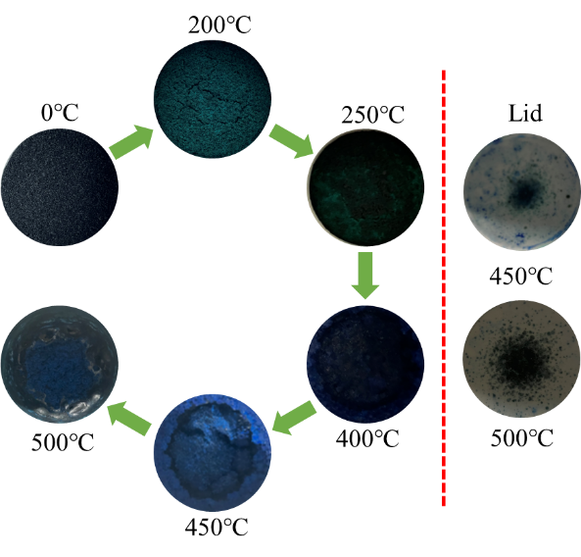
Fig. S3. Color of the roasted products changes with temperature.

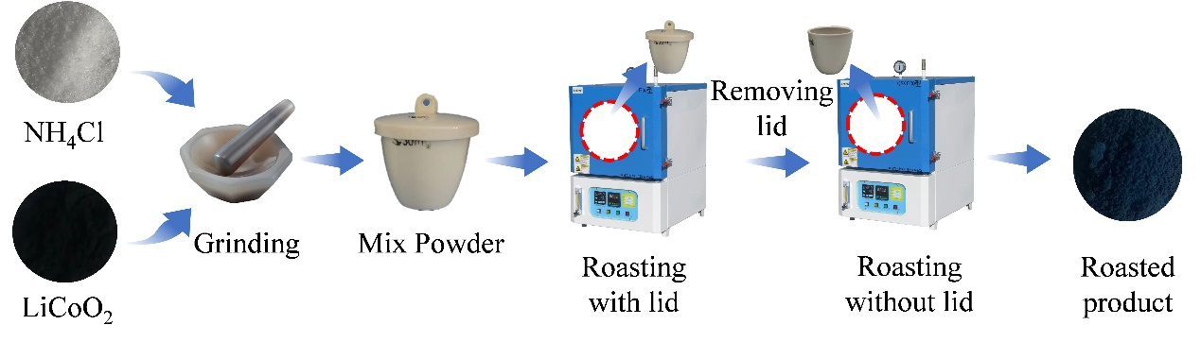
Fig. S4. The two-step method.

