Supplementary Information

**Efficient desorption and reuse of collector from the flotation concentrate surfaces: A case study of scheelite**

*Liming Tao*1), *Jianjun Wang*1,2),🖂, *Dejin Liao*3), *Wenkai Jia*1), *Zihan Zhao*1), *Wenfang Che*4), *Zhongxu Qi*5), *Wei Sun*1), *and Zhiyong Gao*1),🖂

1) School of Minerals Processing and Bioengineering, Key Laboratory of Hunan Province for Clean and Efficient Utilization of Strategic Calcium-containing Mineral Resources, Engineering Research Center of Ministry of Education for Carbon Emission Reduction in Metal Resource Exploitation and Utilization, Central South University, Changsha 410083, China

2) State Key Laboratory of Mineral Processing, BGRIMM Technology Group, Beijing 102628, China

3) Mining Technology Research Center, China Tungsten and Hightech Materials Co., LTD, Chenzhou 423000, China

4) Luoyang Luanchuan molybdenum Group Co., Ltd, Luoyang 471500, China

5) Changsha Institute of Mining Research Co..Ltd, Changsha 410012, China

🖂 Corresponding authors: Zhiyong Gao E-mail: zhiyong.gao@csu.edu.cn;

Jianjun Wang E-mail: jianjunwang@csu.edu.cn

# Part 1: Flotation tests

## 1.1. Single mineral

Single mineral flotation tests were carried out in an XFGⅡ flotation machine at a speed of 1750 r/min. In the single-mineral flotation, the 2.0 g sample and 35 mL deionized water was added to a 40 mL plexiglass cell. After the pre-mixed Pb-BHA collector was added, NaOH or HCl solution was added to adjust the pH value, and then 0.3 μL terpineol was added. Finally, the flotation was carried out 3 min. The flow chart of single-mineral flotation is shown in Fig. S1. After flotation, concentrate and tailings were dried and weighed to calculate recovery. Every test was repeated at least three times to calculate the standard deviation of recovery.

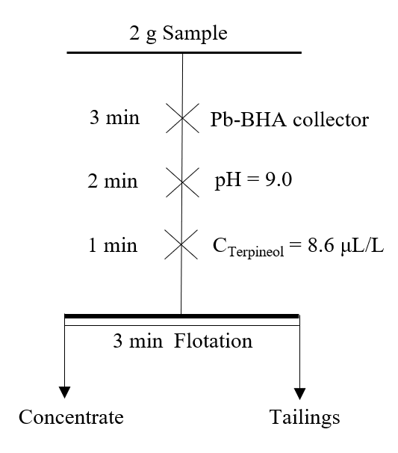

Fig. S1. Flow chart of single-mineral flotation.

## 1.2. The run-of-mine ore

Rough-flotation tests of run-of-mine ore were carried out using a XFD flotation machine (Exploring Machinery Plant, Changchun, China) with a 1.0 L plexiglass cell at a stirring speed of 2000 r/min. the collector was added first, Na2CO3 was added to adjust the pH, and then the flotation experiment was carried out. The flow chart of the rough flotation of run-of-mine ore is shown in Fig. S2. After flotation, the concentrate and tailings were filtered, dried and weighed, respectively. Then, the WO3 grade of concentrate and tailings were measured. The WO3 recovery of the concentrate was calculated from the sample mass and WO3 grade.

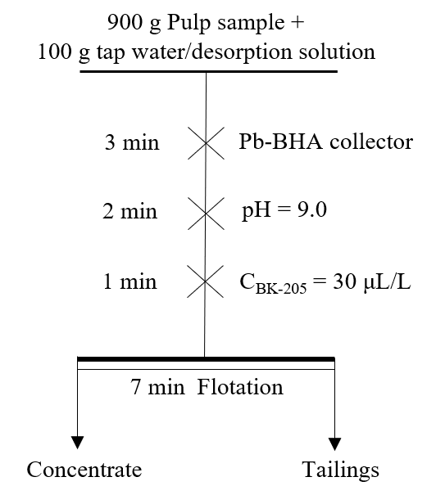

Fig. S2. Flow chart of the rough flotation of run-of-mine ore.

# Part 2: Flotation results

## 2.1. Single-minerals flotation results



Fig. S3. Effect of the molar ratio of Pb to BHA (a), pH (b) and the concentration of BHA (c) on the floatability of scheelite and fluorite.

## 2.2. Run-of-mine flotation results

The experimental process of rough flotation is shown in Fig. S2, and the flotation results are shown in Table S1.

Table S1. Effect of dosage of Pb-BHA on the grade and recovery of scheelite concentrate

|  |  |  |
| --- | --- | --- |
| Pb/BHA dosage / (g·t−1) | WO3 | |
| Grade / % | Recovery / % |
| 400/300 | 1.34 | 49.78 |
| 450/350 | 1.37 | 59.69 |
| 500/400 | 1.38 | 67.58 |
| 550/450 | 1.45 | 72.08 |
| 600/500 | 1.48 | 77.76 |

Note: Flotation pH = 9.0; BK-205 = 30 g/t.

# Part 3: Solution chemistry of Pb2+

When Pb ions reach equilibrium in interfacial adsorption, their ionic hydrolysis process also reaches some equilibrium in the solution and in the interfacial region. The concentration of each hydrolysis component in the interfacial region is calculated by the following equilibrium for a lead ion concentration of 2.4 × 10−4 mol/L.

(a) Homogeneous system [1]

At this point, no Pb(OH)2(s) precipitate is formed in the solution, and the components are in equilibrium with Pb2+.

(S1)

(S2)

(S3)

(S4)

where β1, β2, β3, β4 are the cumulative stability constants, and [ ] represents the concentration of the component.

So according to the mass balance we get Eq. (S5):

$C_{Pb}=\left[Pb^{2+}\right]+\left[{Pb(OH)}^{+}\right]+\left[{Pb(OH)}_{2(aq)}\right]+\left[{{Pb(OH)}_{3}}^{-}\right]+\left[{{Pb(OH)}_{4}}^{2-}\right]$ (S5)

where CPb is the total amount of Pb in solution.

Substitute Eq. (S1)–(S4) into Eq. (S5) to obtain Eq. (S6).

$\left[Pb^{2+}\right]=C_{Pb}{\left(1+β_{1}\left[OH^{-}\right]+β_{2}{\left[OH^{-}\right]}^{2}+β_{3}{\left[OH^{-}\right]}^{3}\right)}^{-1}$ (S6)

Define the side reaction coefficients as follows:

$α_{\text{Pb}}=\frac{C_{Pb}}{\left[Pb^{2+}\right]}=1+β_{1}\left[OH^{-}\right]+β_{2}{\left[OH^{-}\right]}^{2}+β_{3}{\left[OH^{-}\right]}^{3}$ (S7)

The concentrations of each component of Pb were obtained as follows.

$\left[Pb^{2+}\right]=\frac{C_{Pb}}{α_{\text{Pb}}}$ (S8)

$\left[{Pb\left(OH\right)}^{+}\right]=β_{1}\left[Pb^{2+}\right]\left[OH^{-}\right]$ (S9)

$\left[{Pb(OH)}_{2(aq)}\right]=β_{2}\left[Pb^{2+}\right]{\left[OH^{-}\right]}^{2}$ (S10)

$\left[{{Pb\left(OH\right)}_{3}}^{-}\right]=β_{3}\left[Pb^{2+}\right]{\left[OH^{-}\right]}^{3}$ (S11)

$\left[{{Pb\left(OH\right)}_{4}}^{2-}\right]=β_{4}\left[Pb^{2+}\right]{\left[OH^{-}\right]}^{4}$ (S12)

(b) Multiphase system [2]

From Eq. (S5), it can be seen that the content of the Pb2+ component decreases. with increasing pH, When , Pb(OH)2(s) precipitate from the solution, and the pH of the solution is the critical pH at this time.

When the pH exceeds the critical value, the solution is a multiphase system and the components are in equilibrium with Pb(OH)2(s).

(S13)

${Pb(OH)}_{2(s)}⇌{Pb(OH)}^{+}+OH^{-} {\text{K}}_{\text{S1}}=\left[(PbOH)^{+}\right]\left[OH^{-}\right]=10^{-8.9 }$ (S14)

${Pb(OH)}_{2(s)}⇌ {Pb(OH)}_{2(aq)} {\text{K}}_{\text{S2}}=\left[{Pb(OH)}_{2(aq)}\right]=10^{-4.3}$ (S15)

${Pb(OH)}_{2(s)}+OH^{-}⇔{\left[{Pb(OH)}_{3}\right]}^{-} {\text{K}}_{\text{S3}}=\frac{{\left[{Pb(OH)}_{3}\right]}^{-}}{\left[OH^{-}\right]}=10^{-1.3}$ (S16)

${Pb(OH)}_{2(s)}+2OH^{-}⇔{{Pb(OH)}_{4}}^{2-} {\text{K}}_{\text{S4}}=\frac{\left[{{Pb(OH)}_{4}}^{2-}\right]}{{\left[{OH}^{-}\right]}^{2}}=10^{-1.08}$ (S17)

Ksp, Ks1, Ks2, Ks3, Ks4 are the solubility products of the mineral/water interface area.

The following equations can be obtained from Eqs. (S13)–(S17).

$\left[Pb^{2+}\right]=\frac{K_{\text{sp}}}{{\left[OH^{-}\right]}^{2}}$ (S18)

$\left[{Pb(OH)}^{+}\right]=\frac{K_{\text{s1}}}{\left[OH^{-}\right]}$ (S19)

$\left[{Pb(OH)}_{2(aq)}\right]=K_{\text{s2}}$ (S20)

$\left[{{Pb(OH)}_{3}}^{-}\right]=K_{s3}\left[OH^{-}\right]$ (S21)

$\left[{{Pb(OH)}_{4}}^{2-}\right]=K_{s4}{\left[{OH}^{-}\right]}^{2}$ (S22)

According to Eqs. (S8)–(S12) and Eqs. (S18)–(S22), logarithmic plots of Pb2+ hydrolysis component concentrations at different concentrations can be plotted.

References

[1] G.D. Sheng, S.W. Wang, J. Hu, *et al.*, Adsorption of Pb(II) on diatomite as affected *via* aqueous solution chemistry and temperature, *Colloids Surf*. *A*, 339(2009), No. 1-3, p. 159.

[2] H.S. Han, *The Application of Metal-Coordinated Complexes in the Flotation of Tungsten Minerals and Fundermental Research of the Adsorption Mechanism* [Dissertation], Central South University, Changsha, 2017, p. 52.