Supplemental Information

Upcycling the spent graphite/LiCoO₂ batteries for high-voltage graphite/LiCoPO₄-co-workable dual-ion batteries
Miao Du¹⁾, Hongyan Lü²⁾, Kaidi Du²⁾, Shuohang Zheng¹⁾, Xiaotong Wang¹⁾, Xiaotong Deng³⁾, Ronghua Zeng³⁾, and Xinglong Wu^{1,2),}
1) Ministry of Education Key Laboratory for UV Light-Emitting Materials and Technology, Northeast Normal University, Changchun 130024, China
2) Faculty of Chemistry, Northeast Normal University, Changchun 130024, China
3) School of Chemistry, South China Normal University, Guangzhou 510006, China
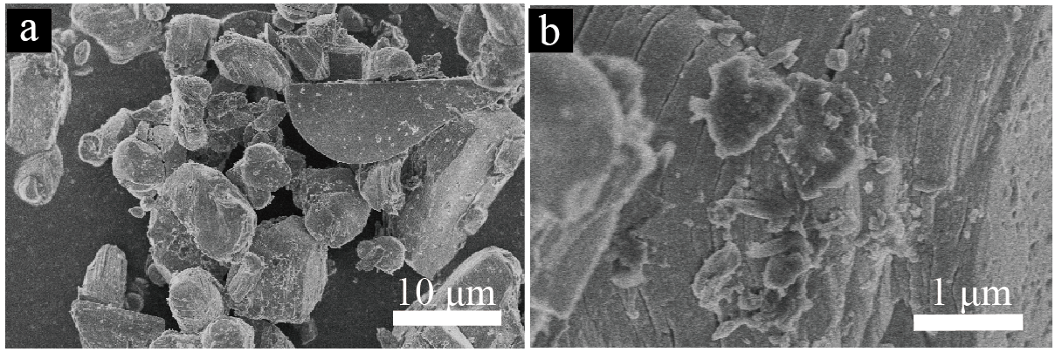
Fig. S1 (a, b) SEM images of spent LiCoO₂ material under different magnifications.

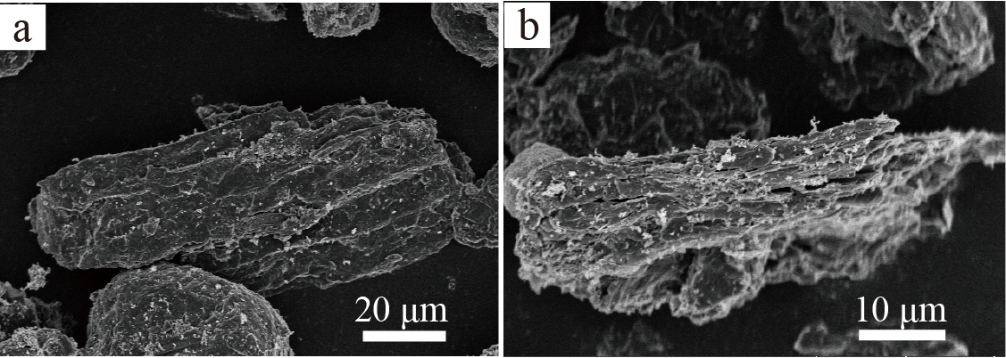
Fig. S2 (a, b) SEM images of spent graphite material under different magnifications.

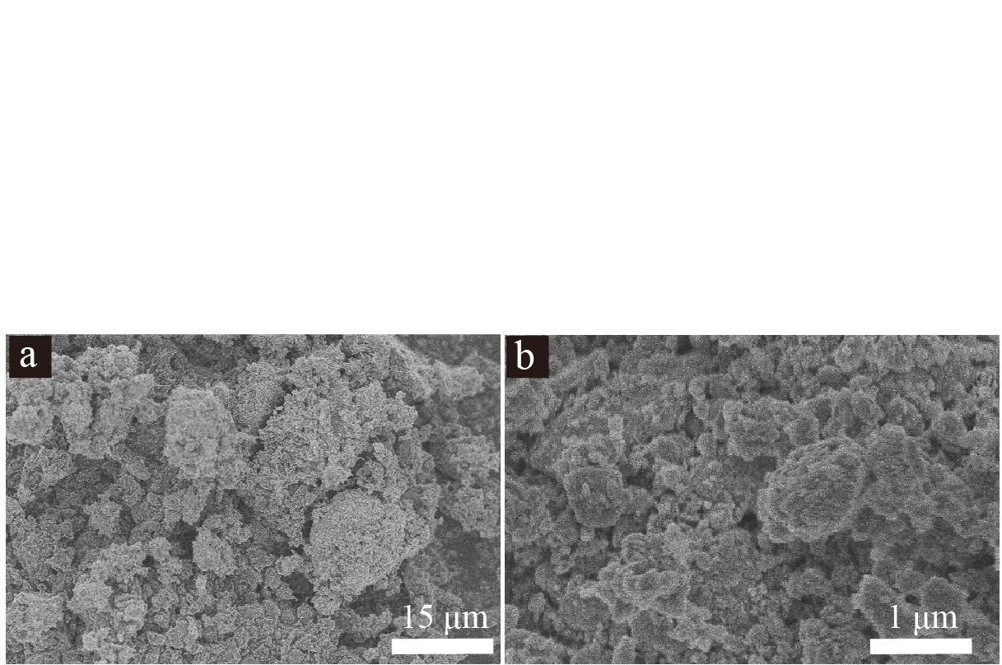
Fig. S3 (a, b) SEM images of spent LiCoO₂ material after ball‐milling under different magnifications.

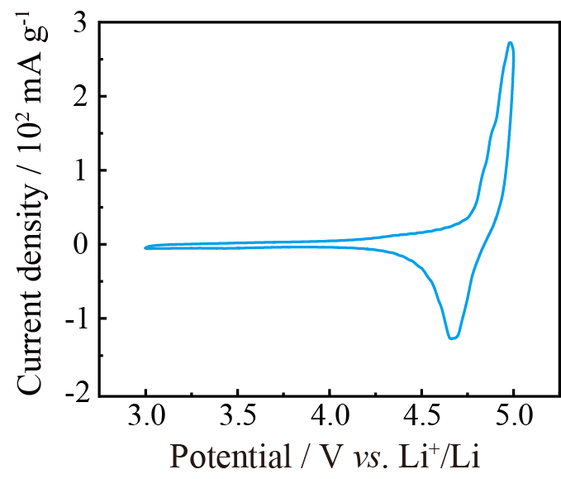
Fig. S4. CV profile of LCP at 0.1 mV⋅s⁻¹.

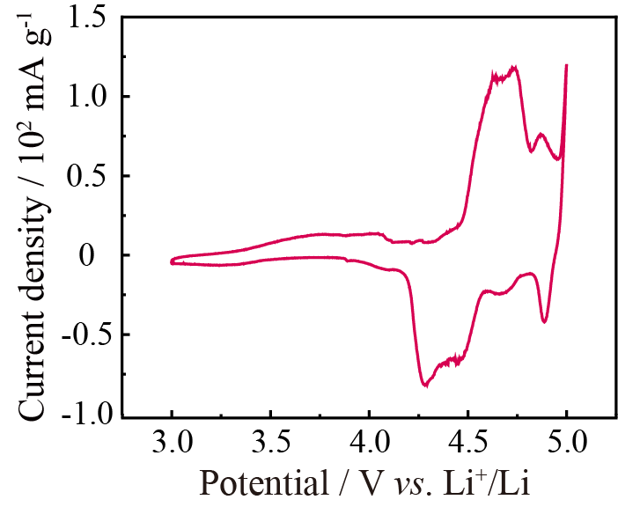
Fig. S5. CV profile of G at 0.1 mV⋅s⁻¹.

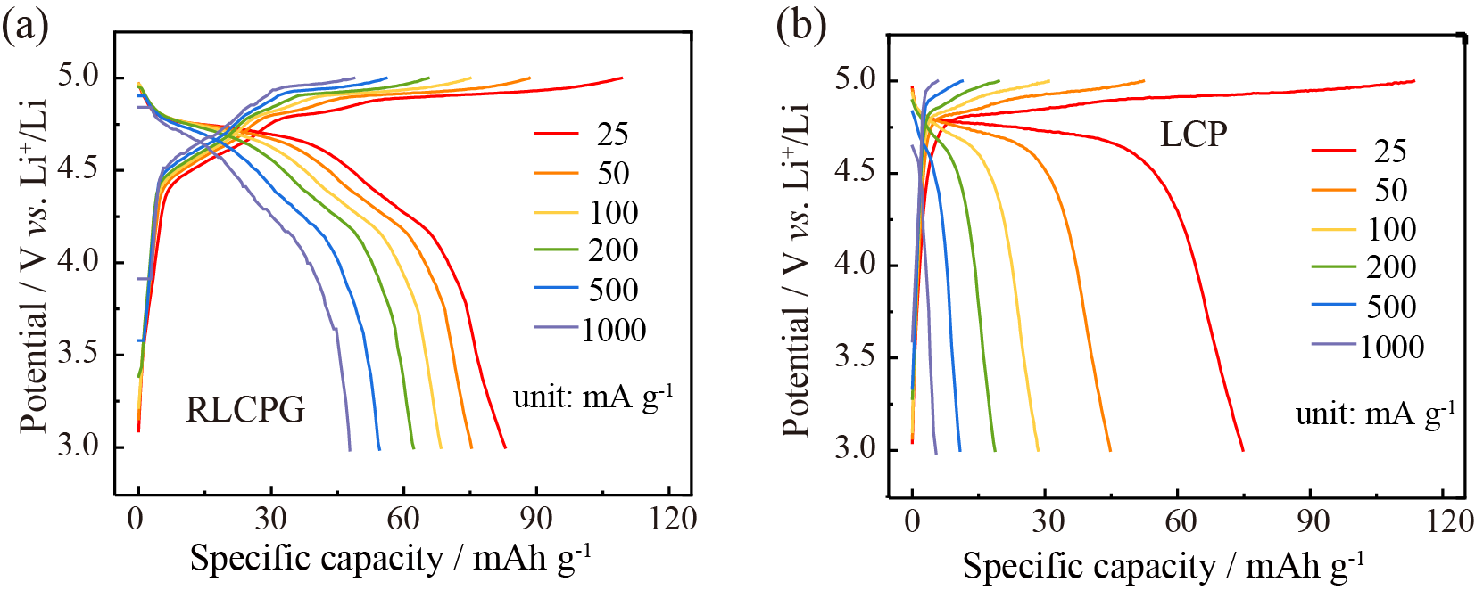
Fig. S6. GCD curves of RLCPG and LCP from the current densities of 25 to 1000 mA⋅g⁻¹.
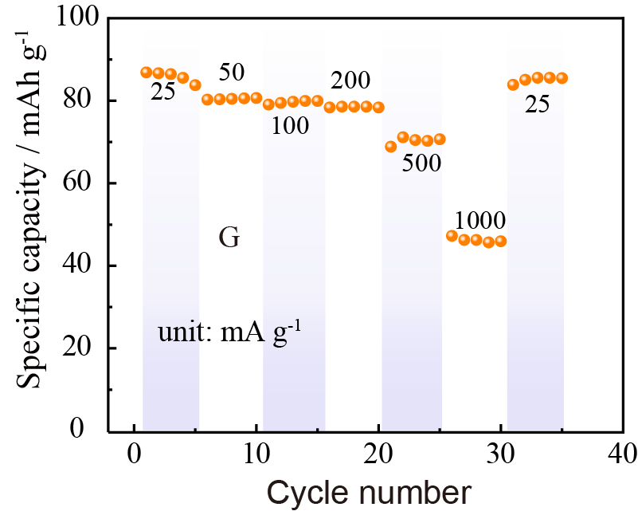
Fig. S7 Rate capability of G at various current densities from 25 to 1000 mA⋅g⁻¹.
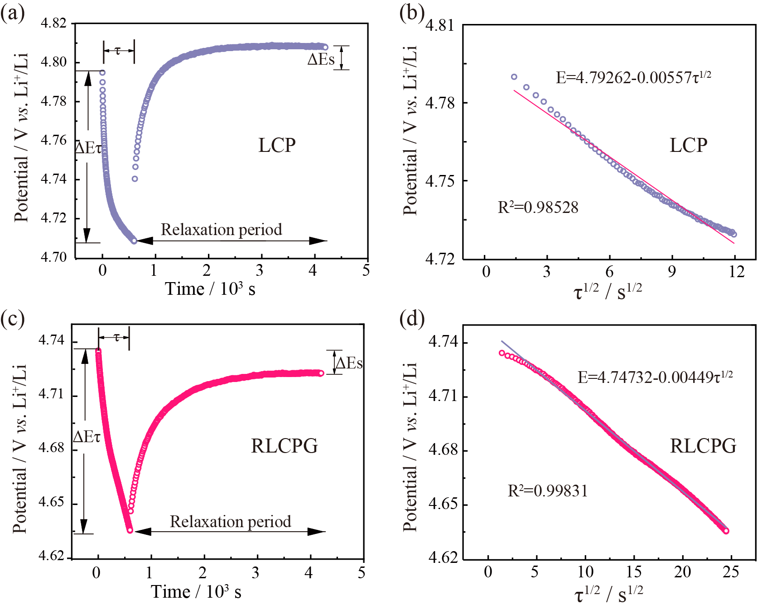
Fig. S8. (a, c) One single GITT profile of LCP and RLCPG in the discharge processes. (b, d) The corresponding linearly fitting behavior for the E vs. τ ^{1/2} in the discharge GITT titration.

The apparent Li⁺ diffusion coefficients (D_{app,Li}) were further calculated by GITT tests. The GITT tests were performed at different states at current density of 5 mA⋅g⁻¹ during the charge-discharge process. The D_{app,Li} can be calculated by the following formula [1]:
${\text{D}}_{\text{app}\text{,Li}}\text{=}\frac{\text{4}}{\text{π}\text{t}}{\text{(}\frac{\text{mV}}{\text{Ms}}\text{)}}^{\text{2}}{\text{(}\frac{\text{∆}{\text{E}}_{\text{S}}}{\text{∆}E_{\text{τ}}}\text{)}}^{\text{2}}$ ($\text{τ}\text{≪}{{\text{L}}^{\text{2}}}/{\text{D}}$) (S1)
where m, M, L, and V are the mass, molecular weight, average radius, and molar volume of electrode, respectively; s is the active surface area of electrode; τ is the time for an applied galvanostatic current; ΔE_{s} together with ΔE_{τ} are the quasi-equilibrium potential and the total change of cell voltage E during the current pulse.

References
[1] Z.Y. Gu, J.Z. Guo, J.M. Cao, et al., An advanced high-entropy fluorophosphate cathode for sodium-ion batteries with increased working voltage and energy density, Adv. Mater., 34(2022), No. 14, art. No. 2110108.

