Supporting Information

High-temperature corrosion of sintered RE₂Si₂O₇ (RE = Yb and Ho) environmental barrier coating materials by volcanic ash
Ayahisa Okawa^{1),}, Son Thanh Nguyen²⁾, Tadachika Nakayama^{3),}, Thi-Mai-Dung Do³⁾, Hisayuki Suematsu³⁾, Shu Yin^{1,4)}, Takuya Hasegawa¹⁾, Tsuneo Suzuki³⁾, Takashi Goto³⁾, and Koichi Niihara³⁾
1) Institute of Multidisciplinary Research for Advanced Materials, Tohoku University, Sendai 980-8577, Japan
2) Department of Creative Engineering, National Institute of Technology, Kushiro 084-0916, Japan
3) Extreme Energy-Density Research Institute, Nagaoka University of Technology, Nagaoka 940-2188, Japan
4) Advanced Institute for Materials Research (WPI-AIMR), Tohoku University, Sendai 980-8577, Japan
(Received: 31 October 2023; revised: 27 March 2024; 2 April 2024)
Corresponding authors: Ayahisa Okawa E-mail: ayahisa.okawa@tohoku.ac.jp; Tadachika Nakayama E-mail: nky15@vos.nagaokaut.ac.jp
Table S1. Full chemical compositions of as-collected volcanic ash mol%
SiO₂ | Al₂O₃ | CaO | MgO | Na₂O | Fe₂O₃ | K₂O | TiO₂ | MnO | SO₃
64.2 | 11.8 | 9.3 | 4.8 | 4.1 | 3.6 | 1.1 | 0.6 | 0.2 | 0.2

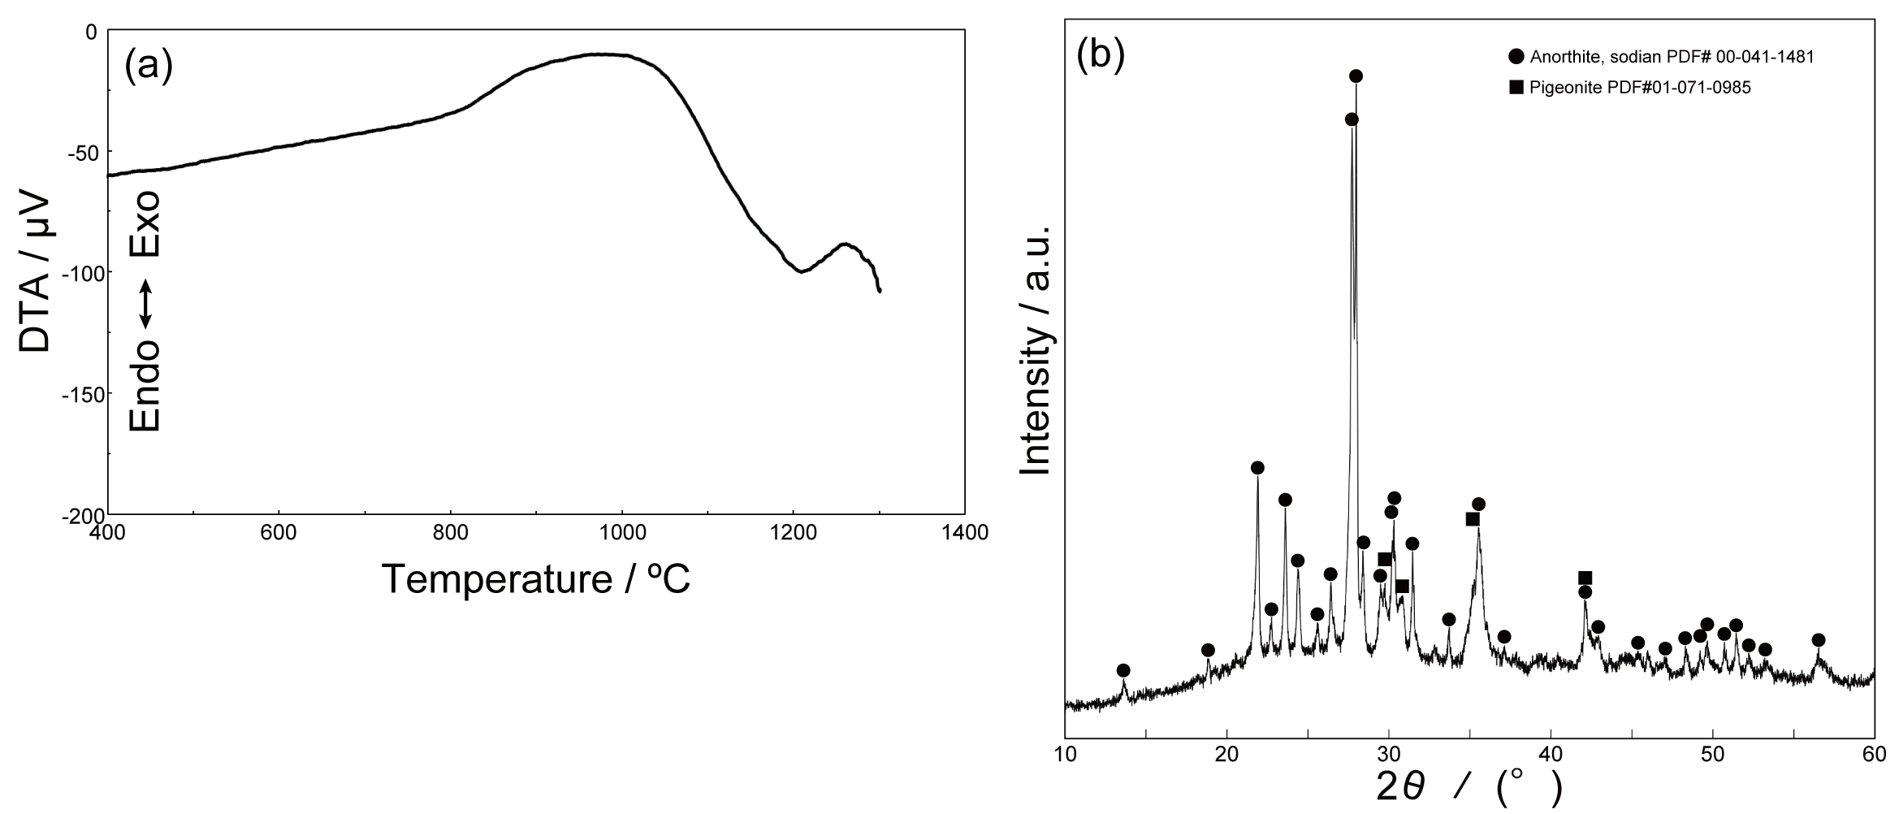Fig. S1. (a) DTA results of volcanic ash and (b) XRD pattern of as-collected Kagoshima volcanic ash.

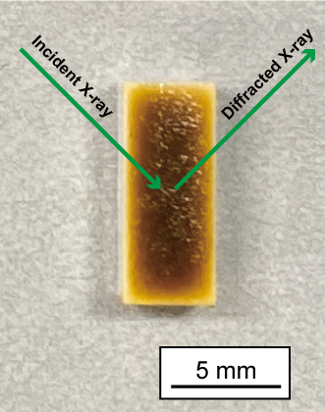
Fig. S2. Schematic illustration of XRD measurement.

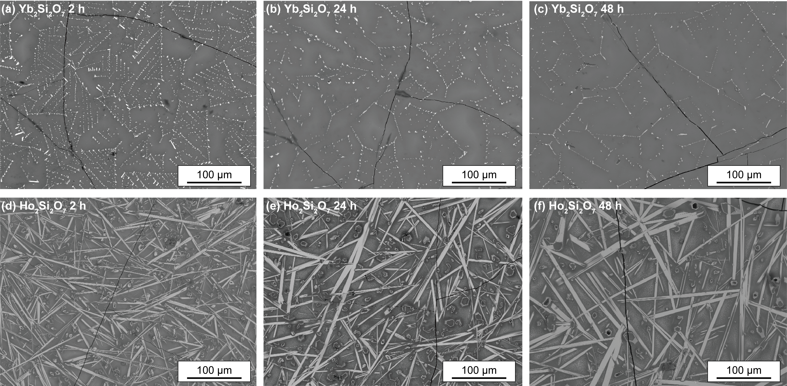
Fig. S3. Surface images of (a–c) Yb₂Si₂O₇ and (d–f) Ho₂Si₂O₇ after heat treatment at 1400℃.
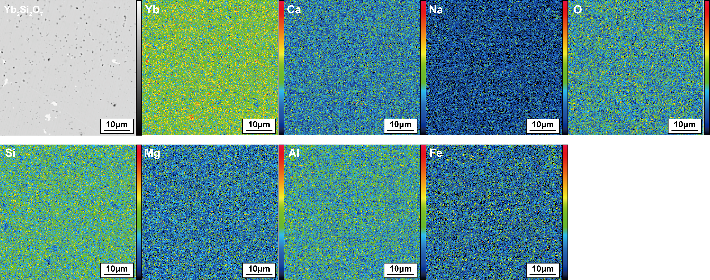
Fig. S4. Elemental mapping near the tip of volcanic ash penetration of the cross-section of Yb₂Si₂O₇ after heat treatment at 1400℃ for 24 h (The top refers to the surface direction, while the bottom direction indicates the internal aspect).

