Supporting Information
Co/Co₇Fe₃ heterostructures with controllable alloying degree on carbon spheres as bifunctional electrocatalyst for rechargeable zinc-air batteries
Junkang Chen¹⁾, Yongyue Zhuang¹⁾, Yanxin Qiao¹⁾, Yu Zhang¹⁾, Aihua Yuan²⁾, and Hu Zhou^{1,2),}
1) School of Materials Science and Engineering, Jiangsu University of Science and Technology, Zhenjiang 212003, China
2) School of Environmental and Chemical Engineering, Jiangsu University of Science and Technology, Zhenjiang 212003, China
(Received: 16 April 2024; revised: 28 May 2024; accepted: 18 June 2024)

 Corresponding author: Hu Zhou E-mail: zhmiao119@sina.com

Experimental
Material Characterizations
Powder X-ray diffraction (XRD) patterns of materials were collected by Shimadzu XRD-6000 diffractometer with Cu K_{α} radiation. The morphology was observed by a scanning electron microscope (SEM, Zeiss Merlin Compact) and transmission electron microscope (TEM, JEOL JEM-2100F) equipped with energy dispersive spectrometer (EDS, Oxford X-Max). Raman spectra were recorded on a Renishaw Raman spectroscope with an exciting source of 532 nm. Surface composition and valence state of samples were measured by X-ray photoelectron spectroscopy (XPS, Thermo Fisher ESCALAB 250 Xi) with monochromatized Al K_{α} radiation (1486.6 eV). N₂ adsorption-desorption isotherms were performed by Micromeritics ASAP 2020 system at 77 K. The specific surface area was calculated based on Brunauer-Emmett-Teller (BET) model, and the pore size distribution was analyzed by the Barrett-Joyner-Halenda (BJH) method.
Electrochemical Measurements
The electrochemical measurements were performed on CHI-760E electrochemical workstation (CH Instruments, Inc., Shanghai, China) with a standard three-electrode system at room temperature. For the ORR, the Ag/AgCl (saturated KCl solution) electrode, Pt wire, and glassy carbon rotating disk electrode (RDE, 5 mm in diameter) were employed as the reference, counter, and working electrode, respectively. For the OER, graphite rod, Hg/HgO (1.0 M KOH) and glassy carbon electrode was used as the counter, reference, and working electrodes, respectively. Typically, the homogeneous catalyst ink was prepared by dispersing 5.0 mg of catalyst in 1 mL of mixture containing ethanol (600 μL), deionized water (370 μL), and 5 wt% Nafion solution (30 μL), followed by sonicated for 0.5 h. Then, the freshly-prepared catalyst ink was uniformly dropped onto the glassy carbon electrode to obtain a mass loading of ~0.34 mg cm⁻². As a comparison, the working electrodes of Pt/C and RuO₂ were also fabricated by the same protocol as contrasts for ORR and OER, respectively.
The KOH electrolyte in the cell was saturated by a flowing N₂ or O₂ gas for 30 min before the test. For the OER, the electrocatalytic performance was tested in an O₂-saturated 1.0 M KOH by LSV curves at a scan rate of 10 mV s⁻¹ with iR compensation. The potentials were calculated using the equation of E_{RHE} = E_{Hg/HgO} + 0.098 + 0.0592 × pH. For the ORR, CV curves were recorded in an O₂-saturated 0.1 M KOH at a scan rate of 50 mV s⁻¹, and polarization curves were collected with a scan rate of 10 mV s⁻¹ at rotating speeds from 400 to 2025 rpm. The potentials were calculated using the equation of E_{RHE} = E_{Ag/AgCl} + 0.197 + 0.0592 × pH - 95% iR. For both OER and ORR, the Tafel slope was calculated based on the Tafel equation, whereas the ESCA value was estimated from the electrochemically double-layer capacitance (C_{dl}), which is obtained by measuring CV curves at different scan rates (20–120 mV s⁻¹) in the non-Faradaic potential range. The electron transfer number (n) during the ORR was obtained by the Koutecky-Levich (K-L) Equation. The long-cycle durability was assessed via a chronopotentiometry measurement at the current density of 10 mA cm⁻². Also, the accelerated degradation test was performed by subjecting the electrode to 1000 consecutive CV cycles. Electrochemical impedance spectra (EIS) were recorded in the frequencies ranged from 100 kHz to 0.1 Hz with an amplitude of 5 mV.
Rechargeable Zn-air battery measurements
A liquid-state Zn-air battery (ZAB) was fabricated using a polished Zn foil as the anode, 6.0 M KOH containing 0.2 M zinc acetate as the electrolyte, and the catalyst-coated carbon paper as the cathode (a mass loading of ~1.5 mg cm⁻²). The polarization curve was recorded on a CHI-760E electrochemical workstation. The specific capacity was calculated from the discharge data normalized to the mass of consumed Zn, whereas the power density was obtained from LSV data. The galvanostatic discharge-charge curves was acquired on LAND CT2100A instrument at a current density of 10 mA cm⁻² (12 min per cycle). The rate capability was evaluated from the discharge data under different current densities. Moreover, the solid-state flexible ZAB was customized via a layer-by-layer method, where the cleaned Zn foil and air cathode were placed face-to-face with PVA/KOH gel electrolyte. The catalyst mass loading was about 1.5 mg cm⁻².
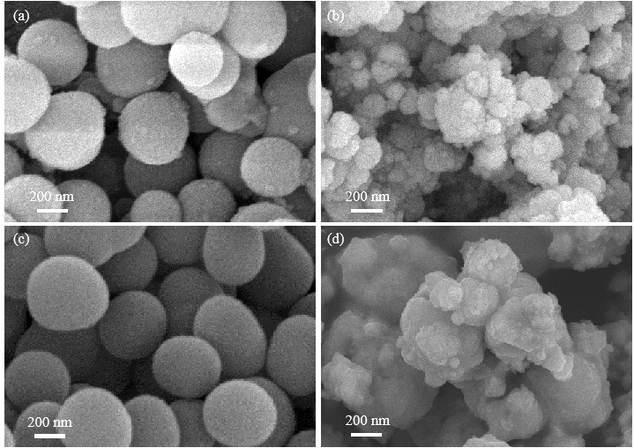
Fig. S1. SEM images: (a) PDA; (b) CoFe_{0.08}-ZIF; (c) NCS; (d) CoFe_{0.08}-NC.
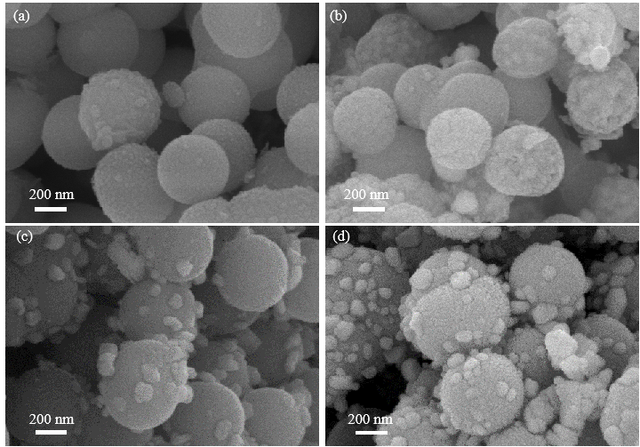
Fig. S2. SEM images: (a) Co-ZIF@PDA; (b) Co@NCS; (c) Fe-ZIF@PDA; (d) Fe@NCS.
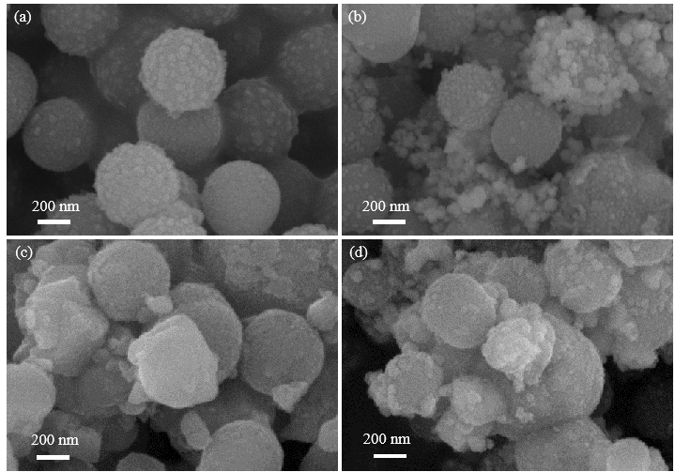
Fig. S3. SEM images: (a) CoFe_{0.04}-ZIF@PDA; (b) CoFe_{0.04}@NCS; (c) CoFe_{0.16}-ZIF@PDA; (d) CoFe_{0.16}@NCS.
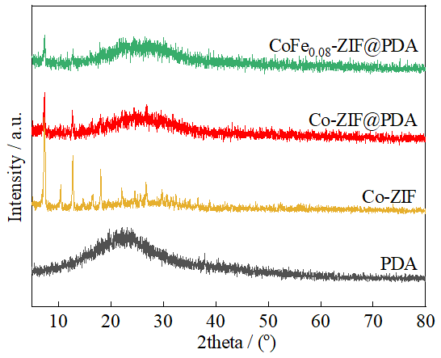
Fig. S4. XRD patterns of the precursors.
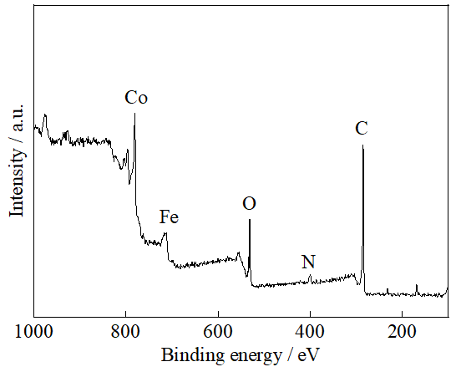
Fig. S5. XPS survey spectrum of CoFe_{0.08}@NCS.
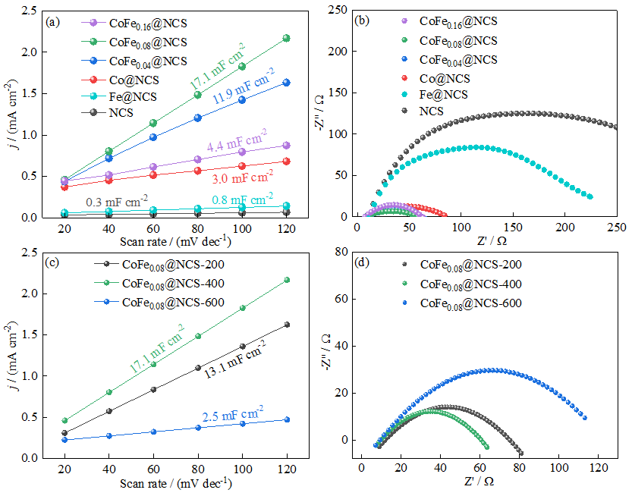
Fig. S6. (a,c) OER C_{dl} calculations and (b,d) EIS plots of catalysts in 1.0 M KOH electrolyte.

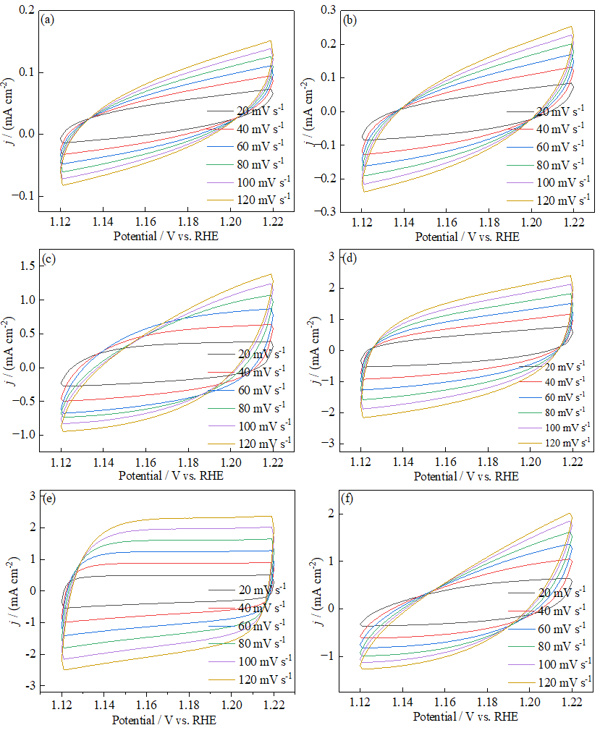
Fig. S7. OER CV curves at various scanning rates of the catalysts in an O₂-saturated 0.1 M KOH solution: (a) NCS; (b) Fe@NCS; (c) Co@NCS; (d) CoFe_{0.04}@NCS; (e) CoFe_{0.08}@NCS; (f) CoFe_{0.16}@NCS.

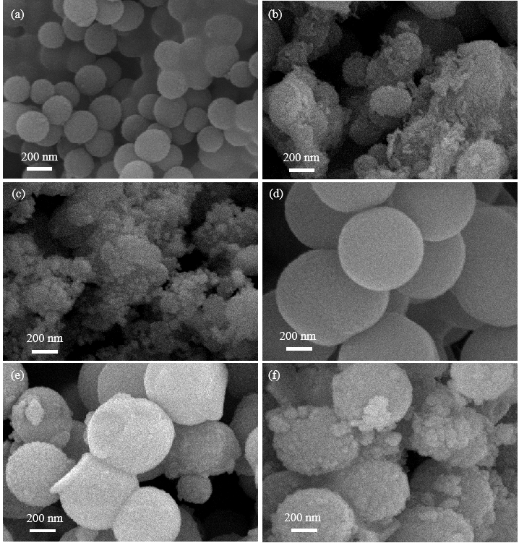
Fig. S8. SEM images: (a) 200 nm PDA; (b) CoFe_{0.08}-ZIF@PDA-200; (c) CoFe_{0.08}@NCS-200; (d) 600 nm PDA; (e) CoFe_{0.08}-ZIF@PDA-600; (f) CoFe_{0.08}@NCS-600.
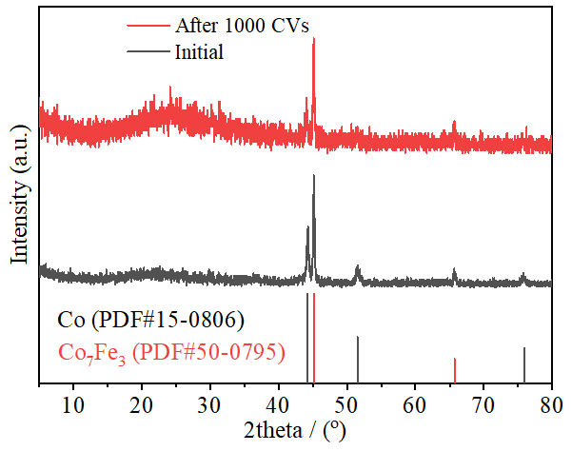
Fig. S9. XRD patterns of CoFe_{0.08}@NCS after 1000 cycles of OER CV scanning.
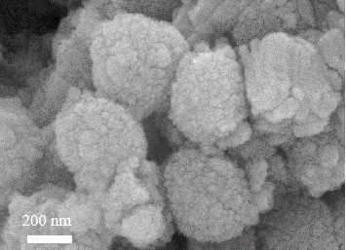
Fig. S10. SEM image of CoFe_{0.08}@NCS after 1000 cycles of OER CV scanning.
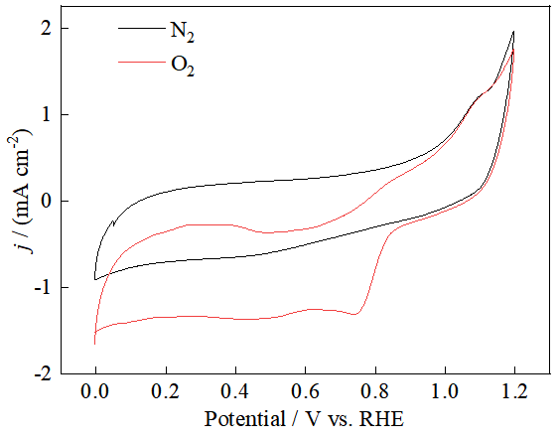
Fig. S11. CV curves of CoFe_{0.08}@NCS in N₂- and O₂-saturated 0.1 M KOH electrolytes with a scan rate of 50 mV s⁻¹.
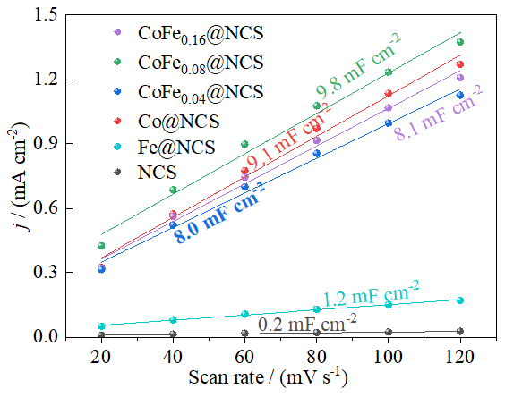
Fig. S12. ORR C_{dl} plots of the catalysts in an O₂-saturated 0.1 M KOH solution.

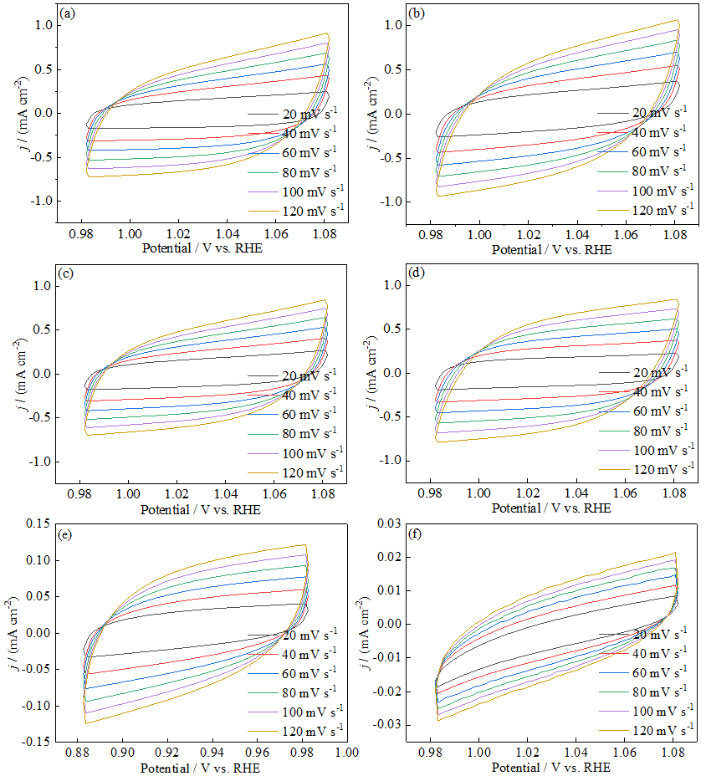
Fig. S13. ORR CV curves at various scanning rates of the catalysts in an O₂-saturated 0.1 M KOH solution: (a) CoFe_{0.16}@NCS; (b) CoFe_{0.08}@NCS; (c) CoFe_{0.04}@NCS; (d) Co@NCS; (e) Fe@NCS; (f) NCS.
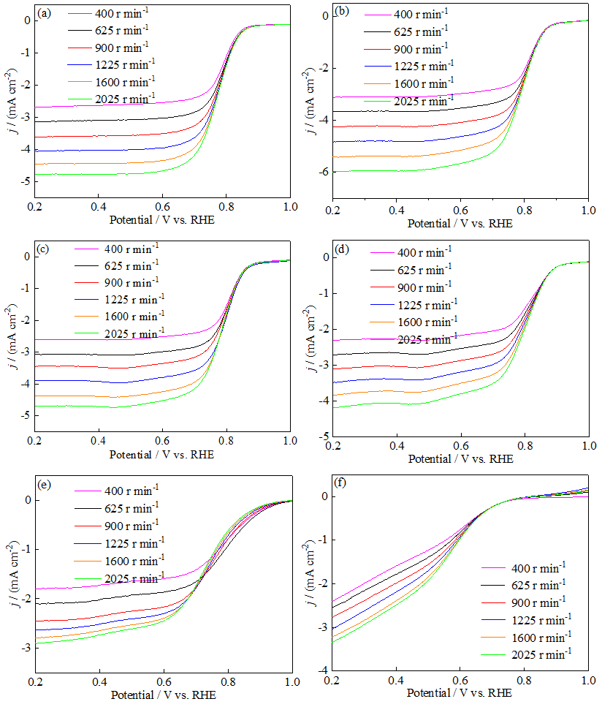
Fig. S14. Rotation speed-dependent ORR polarization curves of the catalysts in an O₂-saturated 0.1 M KOH solution: (a) CoFe_{0.16}@NCS; (b) CoFe_{0.08}@NCS; (c) CoFe_{0.04}@NCS; (d) Co@NCS; (e) Fe@NCS; (f) NCS.

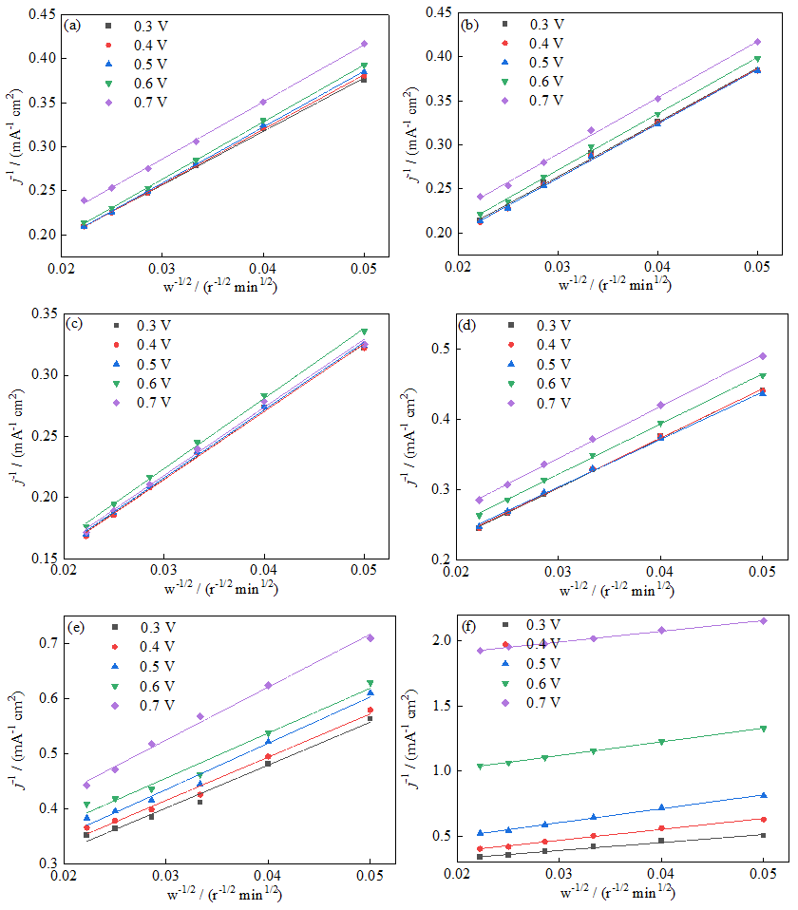
Fig. S15. K-L plots at different potentials of the catalysts: (a) CoFe_{0.16}@NCS; (b) CoFe_{0.08}@NCS; (c) CoFe_{0.04}@NCS; (d) Co@NCS; (e) Fe@NCS; (f) NCS.
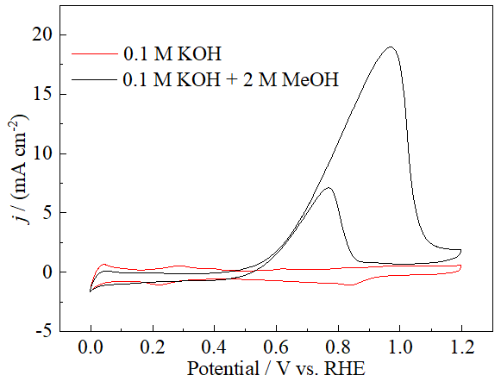
Fig. S16. CV curves of Pt/C in O₂-saturated 0.1 M KOH with/without 2 M methanol.
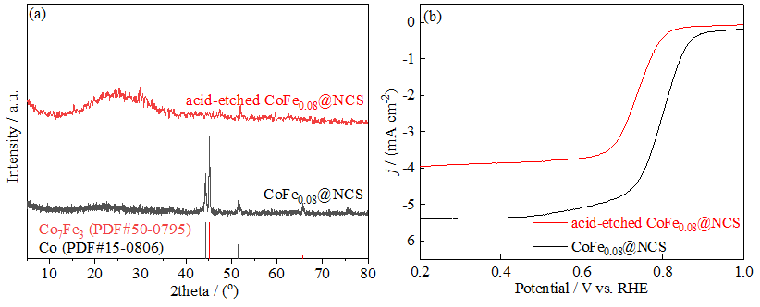
Fig. S17. (a) XRD pattern and (b) ORR LSV curve of acid-etched CoFe_{0.08}@NCS.

Table S1. Comparison of the ORR/OER activities of CoFe_{0.08}@NCS with recently reported CoFe-based bifunctional electrocatalysts
Catalyst | ORR: E_{1/2} / V | OER: E_{j=10} / V | Ref.
CoFe_{0.08}@NCS | 0.80 | 1.51 | This work
Co/CoFe@NC | 0.84 | 1.54 | [S1]
CoFe-Co_{5.47}N@NC | 0.79 | 1.63 | [S2]
CoFe@NP-CHS | 0.86 | 1.53 | [S3]
FeCo/NSC | 0.82 | 1.55 | [S4]
CoFe-Co₃C@NCNTs | 0.93 | 1.55 | [S5]
CoFe@N-CNTs | 0.85 | 1.54 | [S6]
CoFe@N-GCNCs | 0.80 | 1.50 | [S7]
CoFe/CN-C | 0.84 | 1.50 | [S8]
CoFe@N-CNWF | 0.80 | 1.55 | [S9]
WC/Co₇Fe₃-NPHC | 0.83 | 1.55 | [S10]
CoFe@NC-SE | 0.82 | 1.62 | [S11]
CoFe@NCNT/CFC | 0.87 | 1.51 | [S12]
CoFe/N-HCSs | 0.79 | 1.52 | [S13]
Co₇Fe₃/CFNC | 0.85 | 1.66 | [S14]

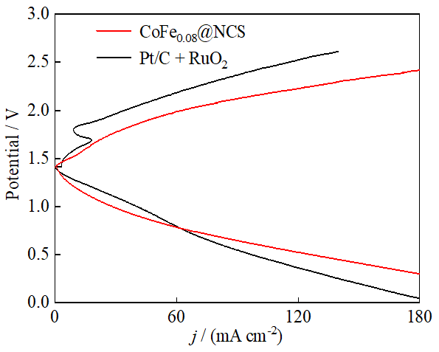
Fig. S18. Galvanodynamic charge and discharge polarization curves of CoFe_{0.08}@NCS- and (Pt/C+RuO₂)-based ZABs at 10 mA cm⁻².
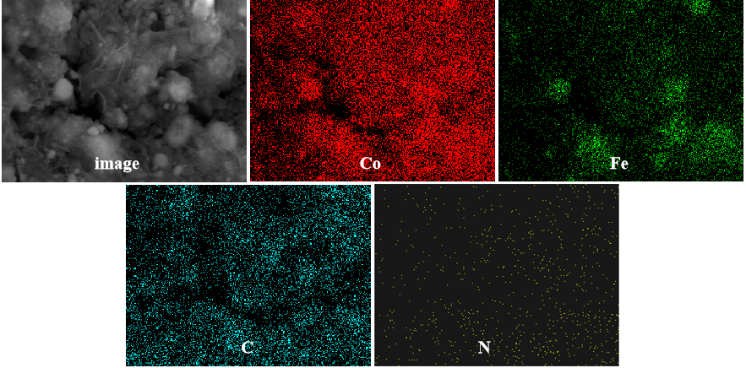
Fig. S19. Elemental mapping distribution images of CoFe_{0.08}@NCS air-cathode catalyst after a long-cycle ZAB operation.
Table S2. Performance of liquid-state rechargeable ZABs assembled with CoFe_{0.08}@NCS and reported CoFe-based electrocatalysts
Catalyst | ∆E (= E_{j=10} − E_{1/2}) / V | Peak power density /  (mW cm⁻²) | Charge/discharge  voltage gap / V | Specific capacity  / (mAh g_{Zn}⁻¹) | Stability | Ref.
CoFe_{0.08}@NCS | 0.71 | 157 | 0.94@10 mA cm⁻² | 783@10 mA cm⁻² | Life time of over 150 h@10 ma cm⁻² | This work
Fe,Co,N-C | 0.74 | 198 | 0.90@10 mA cm⁻² | 726@2 mA cm⁻² | Life time of over 51 h@5 ma cm⁻² | [S15]
FeCo/NUCSs | 0.65 | 152 | 0.64@10 mA cm⁻² | 792@10 mA cm⁻² | Life time of over 102 h@10 ma cm⁻² | [S16]
A-FeCo@NCNs | 0.80 | 132 | 0.81@10 mA cm⁻² | 736@10 mA cm⁻² | Life time of over 150 h@2 ma cm⁻² | [S17]
FeCoNC/D | 0.70 | 157 | 0.70@10 mA cm⁻² | 725@10 mA cm⁻² | Life time of over 40 h@10 ma cm⁻² | [S18]
CoFe/Co@NCNT | 0.74 | 161 | 0.82@20 mA cm⁻² | N/A | Life time of over 300 h@20 ma cm⁻² | [S19]
CoFe-NCNFs | 0.70 | 116 | 0.70@10 mA cm⁻² | N/A | Life time of over 110 h@5 ma cm⁻² | [S20]
FeCo-NPC | 0.69 | 301 | 0.63@5 m A cm⁻² | 735@5 mA cm⁻² | Life time of over 200 h@5 ma cm⁻² | [S21]
NSCA/FeCo | 0.72 | 132 | 0.82@10 mA cm⁻² | 805@20 mA cm⁻² | Life time of over 120 h@10 ma cm⁻² | [S22]
FeCo/N-CF | 0.79 | 172 | 0.98@5 mA cm⁻² | 811@5 mA cm⁻² | Life time of over 1000 h@5 ma cm⁻² | [S23]
FeCo-LCNT | 0.74 | 127 | 0.85@5 mA cm⁻² | 818@5 mA cm⁻² | Life time of over 1100 h@5 ma cm⁻² | [S24]
CoFe@NOC | 0.69 | 206 | ~0.86@10 mA cm⁻² | 830@5 mA cm⁻² | Life time of over 100 h@10 ma cm⁻² | [S25]
FeCo/NUCSs | 0.89 | 152 | ~1.20@10 mA cm⁻² | 792@10 mA cm⁻² | Life time of over 100 h@10 ma cm⁻² | [S26]
FeCo/PNSC | 0.67 | 145 | ~0.60@10 mA cm⁻² | N/A | Life time of over 190 h@10 ma cm⁻² | [S27]
CoFe/C | 0.81 | 199 | 0.72@10 mA cm⁻² | 792@50 mA cm⁻² | Life time of over 350 h@10 ma cm⁻² | [S28]
Co₃Fe₇-PCNF | 0.80 | 213 | 0.90@5 mA cm⁻² | 722@5 mA cm⁻² | Life time of over 300 h@5 ma cm⁻² | [S29]
CoFe/NC | N/A | 173 | 0.84@10 mA cm⁻² | N/A | Life time of over 230 h@10 ma cm⁻² | [S30]
CoFe@NC/WC | 0.74 | 139 | ~1.00@5 mA cm⁻² | N/A | Life time of over 240 h@5 ma cm⁻² | [S31]

References
[S1] Y.L. Niu, X. Teng, S.Q. Gong, M.Z. Xu, S.G. Sun, and Z.F. Chen, Engineering two-phase bifunctional oxygen electrocatalysts with tunable and synergetic components for flexible Zn-air batteries, Nano-Micro Lett., 13(2021), p. 126.
[S2] J.H. Zhang, J.L. Liu, B.W. Liu, X.L. Lin, and Y.L. Qin, CoFe-Co_{x}N heterojunction encapsulated by lignin-derived nitrogen-doped biochar as bifunctional oxygen electrocatalysts for zinc-air batteries, Chem. Eng. Sci., 280(2023), p. 119049.
[S3] H.J. Niu, S.S. Chen, J.J. Feng, L. Zhang, and A.J. Wang, Assembled hollow spheres with CoFe alloyed nanocrystals encapsulated in N, P-doped carbon nanovesicles: An ultra-stable bifunctional oxygen catalyst for rechargeable Zn-air battery, J. Power Sources, 475(2020), p. 228594.
[S4] S.M. Chang, H. Zhang, and Z.Y. Zhang, FeCo alloy/N, S dual-doped carbon composite as a high-performance bifunctional catalyst in an advanced rechargeable zinc-air battery, J. Energy Chem., 56(2021), p. 64.
[S5]X. Meng, J.H. Xie, J. Liu, B. Liu, R.Y. Wang, P. Gu, F.W. Ma, X.Y. Wang, and J.L. Zou, Co₃C-stabilized-CoFe heterostructure wrapped by bamboo-like N-doped carbon nanotubes for highly-efficient oxygen electrocatalysis, Chem. Eng. J., 459(2023), p. 141591.
[S6] P.F. Guo, R.B. Wu, B. Fei, J. Liu, D. Liu, X.X. Yan, and H.G. Pan, Multifunctional bayberry-like composites consisting of CoFe encapsulated by carbon nanotubes for overall water splitting and zinc-air batteries, J. Mater. Chem. A, 9(2021), p. 21741.
[S7] H.J. Niu, Y.P. Chen, R.M. Sun, A.J. Wang, L.P. Mei, L. Zhang, and J.J. Feng, Prussian blue analogue-derived CoFe nanocrystals wrapped in nitrogen-doped carbon nanocubes for overall water splitting and Zn-air battery, J. Power Sources, 480(2020), p. 229107.
[S8] C.H. Li, E.H. Zhou, Z.Y. Yu, H.X. Liu, and M. Xiong, Tailor-made open porous 2D CoFe/SN-carbon with slightly weakened adsorption strength of ORR/OER intermediates as remarkable electrocatalysts toward zinc-air batteries, Appl. Catal. B-Environ., 269(2020), p. 118771.
[S9] Q.X. Zhou, L. Ai, Q.X. Li, S.Y. Hou, L. Xu, D.M. Sun, H.P, K. Huang, and Y.W. Tang, A ''Ship-in-a-Bottle'' strategy to anchor CoFe nanoparticles inside carbon nanowall-assembled frameworks for high-efficiency bifunctional oxygen electrocatalysis, Chem. Eng. J., 417(2021), p. 127895.
[S10] H. M. Mao, X.B. Liu, S.Q. Wu, Y.X. Fu, G.S. Liu, G.Z. Zhou, and L. Wang, WC/Co7Fe3 heterojunction embedded in N,P co-doped hierarchical carbon enables rechargeable/flexible Zn-air battery, Nano Res., 16(2023), No. 2, p. 2519.
[S11] A. Samanta, and C.R. Raj, Bifunctional nitrogen-doped hybrid catalyst based on onion-like carbon and graphitic carbon encapsulated transition metal alloy nanostructure for rechargeable zinc-air battery, J. Power Sources, 455(2020), p. 227975.
[S12] L.N. Liu, X. Zhang, F. Yan, B. Geng, C.L. Zhu, Y.J. Chen, Self-supported N-doped CNT arrays for flexible Zn-air batteries, J. Mater. Chem. A, 8(2020), p. 18162.
[S13] J. M. Li, Y.M. Kang, W.L. Wei, X. Li, Z.Q. Lei, and P. Liu, Well-dispersed ultrafine CoFe nanoalloy decorated N-doped hollow carbon microspheres for rechargeable/flexible Zn-air batteries, Chem. Eng. J., 407(2021), p. 127961.
[S14] T.X. Tu, X. Zhou, P.F. Zhang, L. Tan, Z.F. Xu, M.Q. Liu, W.Y. Li, X.M. Kang, Y.J. Wu, and J.Z. Zheng, Co₇Fe₃ Nanoparticles confined in N-doped carbon nanocubes for highly efficient, rechargeable zinc-air batteries, ACS Sustainable Chem. Eng., 10(2022), No. 27, p. 8694.
[S15] S. Sarkar, A. Biswas, E.E. Siddharthan, R. Thapa, and R.S. Dey, Strategic modulation of target-specific isolated Fe,Co single-atom active sites for oxygen electrocatalysis impacting high power Zn-air battery, ACS Nano, 16(2022), No. 5, p. 7890.
[S16] X.Q. Xu, J.H. Xie, B. Liu, R.Y. Wang, M.Y. Liu, J. Zhang, J. Liu, Z. Cai, and J.L. Zou, PBA-derived FeCo alloy with core-shell structure embedded in 2D N-doped ultrathin carbon sheets as a bifunctional catalyst for rechargeable Zn-air batteries, Appl. Catal. B-Environ., 316(2022), p. 121687.
[S17] Y. Luo, J. Zhang, J.W. Chen, Y.H. Chen, C.Y. Zhang, Y.J. Luo, G. Wang, and R.L. Wang, Bi-functional electrocatalysis through synergetic coupling strategy of atomically dispersed Fe and Co active sites anchored on 3D nitrogen-doped carbon sheets for Zn-air battery, J. Catal., 397(2021). p. 223.
[S18] K. Kim, K. Min, Y. Go, Y. Lee, S.E. Shim, D. Lim, and S.H. Baeck, FeCo alloy nanoparticles embedded in N-doped carbon supported on highly defective ketjenblack as effective bifunctional electrocatalysts for rechargeable Zn-air batteries, Appl. Catal. B-Environ., 315(2022), p. 121501.
[S19] P. Zhu, J.X. Gao, S. Liu, Facile in situ coupling CoFe/Co nanoparticles and N-doped carbon nanotubes/graphitic nanosheets as bifunctional oxygen electrocatalysts for rechargeable Zn-air batteries, J. Power Sources, 449(2020), p. 227512.
[S20] S.Y. Lin, Y.P. Chen, Y. Cao, L. Zhang, J.J. Feng, and A.J. Wang, Aminouracil-assisted synthesis of CoFe decorated bougainvillea-like N-doped carbon nanoflowers for boosting Zn-air battery and water electrolysis, J. Power Sources, 521(2022), p. 230926.
[S21] Y. Zhou, Y.K. Liu, Z.L. Wang, C.Y. Li, Z.Y. Wang, S. Zhang, and C. Deng, Fe-Co dual atomic doublets on N, P codoped carbon as active sites in the framework of heterostructured hollow fibers towards high-performance flexible Zn-Air battery, Energy Storage Mater., 59(2023), p. 102772.
[S22] Y.W. Zhang, X.F. Zhang, Y.T. Li, J. Wang, S. Kawi, and Q. Zhong, FeCo alloy/N, S co-doped carbon aerogel derived from directional casting cellulose nanofibers for rechargeable liquid flow and flexible Zn-air batteries, Nano Res., 16(2023), p. 6870.
[S23] Y.S. Deng, J.H. Zheng, B. Liu, H.M. Li, M. Yang, and Z.Y. Wang, Schiff-base polymer derived FeCo-N-doped porous carbon flowers as bifunctional oxygen electrocatalyst for long-life rechargeable zinc-air batteries, J. Energy Chem., 76(2023), p. 470.
[S24] Y.S. Deng, J.H. Zheng, B. Liu, Y.J. Liu, H.M. Li, and M. Yang, Schiff-base polymer derived ultralong FeCo/N-doped carbon nanotubes as bifunctional oxygen electrocatalyst for liquid and flexible all-solid-state rechargeable zinc-air batteries, Carbon, 210(2023), p. 118000.
[S25] J.J. Zhang, F.M. Tang, K.C. Wan, Y.G. Yang, C.M. Zhang, P.W. Ming, and B. Li, MOF-derived CoFe alloy nanoparticles encapsulated within N,O Co-doped multilayer graphitized shells as an efficient bifunctional catalyst for zinc--air batteries, J. Mater. Chem., A10(2022), No. 28, p. 14866.
[S26] X.Q. Xu, J.H. Xie, B. Liu, R.Y. Wang, M.Y. Liu, J. Zhang, J. Liu, Z. Cai, and J.L. Zou, PBA-derived FeCo alloy with core-shell structure embedded in 2D N-doped ultrathin carbon sheets as a bifunctional catalyst for rechargeable Zn-air batteries, Appl. Catal. B-Enrivon., 316(2022), p. 121687.
[S27] M.H. Wang, H. Wang, J.W. Ren, X.Y. Wang, and R.F. Wang, FeCo nanoclusters inserted N,S -doped carbon foams as bifunctional electrocatalyst for high-performance rechargeable Zn-air batteries, J. Power Sources, 538(2022), p. 231592.
[S28] M.L. Jiao, Q. Zhang, C.L. Ye, R.H. Gao, L.X. Dai, and G.M. Zhou, Isolating contiguous Fe atoms by forming a Co-Fe intermetallic catalyst from spent lithium-ion batteries to regulate activity for zinc-air batteries, ACS Nano, 16(2022), No. 8, p. 13223.
[S29] M.M. Liu, Y.L. He, and J.T. Zhang, Co₃Fe₇ nanoparticles encapsulated in porous nitrogen-doped carbon nanofibers as bifunctional electrocatalysts for rechargeable zinc-air batteries, Mater. Chem. Front., 5(2021), No. 17, p. 6559.
[S30] Z.Y. Du, P. Yu, L. Wang, C.G. Tian, X. Liu, G.Y. Zhang, and H.G. Fu, Cubic imidazolate frameworks-derived CoFe alloy nanoparticles-embedded N-doped graphitic carbon for discharging reaction of Zn-air battery, Sci. China Mater., 63(2020), p. 327.
[S31] K.L. Ao, X.Y. Zhang, R.R. Nazmutdinov, D. Wang, J.H. Shi, X. Yue, J.G. Sun, W. Schmickler, and W.A. Daoud, Hierarchical CoFe@N-doped carbon decorated wood carbon as bifunctional cathode in wearable Zn-air battery, Energy Environ. Mater., 7(2024), No.1, p. e12499.

