**Supporting Information**

**Polypyrrole-coated triple-layer yolk-shell Fe2O3 anode materials with their enhanced cycling stability and capacity in lithium-ion batteries**

*Zhen He*1), *Jiaming Liu*1), *Yuqian Wei*1), *Yunfei Song*1), *Wuxin Yang*2), *Aobo Yang*2), *Yuxin Wang*1),🖂, *and Bo Li*2),🖂

1) School of Materials Science and Engineering, Jiangsu University of Science and Technology, Zhenjiang 212000, China

2) Department of Chemical &Materials Engineering, the University of Auckland, Auckland 1010, New Zealand

(Received: 22 February 2024; revised: 31 May 2024; accepted: 6 June 2024)

Corresponding authors: Yuxin Wang E-mail: [ywan943@163.com;](mailto:ywan943@163.com;(Yuxin) Bo Li E-mail: [bli219@aucklanduni.ac.nz](mailto:bli219@aucklanduni.ac.nz)



**Fig. S1.** Scanning electron microscopy (SEM) image of carbon sphere acted as a template, *d*: diameter.

The cyclic voltammetry (CV) curve of the Fe2O3-TLY in Fig. S2 demonstrates a pronounced reduction peak at 0.75 V during the initial cathodic scan. This substantial reduction peak is attributed to the embedding of Li+ ions, forming Li*x*Fe2O3, followed by a conversion reaction where Fe3+/Fe2+ is reduced to Fe [1]. Subsequent irreversible reduction peaks at 1.03 V and 1.63 V are owing to the formation of the solid electrolyte interface (SEI) layer [2] and Li+ insertion into the Fe2O3 lattices [3]. In the anodic scan, reversible oxidation peaks at 1.68 V and 1.86 V correspond to the delithiation process where Fe is oxidized to Fe3+[4]. In subsequent cycles, the reduction and oxidation peaks stabilize around 0.80 V and 1.56 V, indicating good redox reversibility [5]. The prominent reduction peak shifts from 0.75 V to 0.80 V, and the peak height decreases due to irreversible structural rearrangement and electrolyte loss during the formation of the SEI layer in the first cycle.



**Fig. S2.**  CV curve of the Fe2O3-TLY electrode at a scan rate of 0.1 mV·s−1.

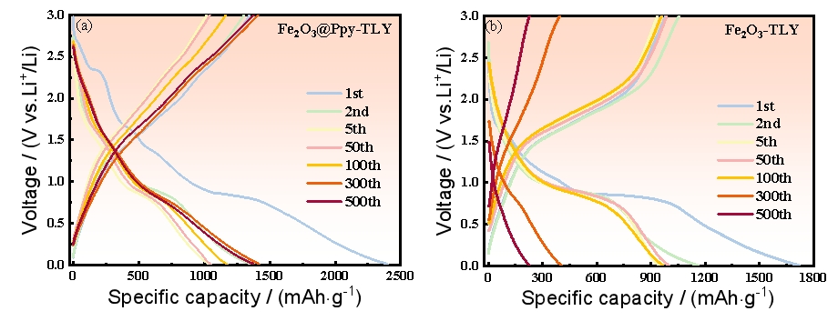

**Fig. S3.** Charge–discharge curves of the (a) Fe2O3@Ppy-TLY and (b) Fe2O3-TLY electrodes at 1 C running after different cycles.

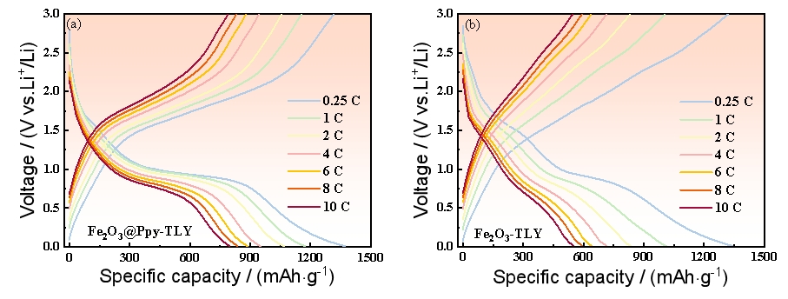

**Fig. S4.** Charge–discharge curves of the (a) Fe2O3@Ppy-TLY and (b) Fe2O3-TLY electrodes at different current densities.



**Fig. S5.** Long cycling performance of Fe2O3@Ppy-TLY electrode at 6 C, after rate performance test.

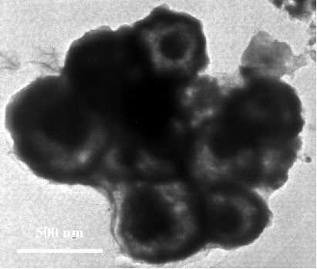

**Fig. S6.** Transmission electron microscopy (TEM) image of Fe2O3@Ppy-TLY electrode after 50 cycles at 0.2 C.

Table S1. Impedance parameters recorded on Fe2O3@Ppy-TLY and Fe2O3-TLY electrodes before and after 250 cycles

|  |  |  |  |  |
| --- | --- | --- | --- | --- |
| Situation | Sample | *R*ct / Ω | CPE1 / F | CPE1 / F |
| After cycling | Fe2O3@Ppy-TLY | 22.01 | 3.05×10−5 | 0.82 |
| Fe2O3-TLY | 193.7 | 5.15×10−5 | 0.70 |
| Before cycling | Fe2O3@Ppy-TLY | 51.35 | 4.89×10−5 | 0.75 |
| Fe2O3-TLY | 74.74 | 5.16×10−5 | 0.71 |

CPE1 represents capacitance, and CPE2 is the degree of similarity to a pure capacitor; *R*ct is the charge transfer impedance.

**References**

[1] F.X. Ma, H.B. Wu, C.Y. Xu, L. Zhen and X.W. (David) Lou, Self-organized sheaf-like Fe3O4/C hierarchical microrods with superior lithium storage properties, *Nanoscale*, 7(2015), No.10, p.4411.

[2] Z.C. Yang, J.G. Shen, and L.A. Archer, An *in situ* method of creating metal oxide–carbon composites and their application as anode materials for lithium-ion batteries, *J*. *Mater*. *Chem*., 21(2011), No. 30, p. 11092.

[3] J.Y. Mao, D.C. Niu, N. Zheng, *et al.*, Fe3O4-embedded and N-doped hierarchically porous carbon nanospheres as high-performance lithium ion battery anodes, *ACS Sustainable Chem*. *Eng*., 7(2019), No. 3, p. 3424.

[4] Y. Yang, J.Q. Li, D.Q. Chen, and J.B. Zhao, A facile electrophoretic deposition route to the Fe3O4/CNTs/rGO composite electrode as a binder-free anode for lithium ion battery, *ACS Appl*. *Mater*. *Interfaces*, 8(2016), No. 40, p. 26730.

[5] P. Huang, W. Tao, H.X. Wu, *et al.*, N-doped coaxial CNTs@α-Fe2O3@C nanofibers as anode material for high performance lithium ion battery, *J*. *Energy Chem*., 27(2018), No. 5, p. 1453.