Supporting Information

Constructing Al@C–Sn pellet anode without passivation layer for lithium-ion battery
Kangzhe Cao^{1,2,3)}, Sitian Wang¹⁾, Yanan He¹⁾, Jiahui Ma¹⁾, Ziwei Yue¹⁾, and Huiqiao Liu^{1,2),}

1) College of Chemistry and Chemical Engineering, Xinyang Normal University, Xinyang 464000, China
2) Xinyang Key Laboratory of Low-Carbon Energy Materials, Xinyang 464000, China
3) Henan Province Key Laboratory of Utilization of Non‐Metallic Mineral in the South of Henan, Xinyang 464000, China
(Received: 16 June 2023; revised:2 August 2023; accepted: 7 August 2023)
Corresponding author: Huiqiao Liu E-mail: liuhq@xynu.edu.cn

Experimental section
Material characterization
The phases of the Al pellets and the as-prepared hybrid products were determined by X-ray diffraction (XRD, Rigaku Miniflex 600X, λ = 1.5406 Å). The samples were scanned at a rate of 5 °·min^{–1} and a step of 0.01°. The valence state and chemical composition of the products were revealed by an X-ray photoelectron spectrometer (XPS, K-Alpha+, Thermo Scientific) using Al Kα radiation. Their morphologies and microstructures were investigated by scanning electron microscopy (SEM, S4800) and transmission electron microscopy (TEM, Tecnai G2 F20). The elemental mapping of the products was analyzed by the energy-dispersive X-ray spectroscopy (EDX) equipped on the TEM.
Electrochemical measurements
The electrochemical performances of samples were evaluated using coin-type half cells (CR2032), which were assembled in a glove box (Ar-filled, H₂O < 0.1 ppm, and O₂ < 0.1 ppm). Typically, the as-prepared products, Super P carbon, and sodium carboxymethylcellulose (CMC) were mixed with H₂O at a weight ratio of 7:2:1 to a homogeneous seriflux and then coated onto copper foil. After being dried in a vacuum, active materials loaded on copper foils were used as working electrodes. The mass loadings of the electrodes for testing were ~1.00 mg·cm^{–2}, which were measured by a microbalance (Mettler, MS105DU) with an accuracy of 0.01 mg. A lithium metal foil was used as the counter electrode and reference electrode. A commercial separator (Celgard 2320 membrane) was selected as the separator, which was cut into a disk with a diameter of 18 mm. 1 M LiPF₆ into a mixture of ethylene carbonate (EC) and diethyl carbonate with the volume ratio of 1:1 was chosen as the electrolyte. The cells were aged for 8.0 h to ensure sufficient infiltration of the electrolyte before measurement. Cyclic voltammetry (CV) testing with a cut-off voltage window of 3.00–0.01 V (vs. Li⁺/Li, 0.1 mV·s^{–1}) and electrochemical impedance spectroscopy (EIS) data in the frequency of 0.1 Hz to 100 kHz were both performed on a CHI760e electrochemical workstation (Chenhua, Shanghai, China). Galvanostatic discharge–charge tests were carried out using a Land Battery Measurement system (Land CT3001A, Wuhan, China) at about 25°C.

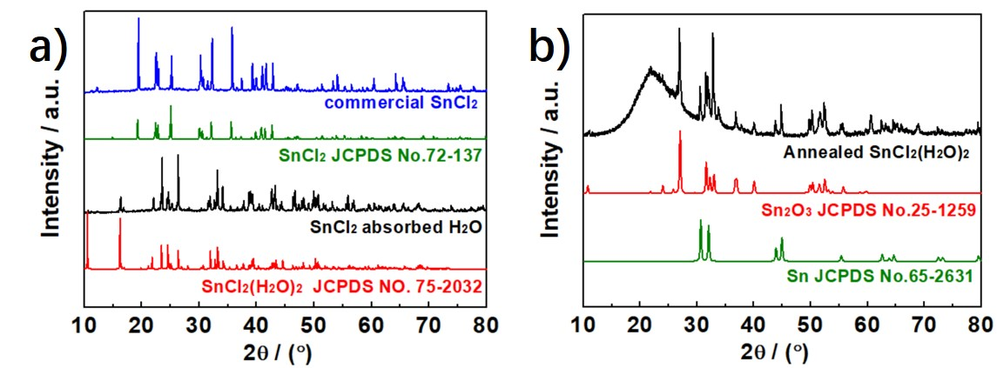
Fig. S1. XRD patterns of the (a) commercial SnCl₂ and its counterpart absorbed H₂O, and (b) the residues of the annealed SnCl₂(H₂O)₂.
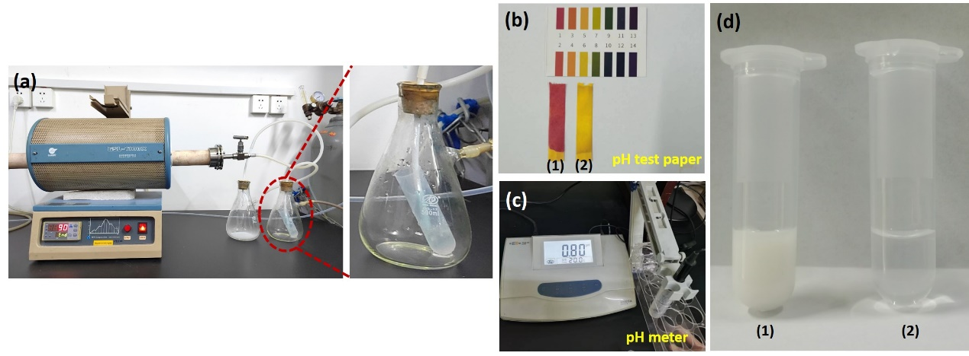
Fig. S2. Photographs of (a) tail gas treatment, (b) pH test paper, (c) pH meter when testing the tail gas absorbed H₂O, and (d) Cl– detecting experiment. The insets of (b) and (d) are the (1) tail gas absorbed H₂O and (2) deionized H₂O, respectively. Typically, 0.1 mL AgNO₃ (1.0 mol·L^{–1}) was added to 1.0 mL solution (1) and (2) when detecting Cl–, respectively. The strong acidity of the solution and AgCl precipitation indicate that the tail gas contains HCl.
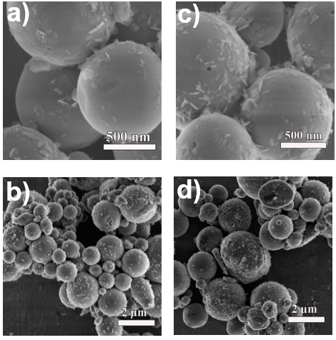
Fig. S3. SEM images of (a–b) the Al-500 and (c–d) commercial Al pellets
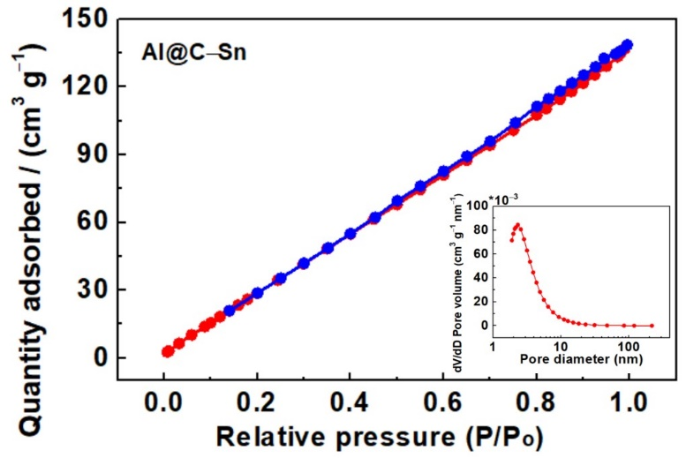
Fig. S4. N₂ adsorption–desorption isothermal curves and the corresponding pore size distributions of the as-prepared Al@C–Sn pellets.
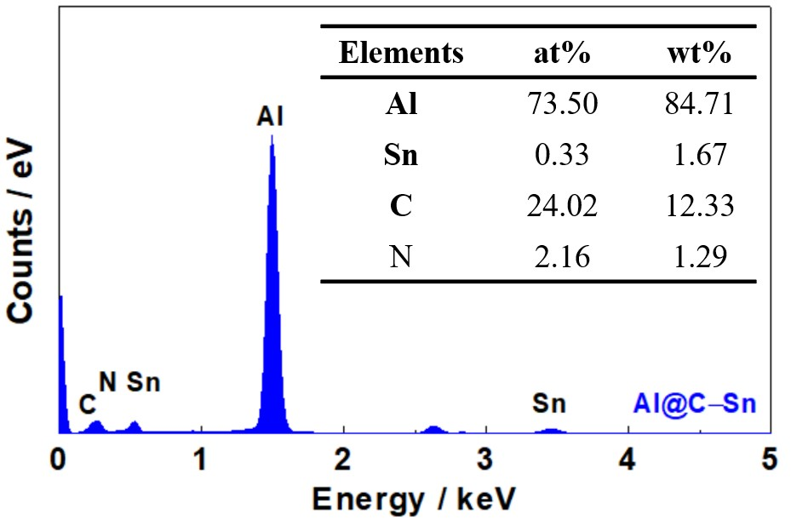
Fig. S5. EDS of the as-prepared Al@C–Sn pellets and the corresponding atom and weight percentages.
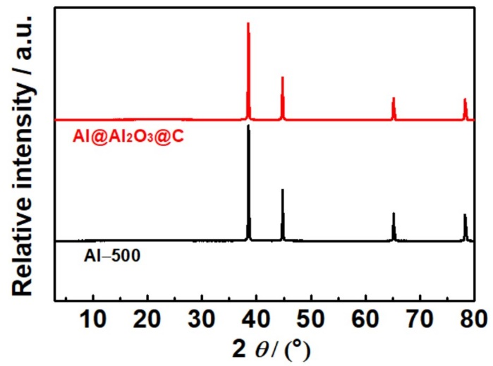
Fig. S6. XRD patterns of the Al-500 and Al@Al₂O₃@C pellets.
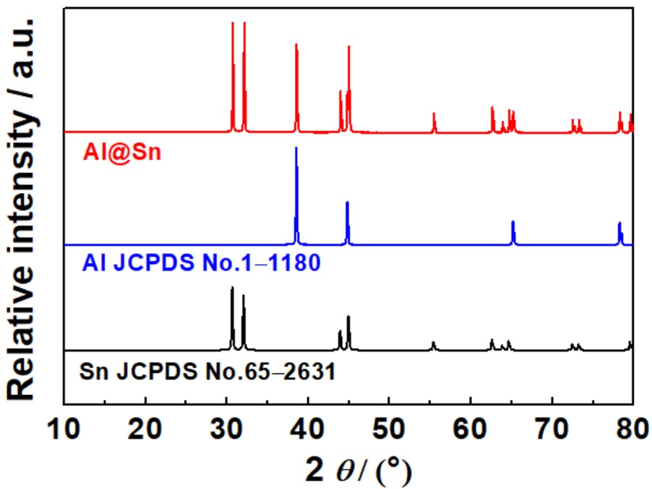
Fig. S7. XRD patterns of the Al@Sn pellets

Table S1. Comparison of Li-ion storage performance for Al based anode materials
Materials | Specific capability | Refs.
70 at% Al–30 at% Si alloy | 1030 mAh·g⁻¹ at 0.05 C (50 cycles) | [1]
Sn–18 wt% Al film | 822 mAh·g⁻¹ at 0.6 A·g⁻¹ (2nd cycle)  420 mAh·g⁻¹ at 3.0 A·g⁻¹ | [2]
Al@C/Expanded Graphite | 498.7 mAh·g⁻¹ at 0.05 A·g⁻¹  (50 cycles) | [3]
Al–NS–CNTs | 990 mAh·g⁻¹ at 1 C (0.13 A·g⁻¹)  524.6 mAh·g⁻¹ at 24 C | [4]
electrodeposited Al film | 1492 mAh·g⁻¹ at 0.1 A·g⁻¹ (1st discharge)  707.9 mAh·g⁻¹ at 0.1 A·g⁻¹ (1st charge) | [5]
Al–Fe/C nanocomposite | 927 mAh·g⁻¹ at 0.1 A·g⁻¹ (600 cycles)  550 mAh·g⁻¹ at 5.0 A·g⁻¹ | [6]
mp-Al@G | 1020 mAh·g⁻¹ at 0.05 A·g⁻¹ (100 cycles)  735 mAh·g⁻¹ at 2.0 A·g⁻¹ (300 cycles) | [7]
EG–MNPs–Al electrode | 403.2 mAh·g⁻¹ at 0.1 A·g⁻¹ (300 cycles)  270 mAh·g⁻¹ at 1.0 A·g⁻¹ (10 cycles) | [8]
Al@C–Sn pellets | 753.9 mAh·g⁻¹ at 0.1 A·g⁻¹ (100 cycles)  295.0 mAh·g⁻¹ at 2.0 A·g⁻¹ (1000 cycles) | This work
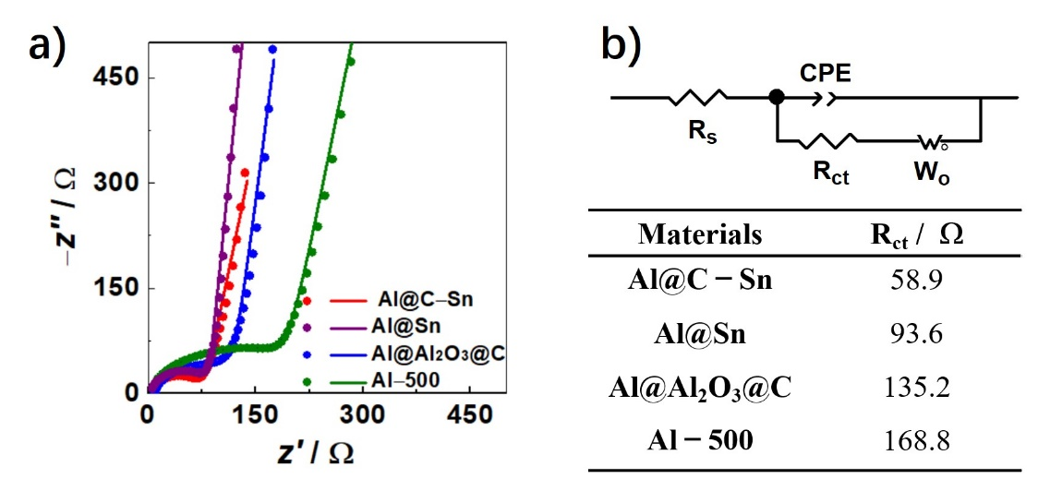
Fig. S8. (a) Electrochemical impedance spectra and (b) equivalent circuit along with the R_{ct} values of the Al@C–Sn electrode and its counterparts.
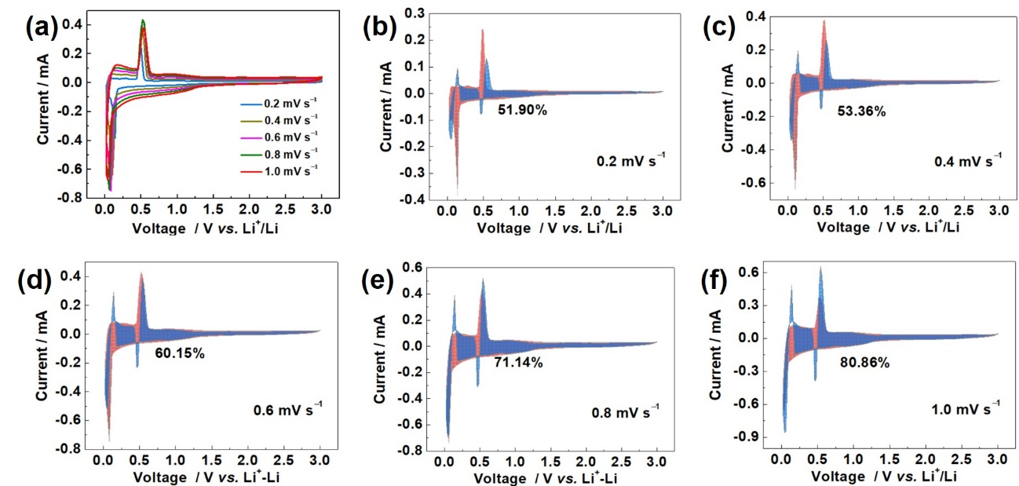
Fig. S9. (a) CV curves at different scan rates, and (b–f) capacitive contribution of at 0.2–1.0 mV·s^{–1} of the Al-500 pellets.
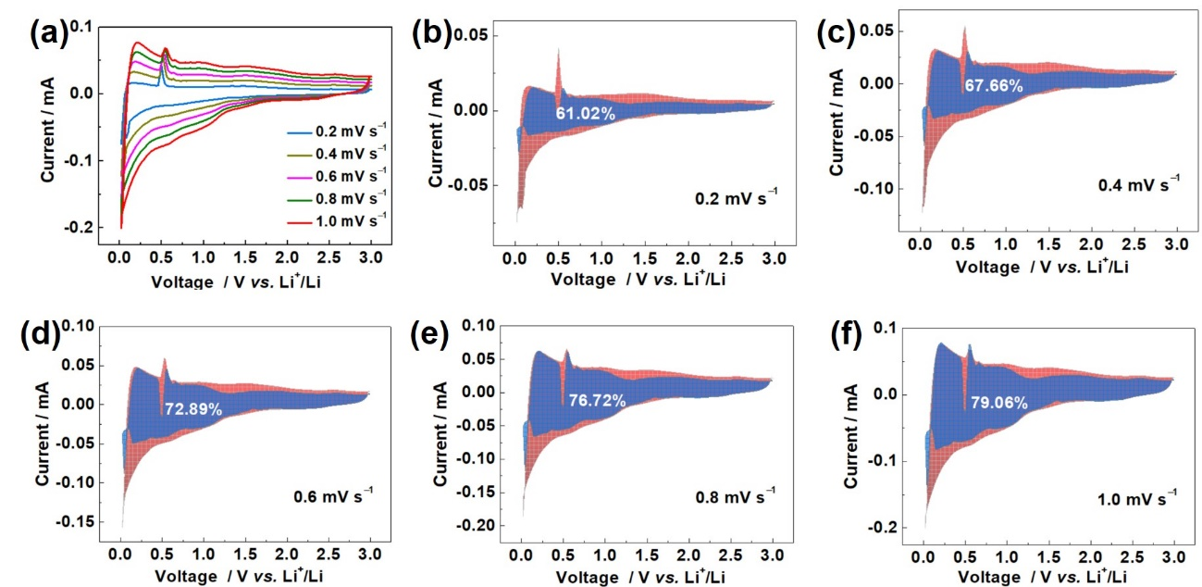
Fig. S10. (a) CV curves at different scan rates, and (b–f) capacitive contribution of at 0.2–1.0 mV·s^{–1} of the Al@Al₂O₃@C pellets.

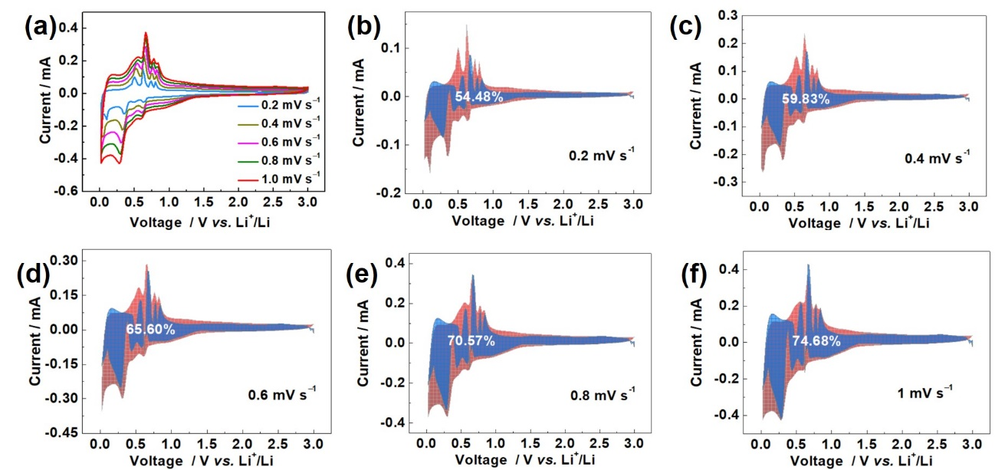
Fig. S11. (a) CV curves at different scan rates, and (b–f) capacitive contribution of at 0.2–1.0 mV·s^{–1} of the Al@Sn pellets electrode.
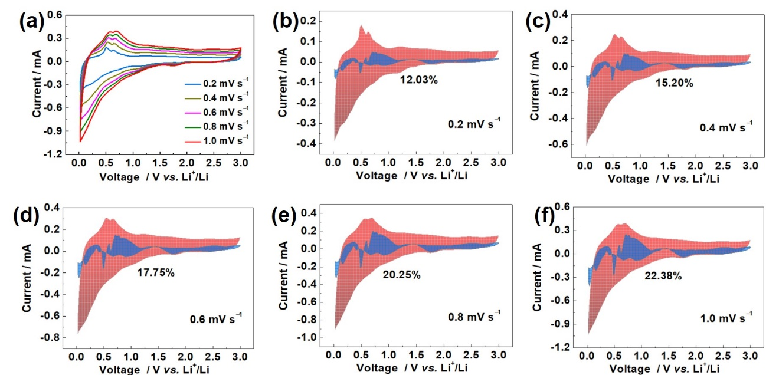
Fig. S12. (a) CV curves at different scan rates, and (b–f) capacitive contribution of at 0.2–1.0 mV·s^{–1} of the Al@C–Sn pellets electrode.

References
[1] M. Tahmasebi，D. Kramer，H. Gewein，et al., In situ formation of aluminum–silicon–lithium active materials in aluminum matrices for lithium-ion batteries, J. Mater. Chem. A, 8(2020), No.9, p. 4877.
[2] L. Wei，K. Zhang，Z.L. Tao, and J. Chen, Sn–Al core–shell nanocomposite as thin film anode for lithium-ion batteries, J. Alloys Compd., 644(2015), p. 742.
[3] Y. Huang，X. Lin，Q. Pan，et al., Al@C/expanded graphite composite as anode material for lithium ion batteries, Electrochimica Acta, 193(2016), p. 253.
[4] X. Sun，C. Yang，Y. Zhao，et al., Ultrathin aluminum nanosheets grown on carbon nanotubes for high performance lithium ion batteries, Adv. Funct. Mater., 32(2022), No.8, art. No. 2109112.
[5] Y. Yang，S. Liu，C. Chi，et al., Electrodeposition of a continuous, dendrite-free aluminum film from an ionic liquid and its electrochemical properties, J. Mater. Sci., 31(2020), No.12, p. 9937.
[6] X. Chang，Z. Xie，Z. Liu，X. Zheng，J. Zheng, and X. Li, Aluminum: An underappreciated anode material for lithium-ion batteries, Energy Storage Mater., 25(2020), p. 93.
[7] H. Zhang，G. Xia，F. Fang，D. Sun, and X. Yu, Low-temperature electroless synthesis of mesoporous aluminum nanoparticles on graphene for high-performance lithium-ion batteries, J. Mater. Chem. A, 7(2019), No.23, p. 13917.
[8] T.K. Zhao，S.F. She，X.L. Ji，et al., Expanded graphite embedded with aluminum nanoparticles as superior thermal conductivity anodes for high-performance lithium-ion batteries, Sci. Rep., 6(2016), art. No. 33833.

