Supplementary Information
Self-supporting and hierarchically porous Ni_{x}Fe–S/NiFe₂O₄ heterostructure as a bifunctional electrocatalyst for fluctuating overall water splitting
Wenjing Yan¹⁾, Jintao Zhang¹⁾, Aijing Lv¹⁾, Songle Lu¹⁾, Yiwei Zhong^{1), }, and Mingyong Wang^{1,2), }
- State Key Laboratory of Advanced Metallurgy, University of Science and Technology Beijing, Beijing 100083, China
- Beijing Key Laboratory of Green Recovery and Extraction of Rare and Precious Metals, University of Science and Technology Beijing, Beijing 100083, China
Corresponding authors: Yiwei Zhong E-mail: ywzhong@ustb.edu.cn; Mingyong Wang E-mail: mywang@ustb.edu.cn

Possible reaction equations of chemical sulfuration：
NiO + Na₂S + H₂O = NiS + 2NaOH | ∆G= -38.196 kJ | (S1)
FeO + Na₂S + H₂O = FeS + 2NaOH | ∆G= -19.516 kJ |  | (S2)
Fe₂O₃ + 3Na₂S + 3H₂O = Fe₂S₃ + 6NaOH | ∆G= -33.945 kJ |  | (S3)
Fe₂O₃ + 3Na₂S + 3H₂O = FeS + FeS₂ + 6NaOH | ∆G= -12.506 kJ |  | (S4)

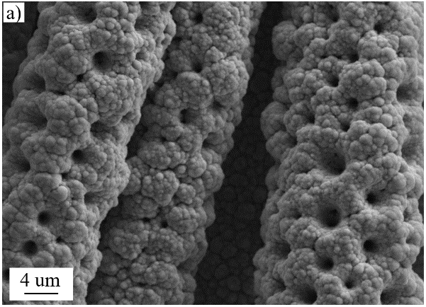 | 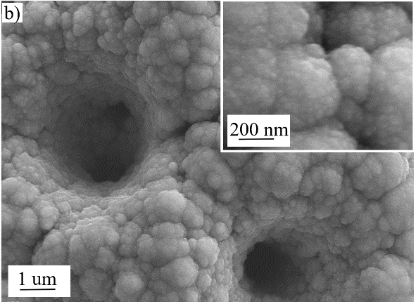
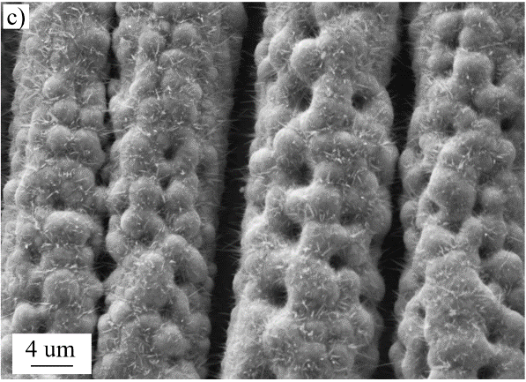 | 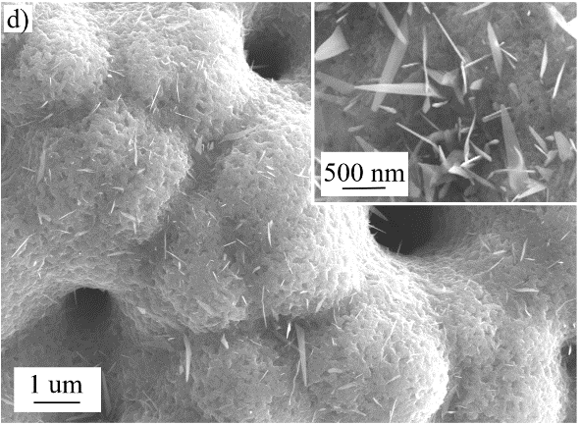
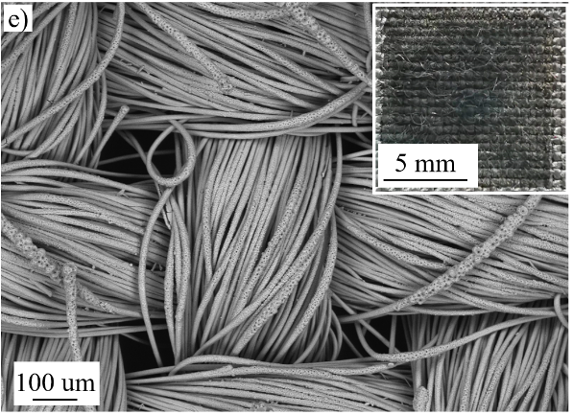
Fig. S1 SEM images of (a, b) porous NiFe alloy, (c, d) NiFe oxides, (e) Ni_{1/2}Fe–S/NiFe₂O₄ at low magnification, Insets in (b) and (d) are the magnification images. Inset in (e) is the optical photo of CC with Ni_{1/2}Fe–S/NiFe₂O₄.

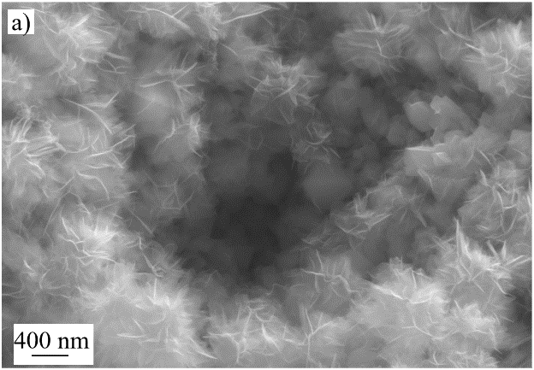 | 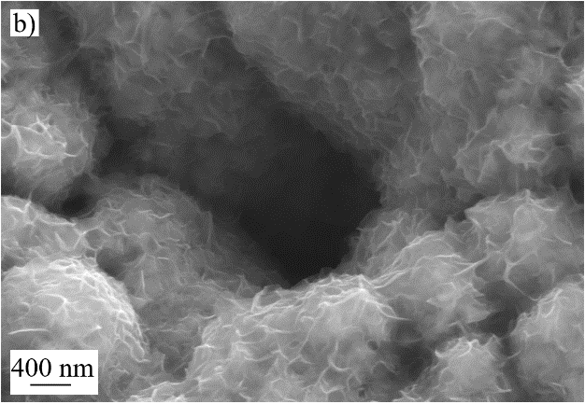
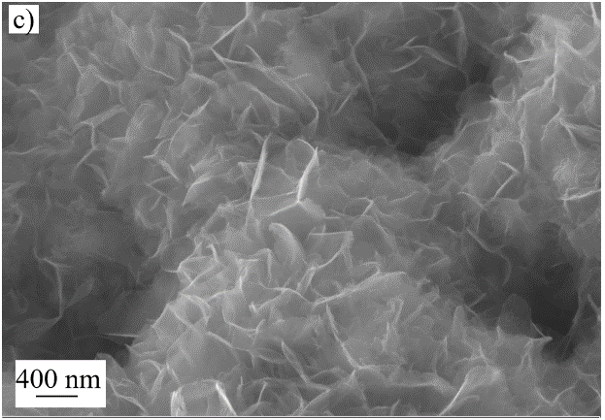 | 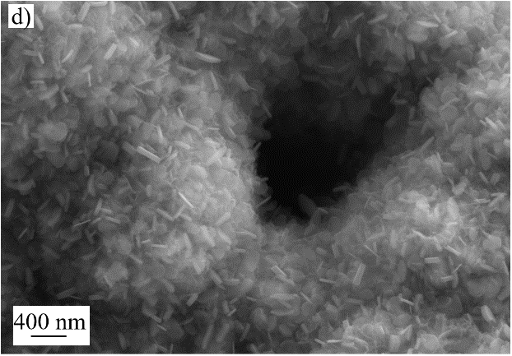
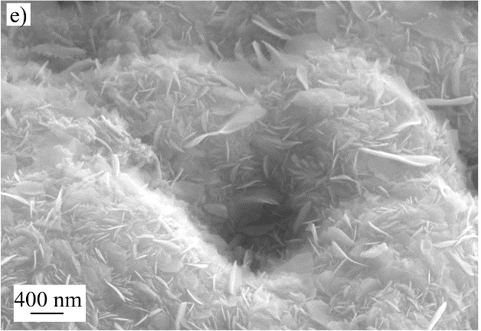

Fig. S2 The dependence of morphology on Ni content. (a) Fe–S/Fe₂O₃, (b) Ni_{1/5}Fe–S/NiFe₂O₄, (c) Ni_{1/2}Fe–S/NiFe₂O₄, (d) Ni_{4/5}Fe–S/NiFe₂O₄, (e) Ni–S/Ni-O.

Fig. S3 Linear scanning voltammogram (LSV) by reverse scan in 1 mol L⁻¹ KOH of Ni_{x}Fe–S/NiFe₂O₄, Ni–S/NiO, Fe–S/Fe₂O₃, NiFe, NiFe₂O₄, IrO₂–Ta₂O₅ and Ni_{1/2}Fe–S.

Fig. S4 OER performance of Ni_{x}Fe–S/NiFe₂O₄ with x value of 1/5 to 4/5 in 1 mol L⁻¹ KOH. Linear scanning voltammogram (LSV) by (a) forward scan and reverse scan. (c) The corresponding Tafel plots obtained by forward scan.

Fig. S5 Cyclic voltammetry curves of (a) NiFe, (b) NiFe₂O₄, (c) Ni–S/NiO, (d) Fe–S/Fe₂O₃, (e) Ni_{4/5}Fe–S/NiFe₂O₄, (f) Ni_{3/4}Fe–S/NiFe₂O₄, (g) Ni_{1/2}Fe–S/NiFe₂O₄, (h) Ni_{1/4}Fe–S/NiFe₂O₄, (i) Ni_{1/5}Fe–S/NiFe₂O₄, (f) Ni_{1/2}Fe–S. Scanning rates: 10–80 mV·s⁻¹.

Fig. S6 Chronopotentiometric curves of Ni_{1/2}Fe–S/NiFe₂O₄ electrode for OER at 20 mA·cm⁻² and 50 mA·cm⁻².

Fig. S7 Cyclic voltammetry curves of unactivated Ni_{1/2}Fe–S/NiFe₂O₄ at 1st, 3rd, 50th and 80th cycles.

Fig. S8 HER performance of Ni_{x}Fe–S/NiFe₂O₄ in 1 mol/L KOH. (a) linear scanning curves. (b) The corresponding Tafel plots.

Fig. S9 Nyquist plots of Ni_{1/5}Fe–S/NiFe₂O₄, Ni–S/NiO, Fe–S/Fe₂O₃, Ni_{1/5}Fe–S and NiFe₂O₄ for HER.

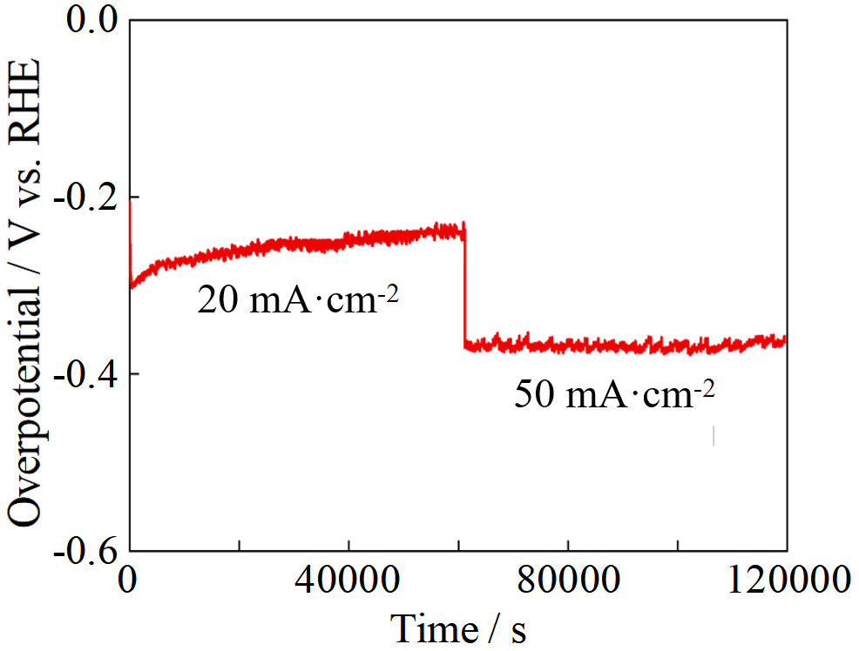
Fig. S10 Chronopotentiometric curves of Ni_{1/5}Fe–S/NiFe₂O₄ electrode for HER at 20 mA·cm⁻² and 50 mA/cm².

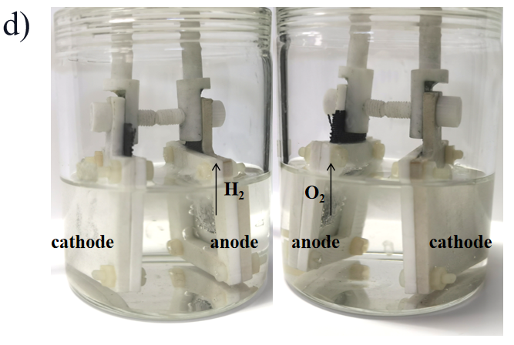
Fig. S11 Photo of Ni_{1/5}Fe–S/NiFe₂O₄||Ni_{1/2}Fe–S/NiFe₂O₄ electrolyzer for overall water splitting.

Table S1 OER performance of Ni_{x}Fe–S/NiFe₂O₄ in 1 mol L⁻¹ KOH solution.
Catalysts | Forward scan |  |  | Reverse scan |  | Tafel slope (mV dec⁻¹)
 |  | η₁₀(mV) | η₅₀(mV) | η₁₀(mV) η₅₀(mV) |  | Tafel slope (mV dec⁻¹)
NiFe |  | 358 | 555 | 363 | 562 | 63
NiFe₂O₄ |  | 321 | 583 | 335 | 584 | 75
Ni–S/NiO |  | 414 | 625 | 418 | 627 | 94
Fe–S/Fe₂O₃ |  | 425 | 640 | 429 | 640 | 102
Ni_{1/2}Fe–S |  | 303 | 492 | 312 | 495 | 79
Ni_{1/5}Fe–S/NiFe₂O₄ |  | 304 | 467 | 313 | 473 | 86
Ni_{1/4}Fe–S/NiFe₂O₄ |  | 259 | 455 | 291 | 458 | 71
Ni_{1/2}Fe–S/NiFe₂O₄ |  | 248 | 396 | 267 | 397 | 52
Ni_{3/4}Fe–S/NiFe₂O₄ |  | 275 | 445 | 302 | 306 | 86
Ni_{4/5}Fe–S/NiFe₂O₄ |  | 309 | 484 | 317 | 485 | 73
IrO₂ |  | 398 | 536 | 398 | 538 | 77

Table S2 C_{dl} results calculated from CV curves.
sample | NiFe | Ni_{1/2}Fe–S | Fe–S/Fe₂O₃ | Ni_{3/4}Fe–S/NiFe₂O₄ | Ni_{1/4}Fe–S/NiFe₂O₄
C_{dl}  (mF·cm⁻²) | 4.2 | 13.5 | 9.9 | 16.9 | 19.4
sample | NiFe₂O₄ | Ni–S/NiO | Ni_{4/5}Fe–S/NiFe₂O₄ | Ni_{1/2}Fe–S/NiFe₂O₄ | Ni_{1/5}Fe–S/NiFe₂O₄
C_{dl}  (mF·cm⁻²) | 7.6 | 9.6 | 15 | 40.8 | 16.1

