Supporting information

Robust ZnS interphase for stable Zn metal anode of high-performance aqueous secondary batteries

S1. Experimental section

Synthesis of NH4V4O10 cathode

Ammonium metavanadate (1.7 g) and oxalic acid dehydrate (2.1 g) were dissolved in 60 mL of deionized water with stirring at 60°C for 1 h to form a yellow-green solution. Afterward, the solution was heated in a polytetrafluoroethylene container at 180°C for 8 h for the hydrothermal reaction. Then, the NH4V4O10 precipitate was got by washing with ethanol and distilled water several times. Finally, the cathode slurry, consisting of NH4V4O10, carbon nanotube, polyvinylidene fluoride, and N-methyl-2-pyrrolidone (NMP) with the weight ratio of 6:3:1:10, was coated on Ti foil to obtain the cathode electrode by drying in an oven for one night at 80°C.

S2. Figure supplementary

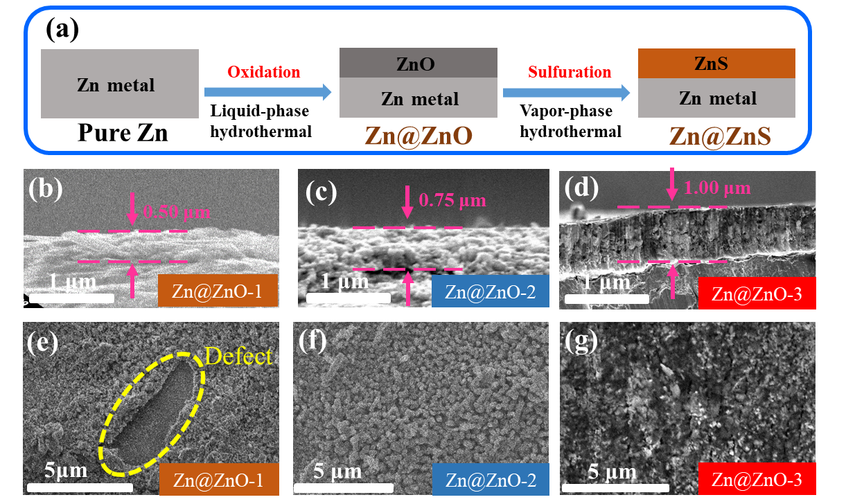

Fig. S1. (a) Schematic of the synthesis process of the Zn@ZnS. Cross-section images of (b) Zn@ZnO-1, (c) Zn@ZnO-2, and (d) Zn@ZnO-3. Surface morphologies of (e) Zn@ZnO-1, (f) Zn@ZnO-2, and (g) Zn@ZnO-3.

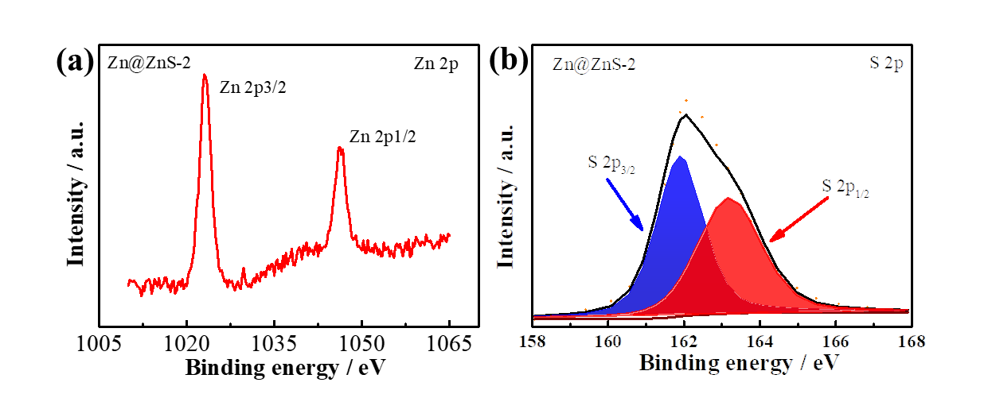

Fig. S2. XPS characterizations of the Zn@ZnS-2. (a) Zn 2p and (b) S 2p.

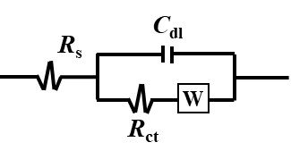

Fig. S3. Equivalent circuit model for EIS data.

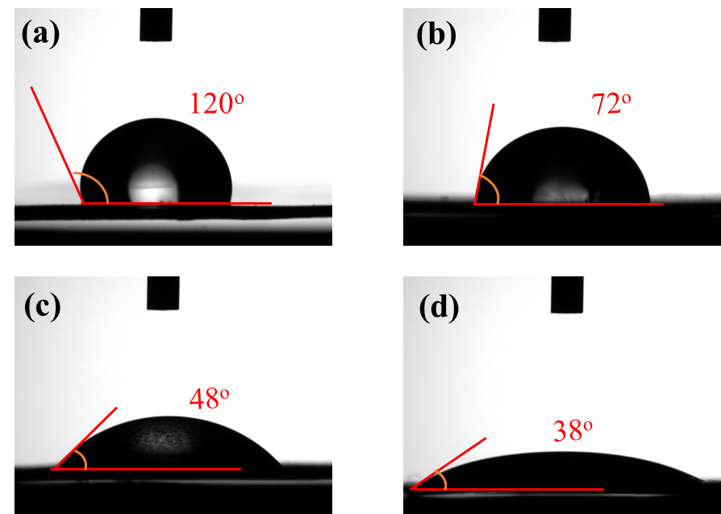

Fig. S4. Contact angles of (a) pure Zn, (b) Zn@ZnS-1, (c) Zn@ZnS-2, and (d) Zn@ZnS-3.

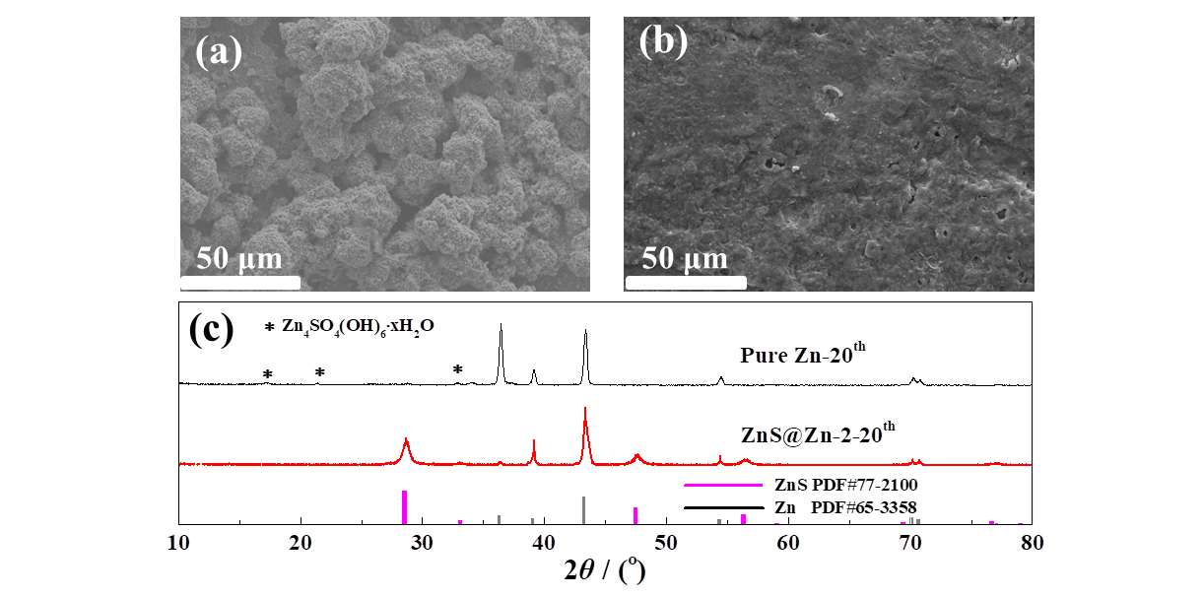

Fig. S5. Surface morphologies after 20 cycles of (a) pure Zn, (b) Zn@ZnS-2, and (c) the corresponding XRD.



Fig. S6. Surface morphology of HVO cathode.

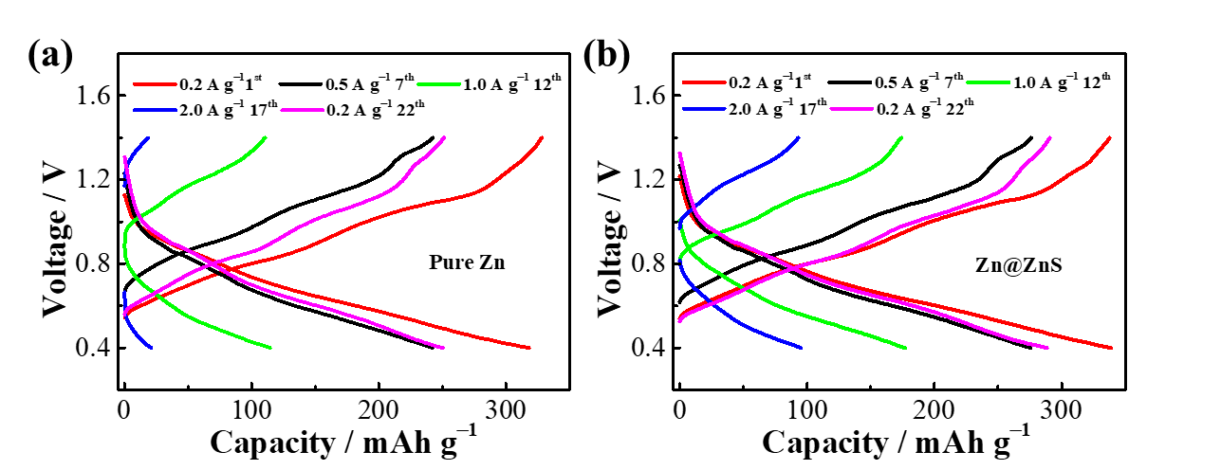

Fig. S7. Voltage-capacity curves of (a) pure Zn//HVO and (b) Zn@ZnS//HVO full cells.

S3. Table supplementary

Table S1. Resistance components extracted from EIS in Fig. 2(b) of symmetric cells

|  |  |  |
| --- | --- | --- |
| Sample | *R*s (Ω) | *R*ct (Ω) |
| Pure Zn | 0.84 | 687 |
| Zn@ZnS-1 | 0.83 | 334 |
| Zn@ZnS-2 | 0.85 | 94 |
| Zn@ZnS-3 | 16.6 | 267 |

Table S2. Resistance components extracted from EIS in Fig. 4(d) of full cells

|  |  |  |
| --- | --- | --- |
| Sample | *R*s (Ω) | *R*ct (Ω) |
| Pure Zn | 1.34 | 288 |
| Zn@ZnS | 1.33 | 201 |