**Supporting Information**

Ultra-broadband microwave absorber and high-performance pressure sensor based on aramid nanofiber, polypyrrole and nickel porous aerogel

Leyi Zhang1), Hongyu Jin1), Hanxin Liao2), Rao Zhang2), Bochong Wang1,2,🖂), Jianyong Xiang1), Congpu Mu1,2,🖂), Kun Zhai1), Tianyu Xue1), and Fusheng Wen1,🖂)

1) State Key Laboratory of Metastable Materials Science & Technology, Yanshan University, Qinhuangdao 066004, China

2) Key Laboratory for Microstructural Material Physics of Hebei Province, School of Science, Yanshan University, Qinhuangdao 066004, China

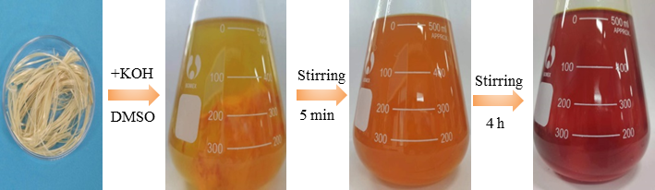

Fig. S1. Preparation of ANF dispersion.

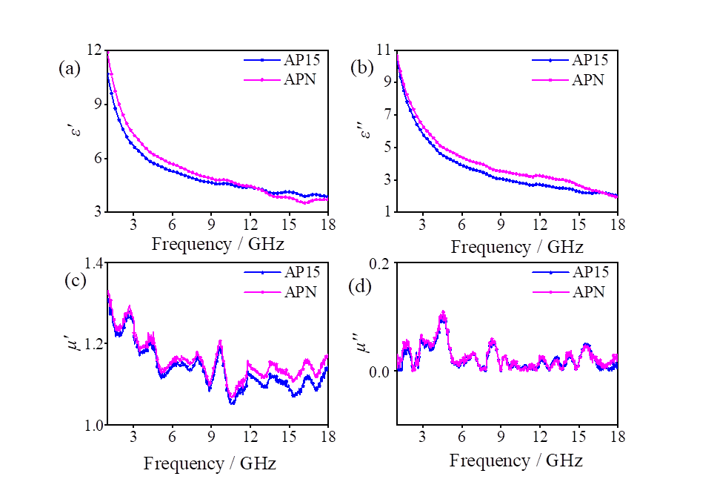

Fig. S2. (a) Real permittivity (*ε'*), (b) imaginary permittivity (*ε"*), (c) real permeability(*µ'*), and (d) imaginary permittivity (*µ"*) of AP15 and APN.

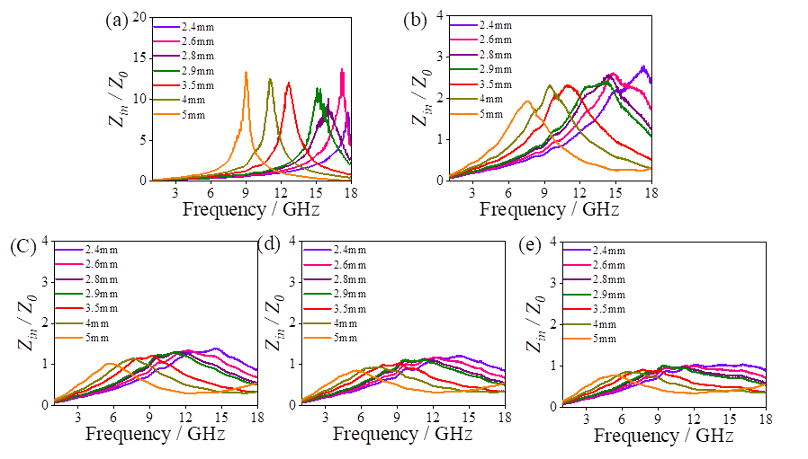

Fig. S3. Impedance matching at optimum thickness of (a) AP31; (b) AP11; (c) AP13; (d) AP15; (e) APN aerogel in the frequency range of 1~18 GHz.

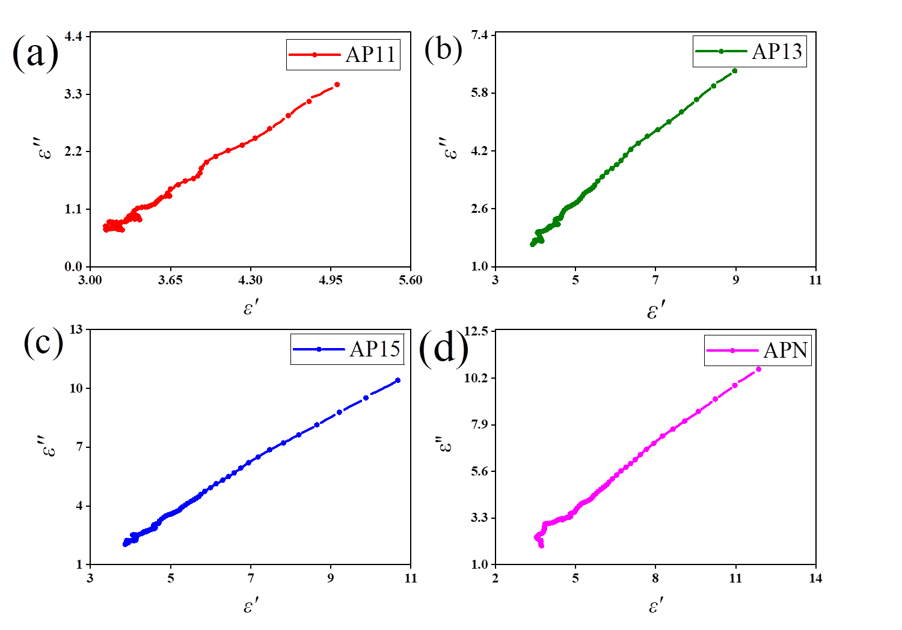

Fig. S4. Cole-Cole curve: (a) AP11; (b) AP13; (c) AP15; (d) APN.

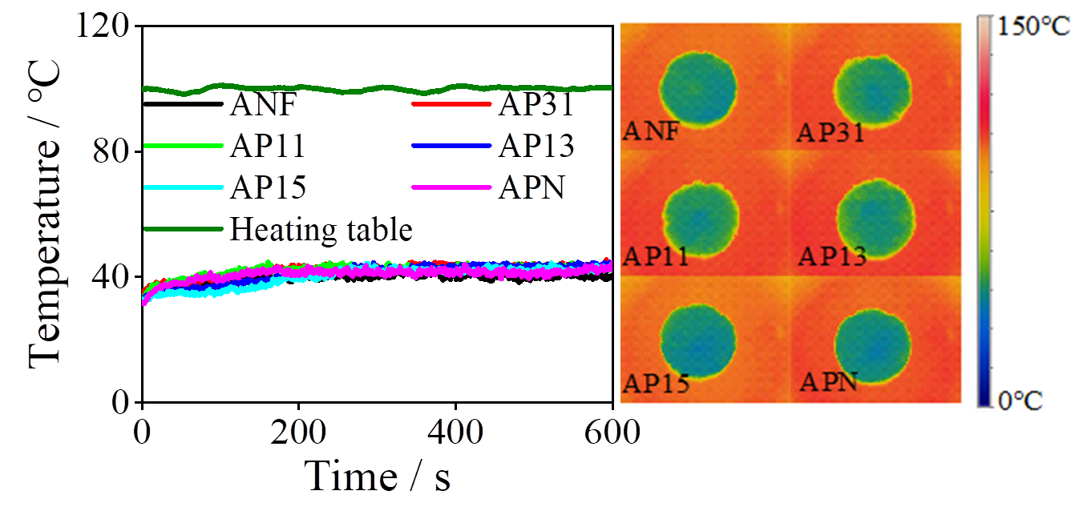

Fig. S5. Temperature-time curves and optical photographs taken with an infrared camera from the top of the aerogel on a heating stage at 100°C.

Table S1. Table of elemental content of C and Ni

|  |  |
| --- | --- |
| Element | at% |
| C | 97.99 |
| Ni | 2.01 |

Table S2. Comparison of the EMA properties in this work with those of other composites in previous studies

|  |  |  |  |  |  |
| --- | --- | --- | --- | --- | --- |
| sample | Filling Content (wt%) | Thickness (mm) | Bandwidth (GHz) | RLmin  (dB) | Ref. |
| AP13 aerogel | 10 | 2.9  5 | 5.82  3.49 | -20.6  -47.9 | This Work |
| AP15 aerogel | 10 | 2.9  2.6 | 7.18  6.55 | -35.1  -52 |
| APN aerogel | 10 | 2.8  2.4 | 8.4  6.24 | -20.7  -48.7 |
| Fe3O4/Fe3S4 | 70 | 1.71 | 5.18 | 16.23 | 1 |
| rGO/Nb2CTx/Fe3O4 | 50 | 2.5 | 6.8 | 59.17 | 2 |
| Brconical prisms Ni@C | 40 | 2.4 | 4.4 | -52.9 | 3 |
| Co@CoO | 25 | 1.65 | 3.6 | 62.76 | 4 |
| Fe4N@C | 40 | 2.5 | 6.7 | -42 | 5 |
| Ni/Ni3ZnC0.7/C | 20 | 2 | 5.4 | -40.2 | 6 |
| BCN/C/Co | 48 | 2.3 | 6.6 | -19.6 | 7 |
| 3D Co/N-GCT | 25 | 2 | 3.2 | -- | 8 |
| BN/Ni | 48 | 1.7 | 3 | -- | 9 |
| FMCM | 40 | 2 | 6.5 | -41.9 | 10 |
| Cu3(HHTP)2 | 40 | 2.1 | 5.76 | -43.5 | 11 |
| B4C@GN NSs | 50 | 1.19 | 3.9 | -24.6 | 12 |
| SnO/SnO2 | 25 | 1.4 | 4.3 | -37.6 | 13 |
| Co@C/CG aerogel | 30 | 1.5 | 4.02 | 45.02 | 14 |
| Fe3O4/CA aerogel | 10 | 1.8 | 5.2 | -57 | 15 |
| CNTs@ZIS/CNF aerogel | 2 | 2.7 | 5.8 | -- | 16 |
| C@NiCo2O4 aerogel | 50 | 1.85  4.09 | 5.7  -- | --  -54.6 | 17 |
| TiO2/Ti3C2Tx/RGO aerogel | 10 | 2  2.5 | 4.3  1 | --  -65.3 | 18 |
| CNTs/Fe3O4 aerogel | 50 | 1.4 | 4 | -33.7 | 19 |
| CeO2/porous carbon aerogel | 20 | 2.1 | 5.28 | -- | 20 |
| Shaddock peel-based carbon aerogel | 20 | 1.7 | 5.8 | -29.5 | 21 |

**Referance**

[1] H.J. Wu, J.L. Liu, H.S. Liang, and D.Y. Zang, Sandwich-like Fe3O4/Fe3S4 composites for electromagnetic wave absorption, *Chem*. *Eng*. *J*., 393(2020), art. No. 124743.[2] C. Cui, R.H. Guo, E.H. Ren, *et al.*, MXene-based rGO/Nb2CT*x*/Fe3O4 composite for high absorption of electromagnetic wave, *Chem*. *Eng*. *J*., 405(2021), art. No. 126626.[3] X. Li, Z.L. Wang, Z. Xiang, *et al.*, Biconical prisms Ni@C composites derived from metal-organic frameworks with an enhanced electromagnetic wave absorption, *Carbon*, 184(2021), p. 115.[4] Y. Shu, T.K. Zhao, X.H. Li, *et al.*, Surface plasmon resonance-enhanced dielectric polarization endows coral-like Co@CoO nanostructures with good electromagnetic wave absorption performance, *Appl*. *Surf*. *Sci*., 585(2022), art. No. 152704.[5] X.C. Liang, C.G. Wang, M.J. Yu, Z.Q. Yao, and Y. Zhang, Fe-MOFs derived porous Fe4N@carbon composites with excellent broadband electromagnetic wave absorption properties, *J*. *Alloys Compd*., 910(2022), art. No. 164844.[6] Q.L. Chang, C.P. Li, J. Sui, G.I.N. Waterhouse, Z.M. Zhang, and L.M. Yu, Ni/Ni3ZnC0.7 modified alginate-derived carbon composites with porous structures for electromagnetic wave absorption, *Carbon*, 200(2022), p. 166.[7] H.Y. Tian, J. Qiao, Y.F. Yang, *et al.*, ZIF-67-derived Co/C embedded boron carbonitride nanotubes for efficient electromagnetic wave absorption, *Chem*. *Eng*. *J*., 450(2022), art. No. 138011.[8] X.C. Zhang, X. Zhang, H.R. Yuan, *et al.*, CoNi nanoparticles encapsulated by nitrogen-doped carbon nanotube arrays on reduced graphene oxide sheets for electromagnetic wave absorption, *Chem*. *Eng*. *J*., 383(2020), art. No. 123208.[9] Y.H. Zhang, H.X. Si, S.C. Liu, Z.Y. Jiang, J.W. Zhang, and C.H. Gong, Facile synthesis of BN/Ni nanocomposites for effective regulation of microwave absorption performance, *J*. *Alloys Compd*., 850(2021), art. No. 156680.[10] Y.H. Cui, K. Yang, J.Q. Wang, T. Shah, Q.Y. Zhang, and B.L. Zhang, Preparation of pleated RGO/MXene/Fe3O4 microsphere and its absorption properties for electromagnetic wave, *Carbon*, 172(2021), p. 1.[11] Z. Shan, S.Y. Cheng, F. Wu, *et al.*, Electrically conductive two-dimensional metal-organic frameworks for superior electromagnetic wave absorption, *Chem*. *Eng*. *J*., 446(2022), art. No. 137409.[12] B.X. Zhang, T. Prikhna, C.P. Hu, and Z.J. Wang, Graphene-layer-coated boron carbide nanosheets with efficient electromagnetic wave absorption, *Appl*. *Surf*. *Sci*., 560(2021), art. No. 150027.[13] H.P. Lv, C. Wu, J. Tang, *et al.*, Two-dimensional SnO/SnO2 heterojunctions for electromagnetic wave absorption, *Chem*. *Eng*. *J*., 411(2021), art. No. 128445.[14] J. Xu, X. Zhang, Z.B. Zhao, *et al.*, Lightweight, fire-retardant, and anti-compressed honeycombed-like carbon aerogels for thermal management and high-efficiency electromagnetic absorbing properties, *Small*, 17(2021), No. 33, art. No. 2102032.[15] X.K. Lu, D.M. Zhu, X. Li, and Y.J. Wang, Architectural design and interfacial engineering of CNTs@ZnIn2S4 heterostructure/cellulose aerogel for efficient electromagnetic wave absorption, *Carbon*, 197(2022), p. 209.[16] Y.Y. Dong, X.J. Zhu, F. Pan, *et al.*, Implanting NiCo2O4 equalizer with designable nanostructures in agaric aerogel-derived composites for efficient multiband electromagnetic wave absorption, *Carbon*, 190(2022), p. 68.[17] Y. Tong, M. He, Y.M. Zhou, *et al.*, Three-dimensional hierarchical architecture of the TiO2/Ti3C2T*x*/RGO ternary composite aerogel for enhanced electromagnetic wave absorption, *ACS* *Sustainable Chem*. *Eng*., 6(2018), No. 7, p. 8212.[18] Y.L. Ma, Y.B. Li, X. Zhao, *et al.*, Lightweight and multifunctional super-hydrophobic aramid nanofiber/multiwalled carbon nanotubes/Fe3O4 aerogel for microwave absorption, thermal insulation and pollutants adsorption, *J*. *Alloys Compd*., 919(2022), art. No. 165792.[19] X.M. Huang, X.H. Liu, Z.R. Jia, B.B. Wang, X.M. Wu, and G.L. Wu, Synthesis of 3D cerium oxide/porous carbon for enhanced electromagnetic wave absorption performance, *Adv*. *Compos*. *Hybrid Mater*., 4(2021), No. 4, p. 1398.[20] W.H. Gu, J.Q. Sheng, Q.Q. Huang, G.H. Wang, J.B. Chen, and G.B. Ji, Environmentally friendly and multifunctional shaddock peel-based carbon aerogel for thermal-insulation and microwave absorption, *Nanomicro Lett*., 13(2021), No. 1, art. No. 102.[21] Z.W. Ye, K.J. Wang, X.Q. Li, and J.J. Yang, Preparation and characterization of ferrite/carbon aerogel composites for electromagnetic wave absorbing materials, *J*. *Alloys Compd*., 893(2022), art. No. 162396.