**Supplemental Materials**

**Nanostructured ZnO/BiVO4 I-scheme heterojunctions for piezocatalytic degradation of organic dyes via harvesting ultrasonic vibration energy**

*Yiling Li, Xiaoyao Yu, Yingjie Zhou, Yao Lin, and Ying Wu*🖂

Key Laboratory of the Ministry of Education for Advanced Catalysis Materials, College of Chemistry and Materials Science, Zhejiang Normal University, Jinhua 321004, China

**1. Experimental**

1.1. Catalyst Preparation

The BiVO4 catalyst was synthesized via solvothermal method. The typical process is as follows: Initially, 1 mmol of Bi(NO3)3·5H2O was introduced into 40 mL mixture of ethanol–glycerol (3:1) solvent and subjected to 30 min of sonication. Subsequently, 30 mL solution of NaVO3 (1 mM) was added dropwise under constant stirring for additional 30 min. The resulting mixture was then transferred into a Teflon-lined stainless-steel autoclave and heated at 140°C for 24 h. Afterward, the resulting solid was collected through centrifugation, rinsed several times with distilled water, and dried at 60°C for 12 h. ZnO/BiVO4 composite samples were prepared using two-step method. Specifically, 0.1g of BiVO4 sample was added to a mixed solution containing 5 mL ethanol and 5 mL deionized water, followed by 20 min of ultrasonic dispersion. Simultaneously, a certain amount of ZnO powder (20wt%, 40wt%, and 60wt%) underwent 20 min ultrasonic dispersion using the same method. Then, under stirring conditions, the dispersed ZnO solution was added dropwise to the BiVO4 solution. The resulting mixture was stirred at room temperature for 50 min, followed by centrifugal drying and finally annealing at 450℃ for 3 h in a muffle furnace, to obtain ZnO/BiVO4 composite catalyst with varying ZnO contents. These samples were denoted as 20wt% ZnO/BV, 40wt% ZnO/BV, and 60wt% ZnO/BV, respectively. For simplicity, the pure BiVO4 catalyst was labeled as BV.

1.2. Catalyst Characterization

The crystal phase and crystallinity of the as-prepared catalysts were determined by using powder X-ray diffraction (XRD. D8 Advance PW3040/6, Bruker, Germany) with Cu Kα radiation. The morphologies of the samples were observed via a field emission scanning electron microscope (SEM. S-4800, Hitachi, Japan) at an accelerating voltage of 5 kV. Transmission electron microscopy (TEM. JEOL-2100F, Japan Inc., Japan) was conducted to further investigate the microstructure of catalyst at an accelerating voltage of 200 kV. The specific surface areas of the samples were determined by N2 absorption–desorption isotherms (JW-BK200, JWGB Sci & Tech Ltd., China) based on the Brauner-Emmett-Teller (BET) method. Fourier-transform infrared (FT-IR. NEXUS670, Nicolet, WI, USA) spectra of the samples were collected with a resolution of 4 cm−1. Raman spectra were recorded on a Raman spectrometer (RM 1000, Renishaw, England). Ultraviolet-visible (UV-vis) diffuse reflectance spectra (DRS) were recorded using a UV-vis spectrometer (Cary 5000, Agilent, Malaysia) within the 200–800 nm range, with BaSO4 signal as the corrected baseline. X-ray photoelectron spectroscopy (XPS) was performed on an ESCLALAB 250Xi system (Thermo Fisher Scientific, UK) with Al Kα radiation. Photoluminescence (PL) spectra were measured on an FLA-980 spectrometer (Edinburgh Instrument, UK) at room temperature. Piezoelectric current (PC) and electrochemical impedance spectroscopy (EIS) response measurements were carried out using an electrochemical workstation (CHI 660E, CH Instruments Ins., China) equipped with a standard three-electrode cell. The catalyst, Ag/AgCl (saturated KCl), and a Pt wire were used as the working electrode, the reference electrode, and the counter electrode, respectively. The coated area of the catalyst on the ITO glass was 1.0 cm × 1.0 cm and Na2SO4 (0.5 M) aqueous solution was used as the electrolyte. For piezoelectric current response analysis, an ultrasonic generator (40 kHz, 120W) was used as the mechanical press source. In order to increase the adhesion of catalyst on the ITO substrate, carbon conductive adhesive was used during the preparation of working electrode. The size of carbon conductive adhesive is 1.0 cm × 1.0 cm, while the catalyst sample is coated on the carbon conductive adhesive.

1.3. Piezo-catalytic reaction

The catalytic activity of the as-prepared catalysts was assessed through the degradation of RhB. For this evaluation, 15 mg of catalyst was added into 50 mL solution of RhB (10 mg/L), and the suspension was initially stirred and adsorbed in darkness for 30 min to reach the adsorption–desorption equilibrium between the catalysts and the dye. Subsequently, the piezoelectric catalytic experiment was conducted within an ultrasonic cleaner (JP-020S) at a frequency of 40 kHz and power of 120 W. The temperature of the reaction system was maintained at 25°C using continuous water inflow and outflow operation. Approximately 5 mL of the suspension was extracted and subjected to centrifugation to get rid of the solid particles after each 10-min interval. The decomposition ratio (*η*) was measured with UV-vis spectrophotometer and calculated using Eq. (1):

*η* = (*C*0 – *C*)/*C*0 × 100% (1)

where, *C*0 and *C* represent the initial and residual dye concentrations at 0 and *t* min, respectively.

1.4. Active species test

Ethylene diamine tetraacetic acid (EDTA), benzoquinone (BQ), and isopropyl alcohol (IPA) were employed as quenchers to capture holes (h+), superoxide radicals (·O2–), and hydroxyl radicals (·OH), respectively. The reaction conditions were identical to those detailed in Section 1.3.



**Fig. S1. Raman spectra of different ZnO/BV catalysts.**



**Fig. S2. Photoluminescence time-resolved PL spectra of different** **ZnO/BV catalysts.**

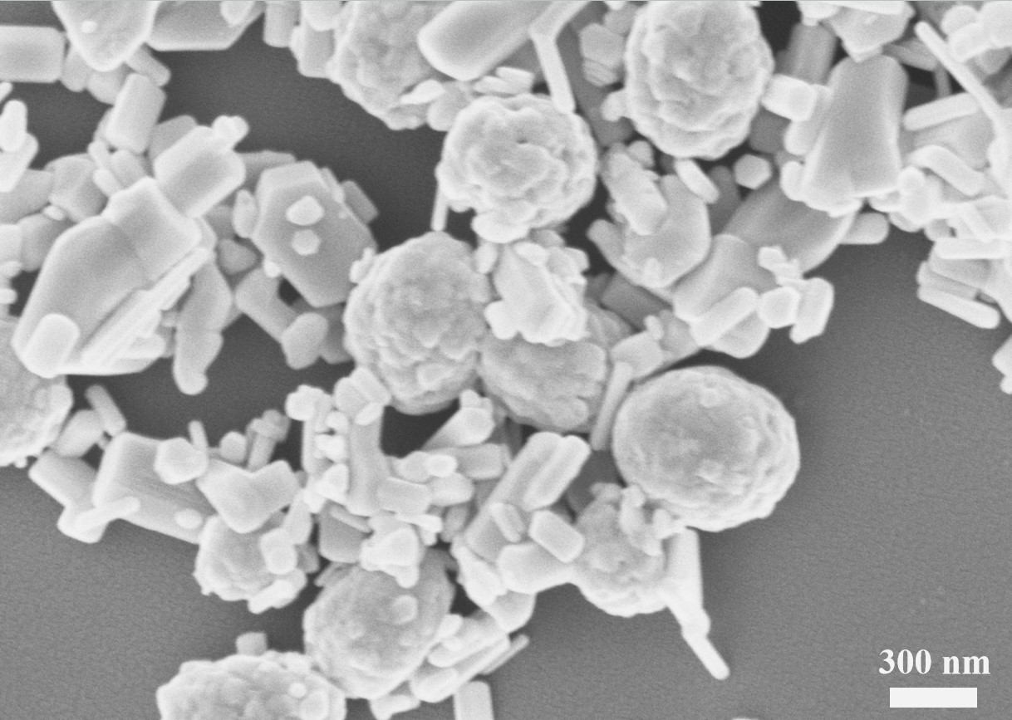

**Fig. S3. SEM image of 40wt% ZnO/BV catalyst.**



**Fig. S4. XRD pattern of the fresh and used 40wt% ZnO/BV catalyst.**



**Fig. S5. Piezoeletric activity of MO and MB degradation without catalyst.**



**Fig. S6.** **Piezoelectric catalytic activity on the degradation of tetracycline**

**Table S1. BET surface areas of the ZnO/BV catalyst**

|  |  |  |
| --- | --- | --- |
| Samples | *S*BET / (m2·g–1) | Pore volume / (cm3·g–1) |
| BV | 4.347 | 0.06977 |
| ZnO | 5.422 | 0.02447 |
| 20wt% ZnO/BV | 9.723 | 0.02819 |
| 40wt% ZnO/BV | 81.057 | 0.23870 |
| 60wt% ZnO/BV | 6.706 | 0.07997 |

**Table S2. Decay time (*τ*) and relative intensities of different ZnO/BV catalysts**

|  |  |  |  |  |  |
| --- | --- | --- | --- | --- | --- |
| Samples | *τ*1 / ns | *τ*2 / ns | *A*1 / % | *A*2 / % | Average lifetime (*τ*) / ns |
| 40wt% ZnO/BV | 0.48 | 5.98 | 97.25 | 2.75 | 1.77 |
| BV | 0.45 | 7.52 | 99.06 | 0.94 | 1.41 |
| ZnO | 0.37 | 4.79 | 98.37 | 1.63 | 1.06 |

Note: The average lifetime was calculated using equation: <*τ*> = (*A*1*τ*12 + *A*2*τ*22)/(*A*1*τ*1 + *A*2*τ*2)

**Table S3. Absolute electronegativity, estimated band gap, energy levels of calculated conduction band edge, and valence band at the point of zero charge for ZnO and BiVO4**

|  |  |  |  |  |
| --- | --- | --- | --- | --- |
| Semiconductor oxides | Absolute electronegativity | Estimated energy band gap, *E*g / eV | Calculated conduction band edge / eV | Calculated valence band edge / eV |
| BiVO4 | 6.161 | 2.38 | 0.47 | 2.85 |
| ZnO | 5.79 | 3.20 | -0.31 | 2.89 |