Supplementary Information

Thermodynamic model for deoxidation of liquid steel considering strong metal–oxygen interaction in the quasichemical model framework
Yong-Min Cho^{1,2)} and Youn-Bae Kang^{1,3),}
- Graduate Institute of Ferrous and Eco Materials Technology, Pohang University of Science and Technology, Pohang, Kyungbuk, 37673, Rep. of Korea
- N.EX.T Hub, POSCO Holdings, Pohang, Kyungbuk, 37673, Republic of Korea
- Department of Materials Science and Engineering, Pohang University of Science and Technology, Pohang, Kyungbuk, 37673, Rep. of Korea
Corresponding Author: Youn-Bae Kang E-mail: ybkang@postech.ac.kr

Appendix A. Deoxidation in liquid steel by Mg, La, and Zr
In continuation of the results discussed in section 5.3, Figs. A.1–A.3 present the deoxidation equilibria of liquid steel by other strong deoxidizers, namely Mg, La, and Zr, respectively. The calculated [%O] in liquid steel deoxidized by Mg (Fig. A.1) [1–2] reasonably agrees with that of the present model. For the deoxidation by La (Fig A.2), the calculated $a_{\underline{O}(wt\%)}$) shows good agreement with the data of Janke and Fischer [3]; however, the calculated [%O] is lower than the reported experimental data [4–5], similar to the case of Ce deoxidation. As for the deoxidation by Zr (Fig. A.3), the calculated [%O] is lower than the reported experimental findings [5–8], and the calculated $a_{\underline{O}(wt\%)}$) agrees well with the data [6–7,9].
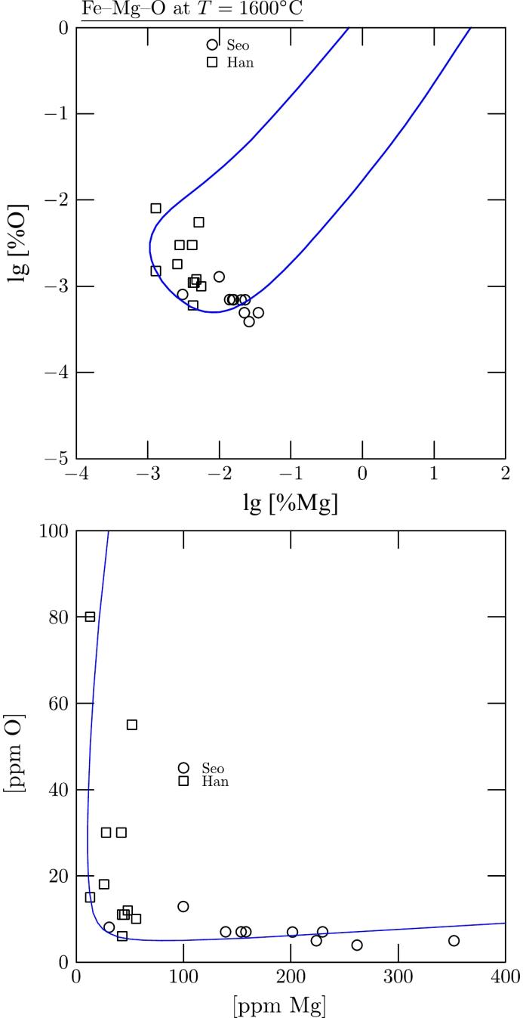
Fig. A.1. Deoxidation equilibria of Mg in liquid steel at 1600°C: [%O] as a function of [%Mg]. Experimental data were taken from [1–2].
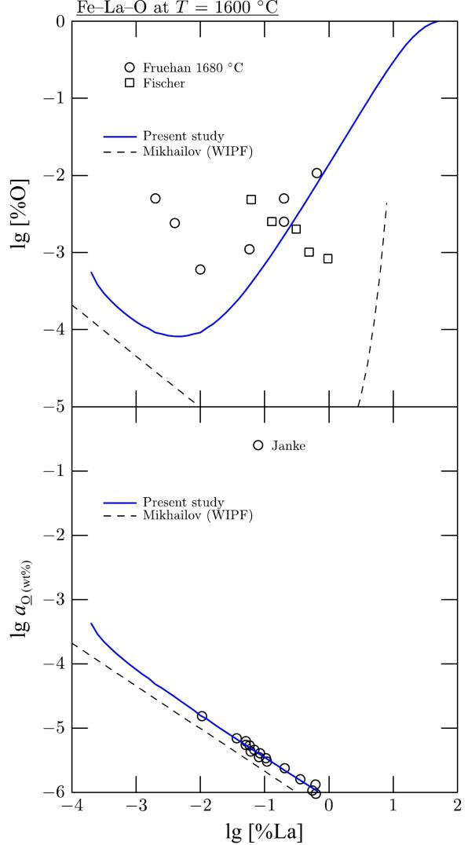
Fig. A.2. Deoxidation equilibria of La in liquid steel at 1600°C: [%O] and $a_{\underline{O}(wt\%)}$ (with respect to 1wt% standard state) as a function of [%La]. Experimental data were taken from [3–5]. Thermodynamic calculation reported in the literature is also shown [10].
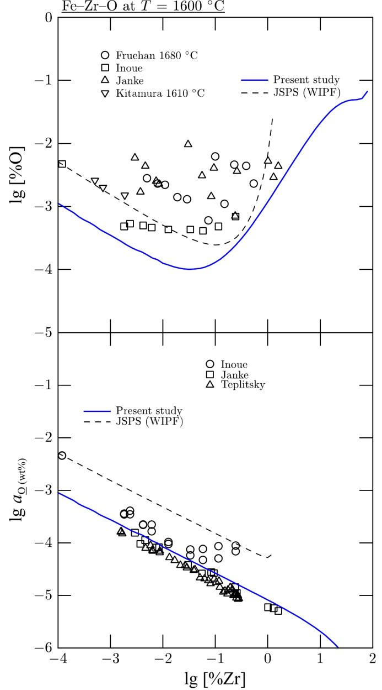
Fig. A.3. Deoxidation equilibria of Zr in liquid steel at 1600°C: [%O] and $a_{\underline{O}(wt\%)}$ (with respect to 1wt% standard state) as a function of [%Zr]. Experimental data were taken from [5–9]. Thermodynamic calculation reported in the literature is also shown [10].

Appendix B. Deoxidation of liquid steel by Nb, V, and B
Deoxidation of liquids steel by Nb, V, and B was also described using the present model. The calculated results are shown in Figs. B.1–B.3.
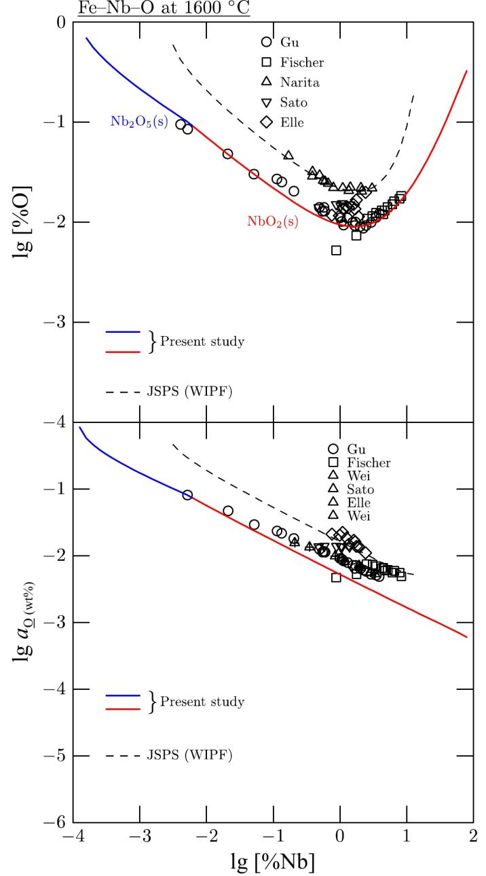
Fig. B.1. Deoxidation equilibria of Nb in liquid steel at 1600°C: [%O] and $a_{\underline{O}(wt\%)}$ (with respect to 1wt% standard state) as a function of [%Nb]. Experimental data were taken from [11–17]. Thermodynamic calculation reported in the literature is also shown.
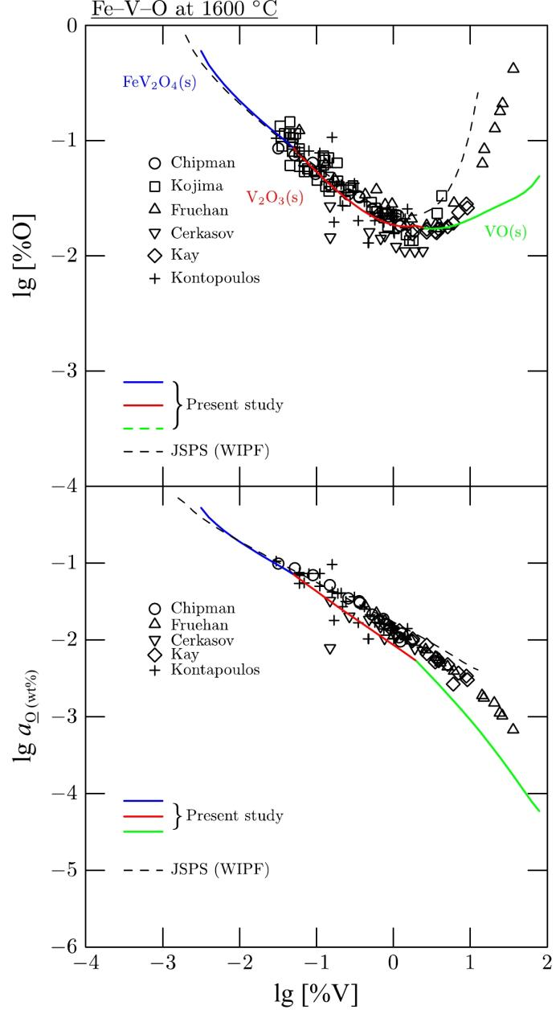
Fig. B.2. Deoxidation equilibria of V in liquid steel at 1600°C: [%O] and $a_{\underline{O}(wt\%)}$ (with respect to 1wt% standard state) as a function of [%V]. Experimental data were taken from [18–23]. Thermodynamic calculation reported in the literature is also shown [10].
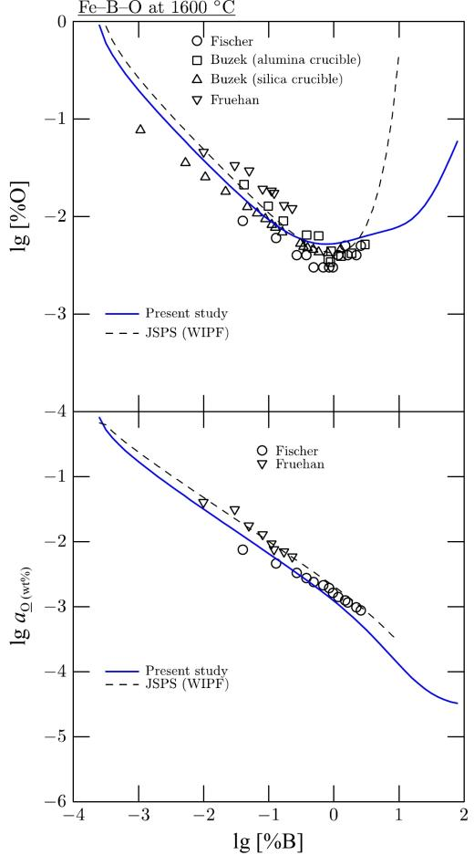
Fig. B.3. Deoxidation equilibria of B in liquid steel at 1600°C: [%O] and $a_{\underline{O}(wt\%)}$(with respect to 1wt% standard state) as a function of [%B]. Experimental data were taken from [20,24−25]. Thermodynamic calculation reported in the literature is also shown [10].

Appendix C. Complex deoxidation in liquid Fe
In a $c$-component solution composed of M₁-...-M_{i}-...-M_{c-1}-M_{c}, where M₁ is the solvent (Fe), M₂ to M_{c-1} are deoxidizing elements (such as Al, Mn, Si, etc.), and M_{c} is O, the Gibbs energy of the solution in Eq. (22) is extended as follows:
$G=\sum_{i=1}^{c}{n_{i}}g_{i}^{∘}+\text{R}T\sum_{i=1}^{c}{n_{i}}lnX_{i}+G^{\text{ex}}$ (C.1)
where
$G^{\text{ex}}=\text{R}T\left[\sum_{i=1}^{c}{n_{ii}}ln\left(\frac{X_{ii}}{Y_{i}^{2}}\right)+\sum_{i=1}^{c−1}{\sum_{\begin{matrix}j=2 \\ j>i\end{matrix}}^{c}{n_{ij}}}ln\left(\frac{X_{ij}}{2Y_{i}Y_{j}}\right)\right]+\sum_{i=1}^{c−1}{\sum_{\begin{matrix}j=2 \\ j>i\end{matrix}}^{c}{\frac{n_{ij}}{2}}}Δg_{ij}$ (C.2)
Through the same procedure introduced in section 4, $γ_{\text{M}}$ and $γ_{\text{O}}$ are then obtained using Eq. (15):
$\begin{matrix}ln{ γ}_{\text{M}} & = & \frac{Z}{2}\left[ln\frac{1−2X_{\text{O}}}{{\left(1−X_{\text{O}}\right)}^{2}}+\frac{2X_{\text{O}}^{2}}{1−X_{\text{O}}}+\frac{2X_{\text{O}}}{Q^{2}}\left(\sum_{k=1}^{c−1}{K_{k\text{O}}}X_{k}\left(K_{\text{MO}}ln\left(\frac{K_{\text{MO}}}{K_{k\text{O}}}\right)+Q−K_{\text{MO}}\right)\right)\right] \\ & + & \frac{Z}{2\text{R}T}\left[\begin{aligned}\frac{3X_{\text{O}}−1}{{\left(1−X_{\text{O}}\right)}^{3}}\sum_{\begin{matrix}j=2 \\ j>i\end{matrix}}^{c−1}{\sum_{i=1}^{c−2}{X_{i}}}X_{j}Δg_{ij}+\frac{1−2X_{\text{O}}}{{\left(1−X_{\text{O}}\right)}^{2}}\sum_{\begin{matrix}k=1 \\ k≠\text{M}\end{matrix}}^{c−1}{X_{k}}Δg_{k\text{M}} \\ +\frac{K_{\text{MO}}X_{\text{O}}}{Q^{2}}\sum_{k=1}^{c−1}{K_{k\text{O}}}X_{k}\left(Δg_{\text{MO}}−Δg_{k\text{O}}\right)\end{aligned}\right] \\ & & \end{matrix}$ (C.3)
and
$\begin{matrix}ln γ_{\text{O}} & = & \frac{Z}{2}\left[ln\frac{{\left(1−X_{\text{O}}\right)}^{2}}{1−2X_{\text{O}}}+\sum_{k=1}^{c−1}{\frac{K_{k\text{O}}X_{k}}{Q}}ln\frac{K_{k\text{O}}}{Q}\right] \\ & + & \frac{Z}{2\text{R}T}\left[\sum_{k=1}^{c−1}{\frac{K_{k\text{O}}X_{k}}{Q}}Δg_{k\text{O}}−\frac{1}{{\left(1−X_{\text{O}}\right)}^{2}}\sum_{\begin{matrix}j=2 \\ j>i\end{matrix}}^{c−1}{\sum_{i=1}^{c−2}{X_{i}}}X_{j}Δg_{ij}\right]\end{matrix}$ (C.4)
where
$Q=\sum_{k=1}^{c−1}{K_{k\text{O}}}X_{k}=\sum_{k=1}^{c−1}{exp}\left(−\frac{Δg_{k\text{O}}−Δg_{\text{FeO}}}{2\text{R}T}\right)X_{k}$ (C.5)
with $K_{k\text{O}}=1$ when $k=1$ (Fe). For example, $Q$ in a liquid steel composed of Fe–C–Si–Mn–Al–O is computed as follows:
$Q=X_{\text{Fe}}+K_{\text{CO}}X_{\text{C}}+K_{\text{SiO}}X_{\text{Si}}+K_{\text{MnO}}X_{\text{Mn}}+K_{\text{AlO}}X_{\text{Al}}$ (C.6)
where
$K_{\text{CO}}= exp\left(−\frac{Δg_{\text{CO}}−Δg_{\text{FeO}}}{2\text{R}T}\right)$ (C.7)
$K_{\text{SiO}}= exp\left(−\frac{Δg_{\text{SiO}}−Δg_{\text{FeO}}}{2\text{R}T}\right)$ (C.8)
$K_{\text{MnO}}= exp\left(−\frac{Δg_{\text{MnO}}−Δg_{\text{FeO}}}{2\text{R}T}\right)$ (C.9)
$K_{\text{AlO}}= exp\left(−\frac{Δg_{\text{AlO}}−Δg_{\text{FeO}}}{2\text{R}T}\right)$ (C.10)
Eqs. (C.3) and (C.4) are reduced to Eqs. (49) and (50), respectively, when $c$ = 3.
Eqs. (C.3) and (C.4) provide explicit functions of composition and temperature for $γ_{\text{M}}$ and $γ_{\text{O}}$, respectively. Thus, $γ_{\text{M}}$ and $γ_{\text{O}}$ can be directly calculated without internal Gibbs energy minimization when the composition and temperature of the system are known. This computational approach eliminates the additional step of internal equilibrium calculation (Fig. 1).

References
[1] J.D. Seo and S.H. Kim, Thermodynamic assessment of Mg deoxidation reaction of liquid iron and equilibria of [Mg]–[Al]–[O] and [Mg]–[S]–[O], Steel Res., 71(2000), No. 4, p. 101.
[2] Q.Y. Han, D.B. Zhou, and C.X. Xiang, Determination of dissolved sulfur and Mg–S, Mg–O equilibria in molten iron, Steel Res., 68(1997), No. 1, p. 9.
[3] D. Janke and W.A. Fischer, Deoxidation equilibria of cerium, lanthanum, and hafnium in liquid iron, Archiv für das Eisenhüttenwesen, 49(1978), No. 9, p. 425.
[4] W.A. Fischer and D. Janke, Elektrochemische aufzeichnung des entkohlungsablaufs von eisenschmelzen, Archiv für das Eisenhüttenwesen, 42(1971), No. 4, p. 249.
[5] R.J. Fruehan, The effect of zirconium, cerium, and lanthanum on the solubility of oxygen in liquid iron, Metall. Trans., 5(1974), No. 2, p. 345.
[6] D. Janke and W.A. Fischer, Desoxidationsgleichgewichte von titan, aluminium und zirconium in eisenschmelzen Bei 1600°C, Archiv für das Eisenhüttenwesen, 47(1976), No. 4, p. 195.
[7] R. Inoue, T. Ariyama, and H. Suito, Thermodynamics of zirconium deoxidation equilibrium in liquid iron by EMF measurements, ISIJ Int., 48(2008), No. 9, p. 1175.
[8] O. Kitamura, S. Ban-ya, and T. Fuwa, Deoxidation of liquid iron with zirconium, [in] 2nd-Japan–USSR joint Symposium on Physical Chemistry of Metallurgical Processes, ISIJ, Tokyo, 1969, p. 47.
[9] E. Teplitsky and L. Vladimirov, Thermodynamics of the deoxidation of steel with Zr, Izvest. VUZ Chernaya Met., 3(1973), p. 5.
[10] Japan Society for the Promotion of Science, Steelmaking Data Sourcebook, Gordon & Breach Science, New York, 1988.
[11] L. Gu and Z. Tang, A study on Fe–Nb–O equilibria and their thermodynamic parameters, Acta Metall. Sin. 21(1985), No. 2.
[12] W. Fischer and D. Janke, Activity of O in Fe melts containing Mo, W, Nb and Ta, Archiv für das Eisenhüttenwesen, 42(1971), No. 10, p. 695.
[13] K. Narita and S. Koyama, Deoxidation equilibria of vanadium, niobium, and tantalum in liquid iron, Trans. Iron Steel Inst. Jpn., 9(1969), No. 1, p. 53.
[14] K. Narita and S. Koyama, Deoxidation equilibria of vanadium, niobium, and tantalum in liquid iron, ISIJ Int., 9(1969), No. 1, p. 53.
[15] Y. Satô, K. Suzuki, Y. Omori, and K. Sanbongi, Study on the activity and solubility of oxygen in liquid iron-niobium alloy, Tetsu-to-Hagané, 54(1968), No. 4, p. 330.
[16] M. Elle and J. Chipman, The columbium-oxygen equilibrium in liquid iron, Trans. Met. Soc. AIME, 221(1961).
[17] S. Wei, S. Zhang, T. Tong, and Z. Tan, A study of the activity of niobium in molten iron by the solid electrolyte oxygen cell technique, J. Beijing Univ. Iron Steel Technol., 1983, No. 2, p. 79.
[18] J. Chipman and M.N. Dastur, Vanadium-oxygen equilibrium in liquid iron, JOM, 3(1951), No. 2, p. 111.
[19] Y. Kojima, M. Inouye, and J.I. Ohi, Vanadinoxid im gleichgewicht mit eisen-vanadin-legierungen bei 1600°C, Archiv für das Eisenhüttenwesen, 42(1971), No. 10, p. 703.
[20] R.J. Fruehan, Activities in liquid Fe-V-O and Fe-B-O alloys, Metall. Trans., 1(1970), No. 8, p. 2083.
[21] P. Cerkasov and W. Fischer, Joint effect of several alloying elements on the O activity of metal melts, Archiv für das Eisenhüttenwesen, 42(1971), No. 10, p. 699.
[22] D. Kay and A. Kontopoulos, in: Chemical Metallurgy of Iron and Steel: Proc. Int. Symp on Metallurgical Chemistry - Application in Ferrous Metallurgy, Iron and Steel Institute, London, 1971, p. 178.
[23] A. Kontopoulous, Thermodynamics of the Fe–V–O system [Dissertation], McMaster University, Hamilton, ON, Canada, 1971.
[24] W.A. Fischer and D. Janke, Die aktivität des sauerstoffs in reinen und mangan-, titan-oder borhaltigen eisenschmelzen, Archiv für das Eisenhüttenwesen, 42(1971), No. 10, p. 691.
[25] Z. Buzek, Chemical metallurgy of iron and steel, [in] Proc. of the International Symposium on Metallurgic Chemistry-Applications in Ferrous Metallurgy held in the University of Sheffield, Iron and Steel Institute, 1971, p. 173.

