Supplementary Information

Influence of rare earth Ce on hot deformation behavior of as-cast Mn18Cr18N high nitrogen austenitic stainless steel
Yushuo Li¹⁾, Yanwu Dong ^{1,2),}, Zhouhua Jiang ^{1,2),}, Qingfei Tang¹⁾, Shuyang Du¹⁾, and Zhiwen Hou¹⁾

1) School of Metallurgy, Northeastern University, Shenyang 110819, China
2) State Key Laboratory of Rolling and Automation, Northeastern University, Shenyang 110819, China
Corresponding authors: Yanwu Dong E-mail: dongyw@smm.neu.edu.cn
Zhouhua Jiang E-mail: jiangzh@smm.neu.edu.cn

1. Effect of TiN–Al₂O₃ inclusions on hot deformation cracking of Mn18Cr18N steel
The most typical inclusions in Mn18Cr18N steel are TiN–Al₂O₃, TiN and Al₂O₃. Such inclusions (Fig. S1) are large, angular, hard, and brittle [1]. Therefore, they will cause significant local stress during the hot deformation. On the one hand, the strength of the interface between such inclusions and matrix is very low, thus micro cracks are easy to appear [2]. On the other hand, such inclusions are easily crushed. After the inclusions are broken, micro gaps appear in the original positions. If the micro cracks or gaps near the inclusions expand further, the billet is easy to scrap. Especially at low temperature, high strain rate, and large strain, and the adverse effect is more serious.

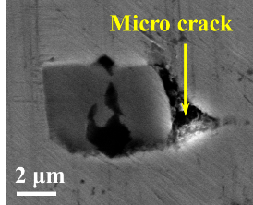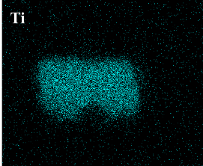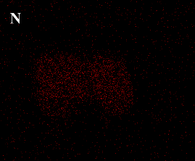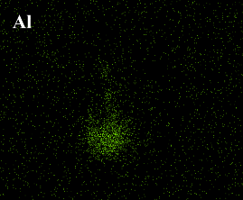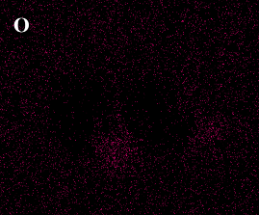
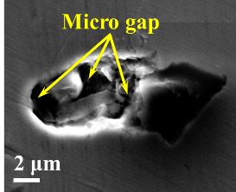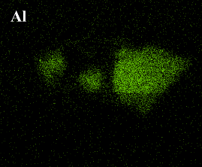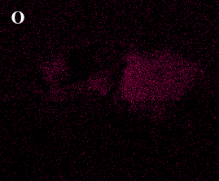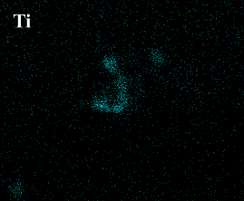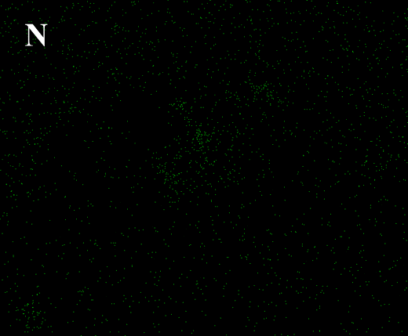
Fig. S1. TiN–Al₂O₃ inclusions in Mn18Cr18N steel.
2. Effect of C-containing inclusions on solidification structure of Mn18Cr18N steel
The results in this paper show that Ce can obviously refine the solidification structure of Mn18Cr18N steel. Therefore, it is necessary to analyze the effectiveness of Ce-containing inclusions as heterogeneous nucleation particles. The lattice mismatch of inclusions–δ or inclusions–γ can be calculated according to the following formula [3]:
$${\text{δ}}_{{\text{(}\text{hkl}\text{)}}_{\text{n}}}^{{\text{(}\text{hkl}\text{)}}_{\text{s}}}\text{=}\sum_{\text{i}\text{=1}}^{\text{3}}{\frac{\frac{\left|{\text{(}\text{d}}_{{\left[\text{uvw}\right]}_{\text{s}}^{\text{i}}}\text{cos}{\text{θ}}\text{)} \text{–} {\text{d}}_{{\left[\text{uvw}\right]}_{\text{n}}^{\text{i}}}\right|}{{\text{d}}_{{\left[\text{uvw}\right]}_{\text{n}}^{\text{i}}}}}{\text{3}}\text{×100}\text{\%} \text{ (S1)}}$$
where δ is lattice mismatch; (hkl)_{s} is the low index plane of the inclusions; [uvw]_{s} is the low index direction in (hkl)_{s}; (hkl)_{n} is the low index plane in the matrix metal; [uvw]_{n} is the low index direction in (hkl)_{n}; ${\text{d}}_{{\left[\text{uvw}\right]}_{\text{s}}}$and ${\text{d}}_{{\left[\text{uvw}\right]}_{\text{n}}}$ are interatomic spacing along [uvw]_{s} and [uvw]_{n}; θ is the angle between [uvw]_{s} and [uvw]_{n}.
As a composite inclusion, the composition and lattice structure of Ce–Al–O–S are not constant, so it cannot be simply considered as a pure compound to calculate. In this paper, it is considered as a mixture of Al₂O₃, Ce₂O₃, and Ce₂O₂S (Since the content of S in Mn18Cr18N+Ce steel is only 0.0003%, pure sulfides of Ce are not considered). Therefore, it is necessary to calculate the lattice mismatch of Al₂O₃–δ, Al₂O₃–γ, Ce₂O₃–δ, Ce₂O₃–γ, Ce₂O₂S–δ, and Ce₂O₂S–γ respectively. On the contrary, though TiN–Ce–Al–O–S is also a composite inclusion, its TiN shell completely wraps the Ce–Al–O–S core, so the lattice mismatch of (TiN–Ce–Al–O–S)–δ and (TiN–Ce–Al–O–S)–γ equals the mismatch of the TiN–δ and TiN–γ, respectively. The calculation results are shown in Table S1.
Table S1. Lattice mismatch between inclusions and Mn18Cr18N steel
Type | Melting point / K | Crystal type | Lattice parameter, a₀ / nm | Lattice mismatch / %
 |  |  |  | With δ | With γ
Al₂O₃ | 2323 | Hexagonal | 0.48224 [4] | 16.32 | 20.48
Ce₂O₃ | 1963 | Hexagonal | 0.3891 [5] | 6.14 | 6.60
Ce₂O₂S | 1913 | Hexagonal | 0.4 [6] | 3.51 | 5.85
TiN | 3223 | NaCl | 0.4308 [7] | 3.91 | 17.03
δ | 1673 | BCC | 0.29315 [7] | — | —
γ | 1618 | FCC | 0.3681 [8] | — | —

3. Effect of Ce segregation on solidification structure of Mn18Cr18N steel
Due to the size of Ce atom (181.8 pm) is much larger than that of Fe atom (121.0 pm) and the melting point of Ce (1072 K) is much lower than that of Fe (1811 K), Ce atoms are extremely easy to enriched at the front of solid–liquid interface during solidification [9]. Moreover, in this paper, Ce atoms in molten steel are mainly transmitted by diffusion, the speed of which is so slow that Ce atoms cannot quickly leave. Therefore, a stable enrichment layer of Ce atoms may be formed at the front of the solid–liquid interface, and with the growth of dendrites, the enrichment becomes more and more obvious until a dynamic equilibrium is reached.
In this paper, EPMA was used to detect the trend of Ce content in as-cast Mn18Cr18N+Ce steel. It can be noted from Fig. S2 that the content of Ce in dendrite is relatively low, but the content of Ce in interdendrite and grain boundary is relatively high. Considering that the result of line scanning is only semi-quantitative, five points (A, B, C, D, and E) were selected for accurate detection, which is completely consistent with the line scanning trend (mass fraction, A: 0.085%, B: 0.000%, C: 0.014%, D: 0.083%, E: 0.000%). In a word, the results of EPMA show that the content of Ce in earlier solidification region is lower, while the content of Ce in the later solidification region is higher, indicating that Ce atoms are indeed enriched in the front of solid–liquid interface.
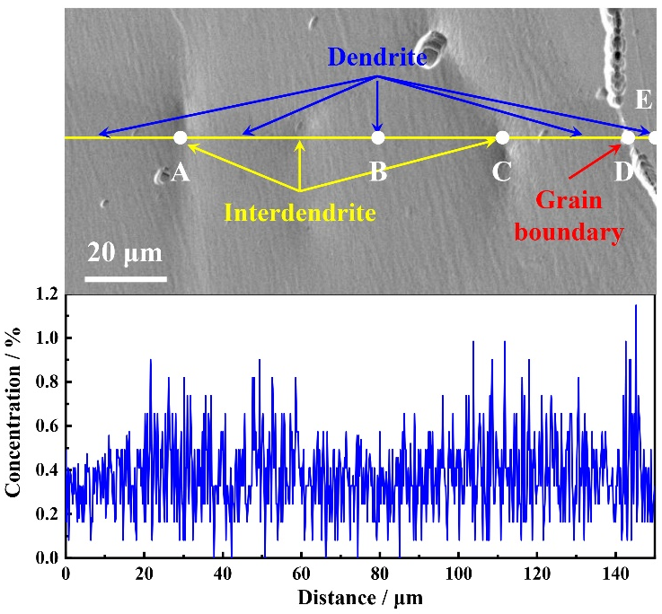
Fig. S2. Trend of Ce at dendrite, interdendrite, and grain boundary of as-cast Mn18Cr18N+Ce steel.
References
- J.L. Lei, Z.L. Xue, H.Y. Zhu, and Y.D. Jiang, Research progress on non-metallic inclusion in tire cord steel for radial tire, J. Iron Steel Res., 30(2018), No. 11, p. 847.
- A.L.V.D. Costa e Silva, The effects of non-metallic inclusions on properties relevant to the performance of steel in structural and mechanical applications, J. Mater. Res. Technol., 8(2019), No. 2, p. 2408.
- B.L. Bramfitt, The effect of carbide and nitride additions on the heterogeneous nucleation behavior of liquid iron, Metall. Trans., 1(1970), No. 7, p. 1987.
- N. Pan, B. Song, Q.J. Zhai, and B. Wen, Effect of lattice disregistry on the heterogeneous nucleation catalysis of liquid steel, J. Univ. Sci. Technol. Beijing, 32(2010), No. 2, p. 179.
- H. Bärnighausen and G. Schiller, The crystal structure of A-Ce₂O₃, J. Less Common Met., 110(1985), No. 1-2, p. 385.
- J.Z. Gao, P.X. Fu, H.W. Liu, and D.Z. Li, Effects of rare earth on the microstructure and impact toughness of H13 steel, Metals, 5(2015), No. 1, p. 383.
- F.X. Yin, L. Wang, Z.X. Xiao, J.H. Feng, and L. Zhao, Effect of titanium and rare earth microalloying on microsegregation, eutectic carbides of M2 high speed steel during ESR process, J. Rare Earths, 38(2020), No. 9, p. 1030.
- Y.C. Yu, S.H. Zhang, H. Li, and S.B. Wang, Effects of rare earth lanthanum on the solidification structure and hot ductility of Fe–43Ni expansion alloy, High Temp. Mater. Process., 37(2018), No. 3, p. 261.
- H.Q. Hu, X.Y. Zhong, and H. Li, Influence of Ce on crystal morphology of austenite and dendritic segregation of Mn in high-Mn steel, Acta Metall. Sin., 20(1984), No. 4, p. 247.

