**Application of g-C3N4/sol–gel nanocomposite on AM60B magnesium alloy and investigation of its properties**

*Roghaye Samadianfard*1), *Davod Seifzadeh*1),🖂, *and Burak Dikici*2)

1) Corrosion and Industrial Electrochemistry Research Laboratory, University of Mohaghegh Ardabili, Ardabil P.O. Box 179, Iran

2) Ataturk University, Department of Metallurgical and Materials Engineering, Erzurum 25240, Turkey

(Received: 16 September 2022; revised: 1 December 2022; accepted: 2 December 2022)

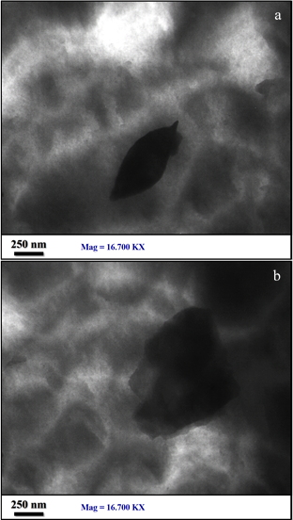

Fig. S1. TEM images of the g-HCN nanoplates inside the matrix of the [s.g@](mailto:s.g@F-SDS)g-HCN coating.

**lg [*Z* / (Ω. cm2)]**

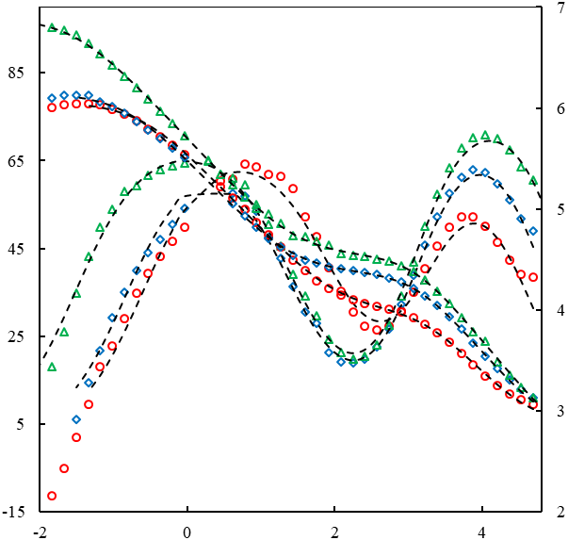

**–Phase angle / (o)**

**lg [*f* / Hz]**

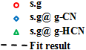

a

**lg [*Z* / (Ω. cm2)]**

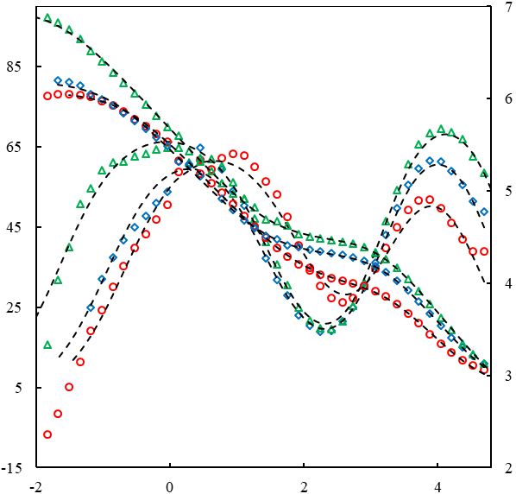

**lg [*f* / Hz]**

**–Phase angle / (o)**

b

**lg [*Z* / (Ω. cm2)]**

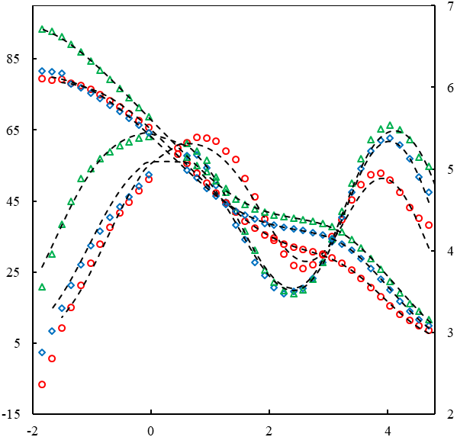

c

**lg [*f* / Hz]**

**–Phase angle / (o)**

**lg [*Z* / (Ω. cm2)]**

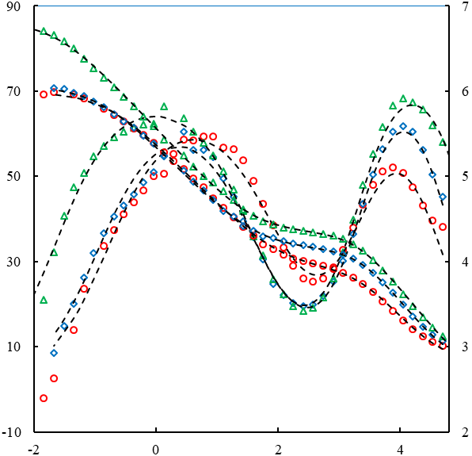

**lg [*f* / Hz]**

**–Phase angle / (o)**

d

**lg [*Z* / (Ω. cm2)]**

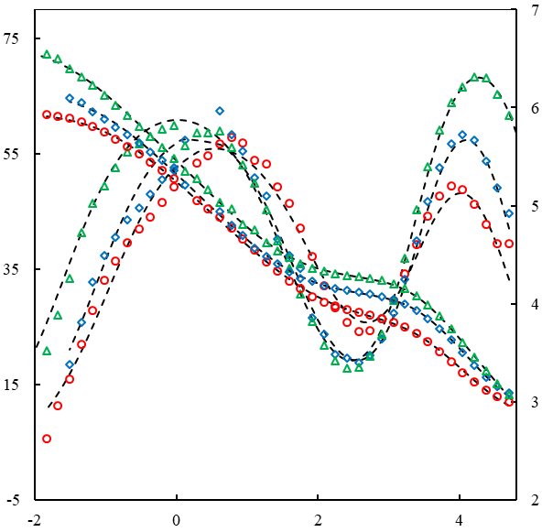

e

**lg [*f* / Hz]**

**–Phase angle / (o)**

**lg [*Z* / (Ω. cm2)]**

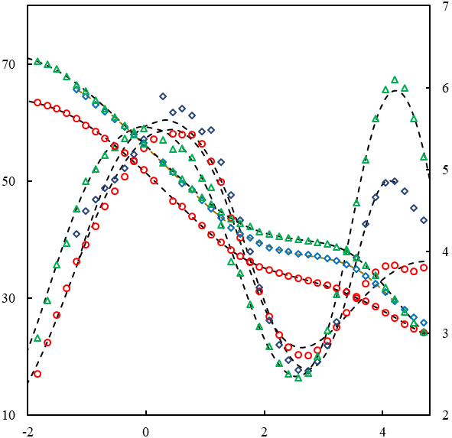

**lg [*f* / Hz]**



**–Phase angle / (o)**

f

**lg [*Z* / (Ω. cm2)]**

(

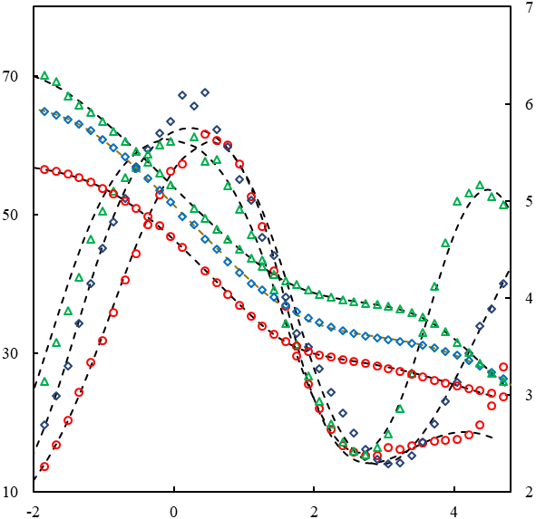

**–Phase angle / (o)**



**lg [*f* / Hz]**

g

**lg [*Z* / (Ω. cm2)]**

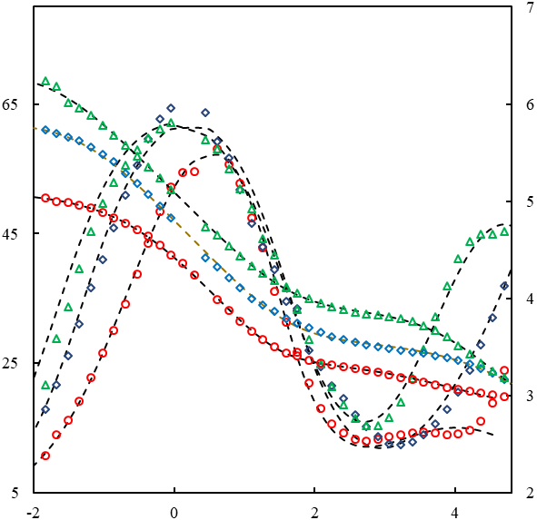

**lg [*f* / Hz]**

**–Phase angle / (o)**

h

**lg [*Z* / (Ω. cm2)]**

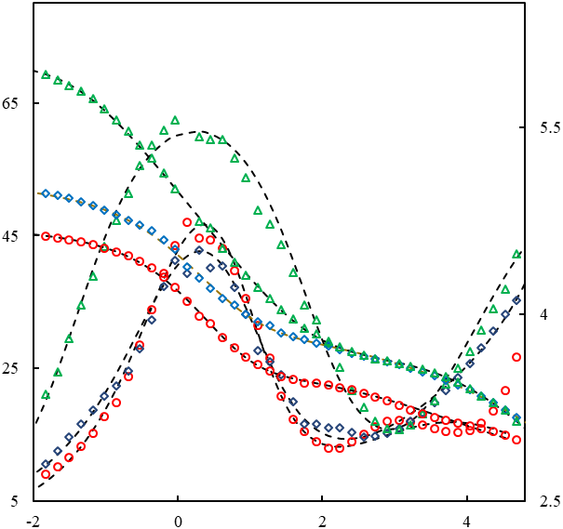

**–Phase angle / (o)**

**lg [*f* / Hz]**



i

**lg [*Z* / (Ω. cm2)]**

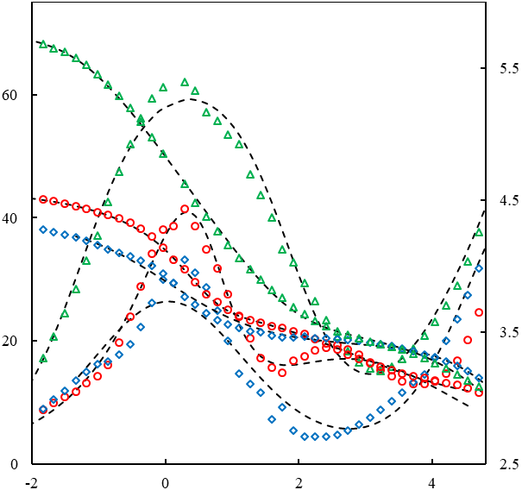

**lg [*f* / Hz]**



**–Phase angle / (o)**

j

Fig. S2. Bode plots of the s.g, [s.g@g-CN](mailto:s.g@g-CN), and [s.g@g-HCN](mailto:s.g@g-HCN) coatings after different immersion times in acid rain solution: (a) 0.5 h; (b) 1 h; (c) 2 h; (d) 4 h; (e) 8 h; (f) 24 h; (g) 48 h; (h) 72 h; (i) 120 h; (j) 168 h.

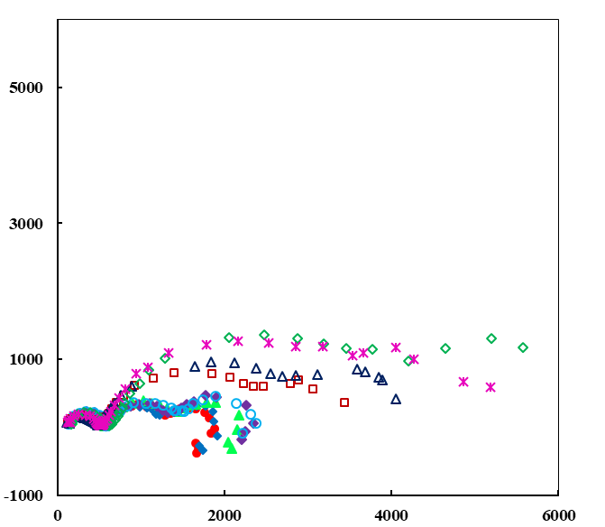

–***Z*i / (Ω·cm2)**

***Z*r / (Ω·cm2)**

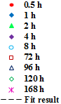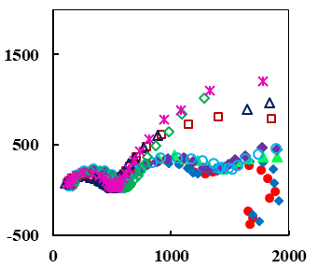

Fig. S3. EIS diagrams of the bare alloy.