**Metal-organic decomposition growth of thin film metastable perovskite nickelates with kinetically improved quantum transitions**

*Haiyan Li*1)*, *Yuzhao Wang*2)*, *Fanqi Meng*3)*, *Wei Mao*4)*, *Xingzhong Cao*5), *Yi Bian*1), *Hao Zhang*2), *Yong Jiang*1), *Nuofu Chen*2), *and Jikun Chen*1)🖂

1) Beijing Advanced Innovation Center for Materials Genome Engineering, School of Materials Science and Engineering, University of Science and Technology Beijing, 100083, China

2) School of Renewable Energy, North China Electric Power University, Beijing 102206, China

3) School of Materials Science and Engineering, Peking University, Beijing 100871, China

4) School of Engineering, The University of Tokyo, 2-11-16 Yayoi, Bunkyo-ku, Tokyo 113-0032, Japan

5) Institute of High Energy Physics, Chinese Academy of Sciences, Beijing 100049, China

(Received: 7 April 2023; revised: 19 June 2023; accepted: 5 July 2023)

🖂Corresponding author: Jikun Chen E-mail: jikunchen@ustb.edu.cn

*These authors contributed equally to this work.

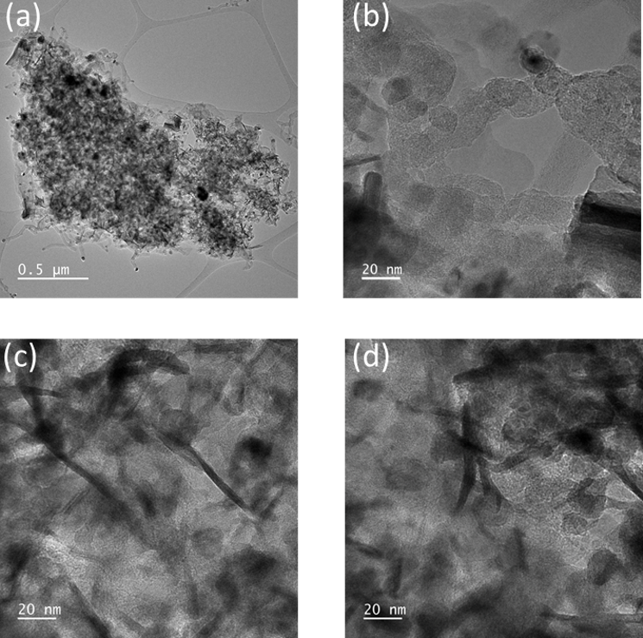

**Fig. S1****. The transmission electron microscope (TEM) images of the intermediate chemical products obtained by high pressure annealing of Sm(C7H15COO)3 and Ni(C7H15COO)2 at 450 °C during the metal organic decomposition (MOD) of SmNiO3.** **From as shown morphology in (a)-(d) at various magnification, it can be seen that the intermediate chemical product exhibits a size of around several tens of nanometer, which is much smaller compared to the previous chemical spin coating based approach to grow SmNiO3 using Sm(NO3)3 and Ni(AC)2 as precursor as reported in ref [S1] (further demonstrated in Figure S2).**

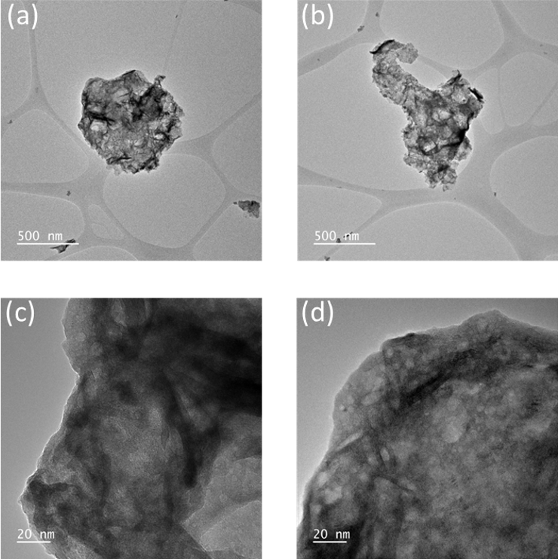

**Fig. S2. The transmission electron microscope (TEM) images of the intermediate chemical products obtained by high pressure annealing of Sm(NO3)3 and Ni(AC)2 at 450 °C during the chemical deposition of SmNiO3 as reported previously in ref [S1].** **From as shown morphology in (a)-(d) at various magnification, it can be seen that the intermediate chemical product exhibits larger size (e.g. several hundreds of nanometers) with more significant aggregations, as compared to the one obtained when performing the present metal-organic decomposition (MOD) approach as shown in Figure S1.**

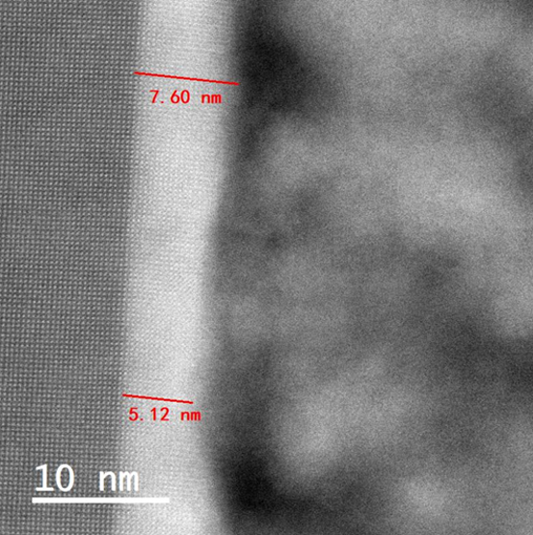

**Fig. S3. The cross-section morphology for as-grown DyNiO3/LaAlO3(001) by metal organic decomposition (MOD) approach. It can be seen that a single crystalline epitaxial layer of DyNiO3 is observed adjacent to the surface of the substrate with a thickness of around 5-8 nm, and polycrystalline DyNiO3 is observed with a grain size of around 10 nm. This is similar to the morphology as observed for SmNiO3/LaAlO3(001) as grown by MOD.**

**Fig. S4. (a) The interfacial high-angle annular dark-field (HAADF) images of as-grown SmNiO3/LaAlO3 by the high oxygen pressure assisted metal-organic decomposition. (b)-(e) the respective energy dispersive spectrometer (EDS) mappings of La (b), Al (c), Sm (d) and Ni (e). It can be seen that the single crystallize intermediate layer adjacent to the surface of the LaAlO3 substrate is SmNiO3.**

D:\Present Research\SNO NbSTO VO2 CCO Project Data Analysis\RNO MOD\Manuscript\投稿\SI图\XRD.tif

**Fig. S5. (a),(b) X-ray diffraction patterns (*θ*-2*θ* scan) of as-grown NdNiO3/LaAlO3(001) (a) and SmNiO3/LaAlO3(001) (b) by metal organic decomposition (MOD) approach. (c),(d) The respective X-ray grazing incident diffraction pattern of as-grown NdNiO3/LaAlO3(001) (c) and SmNiO3/LaAlO3(001) (d). From the*θ*-2*θ* scans, a set of diffraction peaks adjacent to the LaAlO3(001) substrate are observed for both NdNiO3 (to the left of the substrate peak as shown in (a)) and SmNiO3 (overlapped with the substrate peak as shown in (b)). These film peaks are associated to the coherent grown rare-earth nickelates on the surface of LaAlO3(001) with the same crystal orientation. The X-ray grazing incident diffraction pattern demonstrates the crystal structure associated to the surface layer of as-grown rare-earth nickelates thin films, and it clear demonstrates the variation observed for the quasi-single crystalline NdNiO3/LaAlO3(001) (c) and the polycrystalline SmNiO3/LaAlO3(001) (d).**

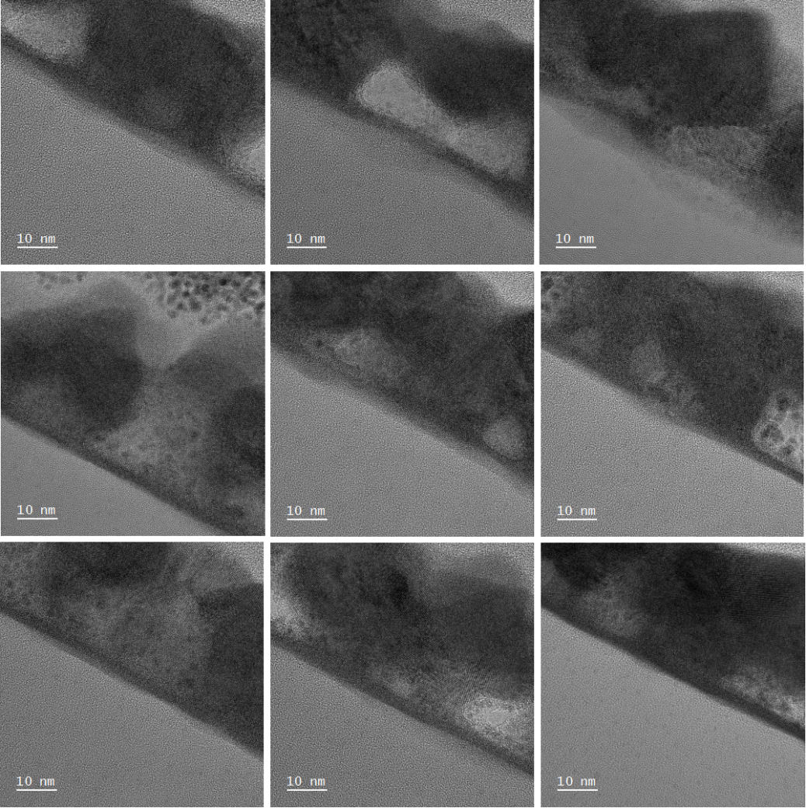

**Fig. S6. The representative transmission electron microscopic cross section morphology of as-grown NdNiO3/quartz via the present metal organic decomposition approach.**

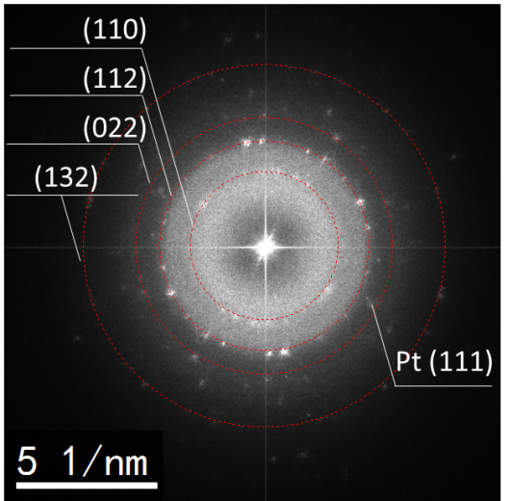

**Fig. S7. The respective diffraction pattern, as obtained by accumulating the 9 transmission electronic microscopic figures shown in Figure S6, where the diffraction rings associated to the perovskite structure is clearly demonstrated.**



**Fig. S8. (a) The X-ray grazing incident diffraction pattern and (b) The temperature dependence of the polycrystalline SmNiO3 grown on quartz substrate, where the abrupt change in the temperature dependence of the resistivity demonstrate the MIT property.**

电脑屏幕的照片上有灯光

**Fig. S9. (a) The *W*-parameter plotted as a function of the incident positron energy. (b) The relationship between the *W*- and *S-* parameters. In the positron annihilation spectrum (PAS), the *W*-parameter is calculated from the wing of the Doppler broadening spectroscopy (DBS) of the positron annihilation induced *γ*-ray profile, by (*B*+*C*)/(*A*+*B*+*C*), where *A*, *B*, and *C* represent for the γ-ray collected in the wavelength range of 510.2-511.8 keV, 505.1-508.4 keV, and 513.6-516.9 keV, respectively, as illustrated in Figure 2c. The *W-*parameter indicates the positron annihilation with high momentum electrons, e.g. the inner shell electrons. Therefore, enlarging the W-parameter represents a reduction in the low momentum electrons associated to the lattice defect. It can be seen that a reverse tendency in the *W-*parameter is observed compared to the one observed for the *S-*parameter shown in Figure 2c, and this is in consistency to the elevation in defect concentration within *Re*NiO3 with a reducing size of the rare-earth composition.**

**Fig. S10. Schematic illustration of the platinum pattern used to trigger the hydronge induced electronic transition of the *Re*NiO3 samples. In brief, the platinum catalyst electrode were grown on the top of the sample covered with a mask by magnetron sputtering, as shown in (a);. The Keithley 4200 was used to test with two probe method. Two probes were used to measure the nearest two adjacent platinum catalyst electrode, as shown in (b).**

**Fig. S11. (a),(b) The representative current-voltage (I-V) curve measured for as grown LaNiO3/LaAlO3(001) with platinum pattern on top before (a) and after (b) the hydrogenation process. (c), (d) Resistance of LaNiO3/LaAlO3(001) with top platinum pattern before (c) and after (d) the hydrogenation process. As shown magnitude of resistance in Figure 3a is the average value of the three magnitudes of the measured resistance.**

**Fig. S12. (a),(b) The representative current-voltage (I-V) curve measured for as grown PrNiO3/LaAlO3(001) with platinum pattern on top before (a) and after (b) the hydrogenation process. (c), (d) Resistance of PrNiO3/LaAlO3(001) with top platinum pattern before (c) and after (d) the hydrogenation process. As shown magnitude of resistance in Figure 3a is the average value of the three magnitudes of the measured resistance.**

**Fig. S13. (a),(b) The representative current-voltage (I-V) curve measured for as grown NdNiO3/LaAlO3(001) with platinum pattern on top before (a) and after (b) the hydrogenation process. (c), (d) Resistance of NdNiO3/LaAlO3(001) with top platinum pattern before (c) and after (d) the hydrogenation process. As shown magnitude of resistance in Figure 3a is the average value of the three magnitudes of the measured resistance.**

文本

**Fig. S14. (a),(b) The representative current-voltage (I-V) curve measured for as grown Sm0.3Nd0.7NiO3/LaAlO3(001) with platinum pattern on top before (a) and after (b) the hydrogenation process. (c), (d) Resistance of Sm0.3Nd0.7NiO3/LaAlO3(001) with top platinum pattern before (c) and after (d) the hydrogenation process. As shown magnitude of resistance in Figure 3a is the average value of the three magnitudes of the measured resistance.**

**Fig. S15. (a),(b) The representative current-voltage (I-V) curve measured for as grown Sm0.5Nd0.5NiO3/LaAlO3(001) with platinum pattern on top before (a) and after (b) the hydrogenation process. (c), (d) Resistance of Sm0.5Nd0.5NiO3/LaAlO3(001) with top platinum pattern before (c) and after (d) the hydrogenation process. As shown magnitude of resistance in Figure 3a is the average value of the three magnitudes of the measured resistance.**

**Fig. S16. (a),(b) The representative current-voltage (I-V) curve measured for as grown Sm0.7Nd0.3NiO3/LaAlO3(001) with platinum pattern on top before (a) and after (b) the hydrogenation process. (c), (d) Resistance of Sm0.7Nd0.3NiO3/LaAlO3(001) with top platinum pattern before (c) and after (d) the hydrogenation process. As shown magnitude of resistance in Figure 3a is the average value of the three magnitudes of the measured resistance.**

**Fig. S17. (a),(b) The representative current-voltage (I-V) curve measured for as grown SmNiO3/LaAlO3(001) with platinum pattern on top before (a) and after (b) the hydrogenation process. (c), (d) Resistance of SmNiO3/LaAlO3(001) with top platinum pattern before (c) and after (d) the hydrogenation process. As shown magnitude of resistance in Figure 3a is the average value of the three magnitudes of the measured resistance.**

**Fig. S18. (a),(b) The representative current-voltage (I-V) curve measured for as grown EuNiO3/LaAlO3(001) with platinum pattern on top before (a) and after (b) the hydrogenation process. (c), (d) Resistance of EuNiO3/LaAlO3(001) with top platinum pattern before (c) and after (d) the hydrogenation process. As shown magnitude of resistance in Figure 3a is the average value of the three magnitudes of the measured resistance.**

**Fig. S19. (a),(b) The representative current-voltage (I-V) curve measured for as grown GdNiO3/LaAlO3(001) with platinum pattern on top before (a) and after (b) the hydrogenation process. (c), (d) Resistance of GdNiO3/LaAlO3(001) with top platinum pattern before (c) and after (d) the hydrogenation process. As shown magnitude of resistance in Figure 3a is the average value of the three magnitudes of the measured resistance.**

**Fig. S20. (a),(b) The representative current-voltage (I-V) curve measured for as grown TbNiO3/LaAlO3(001) with platinum pattern on top before (a) and after (b) the hydrogenation process. (c), (d) Resistance of TbNiO3/LaAlO3(001) with top platinum pattern before (c) and after (d) the hydrogenation process. As shown magnitude of resistance in Figure 3a is the average value of the three magnitudes of the measured resistance.**

文本

**Fig. S21. (a),(b) The representative current-voltage (I-V) curve measured for as grown DyNiO3/LaAlO3(001) with platinum pattern on top before (a) and after (b) the hydrogenation process. (c), (d) Resistance of DyNiO3/LaAlO3(001) with top platinum pattern before (c) and after (d) the hydrogenation process. As shown magnitude of resistance in Figure 3a is the average value of the three magnitudes of the measured resistance.**

文本

**Fig. S22. (a),(b) The representative current-voltage (I-V) curve measured for as grownYNiO3/LaAlO3(001) with platinum pattern on top before (a) and after (b) the hydrogenation process. (c), (d) Resistance of YNiO3/LaAlO3(001) with top platinum pattern before (c) and after (d) the hydrogenation process. As shown magnitude of resistance in Figure 3a is the average value of the three magnitudes of the measured resistance.**

**Fig. S23. (a),(b) The representative current-voltage (I-V) curve measured for as grown HoNiO3/LaAlO3(001) with platinum pattern on top before (a) and after (b) the hydrogenation process. (c), (d) Resistance of HoNiO3/LaAlO3(001) with top platinum pattern before (c) and after (d) the hydrogenation process. As shown magnitude of resistance in Figure 3a is the average value of the three magnitudes of the measured resistance.**

图形用户界面

**Fig. S24. (a),(b) The representative current-voltage (I-V) curve measured for as grown ErNiO3/LaAlO3(001) with platinum pattern on top before (a) and after (b) the hydrogenation process. (c), (d) Resistance of ErNiO3/LaAlO3(001) with top platinum pattern before (c) and after (d) the hydrogenation process. As shown magnitude of resistance in Figure 3a is the average value of the three magnitudes of the measured resistance.**



**Fig. S25. Representative temperature dependence of resistance (*R-T*) of the hydrogenated *Re*NiO3/LaAlO3.**

**Fig. S26. The electrochemical triggered hydrogenation of NdNiO3 and SmNiO3 prepared by metal organic decomposition (MOD) and prepared by spin coating approach were carried out by three electrode test system. Among them, Ag / AgCl electrode is used as reference electrode and graphite electrode is used as counter electrode. The solution used 0.6 mol/L sodium chloride solution. Measure the pristine resistance, the resistance after -0.5V test and after +0.5V test respectively. Using a four probe test bench to measure the resistance of the sample. (a),(b) The *R*/*R*0 of NdNiO3 and SmNiO3 grown by MOD after ± 0.5V treatment, respectively; (c),(d) The *R*/*R*0 of NdNiO3 and SmNiO3 samples prepared by the previous chemical based appearance [S1] after ± 0.5V treatment. The resistance of the four samples increases when negative voltage is applied, and returns to the pristine state when positive voltage is applied. It can be seen that the *R*/*R*0 of NdNiO3 and SmNiO3 prepared by MOD method largely exceed the ones prepared by the previous reported chemical based approach. This observation is in consistency to the results shown in Figure 3b.**

D:\Present Research\SNO NbSTO VO2 CCO Project Data Analysis\RNO MOD\Manuscript\投稿\SI图\NRA、.tif

**Fig. S27. The depth profile of the hydrogen concentration within as-grown GdNiO3/LaAlO3(001) (a) and DyNiO3/LaAlO3(001) (b) as measured before and after the hydrogenation process via resonant nuclear reaction analysis (NRA). In general, the NRA profile observed for GdNiO3 and DyNiO3 are similar to the one shown for SmNiO3 in Figure 4c.**

**Supplementary References**

[1] J. Chen, H. Hu, J. Wang, T. Yajima, B. Ge, X. Ke, H. Dong, Y. Jiang and N. Chen, Overcoming synthetic metastabilities and revealing metal-to-insulator transition & thermistor bi-functionalities for d-band correlation perovskite nickelates, *Mater. Horiz.*, 6(2019), No. 4, p. 788.