Supporting Information

Improvement of hydrogen permeation barrier performance by iron sulphide surface films
Pengpeng Bai¹⁾, Shaowei Li²⁾, Jie Cheng³⁾, Xiangli Wen¹⁾, Shuqi Zheng ^{4),}, Changfeng Chen⁴⁾, and Yu Tian^{1),}
1) State Key Laboratory of Tribology, Department of Mechanical Engineering, Tsinghua University, Beijing 100084, China
2) School of Mechanical Engineering, University of Science and Technology Beijing, Beijing 100083, China
3) School of Mechanical Electronic & Information Engineering, China University of Mining and Technology-Beijing, Beijing 100083, China
4) State Key Laboratory of Heavy Oil Processing, China University of Petroleum, Beijing 102249, China
(Received: 13 August 2022; revised: 25 December 2022; accepted: 27 December 2022)
Corresponding author: Shuqi Zheng E-mail: zhengsq09@163.com; Yu Tian E-mail: tianyu@tsinghua.edu.cn

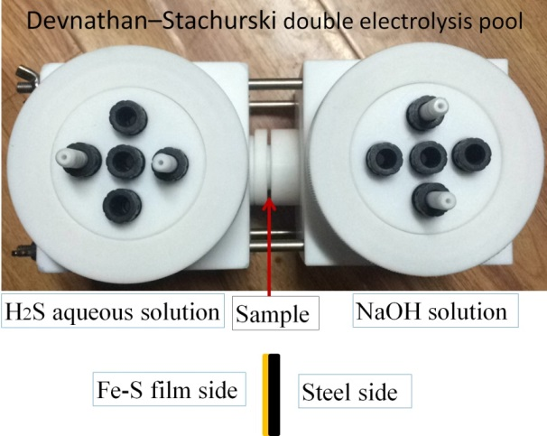
Fig.S1. Devnathan–Stachurski double electrolysis pool.
Fig.S2. Macroscopic photographs of prepared Fe–S films on steel.
Fig.S3. Permeation curves of bare steel in H₂S environment at 18°C.

The calculation of hydrogen diffusion coefficient using time lag method
Assuming that hydrogen diffuses in one dimension perpendicular to the surface of the sample, the hydrogen diffuses in the sample in accordance with Fick’s law.
（S1）
where D is the hydrogen diffusion coefficient, and c(x, t) is the concentration distribution function of hydrogen in steel. Assuming that the initial hydrogen distribution in the sample is uniform, the hydrogen concentration on the hydrogen charging side of steel increases to C₀ at t = 0, and then remains stable at a certain value. At the hydrogen evolution side of steel, the hydrogen concentration remains 0, and the hydrogen concentration distribution in the sample must meet the following conditions:
Initial conditions: t = 0；c(x,0) = 0；
Boundary conditions: t > 0; c(0, t) = C₀, c(L,t) = 0;
From the above initial and boundary conditions, D can be obtained:
(S2)
where t_{0.63} is the time when the instantaneous hydrogen permeation current reaches 0.63 times the steady-state hydrogen permeation current, which is labeled as t_{L}, also known as lag time, and the unit is s. L is the thickness of the sample the unite of which is cm. The steady-state hydrogen permeation current density i_{max} is obtained from the measured hydrogen permeation curves. The steady-state hydrogen diffusion flux J∞
$J_{∞}= \frac{i_{max}}{nF}$ (S3)

The Faraday constant F = 96485 C·mol^{–1}, which is the electron transferred during the reaction n = 1. Hydrogen permeability can be calculated using formula 4.
(S4)
The adsorption of hydrogen (Capp.) on the surface of the sample can be calculated using formula 5:
C_{app}= $\frac{J_{∞}×L}{D}$ (S5)

The basic reactions occurred in the steel–H₂S–H₂S system
(i) Ionization reaction of H₂S [52]:
${\text{H}}_{\text{2}}{\text{S}}_{\text{(g)}}\underset{⇔}{{\text{K}}_{{\text{H}}_{\text{2}}\text{S}}}{\text{H}}_{\text{2}}{\text{S}}_{\text{(aq)}}$ (S6)
${\text{H}}_{\text{2}}{\text{S}}_{\text{(aq)}}\underset{⇔}{{\text{K}}_{\text{1}}}{\text{H}}^{\text{+}}\text{+}{\text{HS}}^{\text{-}}$ (S7)
${\text{HS}}^{\text{-}}\underset{⇔}{{\text{K}}_{\text{2}}}{\text{H}}^{\text{+}}\text{+}{\text{S}}^{\text{2-}}$ (S8)
H₂S dissolves in water to generate H⁺ and HS⁻ ions in the first ionization process. Then, HS⁻ ions undergo secondary ionization to form H⁺ and S^{2–}. ${\text{K}}_{{\text{H}}_{\text{2}}\text{S}}$ and K_{i} (i = 1, 2) are the solubility constants and ionization constants for H₂S, respectively.
(ii) Anode reactions: the dissolution of iron in acidic solution [53–54]:
$\text{Fe+}{\text{H}}_{\text{2}}\text{S+}{\text{H}}_{\text{2}}\text{O}\underset{⇔}{{\text{k}}_{\text{1}}}\text{FeS}{\text{H}}_{\text{ads}}^{\text{-}}\text{+}{\text{H}}_{\text{3}}{\text{O}}^{\text{+}}$ (S9)
$\text{FeS}{\text{H}}_{\text{ads}}^{\text{-}}\underset{⇔}{{\text{k}}_{\text{2}}}\text{Fe(SH}{\text{)}}_{\text{ads}}\text{+}{\text{e}}^{\text{-}}$ (S10)
$\text{Fe(SH}{\text{)}}_{\text{ads}}\underset{⇔}{{\text{k}}_{\text{3}}}\text{FeS}{\text{H}}^{\text{+}}\text{+}{\text{e}}^{\text{-}}$ (S11)
$\text{FeS}{\text{H}}^{\text{+}}\text{+}{\text{H}}_{\text{3}}{\text{O}}^{\text{+}}\underset{⇔}{{\text{k}}_{\text{4}}}{\text{Fe}}^{\text{2+}}\text{+}{\text{H}}_{\text{2}}\text{S+}{\text{H}}_{\text{2}}\text{O}$ (S12)
$\text{2} \text{FeS}{\text{H}}^{\text{+}}\underset{⇔}{{\text{k}}_{\text{5}}}\text{Fe}{\text{S}}_{\text{ads}}\text{+S}{\text{H}}^{\text{-}}\text{+}{\text{H}}^{\text{+}}\text{+}{\text{Fe}}^{\text{2+}}$ (S13)
$\text{2}\text{n} \text{Fe}{\text{S}}_{\text{ads}}\text{→}\text{n} {{\text{Fe}}_{\text{2}}\text{S}}_{\text{2}}\text{→2}\text{n} \text{Fe}{\text{S}}_{\text{mackinawite}}$ (S14)
where FeSH–_{ads} and FeSH_{ads} are adsorbed mesophases, k_{i} (i = 1, 2, 3, 4) is the equilibrium constant, and FeS_{ads} is the adsorbed amorphous FeS. These reactions represent the active dissolution of iron based on the intermediate product FeS_{ads} adsorbed on the surface.
(iii) Cathode reaction [53]:
${\text{H}}_{\text{2}}{\text{S} \text{+} \text{e}}^{\text{-}}\text{→H+H}{\text{S}}^{\text{-}}$ (S15)
$\text{H}{\text{S}}^{\text{-}}\text{+}{\text{e}}^{\text{-}}\text{→H+}{\text{S}}^{\text{2-}}$ (S16)
${\text{H}}^{\text{+}}\text{+}{\text{e}}^{\text{-}}\text{→H}$ (S17)
The cathode reactions are constituted by a series of depolarization processes involving H₂S, HS⁻, and H⁺. The H⁺ ions generated by the ionization of H₂S are ultimately reduced to H₂.

