**Supplementary material**

Enhanced photocatalytic performance of iron oxides@HTCC fabricated from zinc extraction tailings for methylene blue degradation: Investigation of the photocatalytic mechanism

Yang Xue1,2), Xiaoming Liu1,2),🖂, Na Zhang3), 🖂, Yang Shao2), and Chunbao (Charles) Xu4), 🖂

1) State Key Laboratory of Advanced Metallurgy, University of Science and Technology Beijing, Beijing 100083, China

2) School of Metallurgical and Ecological Engineering, University of Science and Technology Beijing, Beijing 100083, China

3) Beijing Key Laboratory of Materials Utilization of Nonmetallic Minerals and Solid Wastes, National Laboratory of Mineral Materials, School of Materials Science and Technology, China University of Geosciences, Beijing 100083, China

4) Department of Chemical & Biochemical Engineering, Western University, London, ON N6A 5B9, Canada

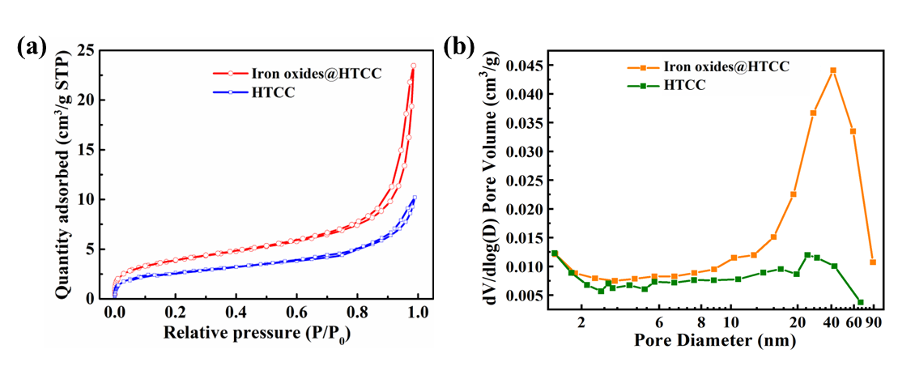**Fig. S1. Characterizations of the HTCC and iron oxides@HTCC: (a) N2 adsorption–desorption isotherms; (b) pore size distributions. Reprinted from *Hydrometallurgy*, 217, Y. Xue, X.M. Liu, N. Zhang, S. Guo, Z.Q. Xie, and C.B. Xu, A novel process for the treatment of steelmaking converter dust: Selective leaching and recovery of zinc sulfate and synthesis of iron oxides@HTCC photocatalysts by carbonizing carbohydrates, art. No. 106039, Copyright 2023, with permission from Elsevier.**