Supporting Information

N-doped graphene quantum dot-decorated N-TiO₂/P-doped porous hollow g-C₃N₄ nanotube composite photocatalysts for antibiotic photodegradation and H₂ production
Jingshu Yuan^{1,2),*}, Yao Zhang^{1),*}, Xiaoyan Zhang¹⁾, Junjie Zhang^{1,3,4)}, and Shen’gen Zhang^{1),✉}
1) Institute for Advanced Materials and Technology, University of Science and Technology Beijing, Beijing 100083, China
2) Xi’an Fanyi University, Xi’an 710105, China
3) Shunde Graduate School of University of Science and Technology Beijing, Foshan 528399, China
4) State Key Laboratory of Lunar and Planetary Sciences, Macau University of Science and Technology, Macau SAR 820000, China
* These authors contributed equally to this work
✉ Corresponding author: Shen’gen Zhang E-mail: zhangshengen@mater.ustb.edu.cn

Experimental section

Raw materials
Ammonium citrate, ethylenediamine, melamine (ME), phosphoric acid, nitric acid, ethanol, ethylenediaminetetraacetic acid disodium (EDTA-2Na), tetracycline (TC), rhodamine B (RhB) and ciprofloxacin (CIP) were purchased from China National Pharmaceutical Industry Co. Ltd. The tetrabutyl titanate (TBOT), p-benzoquinone (p-BQ), and isopropanol (IPA) were supplied by Aladdin Chemical Reagent Co. Ltd. All reagents used for the preparation and analytical testing of photocatalysts were not further purified.

Preparation methods
The N-GQDs solution was prepared according to the method of our previously reported work [1]. Precisely, 1.2188 g ammonium citrate was dissolved into 10 mL deionized water, followed by 7 drops of ethylenediamine drop by drop. The mixed solution was stirred and transferred into a Teflon-lined autoclave and held at 200°C for 6 h. The resulting tan color N-GQDs stock solution was filtered with 0.22 μm filters and dialyzed (3500 Da cutoff) for 24 h and then dried at 75°C under vacuum. Finally, solid N-GQDs were obtained. The N-GQDs powder was prepared into a 0.1 mg/mL solution and set aside.
The P-doped g-C₃N₄ hollow nanotubes (PCN) were fabricated by improving on the already reported procedure [2]. First, 1.0 g melamine (ME) and 1.0 g H₃PO₄ were added into 70 mL deionized water and stirred magnetically for 60 min. Then, the mixed solution was transferred into a Teflon-coated autoclave and held at 180°C for 12 h. The obtained white needle-like supramolecular precursors were cooled to room temperature, washed several times with deionized water, and dried under vacuum at 60°C. Finally, the resulting supramolecular precursors were put into a quartz boat with a cover and heated to 500°C under N₂ ambiance at a rate of 2.3 °C/min and held for 4 h. The light-yellow product acquired after cooling was the P-doped hollow tubular g-C₃N₄ (denoted as PCN). Direct calcination of ME using the same calcination regime yielded bulk g-C₃N₄ (CNB). The obtained PCN sample was subjected to a secondary heat treatment under an air atmosphere, i.e., heated to 450°C for 2 h with a heating rate of 2 °C/min. The PCN after the second heat treatment is noted as PCN-450.
The N-TiO₂ was prepared via an improved synthesis method reported previously [3]. 2 mL HNO₃ was mixed with 70 mL ethanol and stirred for 10 min, followed by 4 mL tetrabutyl titanate drop by drop and sonicated for 1 h. The resulting mixture was transferred to a Teflon-coated autoclave and held at 180°C for 12 h. After cooling down, the product was washed several times with deionized water and ethanol, followed by centrifugation, and collected after drying at 60°C. The obtained brownish-yellow solid was N-TiO₂, which was ground into powder and set aside. Pure TiO₂ was produced by the same preparation method as above but without the addition of HNO₃. The resulting N-TiO₂ sample was transferred to a crucible and heated to 450°C for 2 h with a heating rate of 2 °C/min. The N-TiO₂ after heat treatment is noted as N-TiO₂-450.

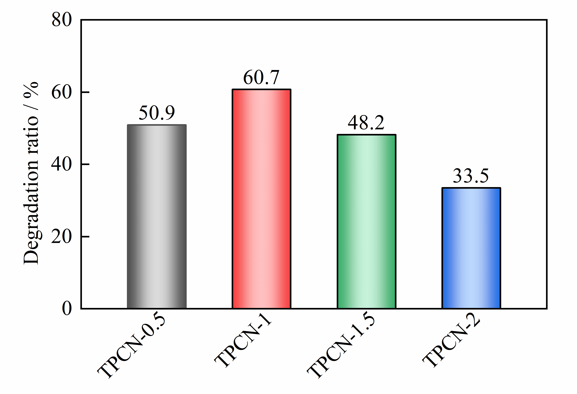

Fig. S1. CIP photodegradation performance of the binary composites under visible light.

Characterization
The crystal structure of the as-prepared samples was studied by X-ray diffractometer with Cu Kα radiation (XRD, Ultima IV, Japan). Fourier transform infrared (FT-IR) spectra were measured on a spectrometer (Thermo Fisher Nicolet iS10, USA). The microscopic morphology of the prepared photocatalysts was analyzed by field emission scanning electron microscopy (FESEM, ZEISS EVO 18, Germany) and field emission transmission electron microscopy (FETEM, JEM-2200FS, Japan). The element distribution of the samples was characterized by FETEM equipped with an energy-dispersive X-ray (EDX) detector. The surface chemical properties of the samples were characterized by X-ray photoelectron spectrometer (XPS, Thermo Scientific, USA) with a monochromatic Al Kα radiation source. The upconversion spectra of N-GQDs were monitored on a fluorescence spectrometer (Nanolog FL3-2iHR, France) with excitation wavelengths of 500–900 nm. The UV–vis diffuse reflectance spectra (DRS) were collected on a spectrophotometer (Shimadzu, UV3600IPLUS, Japan) using BaSO₄ as the reflectance standard. The steady-state/time-resolved photoluminescence (PL) spectra were obtained by a fluorescence spectrometer (Hitachi F-7100, Japan) with an excitation wavelength of 325 nm. The average decay time (τ_{ave}) of the samples can be calculated by the following Eq. (S1) [4]:
(S1)
Where, τ₁ and τ₂ are the decay time, and B₁ and B₂ are the pre-exponential factor.

Photoelectrochemical tests
The photochemical properties were tested by an electrochemical workstation (CHI 660E) equipped with a standard three-electrode system, in which a Pt electrode was used as the counter electrode, an Ag/AgCl (saturated KCl) electrode as the reference electrode, and a NaSO₄ solution (0.5 M) as the electrolyte. A 300 W Xenon lamp (λ > 420 nm) was applied as the light source for the photocurrent test system. Electrochemical impedance spectroscopy (EIS) was measured at a frequency from 10⁵ Hz to 0.01 Hz without illumination. The Mott-Schottky (M-S) plot was measured at 10³ Hz. The charge carrier density (N_{D}) can be calculated from the M-S plot according to the following Eq. (S2) [5].
(S2)
Where ε, ε₀, q, E, in the formula respectively represents the dielectric constant (ε (g-C₃N₄) = 5.25), the permittivity of free space (8.85×10^{–14} F cm^{–1}) of the semiconductor, elementary electron charge (1.60 × 10^{–19} C) and testing potential. C represents the capacitance of space charge layers.

Photocatalytic degradation experiment
The photocatalytic activity of the as-prepared samples was investigated by photocatalytic degradation of CIP (10 mg·L^{–1}), TC (20 mg·L^{–1}), and RhB (10 mg·L^{–1}). A 500 W Xenon lamp (CEL-S500) was used as the visible light (420 nm cutoff filter). Firstly, 50 mg photocatalyst and 100 mL contaminant solution were placed in a glass reactor with continuous stirring in dark for 60 min to achieve adsorption–desorption equilibrium. Subsequently, the lamp was turned on to start the photocatalytic reaction. 4 mL of the suspension was extracted at specified time intervals and the photocatalyst powder was removed by filtration with a microporous filter (0.22 μm). The photocatalytic degradation efficiency was calculated by measuring the absorbance of the filtrate at characteristic absorption peaks (272 nm for CIP; 357 nm for TC; 554 nm for RhB) by UV–Vis spectrophotometer (TU1900, China). The degradation efficiency and the corresponding kinetic function of the contaminant were calculated based on the following Eq. (S3) and (S4) [6, 7]:
(S3)
(S4)
Where C₀ (mg·L⁻¹) and C_{t} (mg·L⁻¹) represent the initial and real-time t (min) concentrations of pollutant solution, respectively; A₀ and A_{t} represent the initial and real-time absorbance of pollutant solution, respectively, and k is the pseudo-first-order rate constant (min⁻¹).
The total organic carbon (TOC) of the filtrate was determined with a TOC analyzer (Vario TOC, Elementar, Germany).
The trapping experiment was used to study the active species produced during photocatalytic degradation. Specifically, p-BQ, EDTA-2Na, and IPA were employed as trapping agents to capture ·O₂–, h⁺, and ·OH, respectively [6]. The different trapping agents (0.1 mM p-BQ, 1 mM EDTA-2Na, and 0.1 M IPA) were dissolved in a certain volume of contaminant solution, respectively, and then subjected to photocatalytic degradation as aforementioned. In addition, the reactive radicals were also detected by electron spin resonance (ESR, Bruker Emxplus, Germany). Therein, the 5,5-dimethyl-1-pyrroline N-oxide (DMPO) was used as the capturer of ·OH and ·O₂–.

Photocatalytic H₂ production experiment
A series of photocatalytic H₂ production experiments were carried out using a Labsolar 6A photocatalytic system (Perfect Light, China). Firstly, 50 mg photocatalyst was dispersed in 100 mL aqueous solution containing 10vol% triethanolamine. Then, 3wt% Pt was loaded on the surface of the photocatalyst by in situ photodeposition using chloroplatinic acid solution (H₂PtCl₆·6H₂O). Subsequently, the reaction system was bubbled with N₂ to remove the air before irradiation. A 300 W Xenon lamp (PLS-SXE300C, Perfect Light, China) equipped with a filter (λ > 420 nm) was used as the light source. The amount of H₂ produced from the continuously irradiated reaction system for 4 h was determined using gas chromatography (GC9790II with thermal conductivity detector (TCD) and N₂ carrier).

Identification of CIP degradation products
For the identification of CIP degradation intermediates, the photocatalytic reaction solutions at different irradiation times were filtered through a 0.22 μm membrane. The collected filtrates were analyzed by liquid chromatography–mass spectrometry (LC–MS). The LC column was a Shimadzu LC-30A C18 column (2.2 μm, 100 × 2.1 mm). The column temperature was 40°C. The flow rate was 0.2 mL·min^{–1}. The feed volume was 2 μL. 0.1% formic acid aqueous solution and acetonitrile were used as mobile phases A and B, respectively. Electrospray ionization source in positive ion mode (ESI⁺) was performed as the MS detection (AB Sciex Triple TOF 5600⁺), and the m/z range was set from 100 to 1500.

Results and discussion
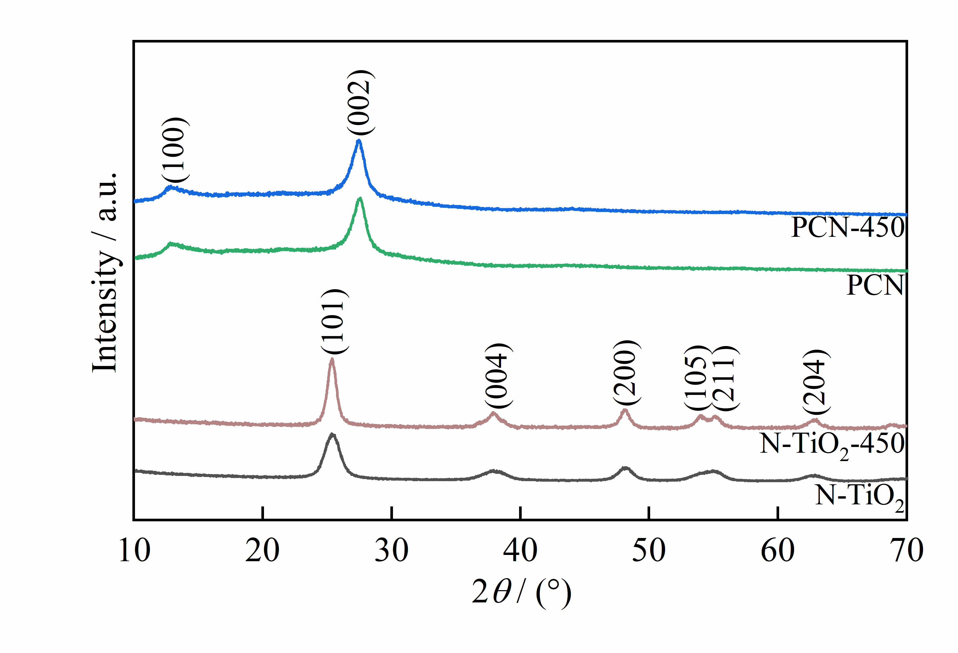

Fig. S2. XRD patterns of PCN and N-TiO₂ before and after heat treatment.
The XRD patterns of PCN and N-TiO₂ before and after heat treatment are shown in Fig. S2. The diffraction peaks of PCN-450 show no significant changes compared to PCN, indicating that the secondary heat treatment does not further change the crystal structure of P-doped g-C₃N₄ hollow nanotubes. Compared to N-TiO₂, the peak shape of N-TiO₂-450 gets sharper, which is attributed to the coarsening of TiO₂ particles due to sintering.

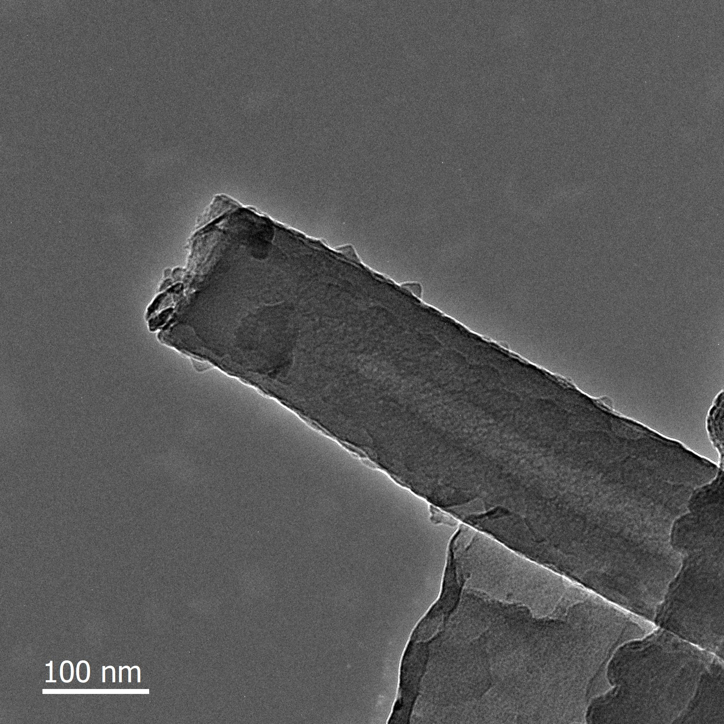

Fig. S3. FETEM image of PCN sample.

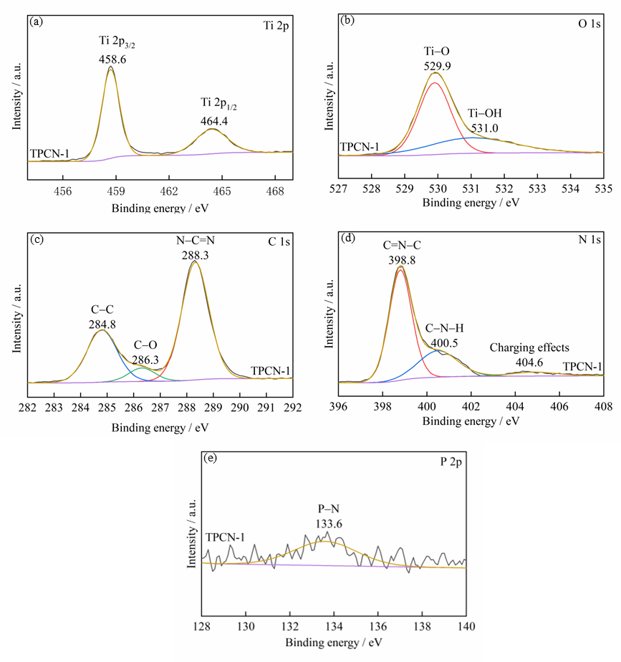

Fig. S4. The high-resolution XPS spectra of (a) Ti 2p, (b) O 1s, (c) C 1s, (d) N 1s, and (e) P 2p for TPCN-1.

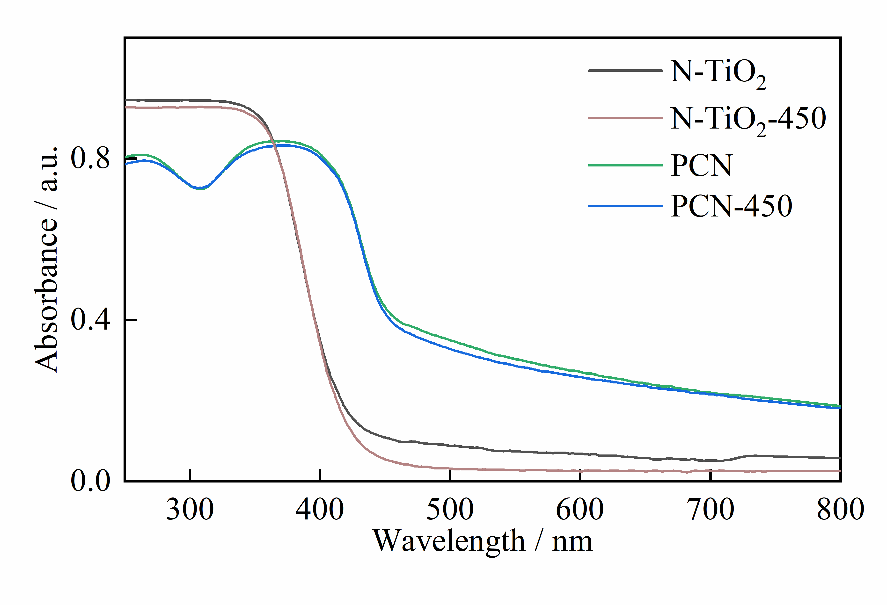

Fig. S5. UV–vis DRS of PCN and N-TiO₂ before and after heat treatment.
The DRS results of PCN and N-TiO₂ before and after heat treatment are presented in Fig. S5. There is no obvious difference in the photoabsorption capacity of PCN-450 compared to PCN, suggesting that the secondary heat treatment has no significant effect on its optical properties. Compared to N-TiO₂, the photoabsorption edge of N-TiO₂-450 has not shifted apparently, but the photoabsorption ability in the range of 430–800 nm is considerably reduced. This is due to the sintering of N-TiO₂ after heat treatment, resulting in larger grains, lower specific surface area, and a significant reduction in exposed atoms on the surface, which in turn causes a decrease in photoabsorption capacity [8].

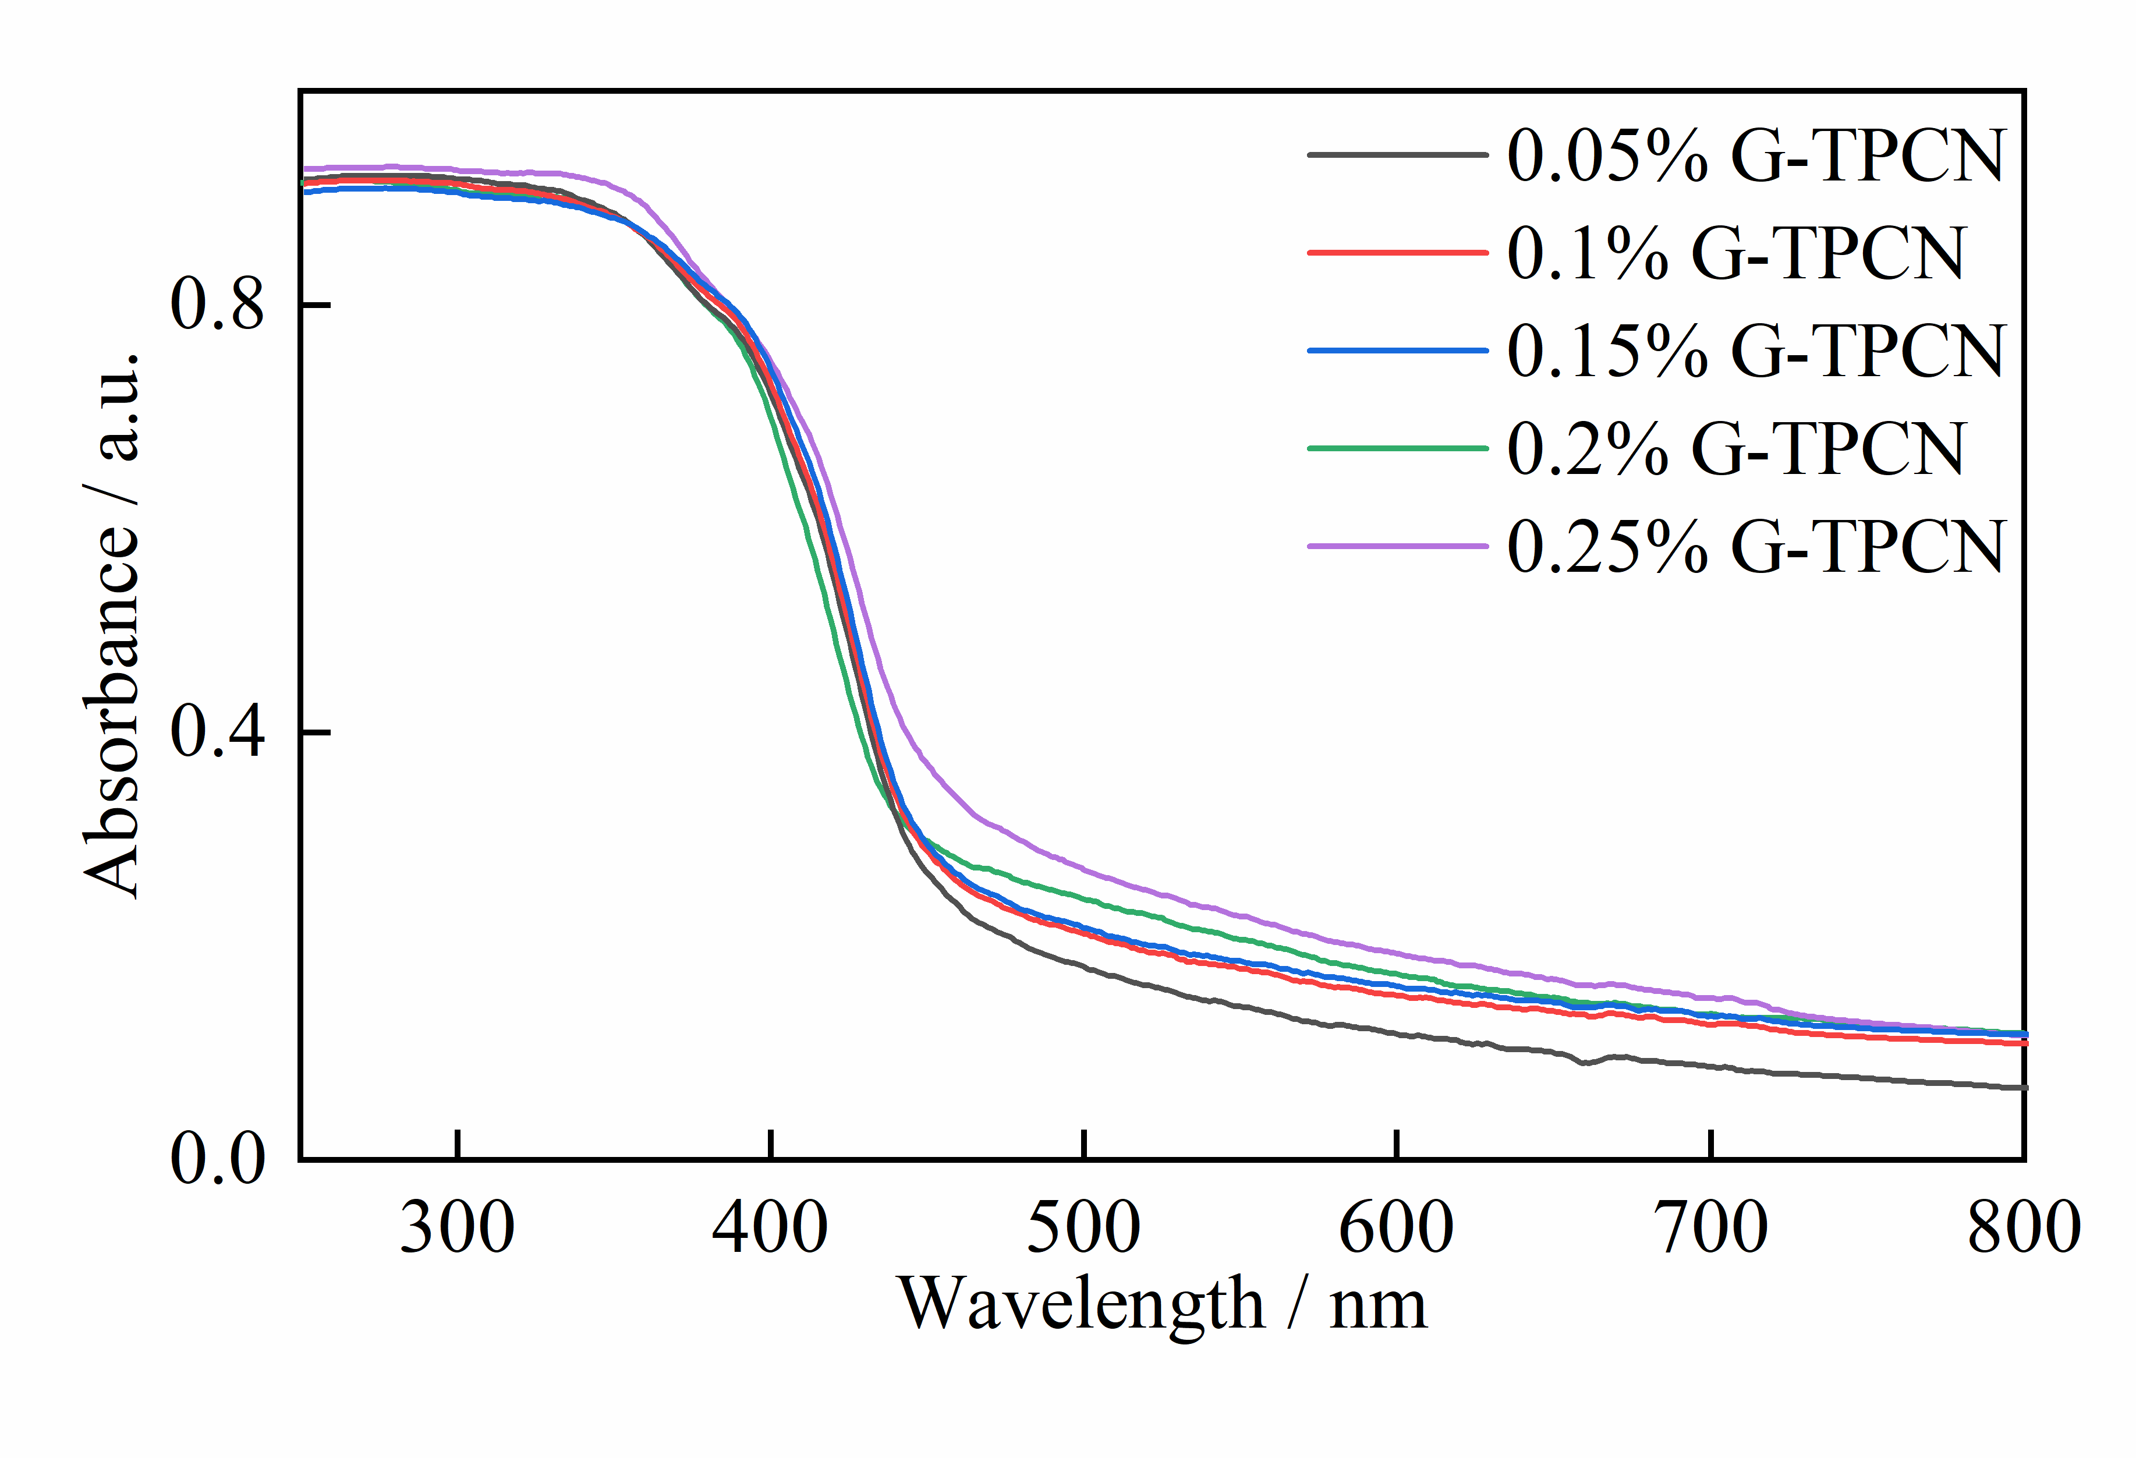

Fig. S6. UV–vis DRS of x%G-TPCN samples.

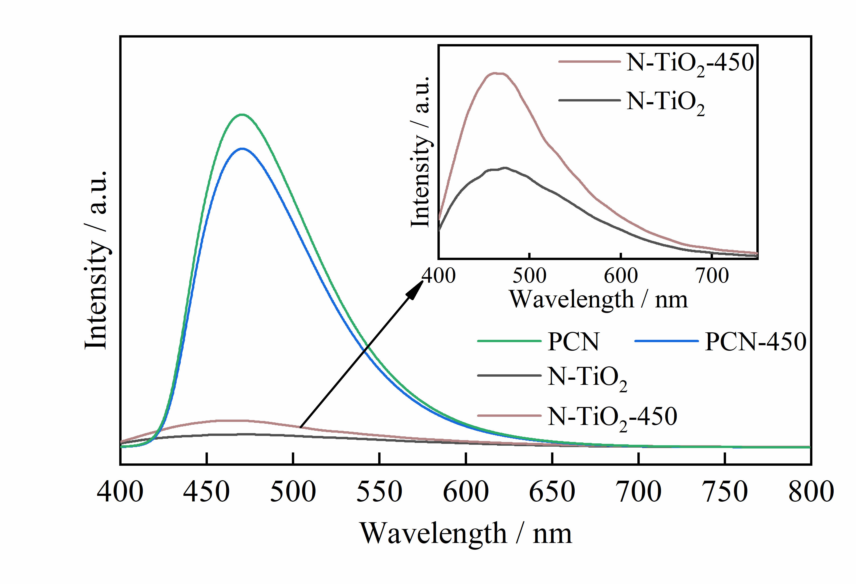

Fig. S7. Steady-state PL spectra of PCN and N-TiO₂ before and after heat treatment.
The steady-state PL spectra of PCN and N-TiO₂ before and after heat treatment are shown in Fig. S7. The peak intensity of PCN-450 is slightly reduced compared to PCN. This may be related to the thinning of a small number of tube walls caused by thermal exfoliation and thus shortening the distance of carrier transfer to the reaction site, which ultimately contributes to some inhibition of electron–hole recombination. The peak intensity of N-TiO₂-450 is higher compared to that of N-TiO₂, representing a higher recombination rate of its internal carriers. This is attributed to the coarsening of grain sintering in the secondary heat treatment of N-TiO₂ so that the diffusion time of electrons from the bulk phase to the surface gets longer, resulting in a higher probability of e––h⁺ recombination.

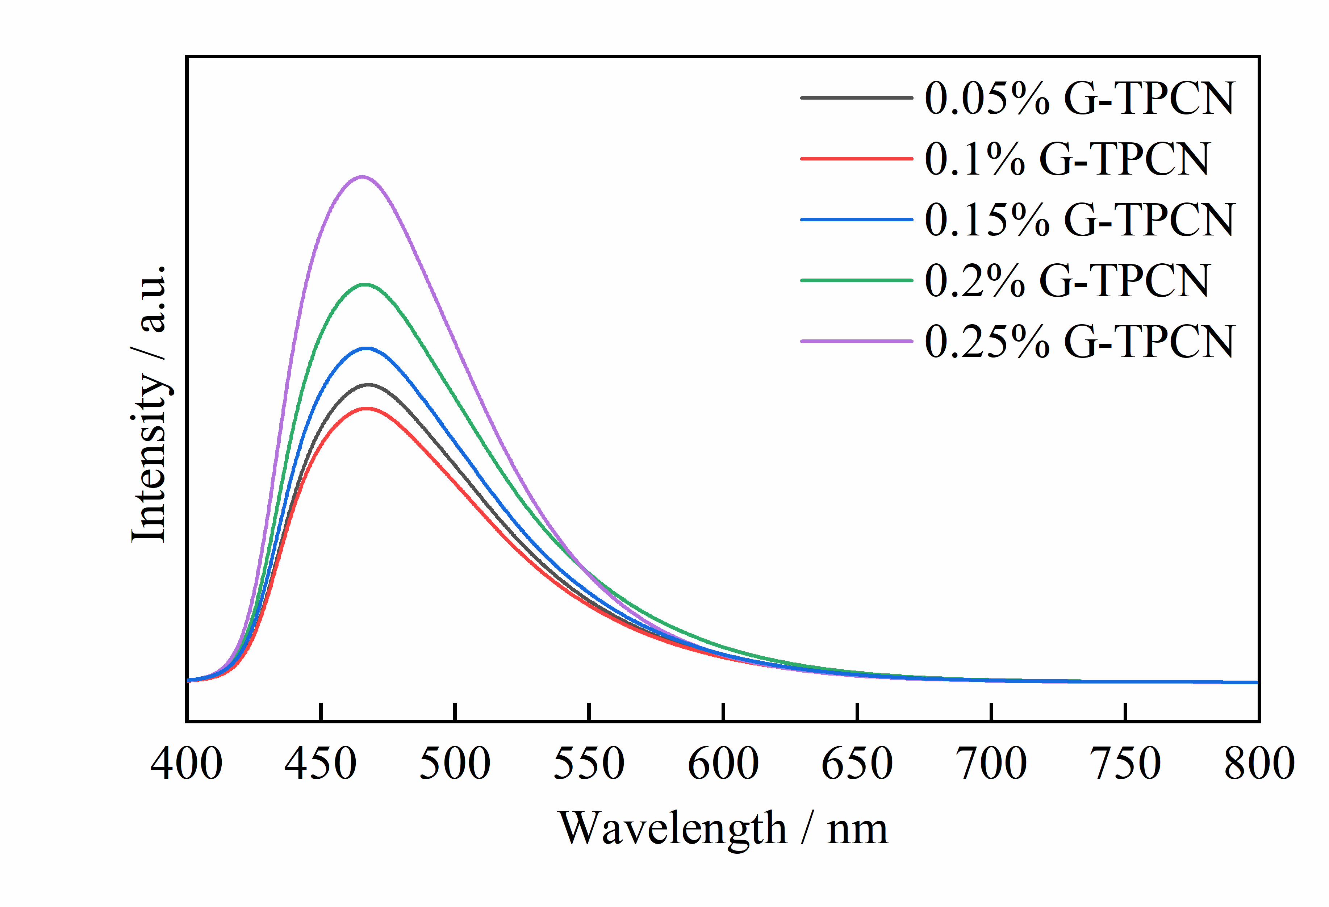

Fig. S8. Steady-state PL spectra of x%G-TPCN samples.

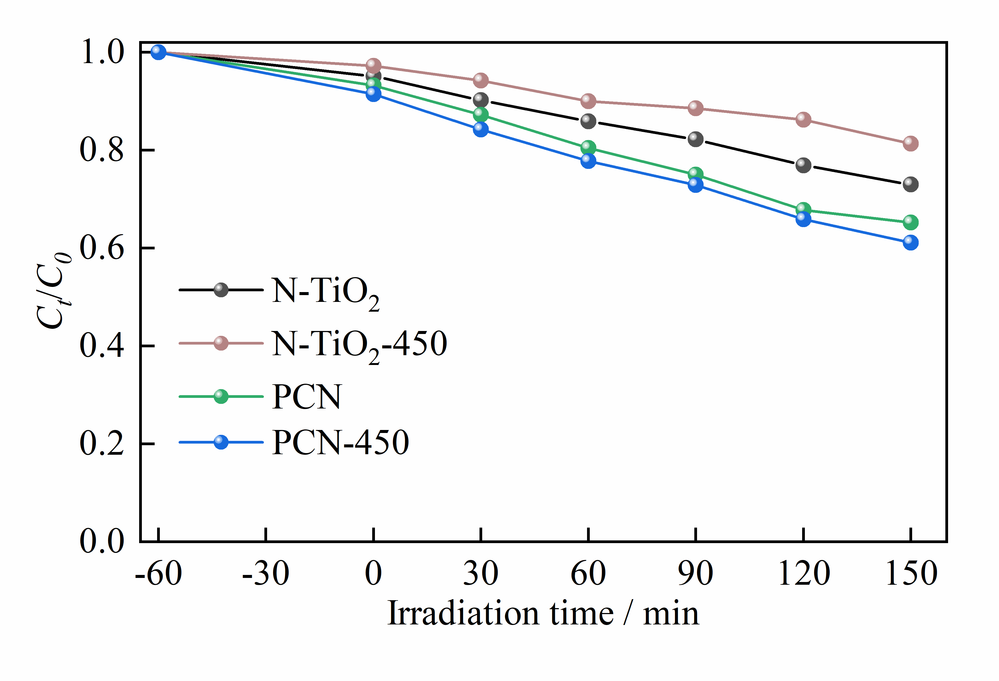

Fig. S9. Photocatalytic degradation curves of PCN and N-TiO₂ before and after heat treatment on CIP under visible light.
The photocatalytic degradation properties of PCN and N-TiO₂ samples before and after heat treatment were evaluated on CIP, respectively, as shown in Fig. S9. It is found that the photodegradation performance of N-TiO₂-450 is instead decreased compared to that of N-TiO₂. This is attributed to the sintering phenomenon of N-TiO₂-450, which results in larger grains and reduced specific surface area. In turn, there is a decrease in photoabsorption ability, an increase in e––h⁺ recombination probability, and a reduction in catalytic active sites exposed on the surface. Eventually, the photocatalytic degradation performance of N-TiO₂-450 deteriorated [8]. In addition, the photocatalytic performance of PCN-450 is slightly improved compared to that of PCN, but still significantly lower than that of TPCN-1 composite. This is because, compared to N-TiO₂ and PCN, the improved performance of TPCN-1 is mainly attributed to the dramatic increase in e––h⁺ separation efficiency caused by the formed Z-scheme heterojunction.

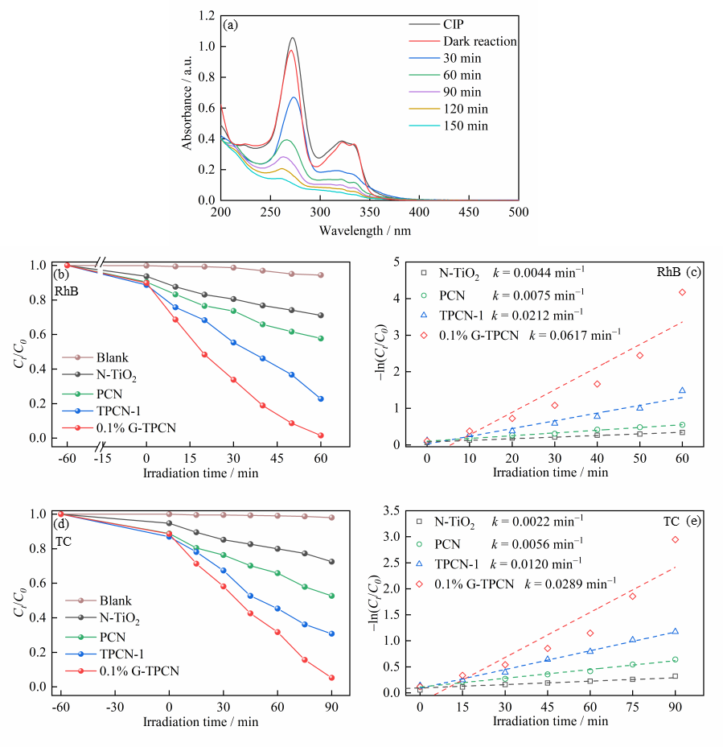

Fig. S10. (a) UV–Vis absorption spectra of CIP in the 0.1%G-TPCN system under dark and visible light conditions; Photodegradation efficiency and corresponding degradation kinetic for (b, c) RhB and (d, e) TC of samples under visible light (k is the rate constant).

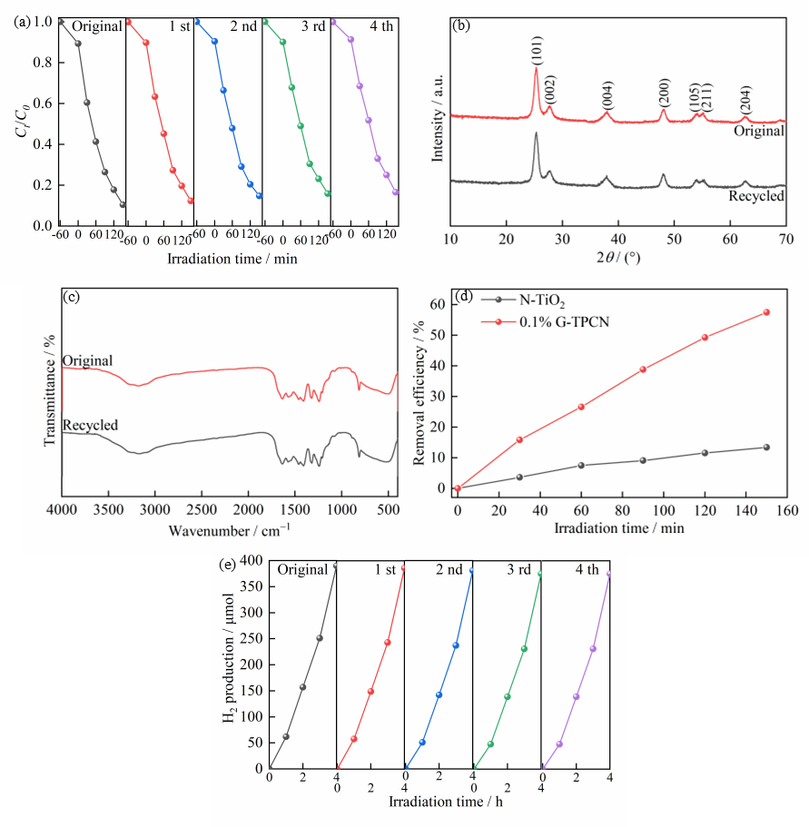

Fig. S11. (a) Photostability test of 0.1%G-TPCN for CIP photodegradation; (b) XRD patterns and (c) FT-IR spectra of original and recycled 0.1%G-TPCN; (d) TOC removal efficiency of the samples in CIP solution; (e) Photostability test of 0.1%G-TPCN for photocatalytic H₂ production.

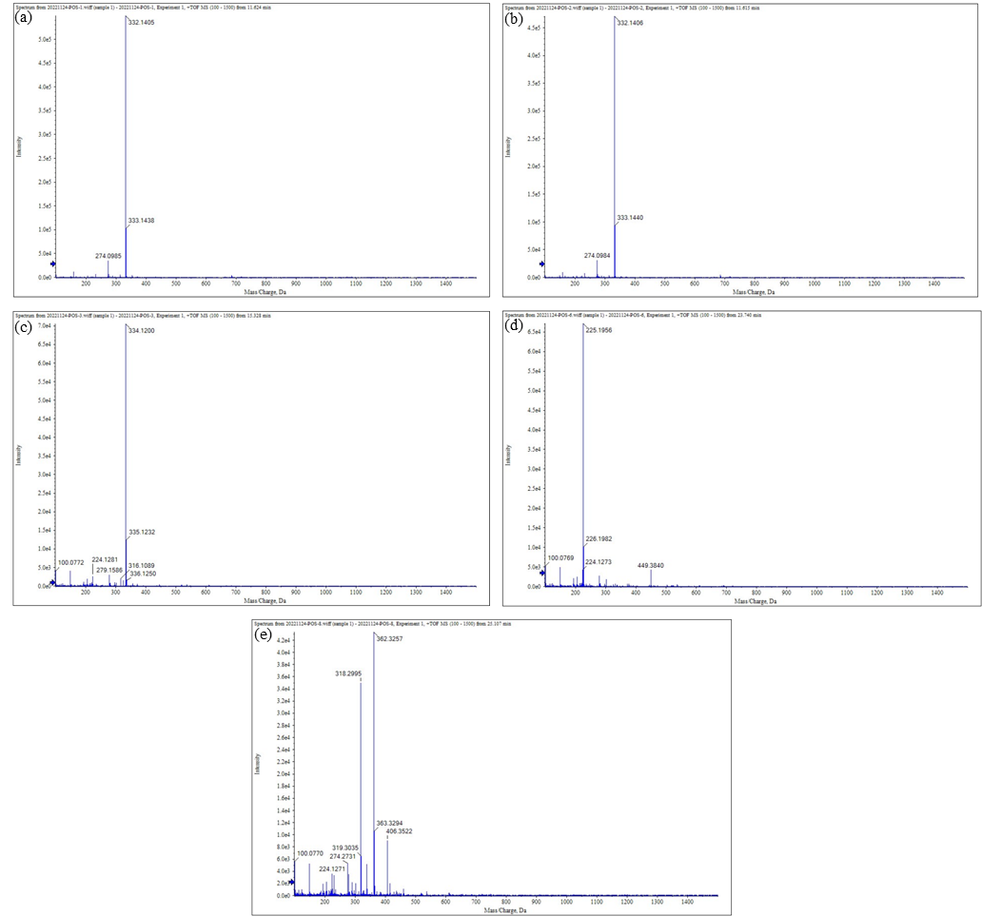

Fig. S12. Mass spectra of CIP solution treated for different times in 0.1%G-TPCN system: (a) initial CIP solution; (b) after adsorption for 60 min; (c–e) photodegradation after 60, 120, and 150 min.

Table S1. Comparison with other TiO₂/g-C₃N₄-based composite photocatalysts for photocatalytic degradation performance
Samples | Light source | Degradation conditions | Degradation efficiency | k (min^{–1}) | Enhanced times | Ref.
0.1%G-TPCN | 500W Xe lamp, λ>420 nm,  100 mW·cm^{–2}. | Cat. dosage=0.5 g·L^{–1},  CIP (10 mg·L^{–1}),  RhB (10 mg·L^{–1}),  TC (20 mg·L^{–1}). | CIP: 89.6% (150 min)  RhB: 98.5% (60 min)  TC: 94.8% (90 min) | CIP: 0.0142  RhB: 0.0617  TC: 0.0289 | CIP: 7.9  RhB: 14.0  TC: 13.1 | This work
TiO₂/g-C₃N₄/CuO | 500W Xe lamp. | Cat. dosage=0.5 g·L^{–1},  RhB (30 mg·L^{–1}) | 90.3% (120 min) | 0.0095 | 4.52 | [9]
g-C₃N₄-TiO₂@  CsPbBr₃ | 300W Xe lamp. | Cat. dosage=0.2 g·L^{–1},  TC (20 mg·L^{–1}). | 75.6% (120 min) | 0.01171 | 2.8 | [10]
Cu₂O-TiO₂-g-C₃N₄ | LED light source | Cat. dosage=0.2 g·L^{–1},  TC (30 mg·L^{–1}). | 93.28% (150 min) | 0.0200 | 9.1 | [11]
TiO₂@g-C₃N₄@ biochar | 250 W metal halide lamp, λ>400 nm. | Cat. dosage=0.5 g·L^{–1},  CIP (20 mg·L^{–1}). | 89.2% (60 min) | — | 6.16 | [12]
TiO₂@N-hollow carbon spheres/g-C₃N₄ | 300 W Xe lamp,  λ>420 nm. | Cat. dosage=1 g·L^{–1},  TC (20 mg·L^{–1}). | 85% (120 min) | 0.0125 | 6 | [13]
TiO₂/g-C₃N₄ | 14 W UV lamp,  λ=254 nm, 2.5 mW·cm^{–2}. | Cat. dosage=0.3 g·L^{–1},  TC (20 mg·L^{–1}). | 97% (60 min) | 0.058 | 6.4 | [14]
Graphene/TiO₂/g-C₃N₄ | 300 W Xe lamp,  λ>400 nm, 300 mW·cm^{–2}. | Cat. dosage=0.6 g·L^{–1},  TC (15 mg·L^{–1}),  CIP (3 mg·L^{–1}),  RhB (20 mg·L^{–1}). | TC: 83.5% (80 min)  CIP: 61.7% (60 min)  RhB: 98.0% (50 min) | TC: 0.0244  CIP: 0.0168  RhB: 0.0559 | TC: 1.63  CIP: 1.89  RhB: 4.18 | [15]
g-C₃N₄/TiO₂ | 150 W Xe lamp | Cat. dosage=0.25 g·L^{–1},  TC (20 mg·L^{–1}). | 99.40% (120 min) | 0.037 | 1.85 | [16]
TiO₂ nanorod/g-C₃N₄ nanosheet | 500W Xe lamp | Cat. dosage=0.2 g·L^{–1},  CIP (15µmol·L^{–1}). | 93.4% (60 min) | 0.0366 | 7.5 | [17]
Fe₃O₄/TiO₂/g-C₃N₄ | 500W Xe lamp,  λ>420 nm. | Cat. dosage=1.0 g·L^{–1},  RhB/MO (20 mg·L^{–1}). | RhB: 96.4% (80 min)  MO: 90% (120 min) | RhB: 0.0441  MO: 0.0186 | RhB: 3.73  MO: 2.74 | [18]
g-C₃N₄/TiO₂/kaolinite | Xe lamp, λ>400 nm,  90 mW·cm^{–2}. | Cat. dosage=2.0 g·L^{–1},  CIP (10 mg·L^{–1}). | 92% (240 min) | 0.00813 | 6.35 | [19]
Mesoporous TiO₂@g-C₃N₄ hollow core@shell | 500W Xe lamp, AM 1.5. | Cat. dosage=0.2 g·L^{–1},  RhB (20 mg·L^{–1}),  CIP (20 mg·L^{–1}). | RhB: 100% (40 min)  CIP: 74% (120 min) | — | — | [6]
g-C₃N₄/TiO₂/ halloysite nanotubes | 300W Xe lamp | Cat. dosage=0.8 g·L^{–1},  CIP (15 mg·L^{–1}). | CIP: 87% (60 min) | — | — | [6]
Abbreviations: Cat.: Catalyst, k: First-order rate constant, CIP: ciprofloxacin, RhB: Rhodamine B, TC: Tetracycline, MO: Methylene orange.

Table S2. Comparison with other TiO₂/g-C₃N₄-based composite photocatalysts for photocatalytic H₂ production
Photocatalysts | H₂ activity  (µmol·h^{–1}·g^{–1}) | Enhanced times | Light source | Reaction system | Ref.
0.1%G-TPCN | 1950 | 12.4 | 300 W Xe lamp,  λ>420 nm. | 50 mg cat., TEOA aqueous solution (100 mL, 10vol%), 3wt% Pt. | This work
R-TiO₂/g-C₃N₄ | 421.445 | 1.6 | 300 W Xe lamp | 100 mg cat., ethylene glycol solution (170 mL, 5.6vol%). | [21]
Cu-TiO₂ NF/gC₃N₄ | 261 | 18.6 | 300 W Xe lamp | 20 mg cat., TEOA aqueous solution (150 mL, 17vol%). | [22]
C dots/g-C₃N₄/TiO₂ | 580 | 6.6 | 3 W LED lamp,  420 nm,  80 mW·cm⁻² | 50 mg cat., TEOA aqueous solution (80 mL, 10vol%), 34 μL H₂PtCl₆ aqueous solution. | [23]
d-Ti₃C₂/TiO₂/g-C₃N₄ | 1620 | 2.4 | 300 W Xe lamp,  λ>420 nm. | TEOA aqueous solution (10vol%), 3wt% Pt. | [24]
Anatase/rutile TiO₂/g-C₃N₄ | 1031 | 13.6 | 300 W Xe lamp,  λ>400 nm,  320 mW·cm⁻². | 20 mg cat., TEOA aqueous solution (50 mL, 20vol%), 2wt% Pt. | [25]
Spheroids TiO₂/g-C₃N₄ | 286 | 2.3 | 300 W Xe lamp,  λ>400 nm. | TEOA aqueous solution (50 mL, 1vol%), 1wt% Pt. | [26]
g-C₃N₄/TiO₂ | 200.806 | 87.5 | 300 W Xe lamp | 60 mg cat., methanol aqueous solution (60 mL, 25vol%), 0.6 mg H₂PtCl₆·6H₂O. | [27]
Ag/TiO₂/g-C₃N₄ | 1707 | 20.6 | 350 W, λ>400 nm. | 10 mg cat., TEOA aqueous solution (5 mL, 10vol%), 1wt% Pt. | [28]
C-TiO₂/g-C₃N₄ | 1409 | 24 | 300 W Xe lamp,  λ>420 nm,  100 mW·cm⁻² | 20 mg cat., TEOA aqueous solution (100 mL, 10vol%), 2wt% Pt. | [29]
TiO₂-C₃N₄ | 1041.6 | 6.4 | 250 W visible light source | TEOA aqueous solution, 3wt% Pt. | [30]
GQDs/Mn-N-TiO₂/g-C₃N₄ | ~675 | — | 300 W Xe lamp,  320 nm ≤ λ ≤ 780 nm | 45 mg cat., 3wt% Pt. | [31]
C-dots/g-C₃N₄/TiO₂ | 210 | 5.3 | 350 W Xe lamp, 70 mW·cm⁻². | 50 mg cat., TEOA aqueous solution (80 mL, 10vol%). | [32]
Abbreviations: Cat.: catalyst, TEOA: triethanolamine.

Supplementary References
[1] Y. Zhang, J. Yuan, Y. Ding, B. Zhang, S. Zhang, and B. Liu, Metal-free N-GQDs/P-g-C₃N₄ photocatalyst with broad-spectrum response: Enhanced exciton dissociation and charge migration for promoting H₂ evolution and tetracycline degradation, Sep. Purif. Technol., 304(2023), p. 122297.
[2] L. Chen, X. Zhao, X. Duan, J. Zhang, Z. Ao, P. Li, S. Wang, Y. Wang, S. Cheng, H. Zhao, F. He, P. Dong, C. Zhao, S. Wang, and H. Sun, Graphitic carbon nitride microtubes for efficient photocatalytic overall water splitting: The morphology derived electrical field enhancement, ACS Sustainable Chem. Eng., 8(2020), No. 38, p. 14386.
[3] Y. Wang, L. Rao, P. Wang, Z. Shi, and L. Zhang, Photocatalytic activity of N-TiO₂/O-doped N vacancy g-C₃N₄ and the intermediates toxicity evaluation under tetracycline hydrochloride and Cr(VI) coexistence environment, Appl. Catal. B: Environ., 262(2020), p. 118308.
[4] Y. Yang, C. Zhang, D. Huang, G. Zeng, J. Huang, C. Lai, C. Zhou, W. Wang, H. Guo, W. Xue, R. Deng, M. Cheng, and W. Xiong, Boron nitride quantum dots decorated ultrathin porous g-C₃N₄: Intensified exciton dissociation and charge transfer for promoting visible-light-driven molecular oxygen activation, Appl. Catal. B: Environ., 245(2019), p. 87.
[5] Z. Zhou, K. Li, W. Deng, J. Li, Y. Yan, Y. Li, X. Quan, and T. Wang, Nitrogen vacancy mediated exciton dissociation in carbon nitride nanosheets: Enhanced hydroxyl radicals generation for efficient photocatalytic degradation of organic pollutants, J. Hazard. Mater., 387(2020), p. 122023.
[6] N. Guo, Y. Zeng, H. Li, X. Xu, H. Yu, and X. Han, Novel mesoporous TiO₂@g-C₃N₄ hollow core@shell heterojunction with enhanced photocatalytic activity for water treatment and H₂ production under simulated sunlight, J. Hazard. Mater., 353(2018), p. 80.
[7] H. Liang, M. Yu, J. Guo, R. Zhan, J. Chen, D. Li, L. Zhang, and J. Niu, A novel vacancy-strengthened Z-scheme g-C₃N₄/Bp/MoS₂ composite for super-efficient visible-light photocatalytic degradation of ciprofloxacin, Sep. Purif. Technol., 272(2021), p. 118891.
[8] N. Shirahata, Solution-processable white-light-emitting germanium nanocrystals, J. Solid State Chem., 214(2014), p. 74.
[9] R. Rajendran, S. Vignesh, S. Suganthi, V. Raj, G. Kavitha, B. Palanivel, M. Shkir, and H. Algarni, g-C₃N₄/TiO₂/CuO S-scheme heterostructure photocatalysts for enhancing organic pollutant degradation, J. Phys. Chem. Solids, 161(2022), p. 110391.
[10] L. Yang, Y. Liu, P. Tan, Y. Lu, Q. Ding, and J. Pan, Anchoring TiO₂@CsPbBr₃ on g-C₃N₄ nanosheet for enhanced photocatalytic degradation activity of tetracycline hydrochloride, Diamond Relat. Mater., 133(2023), p. 109727.
[11] H. Xiong, K. Yin, L. Wang, J. Wang, and Z. Hai, Obvious enhancement of visible photocatalytic performance of Cu₂O modified with TiO₂-g-C₃N₄: A strategy to achieve synergistic effect of p-n junction and Z-scheme, Opt. Mater., 138(2023), p. 113727.
[12] G. Wang, Y. Li, J. Dai, and N. Deng, Highly efficient photocatalytic oxidation of antibiotic ciprofloxacin using TiO₂@g-C₃N₄@biochar composite, Environ. Sci. Pollut. Res., 29(2022), No. 32, p. 48522.
[13] A.B. Dehkordi, and A. Badiei, Insight into the activity of TiO₂@nitrogen-doped hollow carbon spheres supported on g-C₃N₄ for robust photocatalytic performance, Chemosphere, 288(2022), p. 132392.
[14] Z. Li, J. He, H. Ma, L. Zang, D. Li, S. Guo, and Y. Ci, Preparation of heterogeneous TiO₂/g-C₃N₄ with a layered mosaic stack structure by use of montmorillonite as a hard template approach: TC degradation, kinetic, mechanism, pathway and DFT investigation, Appl. Clay Sci., 207(2021), p. 106107.
[15] Z. Wu, Y. Liang, X. Yuan, D. Zou, J. Fang, L. Jiang, J. Zhang, H. Yang, and Z. Xiao, MXene Ti₃C₂ derived Z–scheme photocatalyst of graphene layers anchored TiO₂/g–C₃N₄ for visible light photocatalytic degradation of refractory organic pollutants, Chem. Eng. J., 394(2020), p. 124921.
[16] B. Zhang, X. He, X. Ma, Q. Chen, G. Liu, Y. Zhou, D. Ma, C. Cui, J. Ma, and Y. Xin, In situ synthesis of ultrafine TiO₂ nanoparticles modified g-C₃N₄ heterojunction photocatalyst with enhanced photocatalytic activity, Sep. Purif. Technol., 247(2020), p. 116932.
[17] K. Hu, R. Li, C. Ye, A. Wang, W. Wei, D. Hu, R. Qiu, and K. Yan, Facile synthesis of Z-scheme composite of TiO₂ nanorod/g-C₃N₄ nanosheet efficient for photocatalytic degradation of ciprofloxacin, J. Cleaner Prod., 253(2020), p. 120055.
[18] A. Raza, H. Shen, A.A. Haidry, and S. Cui, Hydrothermal synthesis of Fe₃O₄/TiO₂/g-C₃N₄: Advanced photocatalytic application, Appl. Surf. Sci., 488(2019), p. 887.
[19] C. Li, Z. Sun, W. Zhang, C. Yu, and S. Zheng, Highly efficient g-C₃N₄/TiO₂/kaolinite composite with novel three-dimensional structure and enhanced visible light responding ability towards ciprofloxacin and S. aureus, Appl. Catal. B: Environ., 220(2018), p. 272.
[20] D. Wu, J. Li, J. Guan, C. Liu, X. Zhao, Z. Zhu, C. Ma, P. Huo, C. Li, and Y. Yan, Improved photoelectric performance via fabricated heterojunction g-C₃N₄/TiO₂/HNTs loaded photocatalysts for photodegradation of ciprofloxacin, J. Ind. Eng. Chem., 64(2018), p. 206.
[21] X. Jing, Y. Zhang, W. Yang, Q. Liu, H. Zhao, H. Xie, W. Wang, M. Zhang, H. Lu, S.N. Akanyange, X. Wang, J. Crittenden, X. Lyu, and H. Chang, g-C₃N₄ doping TiO₂ recovered from spent catalyst for H₂ evolution from water, Int. J. Hydrogen Energy (2023). 10.1016/j.ijhydene.2023.01.296.
[22] H. Khan, H. Charles, and C.S. Lee, Fabrication of noble-metal-free copper-doped TiO₂ nanofibers synergized with acetic acid-treated g-C₃N₄ nanosheets for enhanced photocatalytic hydrogen evolution, Appl. Surf. Sci., 607(2023), p. 155068.
[23] Z. Hu, D. Shi, G. Wang, T. Gao, J. Wang, L. Lu, and J. Li, Carbon dots incorporated in hierarchical macro/mesoporous g-C₃N₄/TiO₂ as an all-solid-state Z-scheme heterojunction for enhancement of photocatalytic H2 evolution under visible light, Appl. Surf. Sci., 601(2022), p. 154167.
[24] R. Li, A. Chen, Q. Deng, Y. Zhong, L. Kong, and R. Yang, Well-designed MXene-derived Carbon-doped TiO₂ coupled porous g-C₃N₄ to enhance the degradation of ciprofloxacin hydrochloride under visible light irradiation, Sep. Purif. Technol., 295(2022), p. 121254.
[25] G. Zhang, H. Zhang, J. He, Y. Jiang, H. Zhang, Q. Zhou, and J. Cao, Facile construction Z-scheme anatase/rutile TiO₂/g-C₃N₄ hybrid for efficient photocatalytic H₂ evolution under visible-light irradiation, Ceram. Int., 48(2022), No. 24, p. 36644.
[26] I.M. Sundaram, S. Kalimuthu, G.P. P, K. Sekar, and S. Rajendran, Hierarchical TiO₂ spheroids decorated g-C₃N₄ nanocomposite for solar driven hydrogen production and water depollution, Int. J. Hydrogen Energy, 47(2022), No. 6, p. 3709.
[27] Z. Wu, Y. Zhao, L. Mi, Y. Guo, H. Wang, K. Liu, K. Zhang, and B. Wang, Preparation of g-C₃N₄/TiO₂ by template method and its photocatalytic performance, Colloids Surf., A, 624(2021), p. 126756.
[28] R. Geng, J. Yin, J. Zhou, T. Jiao, Y. Feng, L. Zhang, Y. Chen, Z. Bai, and Q. Peng, In situ construction of Ag/TiO₂/g-C₃N₄ heterojunction nanocomposite based on hierarchical co-assembly with sustainable hydrogen evolution, Nanomaterials, 10(2020), No. 1, p. 1.
[29] X. Han, L. An, Y. Hu, Y. Li, C. Hou, H. Wang, and Q. Zhang, Ti₃C₂ MXene-derived carbon-doped TiO₂ coupled with g-C₃N₄ as the visible-light photocatalysts for photocatalytic H₂ generation, Appl. Catal. B: Environ., 265(2020), p. 118539.
[30] M.A. Alcudia-Ramos, M.O. Fuentez-Torres, F. Ortiz-Chi, C.G. Espinosa-González, N. Hernández Como, D.S. García-Zaleta, M.K. Kesarla, J.G. Torres-Torres, V. Collins-Martínez, and S. Godavarthi, Fabrication of g-C₃N₄/TiO₂ heterojunction composite for enhanced photocatalytic hydrogen production, Ceram. Int., 46(2020), No. 1, p. 38.
[31] Y. Nie, F. Yu, L. Wang, Q. Xing, X. Liu, Y. Pei, J. Zou, W. Dai, Y. Li, and S.L. Suib, Photocatalytic degradation of organic pollutants coupled with simultaneous photocatalytic H₂ evolution over graphene quantum dots/Mn-N-TiO₂/g-C₃N₄ composite catalysts: Performance and mechanism, Appl. Catal. B: Environ., 227(2018), p. 312.
[32] Y. Li, X. Feng, Z. Lu, H. Yin, F. Liu, and Q. Xiang, Enhanced photocatalytic H₂-production activity of C-dots modified g-C₃N₄/TiO₂ nanosheets composites, J. Colloid Interface Sci., 513(2018), p. 866.

