SUPPLEMENTARY INFORMATION
Investigations on the corrosion, mechanical, and microstructural properties of aluminum 7075–carbon nanotube nanocomposites for robots in corrosive environments
Arun David, Satheesh Kumar Gopal, Poovazhagan Lakshmanan, and Amith Sukumaran Chenbagam
Sri Sivasubramaniya Nadar College of Engineering, Kalavakkam, Chennai–603110, India

- CNT TEM morphology
This is done to measure the dimensions of CNTs using TEM morphology images, as shown in Fig. S1. After analysing more than 20 TEM images, the presence of smaller diameter CNTs as low as 4 nm, and higher value up to 20 nm is concluded.
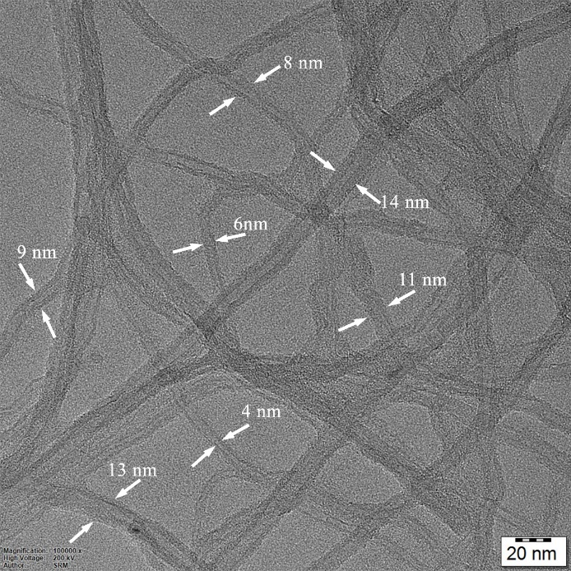
Fig. S1. TEM of the CNTs.
- Characterization of CNTs
From the Fig. 1(c) in the manuscript, the 2θ peaks at 26 º (002) and 43.8 º (100) refer to the reflection of the graphitic structures. There are additional peaks at 53.9 º (004) and 77.6 º (110) indicating the diffraction of graphite.
Fig. 1(a) shows the multiwall CNTs and the enlarged view is shown in Fig. 1(b). The Raman spectroscopy of the multiwall CNT at room temperature is depicted in Fig. 1(d). In the Raman spectrum of MWCNTs, two typical graphite bands can be seen: the band at 1347 cm^{–1} (D band), which is activated by the presence of disorder in carbon systems, and the band at 1575 cm^{–1} (G band), which is assigned to the in-plane vibration of the C–C band and the intensity of the band is 1383.69. The 2D band, which is the overtone of the D band, can be seen in the Raman spectra at a wavelength of 2704 cm^{–1} and the intensity is 419.77. These bands were found in the powder of the MWCNTs as it is received.
- Aluminium Nanocomposites (ANC) fabrication process
RUMS method is utilized to synthesize Al7075/CNTs. Following are the components of this casting machine: resistance furnace, SS310 crucible, box type heat treatment furnace, and an Ultrasonic probe with mechanical stirrer as shown in Fig. S2.
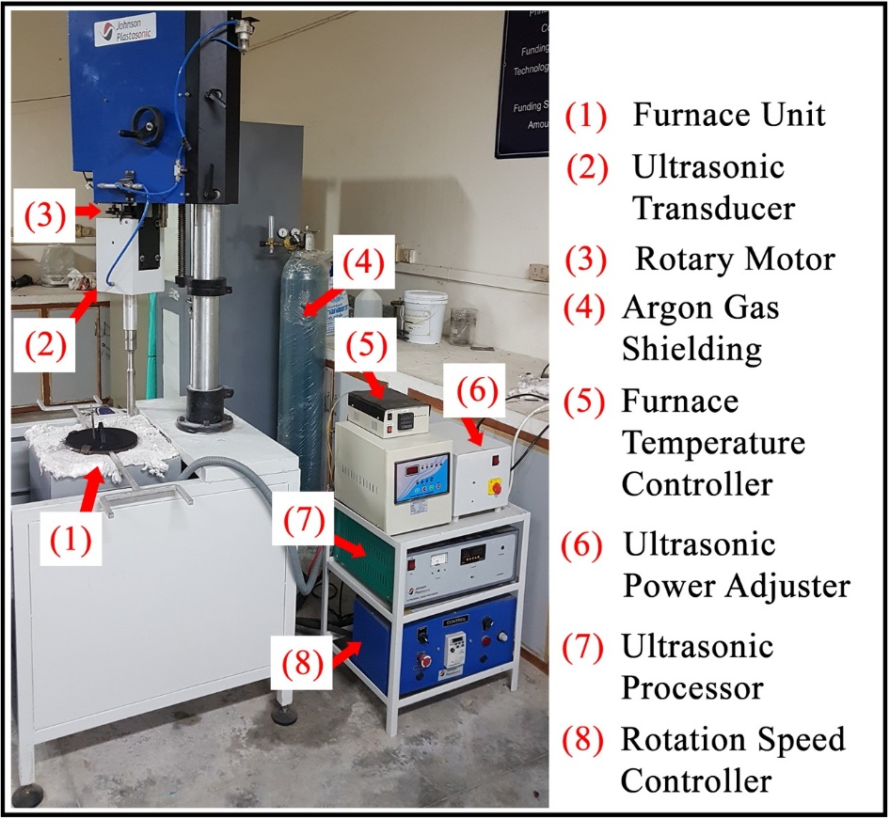
Fig. S2. RUMS machine and its component.
Wrought Al7075 alloy is sliced and made it into small cubes weighing around 1.3 kg each and is placed in the melting-pot and melted at 750ºC in the furnace. The CNT were weighed and is preheated at 850ºC for 10 min and added to the molten Al7075. For the entire procedure, the argon gas is used as a protecting agent at a flow rate of 1 L·min^{–1}. The rotating ultrasonic probe is submerged in the molten melt of aluminium alloy at a depth of 60 mm below the liquid surface. The RUMS process is operated with a 500 r·min^{–1} rotation speed, 20 kHz ultrasonic frequency, 2.5 kW ultrasonic power, and a 10 min processing time. The fabrication setup utilized for this process is shown in Fig. S2 of the supplementary section.
A pulsed mode is used to control the ultrasonication, which alternated on a 5 s duty cycle. In preparation for the solidification process, the casting die is preheated to 450ºC. The nanocomposite slurry is added to the hot die after the RUMS process and is allowed to cool naturally.
In the Al melt, the RUMS technique is employed to induce both ultrasonication and vortex formation. A RUMS probe setup is used to stir and sonicate the Al melt simultaneously. The density of CNTs is less than Al7075, and hence would float on the Al melt surface. In order to avoid that the RUMS process produces a vortex motion to keep the CNTs submerged within Al molten metal and to evenly distribute the nanoparticles. Even the agglomerated CNTs is also eventually broken down into tiny pieces and gets uniformly dispersed throughout the aluminium matrix. This happens due to the formation of bubbles and the sonic streaming effect created by this process in the Al melt. The schematic representation of RUMS process is shown in Fig. S3. Solutionization and ageing of the ANCs are performed at 490 °C for 1 h and then at 120°C for 24 h (ASTM B917M standard - T6 conditions).

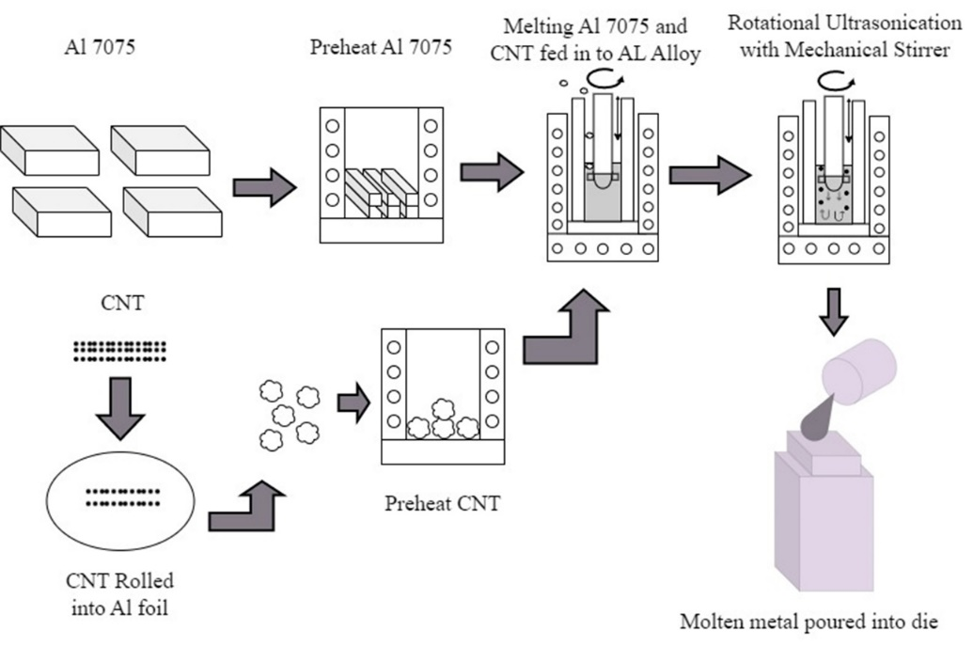
Fig. S3. Schematic diagram of RUMS process.
- Experimental procedure
4.1. Immersion test
The test was carried out as per ASTM standard. The corrosion rate of Al alloy is assessed using weight loss in 10, 20, 40, and 60 percent (v/v) solutions for 24, 48, 72, 96, and 120 h immersion durations.
4.2 Salt fog spray test
The salt fog spray test is performed for as cast and solutionized and aged (T6) ANC samples as per ASTM G85 standard. The corrosion resistance of the Al nanocomposite samples is tested for 120 h as per standards. The number of pits per unit area is used to assess the ANCs resistance to pitting corrosion and the surfaces when corroded are evaluated with the use of SEM.
4.3 Potentiodynamic polarization test (PDP)
In order to collect the corrosion parameter data, anodized samples are subjected to potentiodynamic polarisation at room temperature. The tests are conducted using a three-electrode setup as per ASTM G59 standard. The samples are soaked in acetic acid for 4h before electrochemical experiments to achieve the steady state open-circuit potential (OCP).
- XRD analysis graph of the ANCs
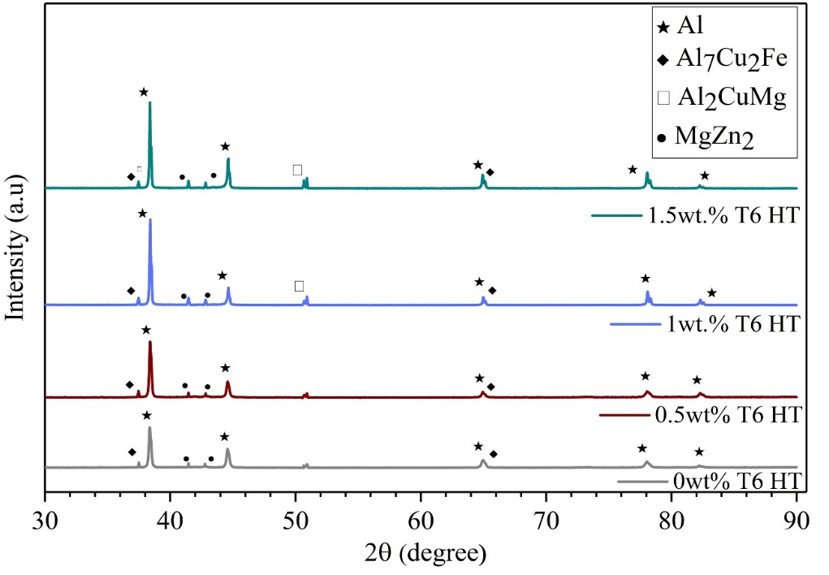
Fig. S4. XRD analysis of T₀, T_{0.5}, T₁, and T_{1.5} ANCs samples.
- Tensile mechanism of ANCs
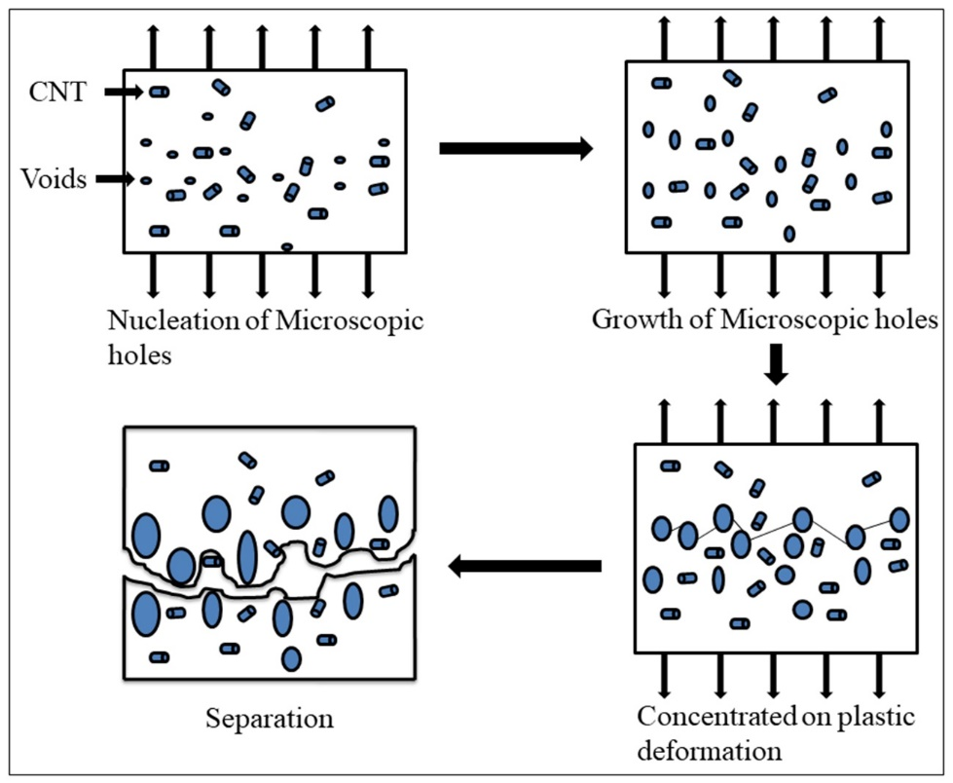
Fig. S5. Tensile fracture mechanism at various stages.
- Corrosion Mechanism of ANCs
Aluminium cations and electrons make up the elemental aluminium as shown in Eq. (1).
Al → Al³⁺ + 3e (1)
Furthermore, the existence of a thin oxide layer makes it relatively simple to achieve Al(OH)₃ saturation solubility. When the aluminium cation reacts with hydroxide ion forms aluminium hydroxide is formed as shown in Eq. (2).
Al³⁺ + 3OH– → Al(OH)₃ (2)
The robot environment has a layer of oxide aluminium oxide would react with acetic acid forms the aluminium hydroxide in the substance. Small anode and large cathode corrosion cells in the anode area of the 7075 aluminium alloy lead to a highly concentrated local corrosion form known as "pitting corrosion" as shown in Fig. S4. It initially begins close to the second phase particles. Due to the competitive adsorption of acetate ion from acetic acid over OH⁻, the end corrosion product is the soluble Al(C₂H₃O₂)₃ as shown in Eq. (3).
3 CH₃COOH + Al(OH)₃ → Al(C₂H₃O₂)₃ + 3 H ₂O (3)
As a result, the oxide coating on the surface of Al7075 and ANC specimens gradually dissolves. This causes the matrix to become exposed, along with other layers covered in oxide film, and this creates a corrosion micro battery that speeds up the corrosion of matrix.

