**Supporting information**

Customization of FeNi alloy nanosheet arrays inserted with biomass-derived carbon templates for boosted electromagnetic wave absorption

Xuanqi Yang1)*, Honghan Wang1)*, Jing Chen1), Qingda An1),🖂, Zuoyi Xiao1), Jingai Hao1), Shangru Zhai1),🖂, and Junyue Sheng2)

1) Liaoning Key Lab of Lignocellulose Chemistry and BioMaterials, Liaoning Collaborative Innovation Center for Lignocellulosic Biorefinery, College of Light Industry and Chemical Engineering, Dalian Polytechnic University, Dalian 116034, China

2) Qingdao Medical College, Qingdao University, Qingdao 266071, China



**Fig. S1. TG curve of** **FeNi/LSC-700.**

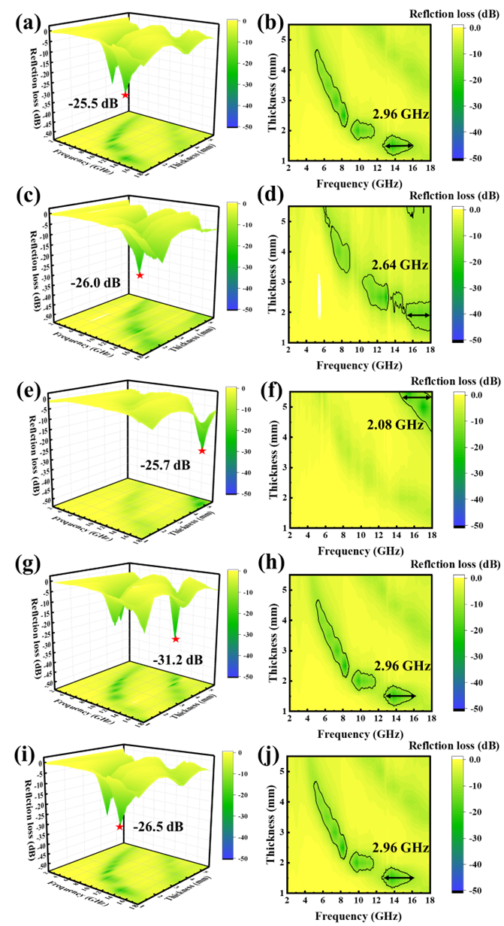

**Fig. S2. 3D images and 2D contours of calculated RL values of (a, b) Fe/LSC-700, (c, d) Fe1Ni0.5/LSC-700, (e, f) Ni/LSC-700, (g, h) Fe0.5Ni1/LSC-700 and (i, j) FeNi/LSC-N.**